**Company Bankruptcy Prediction**

**Ritik Vaidande**

**Data Science Practitioner**

**AlmaBetter, Bengaluru**

**Abstract:**

Prediction of bankruptcy is a phenomenon of increasing interest to firms who stand to lose money because on unpaid debts. Since computers can store huge dataset pertaining to bankruptcy making accurate predictions from them before hand is becoming important.

The data were collected from the Taiwan Economic Journal for the years 1999 to 2009. Company bankruptcy was defined based on the business regulations of the Taiwan Stock Exchange.

**Problem Statement**

The main objective of this project is to use various classification algorithms on bankruptcy dataset to predict bankruptcies with satisfying accuracies long before the actual event.

**Company Bankruptcy Prediction**

* **Attributes**

Updated column names and description to make the data easier to understand (Y = Output feature, X = Input features)

Y - Bankrupt?: Class label 1 : Yes , 0: No

X1 - ROA(C) before interest and depreciation before interest: Return On Total Assets(C)

X2 - ROA(A) before interest and % after tax: Return On Total Assets(A)

X3 - ROA(B) before interest and depreciation after tax: Return On Total Assets(B)

X4 - Operating Gross Margin: Gross Profit/Net Sales

X5 - Realized Sales Gross Margin: Realized Gross Profit/Net Sales

X6 - Operating Profit Rate: Operating Income/Net Sales

X7 - Pre-tax net Interest Rate: Pre-Tax Income/Net Sales

X8 - After-tax net Interest Rate: Net Income/Net Sales

X9 - Non-industry income and expenditure/revenue: Net Non-operating Income Ratio

X10 - Continuous interest rate (after tax): Net Income-Exclude Disposal Gain or Loss/Net Sales

X11 - Operating Expense Rate: Operating Expenses/Net Sales

X12 - Research and development expense rate: (Research and Development Expenses)/Net Sales

X13 - Cash flow rate: Cash Flow from Operating/Current Liabilities

X14 - Interest-bearing debt interest rate: Interest-bearing Debt/Equity

X15 - Tax rate (A): Effective Tax Rate

X16 - Net Value Per Share (B): Book Value Per Share(B)

X17 - Net Value Per Share (A): Book Value Per Share(A)

X18 - Net Value Per Share (C): Book Value Per Share(C)

X19 - Persistent EPS in the Last Four Seasons: EPS-Net Income

X20 - Cash Flow Per Share

X21 - Revenue Per Share (Yuan ¥): Sales Per Share

X22 - Operating Profit Per Share (Yuan ¥): Operating Income Per Share

X23 - Per Share Net profit before tax (Yuan ¥): Pretax Income Per Share

X24 - Realized Sales Gross Profit Growth Rate

X25 - Operating Profit Growth Rate: Operating Income Growth

X26 - After-tax Net Profit Growth Rate: Net Income Growth

X27 - Regular Net Profit Growth Rate: Continuing Operating Income after Tax Growth

X28 - Continuous Net Profit Growth Rate: Net Income-Excluding Disposal Gain or Loss Growth

X29 - Total Asset Growth Rate: Total Asset Growth

X30 - Net Value Growth Rate: Total Equity Growth

X31 - Total Asset Return Growth Rate Ratio: Return on Total Asset Growth

X32 - Cash Reinvestment %: Cash Reinvestment Ratio

X33 - Current Ratio

X34 - Quick Ratio: Acid Test

X35 - Interest Expense Ratio: Interest Expenses/Total Revenue

X36 - Total debt/Total net worth: Total Liability/Equity Ratio

X37 - Debt ratio %: Liability/Total Assets

X38 - Net worth/Assets: Equity/Total Assets

X39 - Long-term fund suitability ratio (A): (Long-term Liability+Equity)/Fixed Assets

X40 - Borrowing dependency: Cost of Interest-bearing Debt

X41 - Contingent liabilities/Net worth: Contingent Liability/Equity

X42 - Operating profit/Paid-in capital: Operating Income/Capital

X43 - Net profit before tax/Paid-in capital: Pretax Income/Capital

X44 - Inventory and accounts receivable/Net value: (Inventory+Accounts Receivables)/Equity

X45 - Total Asset Turnover

X46 - Accounts Receivable Turnover

X47 - Average Collection Days: Days Receivable Outstanding

X48 - Inventory Turnover Rate (times)

X49 - Fixed Assets Turnover Frequency

X50 - Net Worth Turnover Rate (times): Equity Turnover

X51 - Revenue per person: Sales Per Employee

X52 - Operating profit per person: Operation Income Per Employee

X53 - Allocation rate per person: Fixed Assets Per Employee

X54 - Working Capital to Total Assets

X55 - Quick Assets/Total Assets

X56 - Current Assets/Total Assets

X57 - Cash/Total Assets

X58 - Quick Assets/Current Liability

X59 - Cash/Current Liability

X60 - Current Liability to Assets

X61 - Operating Funds to Liability

X62 - Inventory/Working Capital

X63 - Inventory/Current Liability

X64 - Current Liabilities/Liability

X65 - Working Capital/Equity

X66 - Current Liabilities/Equity

X67 - Long-term Liability to Current Assets

X68 - Retained Earnings to Total Assets

X69 - Total income/Total expense

X70 - Total expense/Assets

X71 - Current Asset Turnover Rate: Current Assets to Sales

X72 - Quick Asset Turnover Rate: Quick Assets to Sales

X73 - Working capitcal Turnover Rate: Working Capital to Sales

X74 - Cash Turnover Rate: Cash to Sales

X75 - Cash Flow to Sales

X76 - Fixed Assets to Assets

X77 - Current Liability to Liability

X78 - Current Liability to Equity

X79 - Equity to Long-term Liability

X80 - Cash Flow to Total Assets

X81 - Cash Flow to Liability

X82 - CFO to Assets

X83 - Cash Flow to Equity

X84 - Current Liability to Current Assets

X85 - Liability-Assets Flag: 1 if Total Liability exceeds Total Assets, 0 otherwise

X86 - Net Income to Total Assets

X87 - Total assets to GNP price

X88 - No-credit Interval

X89 - Gross Profit to Sales

X90 - Net Income to Stockholder's Equity

X91 - Liability to Equity

X92 - Degree of Financial Leverage (DFL)

X93 - Interest Coverage Ratio (Interest expense to EBIT)

X94 - Net Income Flag: 1 if Net Income is Negative for the last two years, 0 otherwise

X95 - Equity to Liability

* **Dataset Information**

• Number of instances: 6819

• Number of attributes: 96

* **Cleaning the Dataset**

There are no missing or duplicated values present in our dataset.

* **Exploratory Data Analysis**

After loading the dataset, as there no null values. So, I performed EDA by comparing our target variable that is Bankrupt? with other independent variables. This process helped us figuring out various aspects and relationships among the target and the independent variables. It gave us a better idea of which feature behaves in which manner compared to the target variable. 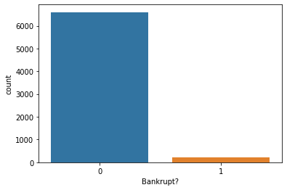

Distribution of Bankrupt

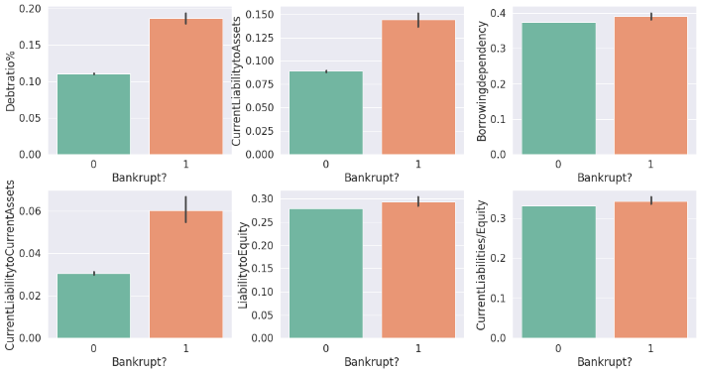

Features which are positively correlated to Bankrupt

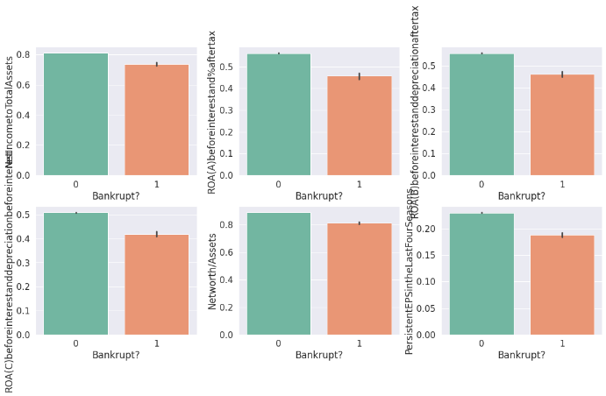

Features which are negatively correlated to Bankrupt

* **Resampling Data**

Synthetic Minority Oversampling Technique (SMOTE) is a statistical technique for increasing the number of cases in your dataset in a balanced way. The component works by generating new instances from existing minority cases.

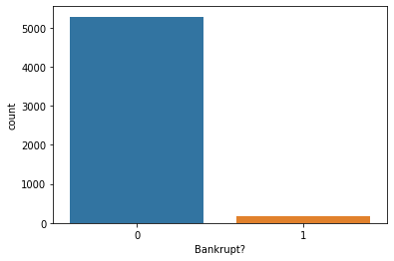

Before SMOTE

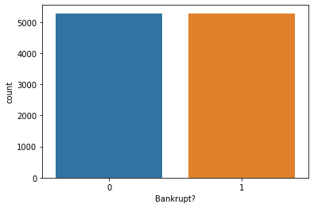

After SMOTE

* **Modeling**

**Feature Preparation**

PCA is an Dimensionality Reduction Technique. It is also a Feature extraction Technique. By PCA we create new features from old (Original) Features but the new features will always be independent of each other. So, its not just Dimensionality Reduction Process, we are even eliminating Correlation between the Variables.

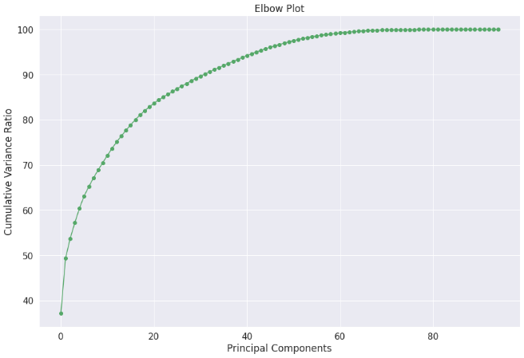

By looking at the Elbow plot, 60 is likely to be the required number of components.

* **Training**

Total 5 Machine Learning Classification Models are implemented.

Logistic Regression:

Logistic regression is a statistical method that is used for building machine learning models where the dependent variable is dichotomous: i.e. binary. Logistic regression is used to describe data and the relationship between one dependent variable and one or more independent variables. The independent variables can be nominal, ordinal, or of interval type.

best_score – 0.903992

Note: best_score is calculated as an average of the cross-validation iterations.

Decision Trees:

Decision Tree is the most powerful and popular tool for classification and prediction. A Decision tree is a flowchart-like tree structure, where each internal node denotes a test on an attribute, each branch represents an outcome of the test, and each leaf node (terminal node) holds a class label.

best_score – 0.956584

Random Forest Classifier:

Random Forest is a Supervised Machine Learning Algorithm that is used widely in Classification and Regression problems. It builds decision trees on different samples and takes their majority vote for classification and average in case of regression.

best_score – 0.913734

Support Vector Classifier:

Support Vector Machine or SVM is one of the most popular Supervised Learning algorithms, which is used for Classification as well as Regression problems. However, primarily, it is used for Classification problems in Machine Learning. The goal of the SVM algorithm is to create the best line or decision boundary that can segregate n-dimensional space into classes so that we can easily put the new data point in the correct category in the future.

best_score – 0.913734

XGBoost:

XGBoost is a powerful approach for building supervised regression models. The validity of this statement can be inferred by knowing about its (XGBoost) objective function and base learners. The objective function contains loss function and a regularization term. It tells about the difference between actual values and predicted values, i.e how far the model results are from the real values.

best_score – 0.968976

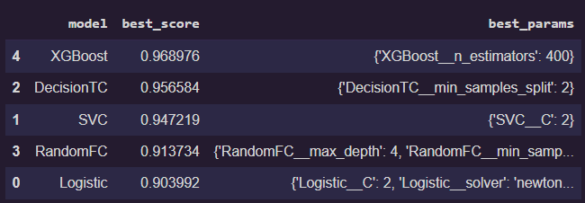

XGBoost and Decision Trees Classifier achieved good results while Logistic Regression and Random Forest Classifier gave satisfactory performance. Thus, XGBoost is the optimal model for this dataset.

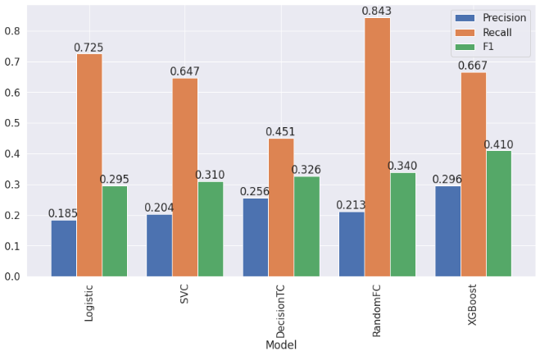

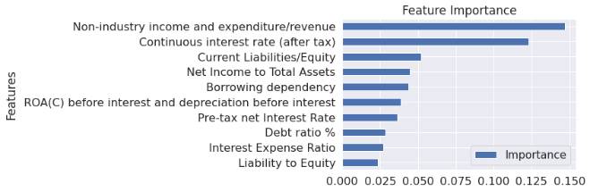

These are the top 10 most important features as per the top performing model XGBoost.

* **Conclusion**
* There are many attributes that play important roles to decide whether a company will go bankrupt or not.
* Net Income Flag plot showed us that most of the companies are running into Losses for the past 2 years.
* There are high chances that a company can go Bankrupt if the attributes “Debt Ratio %, Current Liability To Assets, Current Liability To Current Assets” are high.
* The best performing model is XGBoost by considering the F1 score which is an ideal metric to choose for an classification model.
* Analyzing the dataset and building the best model to predict bankruptcy is been done successfully.

**References**

1. Towards Data Science
2. StackOverflow
3. Medium
4. GitHub