College admission prediction

Level0 DFD

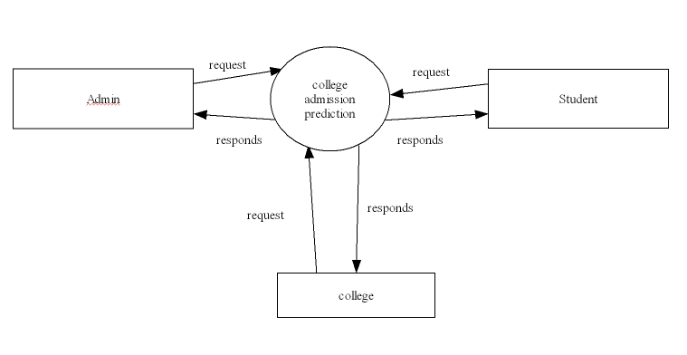

Level0 dfd for admin



Level1 DFD for college



Level1 dfd for student



Level2 DFD for student



Level2 DFD for college

