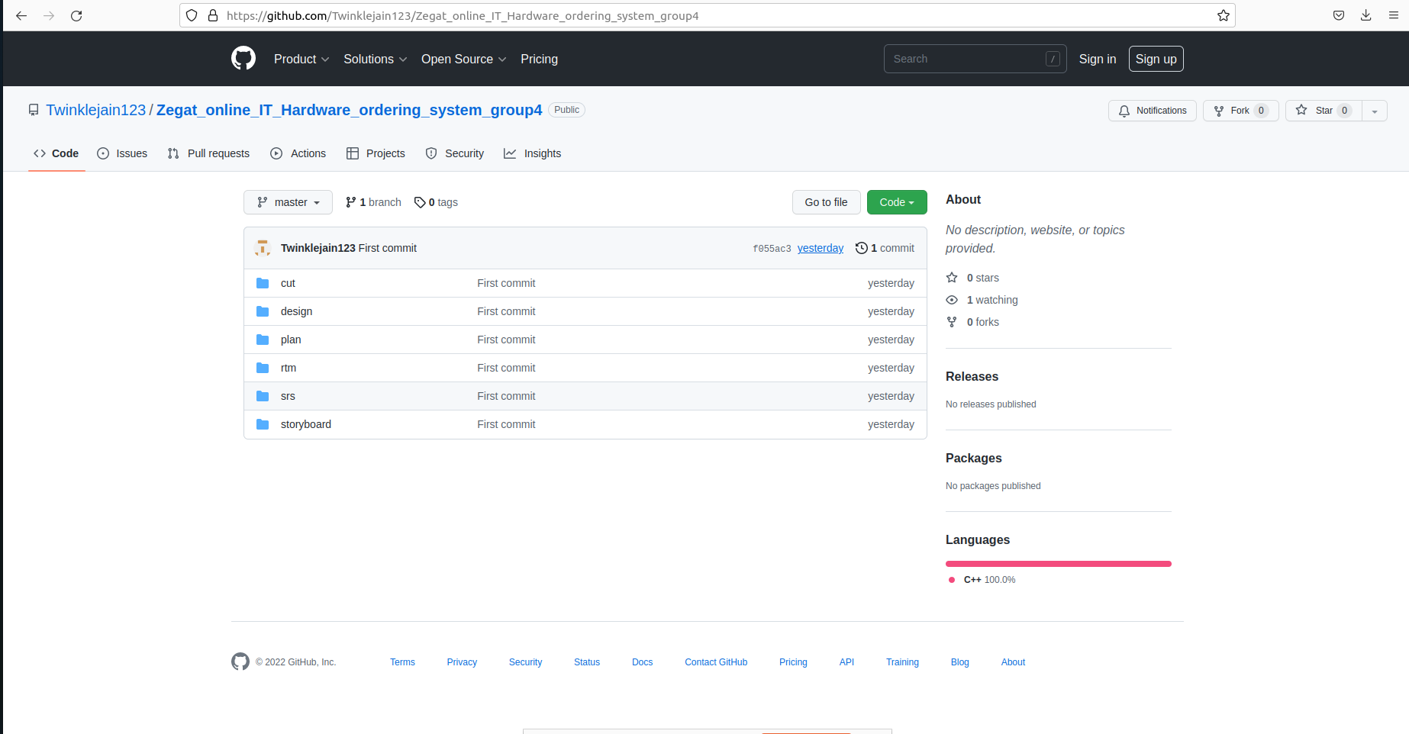

github link:<https://github.com/Twinklejain123/Zegat_Online_IT_hardware_G4>