**IT CASE 1: Supplier Account Registration**

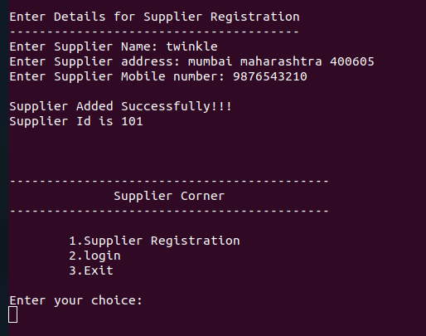

**IT_CASE 2: View Details of Supplier**

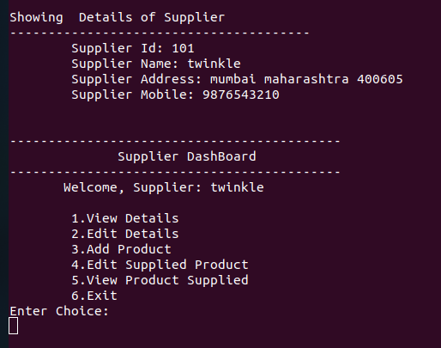

IT_CASE 3: Adding Product By Supplier

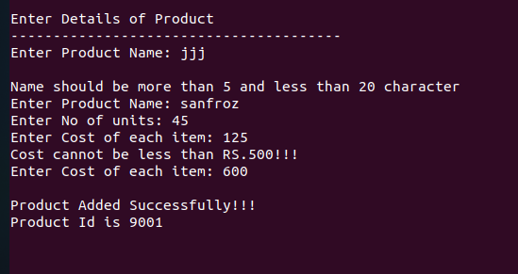

IT_CASE 4: Customer Account Registration

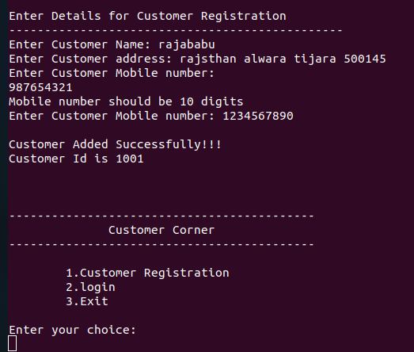

IT_CASE 5: Place Order by Customer

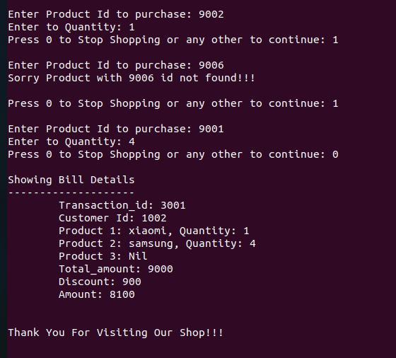

IT_CASE 6:Viewing list by Admin

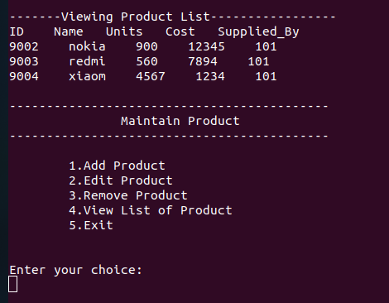

IT _CASE 7:View transaction story

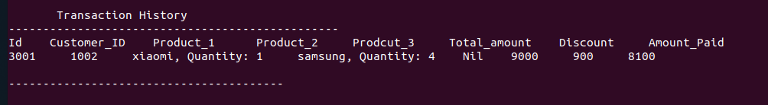

IT_CASE 8:Stock Report

