Format issue in CSV files

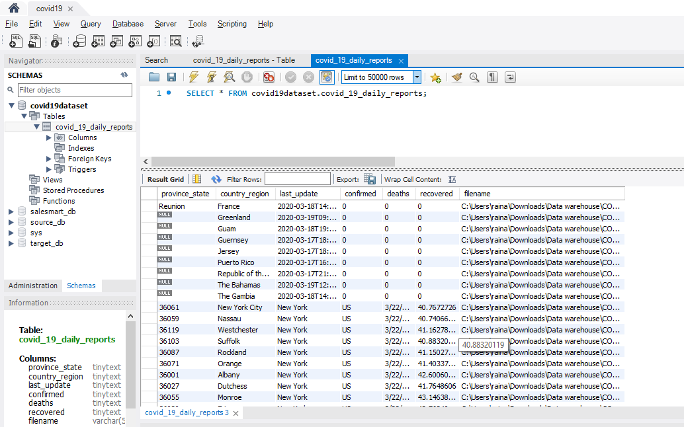

After applying ETL process and changing filename to date_reported, we got the following well formatted data.

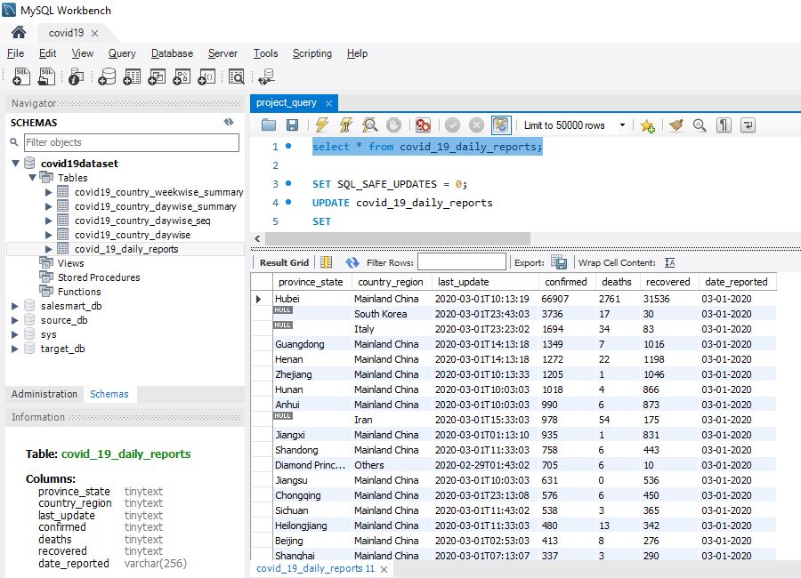

ETL pipeline

