JSPM’s
Rajarshi Shahu College of Engineering, Pune
Department of Computer Science and Business Systems
AY: 2026–27 Sem III
S.Y. B.Tech

MINI PROJECT REPORT
ON
“Pet Care - Veterinary Clinic Management System”

Ankita Kambale RBTL26CB067
Asmita Jadhav RBTL26CB068

Under the guidance of
Prof . Rutuja Bachhav

1. Introduction

1.1 Background
Veterinary clinics handle a large amount of connected information: pet owners and their contact numbers, many pets of different species, doctors with different specialisations, appointments, diagnoses, medicines and bills. When this data is kept in registers or spreadsheets, it is easy to double-book a doctor, lose a prescription, run out of medicine unnoticed, or bill a customer incorrectly. A Database Management System (DBMS) solves these problems by storing the data once, in related tables, and enforcing rules on it automatically.

1.2 Problem Statement
To design and implement a database-driven application, PetCare – Pet Care and Veterinary Clinic Management System, that manages owners, pets, veterinarians, appointments, treatments, medicines and billing with correct relationships, automatic validation and reliable reports.

1.3 Objectives
- Design a normalised relational database (up to 3NF) with an ER diagram, keys and functional dependencies.
- Implement nine related tables with primary, foreign, candidate, composite and alternate keys and integrity constraints.
- Apply advanced SQL: joins, aggregates, GROUP BY/HAVING, subqueries, EXISTS, views, stored procedures, functions, triggers, indexes and transactions.
- Maintain data consistency automatically – stock reduction, bill calculation and slot validation – using triggers and procedures.
- Provide a modern, responsive web dashboard for daily clinic operations and reports.

1.4 Scope
The system covers owner and pet registration, doctor management, appointment booking and cancellation, treatment and prescription entry, medicine inventory with low-stock alerts, automatic billing with payment recording and printable invoices, and analytical reports. It is a single-clinic, single-user-role application intended as a DBMS mini project.

2. Technology Stack

2.1 Technologies Used
The project follows a three-tier architecture: a browser-based presentation layer, a Python Flask application layer and a MySQL data layer.

Layer | Technology | Purpose
Frontend | HTML5 | Page structure and forms
Frontend | CSS3 (Flexbox, Grid, custom properties) | Responsive layout, gradient theme, consistent design system
Frontend | JavaScript (ES6) | Live search, sorting, pagination, CSV export, edit forms, chart logic
Frontend | Chart.js 4.4 | Interactive dashboard charts (bundled locally)
Frontend | Google Fonts – Poppins | Typography
Backend | Python 3.11 | Application language
Backend | Flask (with Jinja2 templating) | Routing, server-side rendering, JSON endpoints
Database | MySQL 8.0 (InnoDB engine) | Relational storage, constraints, triggers, procedures, views
Connector | mysql-connector-python | Connects Flask to MySQL and executes SQL
Tools | VS Code, MySQL Command Line Client / Workbench, Graphviz | Development, SQL execution, ER diagram generation

3. System Analysis

3.1 Existing System Problems
- Manual registers make searching for a pet’s history slow and error-prone.
- Doctors can be double-booked because there is no central schedule.
- Medicine stock is not updated automatically, causing shortages or expiry losses.
- Bills are calculated by hand, leading to mistakes and unpaid dues being forgotten.

3.2 Proposed System
PetCare centralises all clinic data in one MySQL database. Business rules are enforced inside the database (constraints, triggers and stored procedures), so they hold no matter which program accesses the data. The Flask web application provides forms, tables, profiles, invoices and a dashboard on top of it.

3.3 Modules
Module | Responsibility
Owner & Pet Management | Register owners (with several phone numbers) and their pets; view profiles
Veterinarian Management | Maintain doctors, specialisations and fees
Appointment Management | Book (via stored procedure), cancel and edit appointments; prevents double-booking
Treatment & Prescription | Record diagnosis, procedure and medicines used; stock reduces automatically
Medicine Inventory | Track price, stock, expiry and reorder level; low-stock highlighting
Billing | Auto-calculate bills, record payments, print invoices
Reports & Dashboard | KPI cards, interactive charts, and eight analytical SQL reports

4. Database Design

4.1 Entity–Relationship Diagram
The ER diagram below shows the nine entities, their key attributes and the cardinality of each
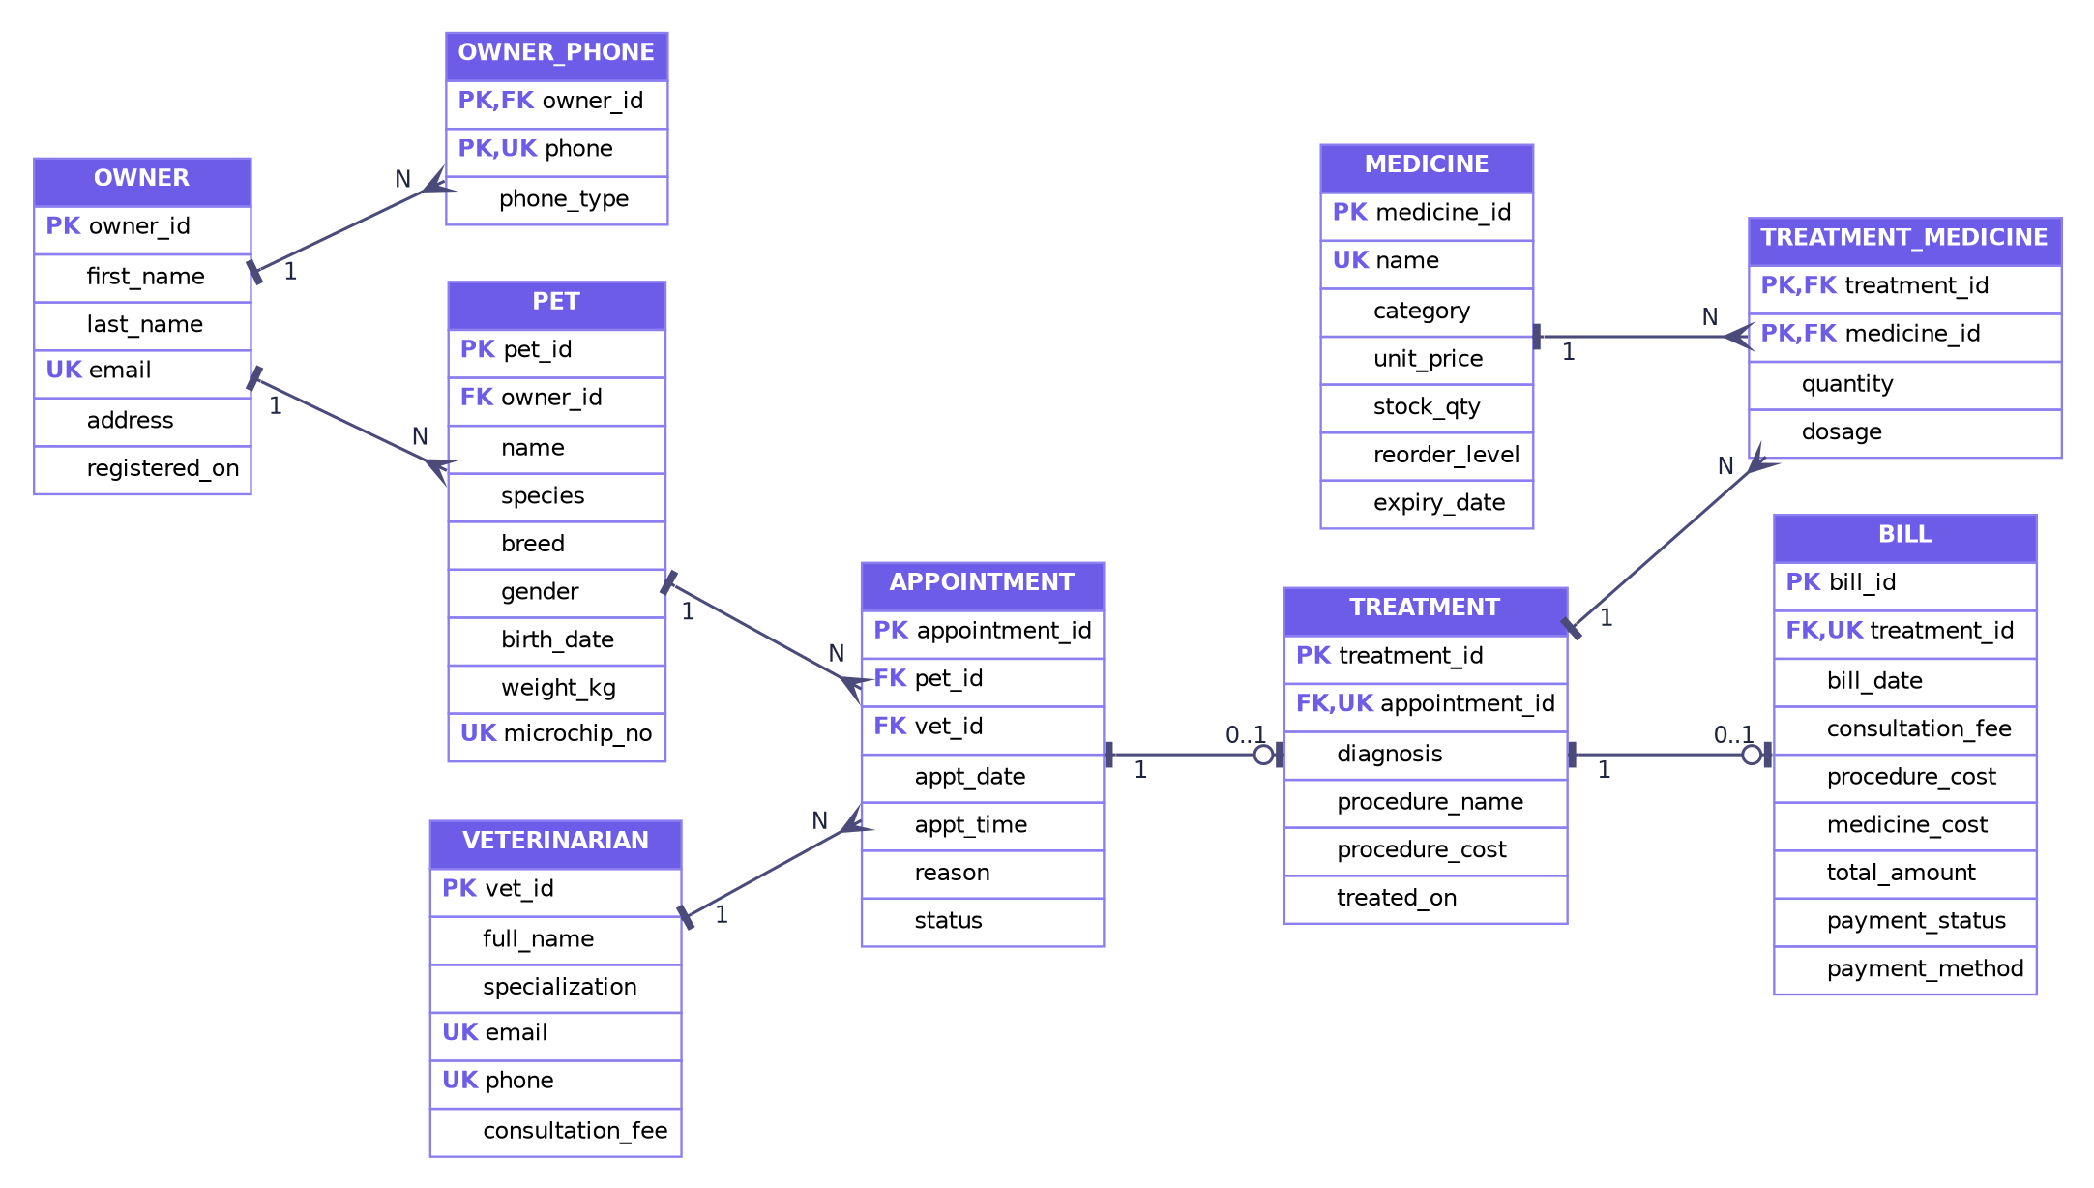
Figure 4.1: ER diagram of the PetCare database

4.2 Relationships and Cardinality

Relationship | Entities | Cardinality | Explanation
has | OWNER – OWNER_PHONE | 1 : N | An owner can have many phone numbers
owns | OWNER – PET | 1 : N | An owner can own many pets; a pet has one owner
books | PET – APPOINTMENT | 1 : N | A pet can have many appointments
attends | VETERINARIAN – APPOINTMENT | 1 : N | A vet attends many appointments
results in | APPOINTMENT – TREATMENT | 1 : 0..1 | A completed appointment has at most one treatment
billed by | TREATMENT – BILL | 1 : 0..1 | A treatment has at most one bill
prescribes | TREATMENT – MEDICINE | M : N | Resolved by TREATMENT_MEDICINE (quantity, dosage)

5. Data Dictionary
The database petcare_db contains 9 tables. The structure of each table is given below.

5.1 OWNER
Stores pet owners.
Column | Data type | Constraints | Description
owner_id | INT | PK, AUTO_INCREMENT | Unique owner identifier
first_name | VARCHAR(40) | NOT NULL | Owner first name
last_name | VARCHAR(40) | NOT NULL | Owner last name
email | VARCHAR(100) | NOT NULL, UNIQUE | Contact e-mail (alternate key)
address | VARCHAR(200) | — | Postal address
registered_on | DATE | NOT NULL, DEFAULT today | Registration date

5.2 OWNER_PHONE
Stores multiple phone numbers per owner (resolves the multivalued attribute).
Column | Data type | Constraints | Description
owner_id | INT | PK, FK → OWNER (CASCADE) | Owner the number belongs to
phone | VARCHAR(20) | PK, UNIQUE | Phone number (multivalued attribute)
phone_type | ENUM | DEFAULT ‘Mobile’ | Mobile / Home / Work

5.3 PET
Stores pets and their owners.
Column | Data type | Constraints | Description
pet_id | INT | PK, AUTO_INCREMENT | Unique pet identifier
owner_id | INT | NOT NULL, FK → OWNER (CASCADE) | Owner of the pet
name | VARCHAR(40) | NOT NULL | Pet name; UNIQUE with owner_id
species | ENUM | NOT NULL | Dog, Cat, Rabbit, Bird, Hamster, Turtle
breed | VARCHAR(50) | — | Breed
gender | ENUM | NOT NULL | Male / Female
birth_date | DATE | NOT NULL | Used to derive age
weight_kg | DECIMAL(5,2) | NOT NULL, CHECK > 0 | Weight in kilograms
microchip_no | VARCHAR(20) | UNIQUE | Microchip identifier

5.4 VETERINARIAN
Stores doctors and their consultation fees.
Column | Data type | Constraints | Description
vet_id | INT | PK, AUTO_INCREMENT | Unique vet identifier
full_name | VARCHAR(80) | NOT NULL | Doctor name
specialization | VARCHAR(60) | NOT NULL | Area of expertise
email | VARCHAR(100) | NOT NULL, UNIQUE | E-mail
phone | VARCHAR(20) | NOT NULL, UNIQUE | Phone
consultation_fee | DECIMAL(8,2) | NOT NULL, CHECK ≥ 0 | Fee per consultation (₹)

5.5 APPOINTMENT
Stores visit bookings with unique slot constraints.
Column | Data type | Constraints | Description
appointment_id | INT | PK, AUTO_INCREMENT | Unique appointment id
pet_id | INT | NOT NULL, FK → PET (CASCADE) | Pet being treated
vet_id | INT | NOT NULL, FK → VETERINARIAN | Attending vet
appt_date | DATE | NOT NULL | Appointment date
appt_time | TIME | NOT NULL | Appointment time
reason | VARCHAR(200) | NOT NULL | Reason for visit
status | ENUM | DEFAULT ‘Scheduled’ | Scheduled / Completed / Cancelled
(vet_id, appt_date, appt_time) | UNIQUE | uq_vet_slot | Prevents double-booking a vet
(pet_id, appt_date, appt_time) | UNIQUE | uq_pet_slot | Prevents double-booking a pet

5.6 TREATMENT
Stores diagnosis and procedure for a completed visit.
Column | Data type | Constraints | Description
treatment_id | INT | PK, AUTO_INCREMENT | Unique treatment id
appointment_id | INT | NOT NULL, UNIQUE, FK → APPOINTMENT (CASCADE) | One treatment per appointment
diagnosis | VARCHAR(150) | NOT NULL | Diagnosis
procedure_name | VARCHAR(100) | NOT NULL | Procedure performed
procedure_cost | DECIMAL(8,2) | DEFAULT 0, CHECK ≥ 0 | Cost of procedure (₹)
treated_on | DATE | NOT NULL | Treatment date

5.7 MEDICINE
Medicine inventory with stock and reorder level.
Column | Data type | Constraints | Description
medicine_id | INT | PK, AUTO_INCREMENT | Unique medicine id
name | VARCHAR(80) | NOT NULL, UNIQUE | Medicine name
category | VARCHAR(40) | NOT NULL | Antibiotic, Vaccine, Supplement…
unit_price | DECIMAL(8,2) | NOT NULL, CHECK > 0 | Price per unit (₹)
stock_qty | INT | NOT NULL, CHECK ≥ 0 | Units in stock
reorder_level | INT | NOT NULL, DEFAULT 10 | Low-stock threshold
expiry_date | DATE | NOT NULL | Expiry date

5.8 TREATMENT_MEDICINE
Associative table resolving the M:N relation between treatments and medicines.
Column | Data type | Constraints | Description
treatment_id | INT | PK, FK → TREATMENT (CASCADE) | Treatment
medicine_id | INT | PK, FK → MEDICINE | Medicine used
quantity | INT | NOT NULL, CHECK > 0 | Units prescribed
dosage | VARCHAR(60) | — | Dosage instructions

5.9 BILL
Billing record generated for each treatment.
Column | Data type | Constraints | Description
bill_id | INT | PK, AUTO_INCREMENT | Unique bill id
treatment_id | INT | NOT NULL, UNIQUE, FK → TREATMENT (CASCADE) | Treatment billed
bill_date | DATE | DEFAULT today | Bill date
consultation_fee | DECIMAL(10,2) | DEFAULT 0 | Vet fee snapshot (set by trigger)
procedure_cost | DECIMAL(10,2) | DEFAULT 0 | Procedure cost snapshot
medicine_cost | DECIMAL(10,2) | DEFAULT 0 | Sum of quantity × unit price
total_amount | DECIMAL(10,2) | DEFAULT 0 | Computed total
payment_status | ENUM | DEFAULT ‘Unpaid’ | Paid / Unpaid
payment_method | ENUM | NULL; CHECK | Cash / Card / UPI; required when Paid

6. Results

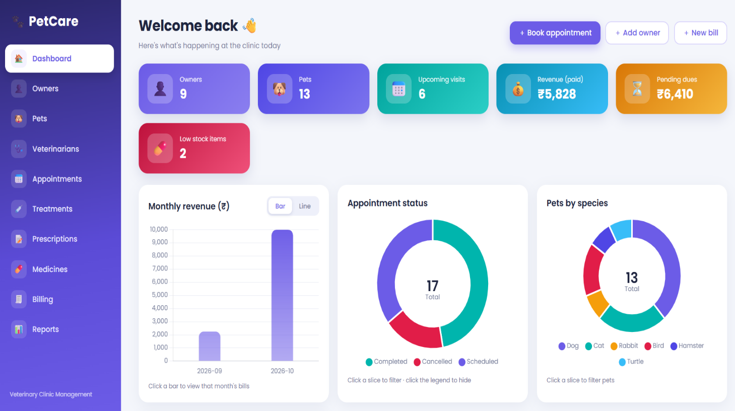

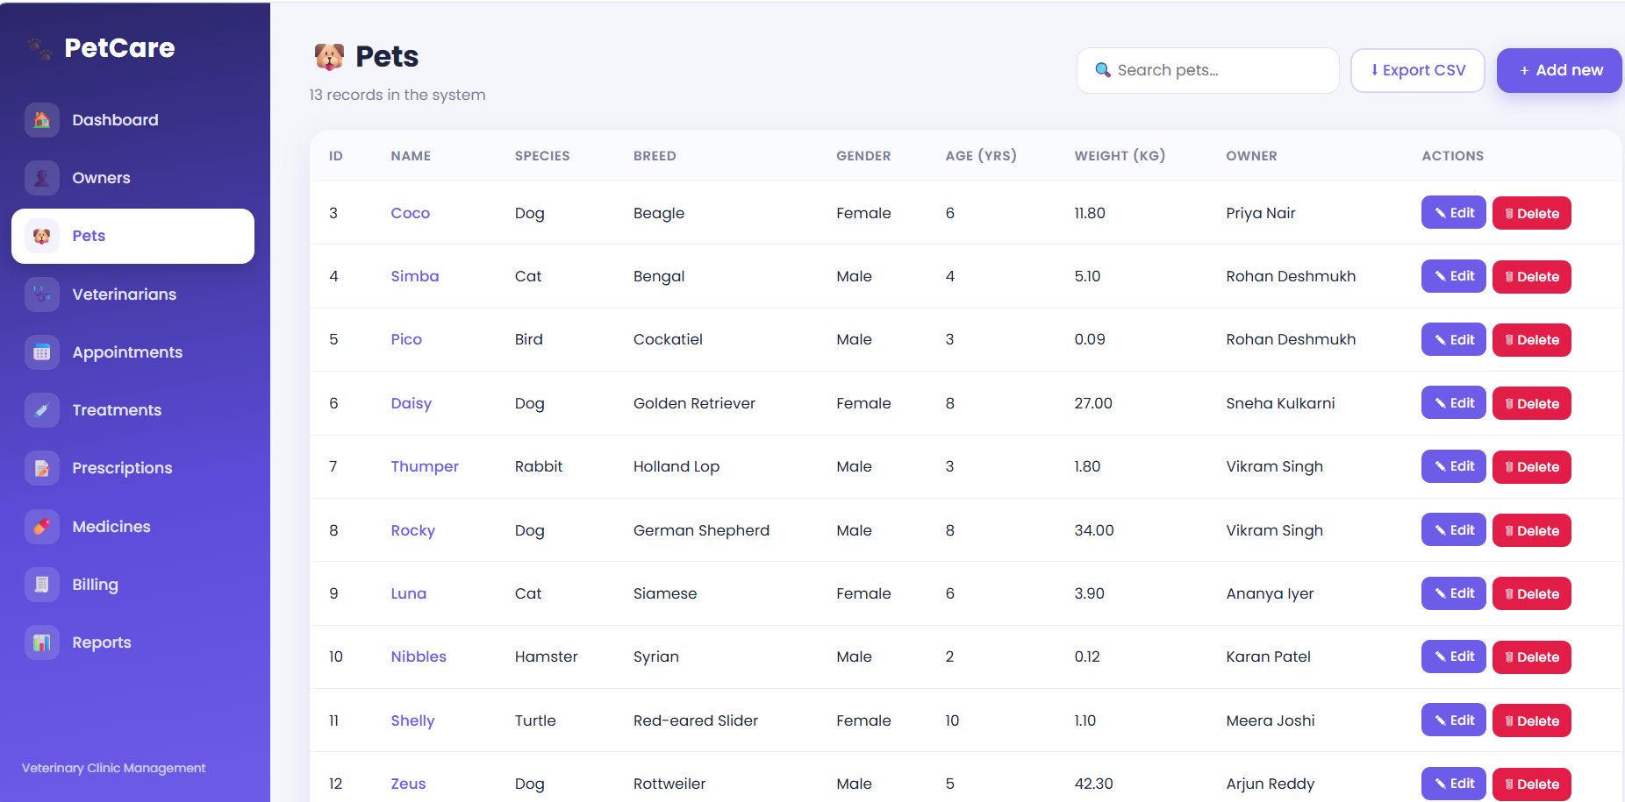

7. Conclusion
PetCare demonstrates how a well-designed relational database can run a veterinary clinic reliably. The schema is normalised to 3NF, with nine tables protected by primary, foreign, unique and check constraints. Triggers and stored procedures keep stock, billing and appointments consistent automatically, and transactions preserve ACID properties. The Flask web application with its dashboard, profiles, invoices and reports makes these database features easy to use and easy to demonstrate. The project covers the required SQL concepts – joins, aggregates, subqueries, views, procedures, functions, triggers, indexes, transactions and access control – in a practical, working system.

