GUJARAT TECHNOLOGICAL UNIVERSITY

Navyug Vidyabhavan Trust
C. K. Pithawalla College of Engineering and Technology, Surat
A
Project Report
On
Sentiment Analysis of Smartphone Reviews
Prepared as a part of the requirements for the subject of
Python for Data Science (BE05000231)

B. E. III, Semester – V
(Computer Engineering)

Submitted by:

Sr. No. | Enrolment No | Name of Student | Division
1 | 240090107021 | Patil Darshna Satish | C
2 | 240090107094 | Mistry Mahek Devndrabhai | C
3 | 240090107095 | Mistry Vaidehi Dharmeshkumar | C
4 | 240090107098 | More Heer Sanjay | C
5 | 240090107152 | Patel Tisha Rohitkumar | C

Academic year (2026-27)
Table of Contents
Sr. No | Title | Page No
1 | Problem Statement
2 | Research/Idea development
3 | Implementation (code/model/experiment)
 | Conclusion and Future Work
 | References

Problem Statement

Topic : Sentiment Analysis of Smartphone Reviews
  - Problem Statement
Online mobile-phone reviews contain useful information about customer experiences, but reading hundreds of reviews manually is time-consuming. The project addresses the problem of organizing and analysing review text together with product ratings and brands. The system classifies reviews into Positive, Negative, and Neutral sentiments and performs descriptive, statistical, visualization, natural-language-processing, database, and machine-learning tasks.

The project uses a dataset of 500 mobile-phone reviews containing brand, rating, review text, price, and sentiment-related information. The analysis is intended to identify sentiment distribution, compare brands, study the relationship between rating and sentiment, preprocess review text, convert text into numerical TF-IDF features, and train a Logistic Regression classifier for sentiment prediction.

Research/Idea development

2.1 Project Overview
Sentiment Analysis of Mobile Phone Reviews Using Python is a data science project that analyses customer reviews of mobile phones to understand their opinions and experiences. The project uses a dataset containing 500 mobile phone reviews with information such as brand, rating, review text, price, and sentiment. Python libraries including Pandas, NumPy, SciPy, Matplotlib, NLTK, and Scikit-learn are used for data processing, statistical analysis, visualization, natural language processing, and machine learning.
The project begins with data loading, inspection, and preprocessing, including handling missing values, checking duplicates, cleaning review text, tokenization, stop-word removal, and lemmatization. Exploratory analysis is performed to study sentiment distribution, brand-wise reviews, ratings, and other patterns. Statistical techniques such as probability, sampling, descriptive statistics, and hypothesis testing are also applied. For machine learning, TF-IDF is used to convert review text into numerical features, followed by a Logistic Regression model for sentiment classification. The model achieved 88% accuracy on the test dataset. The project demonstrates how Python can be used to extract meaningful insights from real-world customer review data.
2.2 Objective
The main objective of this project is to analyse customer reviews of mobile phones using Python and understand the opinions expressed by customers. The project focuses on classifying reviews into Positive, Negative, and Neutral sentiments and identifying patterns based on mobile-phone brands and customer ratings. It also aims to preprocess review text using Natural Language Processing techniques such as tokenization, stop-word removal, and lemmatization. Statistical analysis, probability, sampling, and hypothesis testing are performed to obtain meaningful insights from the dataset. Furthermore, the project uses TF-IDF to convert review text into numerical features and applies Logistic Regression to build a sentiment classification model. The project also demonstrates important Python concepts such as file handling, exception handling, custom modules, data visualization, and SQLite CRUD operations.
2.3 Scope
The scope of this project is to analyse customer reviews of mobile phones and extract useful information about customer opinions, ratings, and brand-wise performance. The project focuses on the available review dataset and uses Python-based techniques for data cleaning, exploratory data analysis, natural language processing, statistical analysis, data visualization, and machine learning. The analysis covers sentiment classification into Positive, Negative, and Neutral categories and examines the relationship between ratings, brands, and sentiments. The project also demonstrates supporting Python concepts such as file handling, exception handling, custom modules, and SQLite CRUD operations.
2.4 Key Outcomes
The project provides a structured analysis of the mobile phone review dataset and identifies patterns in customer sentiment, ratings, and brands. The analysis classifies the reviews into Positive, Negative, and Neutral categories and presents the results through statistical analysis and visualizations. The project also applies Natural Language Processing techniques to clean and prepare review text for further analysis. TF-IDF is used to convert the processed text into numerical features, which are then used to train a Logistic Regression model for sentiment classification. The trained model achieves an accuracy of 88% on the test dataset. Overall, the project demonstrates the practical use of Python data science, NLP, statistical analysis, visualization, and machine learning techniques for analysing customer review data.
2.5 Dataset Used
The project uses a dataset containing 500 mobile phone customer reviews. The dataset includes information related to the mobile phone, customer rating, review text, brand, price, cleaned review text, and sentiment. The review text is used as the main source for Natural Language Processing and sentiment analysis, while the rating and brand fields are used for statistical and comparative analysis.
The dataset contains reviews from different mobile phone brands, including Apple, Samsung, OnePlus, Redmi, Oppo, Nokia, realme, Google Pixel, Vivo, and Motorola. Before performing the analysis, the dataset is inspected for missing values and duplicate records. Missing price values are handled using the median, while records without review text or sentiment information are removed. After preprocessing, the dataset is used for exploratory analysis, visualization, statistical analysis, NLP processing, and machine-learning-based sentiment classification.
2.6 Python Core Concepts
The project uses several core Python concepts to perform data analysis and process customer reviews. Variables and expressions are used to store and manipulate data, while conditional statements are used for decision-making and validation. Loops are used to process multiple records and perform repetitive operations. Functions are created to perform specific and reusable tasks, such as cleaning review text and calculating sentiment percentages. Lists and dictionaries are used to store and organize data, while list and dictionary comprehensions are used for efficient data processing. String operations and regular expressions are also used extensively for cleaning and preparing the review text for Natural Language Processing.

2.7 Python Libraries
The project uses several Python libraries to perform different stages of data analysis and machine learning. Pandas is used for loading, cleaning, organizing, and analysing the dataset. NumPy is used for numerical calculations and statistical operations, while SciPy is used for statistical analysis and hypothesis testing. Matplotlib is used to create visualizations such as pie charts and bar charts for presenting the analysis results. NLTK (Natural Language Toolkit) is used for Natural Language Processing tasks such as tokenization, stop-word removal, and lemmatization. Scikit-learn is used for TF-IDF feature extraction, train-test splitting, Logistic Regression, and model evaluation. The SQLite3 library is used to demonstrate database operations such as creating, inserting, reading, updating, and deleting review records.
2.8 Custom Modules
A custom Python module named sentiment_analysis.py is used in the project to organize reusable functions related to sentiment analysis. The module contains functions for calculating percentages and determining the percentage of Positive, Negative, and Neutral reviews. The calculate_percentage() function calculates the percentage of a given count with respect to the total number of records, while the sentiment_percentage() function calculates the percentage of each sentiment category from the dataset. The custom module is imported into the main program and used to perform sentiment-related calculations, demonstrating the use of modular programming in Python.
2.9 Exception Handling
Exception handling is used in the project to handle errors that may occur during the execution of the program. The try and except blocks are used to prevent the program from terminating unexpectedly when an error occurs. In the project, exception handling is applied while loading the dataset, converting values into numeric form, accessing required columns, processing review text, and performing calculations. Different exceptions such as FileNotFoundError, ValueError, KeyError, and ZeroDivisionError are handled according to the operation being performed. This makes the program more reliable and allows meaningful error messages to be displayed when an unexpected situation occurs.
2.10 Web Scraping
Web scraping is a technique used to collect information automatically from websites. In the context of this project, web scraping could be used to collect mobile phone reviews, ratings, prices, and other product-related information from online sources. However, web scraping is not implemented in the provided project notebook, so it is not included as an implemented part of the project's results.
2.11 File Handling
File handling is used in the project to read and write data files. The dataset is loaded from an Excel file using the Pandas library, which allows the data to be accessed and processed as a DataFrame. After performing data cleaning and sentiment analysis, the processed results can be stored in a new Excel file for further use. This demonstrates how Python can be used to manage external data files during a data-science project.
2.12 CRUD Operations
The project demonstrates CRUD (Create, Read, Update, and Delete) operations using the SQLite database. A database table is created to store review information, and records are inserted into the table using the Create operation. The Read operation is used to retrieve and display stored review records. The Update operation modifies existing information in a review record, such as changing its rating. The Delete operation removes a selected record from the database. These operations demonstrate how Python can be used to manage structured review data using a relational database.
2.13 NumPy
NumPy is used in the project for performing numerical operations and statistical calculations on the dataset. It provides efficient array-based operations that are useful for analysing numerical values such as ratings and prices. In the project, NumPy is used to calculate values such as the mean, minimum, and maximum of numerical data. It helps simplify numerical analysis and supports the statistical processing performed during the project.
2.14 SciPy
SciPy is used in the project for performing statistical analysis on the dataset. It provides statistical functions that help analyse the distribution of numerical data and perform hypothesis testing. In the project, SciPy is used to obtain descriptive statistical information and to perform the Chi-Square test of independence between rating and sentiment. The statistical results help in understanding the relationship between the variables present in the dataset.
2.15 Pandas
Pandas is one of the main Python libraries used in this project for handling and analysing the mobile phone review dataset. It is used to load the Excel dataset into a DataFrame and inspect its structure, columns, data types, missing values, and duplicate records. Pandas is also used for data cleaning, including handling missing values and removing duplicate records. Various operations such as filtering records, grouping data by brand, calculating sentiment counts, and creating cross-tabulations between ratings and sentiments are performed using Pandas. This makes it easier to organize the dataset and prepare it for further statistical analysis, visualization, and machine learning.
2.16 Data Preprocessing
Data preprocessing is performed to prepare the mobile phone review dataset for analysis and machine learning. The dataset is first checked for duplicate records and missing values. Missing values in the actual_price column are handled using the median value, while records without required review_text or sentiment information are removed. The review text is then converted into lowercase and unwanted characters and punctuation are removed. Natural Language Processing techniques are applied to tokenize the text, remove stop words, and perform lemmatization. The resulting cleaned review text is stored for further analysis and is later used for TF-IDF feature extraction and sentiment classification.
2.17 Statistical Analysis
Statistical analysis is performed to understand the numerical characteristics and patterns present in the mobile phone review dataset. Descriptive statistics are used to analyse values such as ratings and prices, including the minimum, maximum, mean, and variance. The project also performs brand-wise analysis to compare customer ratings among different mobile phone brands. For example, the Samsung reviews contain 64 records, with ratings ranging from 1 to 5 and an average rating of approximately 3.05. These statistical measures help in understanding the distribution and overall characteristics of the dataset.
2.18 Probability
Probability analysis is used to determine the likelihood of each sentiment category occurring in the dataset. The project contains a total of 500 reviews, including 209 Positive, 191 Negative, and 100 Neutral reviews. Based on these values, the probability of a randomly selected review being Positive is 0.418, Negative is 0.382, and Neutral is 0.200. This analysis provides a numerical representation of the sentiment distribution in the dataset and helps in understanding the relative occurrence of each sentiment category.
2.19 Sampling & Inference
Sampling is used in the project to select a smaller group of records from the complete dataset for analysis. From the total 500 reviews, a random sample of 50 reviews is selected using a fixed random state. The sample contains 28 Positive, 12 Negative, and 10 Neutral reviews. The corresponding sample proportions are 0.56 Positive, 0.24 Negative, and 0.20 Neutral. These sample results are compared with the proportions of the complete dataset to demonstrate how the distribution of a sample can differ from the overall dataset.

2.20 Hypothesis Testing
Hypothesis testing is used in the project to determine whether there is a significant relationship between rating and sentiment. A Chi-Square Test of Independence is applied to the rating-by-sentiment contingency table. The test produces a Chi-Square statistic of approximately 1000 and a very small p-value of approximately 1.49 × 10⁻²¹⁰. Using a significance level of 0.05, the null hypothesis is rejected in the notebook, indicating a statistically significant association between rating and sentiment in the analysed dataset.
2.21 Machine Learning
The project uses machine learning to classify mobile phone reviews according to their sentiment. The review text is first converted into numerical features using TF-IDF (Term Frequency–Inverse Document Frequency). The dataset is divided into training and testing sets using an 80:20 split, with 400 records used for training and 100 records used for testing. A Logistic Regression model is then trained using the TF-IDF features to predict whether a review is Positive, Negative, or Neutral.
The trained model achieves an accuracy of 88% on the test dataset. Precision, recall, and F1-score are also calculated for each sentiment category to evaluate the classification performance. The confusion matrix is used to identify correctly and incorrectly classified reviews. The machine-learning implementation demonstrates how text data can be transformed into numerical features and used to build a sentiment classification model.

Implementation (code/model/experiment)

Topic

The following section presents the implementation of the project with selected code and corresponding outputs. The screenshots are arranged according to the workflow: dataset loading, preprocessing, analysis, NLP, visualization, database operations, and machine learning. Each figure is accompanied by a short explanation of its purpose.
3.1 Dataset Loading

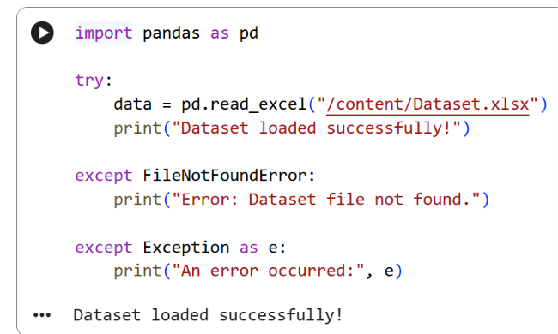
The Excel dataset is loaded using Pandas. Exception handling is included to handle a missing dataset file.

3.2 DataFrame Creation
Implementation workflow: Dataset Loading → Data Cleaning → NLP Preprocessing → Statistical Analysis → Visualization → TF-IDF → Logistic Regression → Evaluation → SQLite CRUD.

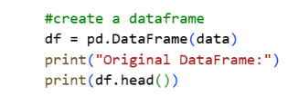
The loaded data is converted into a Pandas DataFrame, providing a structured format for further processing and analysis.
3.3: Initial Dataset Preview
The first records of the dataset are displayed to verify the columns and values before analysis
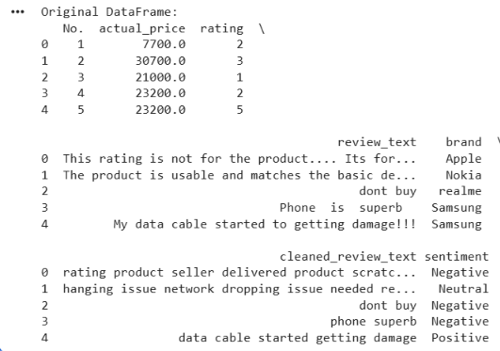
.3.4: File Handling Using Pandas
The project demonstrates reading the Excel dataset and writing processed data to an Excel file. 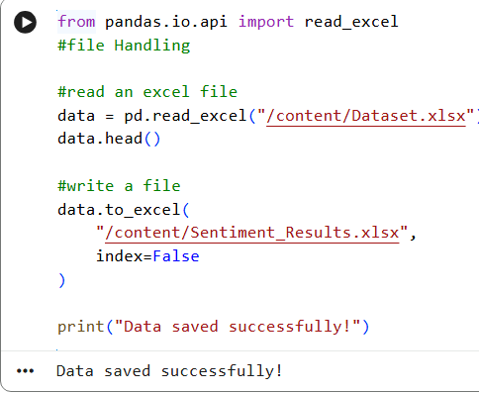
3.5: Dataset Information
The DataFrame information is inspected to verify the number of records, columns, non-null values, and data types.
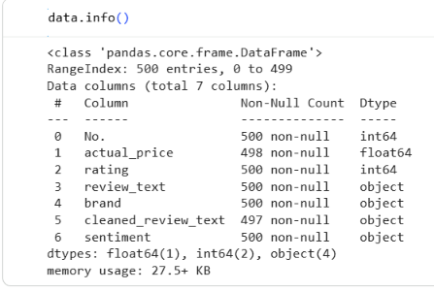

3.6: Dataset Head
The head() function displays the first five records for an initial inspection of the dataset.
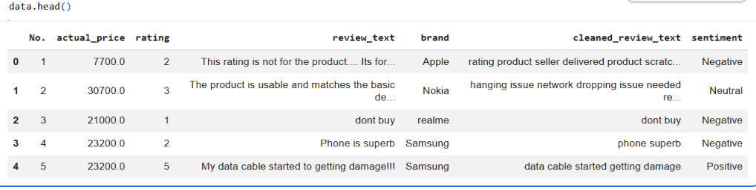

3.7: Brand and Sentiment Count
Value counts are used to examine the distribution of mobile-phone brands and sentiment categories. 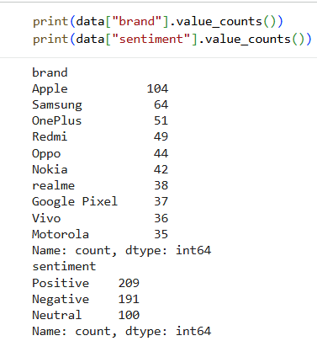

3.8: Missing Values and Duplicate Check
The dataset is checked for missing values and duplicate records before further processing.
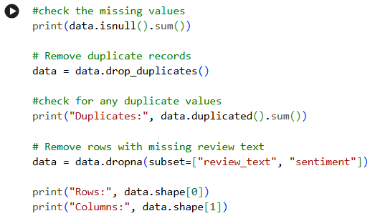

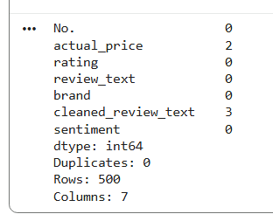
3.9: Handling Missing Values
Missing values in the price field are handled using the median, and the resulting dataset dimensions are checked.
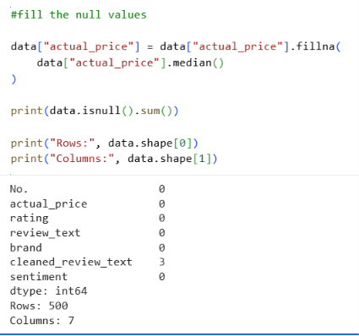

3.10: Exception Handling for Rating Values
The rating column is converted to numeric form and ValueError is handled if an invalid value is encountered.
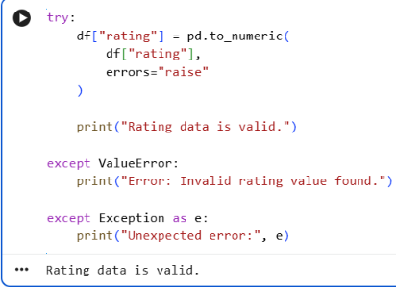

3.11: Exception Handling for Sentiment Column
KeyError handling is used to detect whether the required sentiment column exists.
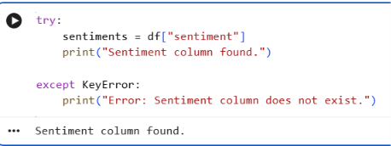

3.12: Sentiment Filtering and Counting
Sentiment categories are counted and positive reviews are filtered for further analysis.
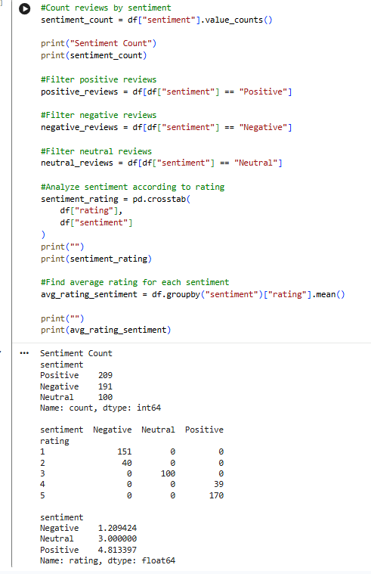

3.13: Samsung Review Analysis
Samsung reviews are filtered to analyse their ratings and sentiment-related information.
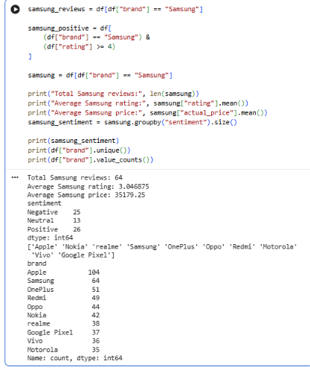

3.14: Apple Sentiment Analysis
Apple reviews are selected and their sentiment distribution is calculated using Pandas

.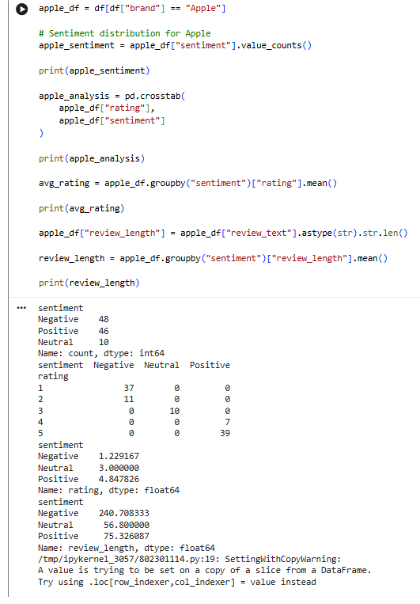
3.15: Brand-wise Average Rating
Average ratings are calculated for each brand and sorted to compare brand-wise rating performance.
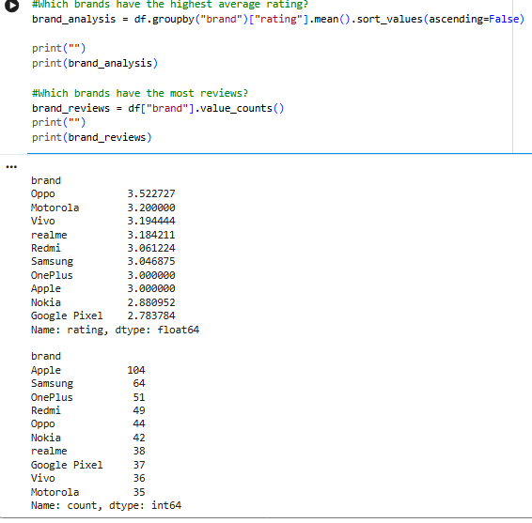

3.16: Sentiment Probability Calculation
The probability of Positive, Negative, and Neutral reviews is calculated from their frequencies in the complete dataset.
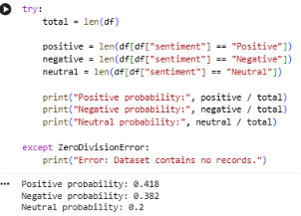
3.17: Brand-wise Sentiment Probability
Sentiment proportions are calculated for a selected mobile-phone brand.
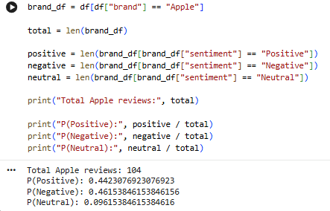

3.18: Random Sampling
A random sample of 50 reviews is selected using a fixed random state, and its sentiment distribution is analysed.
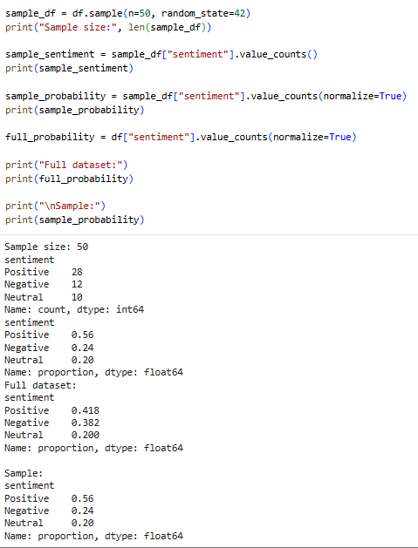

3.19: Chi-Square Test of Independence
A rating-by-sentiment contingency table is created and the Chi-Square test is applied to examine their association.
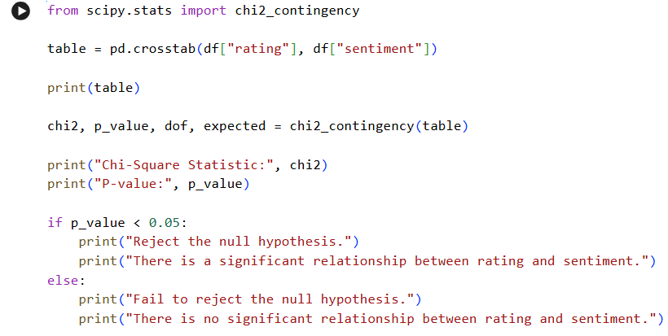
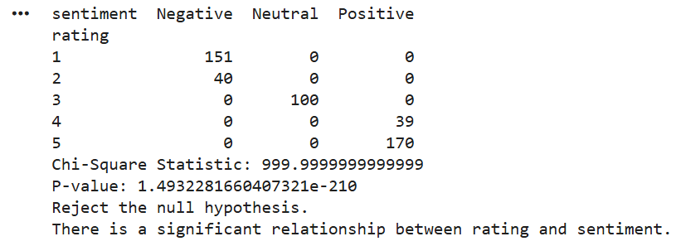

3.20: Custom Python Module
The custom sentiment_analysis.py module contains reusable functions for calculating sentiment percentages.
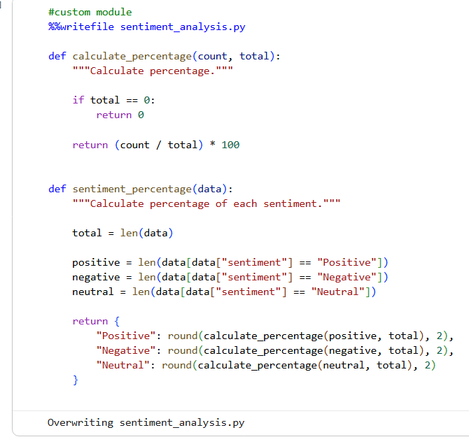

3.21: NumPy Numerical Analysis
NumPy arrays are used to perform numerical calculations on Samsung ratings and prices.
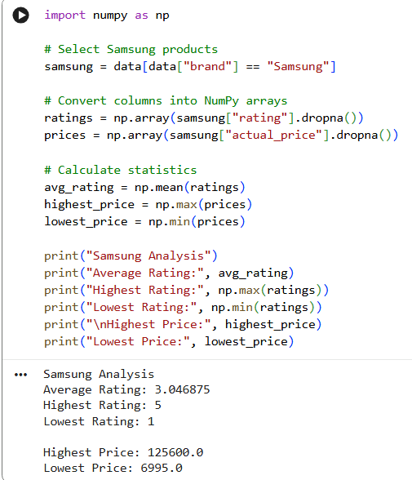

3.22: Sentiment Percentage Analysis
Sentiment counts are converted into percentages to compare the distribution of sentiment categories.
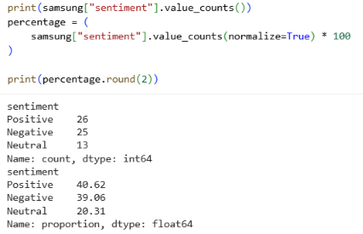
3.23: SciPy Descriptive Statistics
SciPy statistical functions are used to calculate descriptive statistics for Samsung ratings.
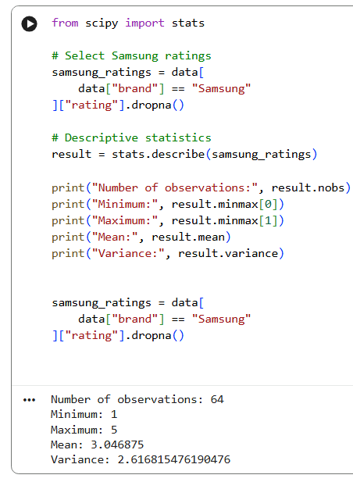
3.24: NLTK Setup for NLP
NLTK resources are downloaded and prepared for tokenization, stop-word removal, and lemmatization.
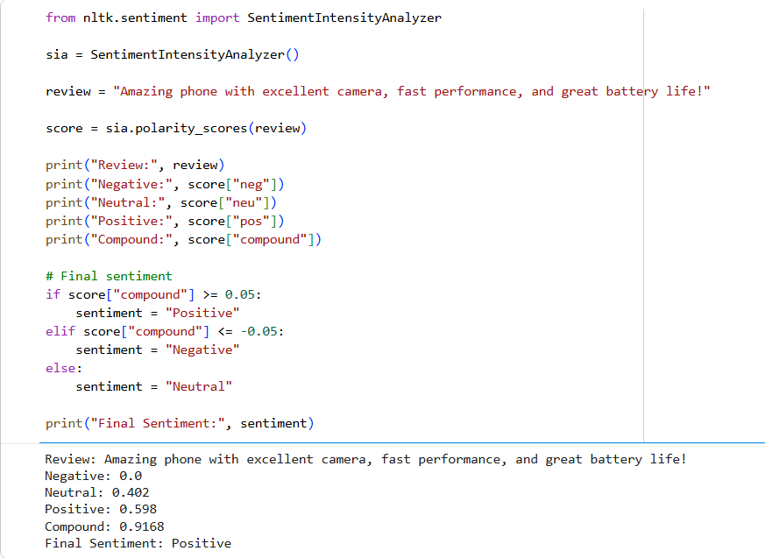

3.25: Text Cleaning and Preprocessing
The review text is cleaned and the original and cleaned versions are displayed for comparison.
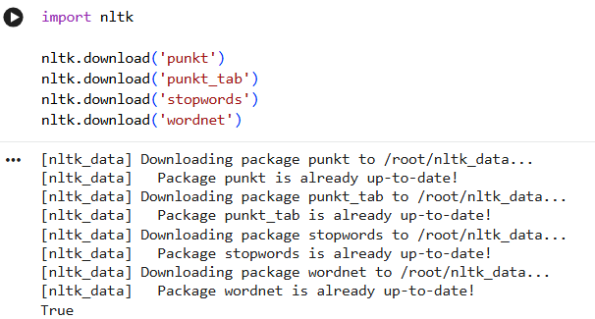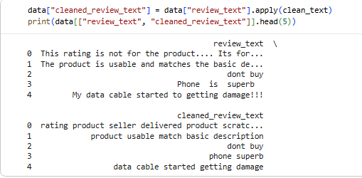 .

3.26: Cleaned Review Text
The cleaned_review_text field is generated from the original review text for subsequent NLP and machine-learning processing.
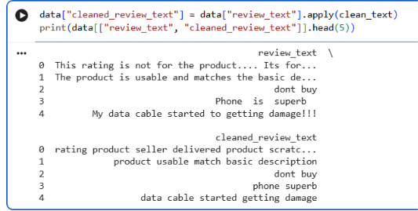
3.27 Sentiment Analysis Example
A sample review is processed with NLTK sentiment-analysis functionality to demonstrate sentiment scoring.
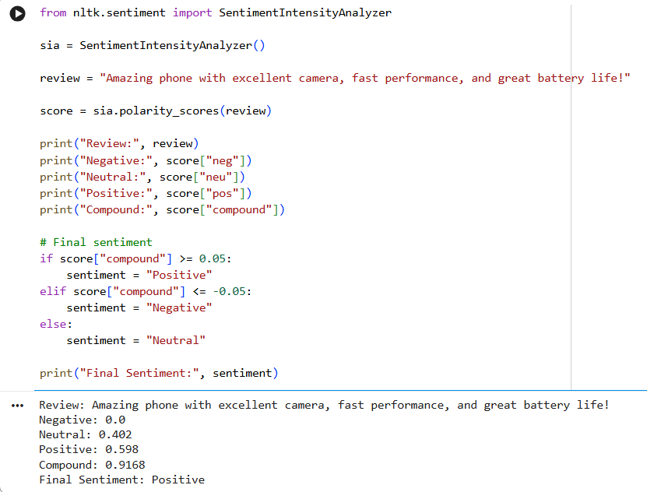
3.28: TF-IDF Vectorization
TfidfVectorizer converts the cleaned review text into numerical TF-IDF features for machine learning.
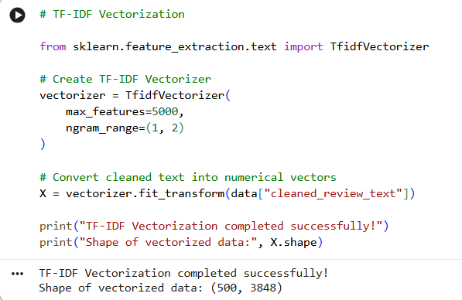
3.29: TF-IDF Feature Names
The generated TF-IDF feature names are inspected to understand the vocabulary used by the model.
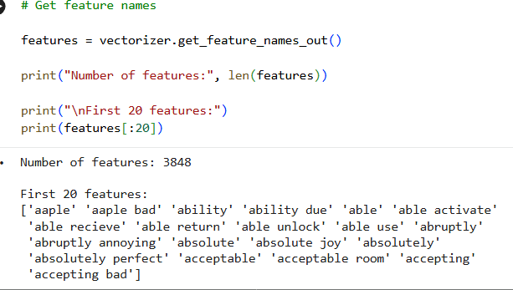
3.30: TF-IDF Feature Matrix
The TF-IDF matrix is displayed as a DataFrame so that textual reviews can be represented numerically.

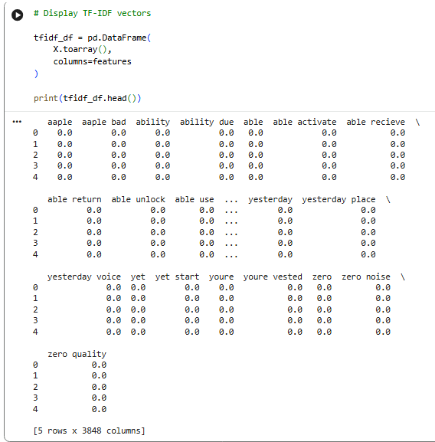

3.32: Positive Reviews by Brand
Positive reviews are grouped by mobile-phone brand to compare the number of positive customer opinions.
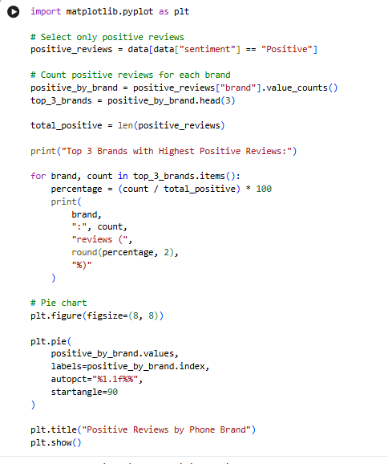

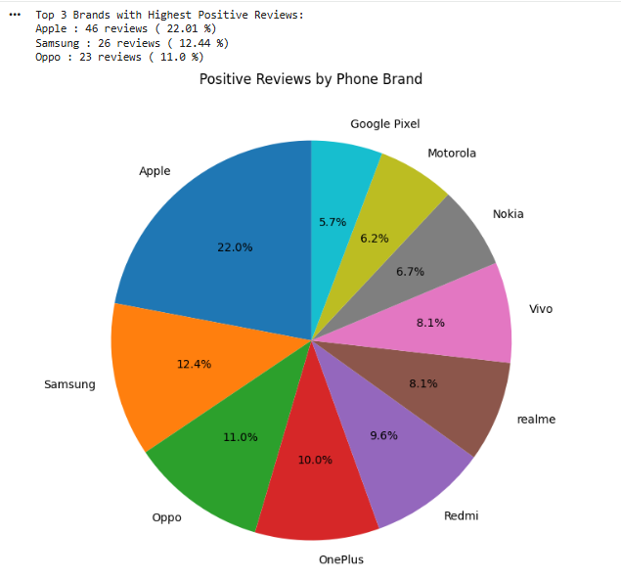

3.33: Samsung Sentiment Distribution
A pie chart presents the distribution of sentiment categories among Samsung reviews.
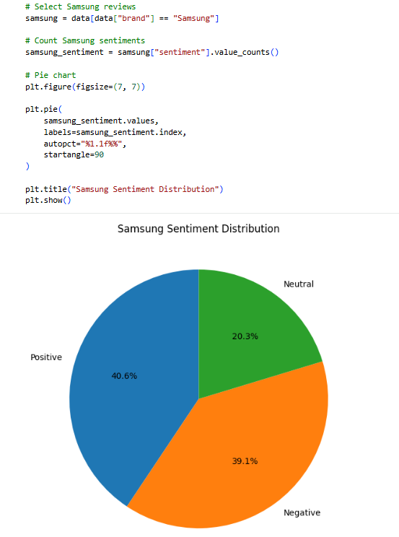

3.34: Top Brands with Positive Reviews
The top brands by number of positive reviews are identified and visualized.
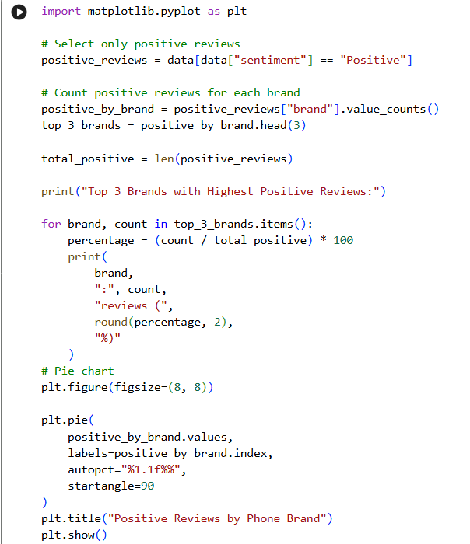

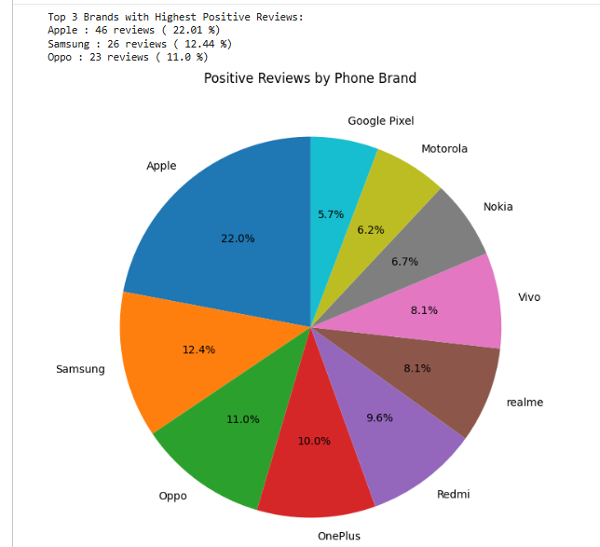

3.35: Sentiment Distribution by Brand
A stacked bar chart compares Positive, Negative, and Neutral reviews across mobile-phone brands. 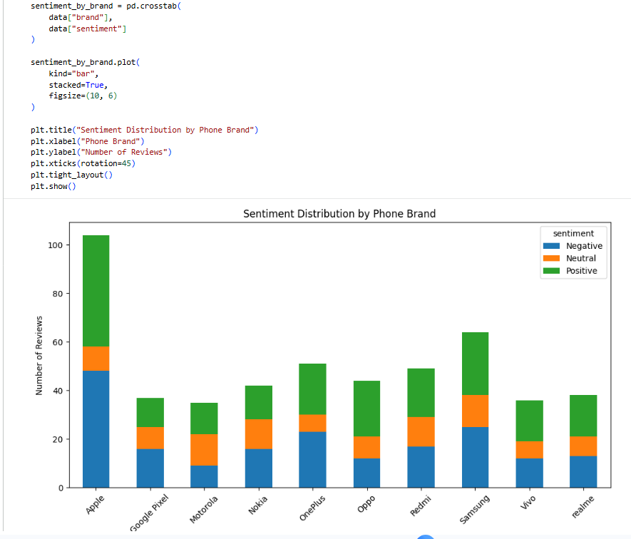

3.36: Average Rating by Brand
Average customer ratings are calculated and plotted for each mobile-phone brand.
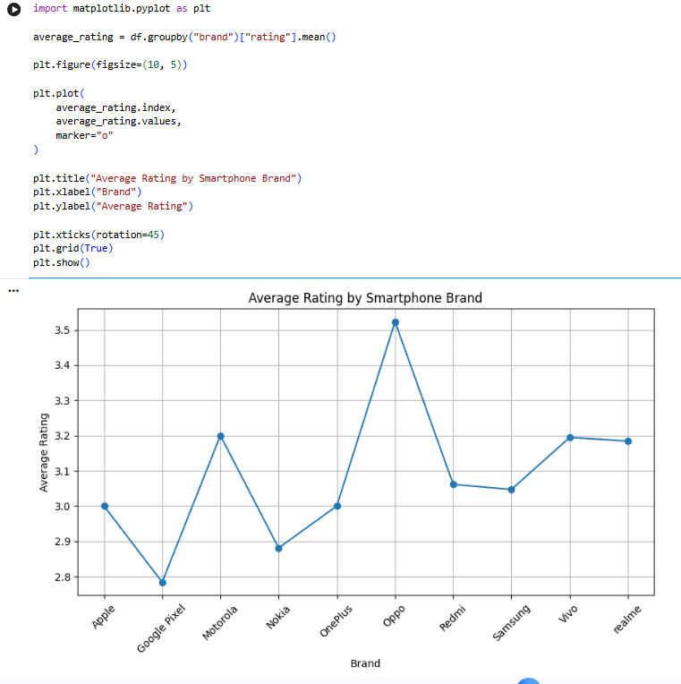

3.37: SQLite Database Connection
A SQLite database connection is created and a cursor is initialized for database operations.
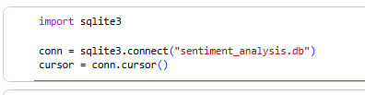
3.38: SQLite Table Creation
The reviews table is created in SQLite to store structured review information.
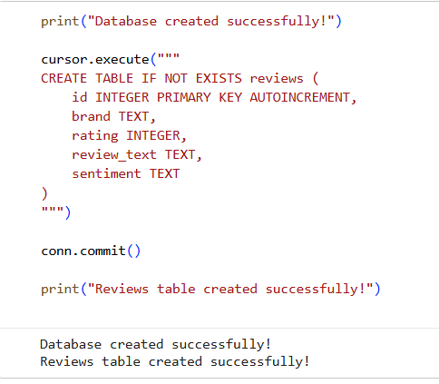
3.39: SQLite Create/Insert Operation
Review records are inserted into the SQLite database using the Create operation.
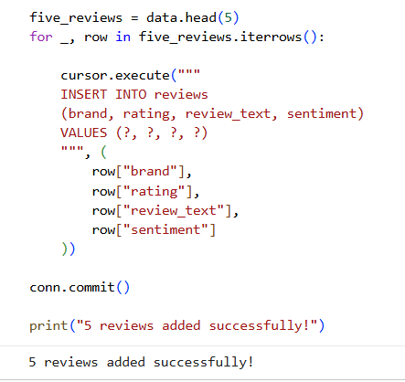v
3.40: SQLite Read Operation
Stored review records are retrieved from the database using a SELECT query.
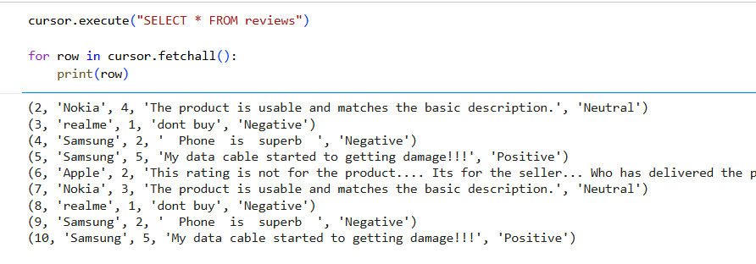

3.41: Model Training and Prediction and Machine-Learning Results
The final results show the training and testing sizes, model accuracy, and classification report for sentiment prediction.
The Logistic Regression model is trained on the TF-IDF training features and used to predict sentiment for the test set.
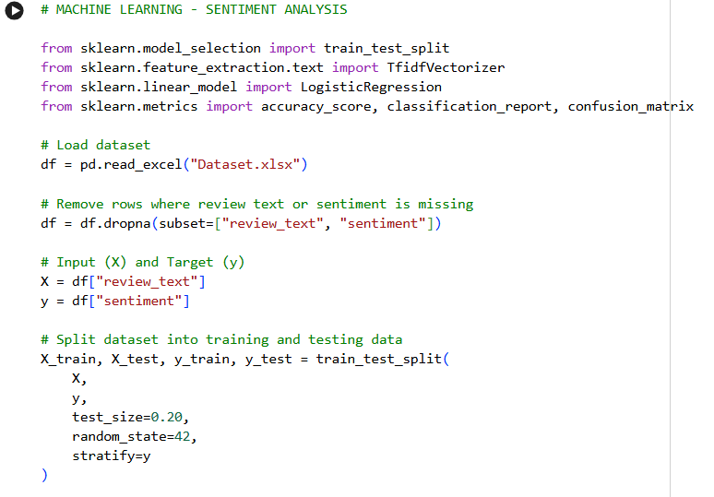
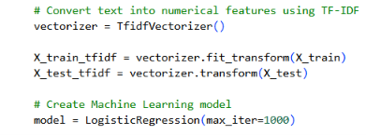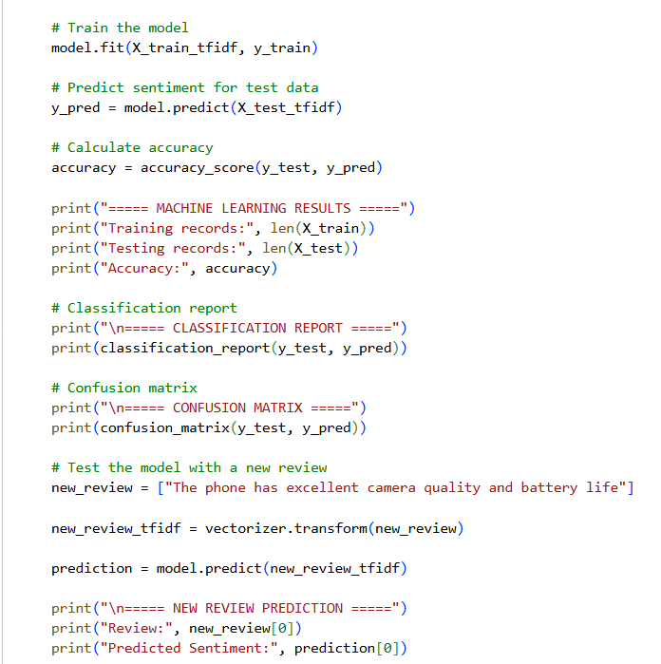

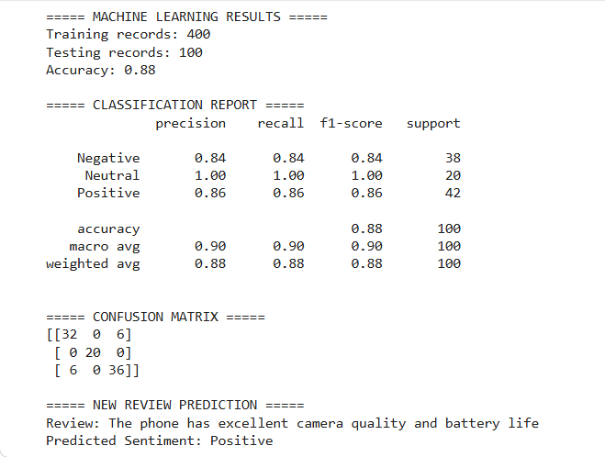

Conclusion and Future Work

Conclusion

The project successfully demonstrates the use of Python for analysing mobile phone customer reviews and extracting meaningful information from the dataset. The data was cleaned and preprocessed before performing exploratory, statistical, and Natural Language Processing operations. Different Python libraries were used for data manipulation, numerical analysis, visualization, text processing, and machine learning. The sentiment analysis classified the reviews into Positive, Negative, and Neutral categories, while the statistical analysis helped identify patterns between ratings and sentiments. TF-IDF was used to convert review text into numerical features, and a Logistic Regression model was trained for sentiment classification. The model achieved an accuracy of 88% on the test dataset. Overall, the project demonstrates a complete data-science workflow from data preprocessing to analysis and machine learning.

Future Work

In the future, the project can be extended by using a larger and more diverse collection of customer reviews. More detailed analysis can be performed to identify specific aspects of mobile phones that customers appreciate or dislike, such as camera quality, battery life, performance, design, and price. The classification process can also be improved to handle more complex customer opinions and mixed sentiments. Additional visual analysis can be introduced to study trends over time, compare products in greater detail, and provide deeper insights into customer preferences.

.

References

Web Link

Text books

Research Papers

