Question
Design a scheduler that can schedule the processes arriving system at periodical intervals. Every process is assigned with a fixed time slice t milliseconds. If it is not able to complete its execution within the assigned time quantum, then automated timer generates an interrupt. The scheduler will select the next process in the queue and dispatcher dispatches the process to processor for execution. Compute the total time for which processes were in the queue waiting for the processor. Take the input for CPU burst, arrival time and time quantum from the user.

Description
For the following problem we would use Round Robin algorithm. The Algorithm focuses on Time Sharing. In this algorithm, every process gets executed in a cyclic way. In the system, a certain time slice is defined which is called time quantum. For that time quantum, each process present in the ready queue is assigned to the CPU, if the process execution is completed during that time, then the process will be terminated, otherwise the process will return to the ready queue and wait for the next turn to complete the execution.

Algorithm
- Create an array arrival_time[], burst_time[] to keep track of arrival and bust time of processes.
- Create another array temp[] to store waiting times of processes temporarily in between execution.
- Initialize time: total = 0, counter = 0, wait time = 0, turnaround time = 0.
- Ask user for no of process and store it in limit.
- Repetitively ask user to give input for - arrival time, bust time up to limit.
- Ask user to enter time quantum and store it into time_quantum.
- Keep traversing the all processes while all processes are not done. Do following for i'th process if it is not done yet.
  - If temp[i] <= time_quantum && temp[i] > 0
    - total = total + temp[i]; (ii) temp[i] = 0;
    - temp[i] = 0;
    - counter = 1;
  - Else if temp[i] > 0
    - temp[i] = temp[i] - time_quantum;
    - total = total + time_quantum;
  - If temp[i] == 0 && counter == 1
    - x--;
    - print burst_time[i], total, arrival_time[i], total - arrival_time[i] - burst_time[i]);
    - wait_time = wait_time + total - arrival_time[i] - burst_time[i];
    - turnaround_time = turnaround_time + total - arrival_time[i];
    - counter = 0;
  - If i == limit – 1
    - i = 0;
  - Else if arrival_time[i + 1] <= total
    - (i) i++;
  - Else
    - i = 0;
- Print total waiting time - wait_time, average waiting time - wait_time/limit, average turnaround time - average_turnaround_time/limit.

Complexity
Complexity of initialization of variables is O(1). total = 0 counter = 0 wait_time = 0 turnaround_time = 0 • Complexity for initializing arrays with for loop is O(limit). for(i = 0; i < limit; i++) { … } • Complexity of calculating waiting and turnaround time is O(limit). for(total = 0, i = 0; x != 0;) { …. } • Complexity of implemented algorithm is O(limit).

Constrains
- If we have large number of processes and a process with very less burst time. According to round robin it will have to wait for very long time if burst time of other processes is large and its turn comes late.
- If we have some processes running according to round robin and we have a process whose arrival time is after the completion of those processes, then that process will not execute. If we want that all the processes should execute successfully then the arrival time of other process must be less than or equal to the completion time of the running processes.

Explanation
- Round Robin is the preemptive process scheduling algorithm.
- Each process is provided a fix time to execute, it is called a quantum.
- Once a process is executed for a given time period, it is preempted and other process executes for a given time period.
- Context switching is used to save states of preempted processes.
Example: Assume there are 5 processes with process ID and burst time given below PID Burst Time P1 6 P2 5 P3 2 P4 3 P5 7 – Time quantum: 2 – Assume that all process arrives at 0. Now, we will calculate average waiting time for these processes to complete. Solution – We can represent execution of above processes using GANTT chart as shown below –
Explanation: – First p1 process is picked from the ready queue and executes for 2 per unit time (time slice = 2). If arrival time is not available, it behaves like FCFS with time slice. – After P2 is executed for 2 per unit time, P3 is picked up from the ready queue. Since P3 burst time is 2 so it will finish the process execution at once. – Like P1 & P2 process execution, P4 and p5 will execute 2 time slices and then again it will start from P1 same as above. Waiting time = Turn Around Time – Burst Time P1 = 19 – 6 = 13 P2 = 20 – 5 = 15 P3 = 6 – 2 = 4 P4 = 15 – 3 = 12 P5 = 23 – 7 = 16 Average waiting time = (13+15+4+12+16) / 5 = 12

Test Cases
1.
Process | Arrival Time | Burst Time
P1 | 0 | 9
P2 | 1 | 5
P3 | 2 | 3
P4 | 3 | 4
Time Quantum :- 2
Output:
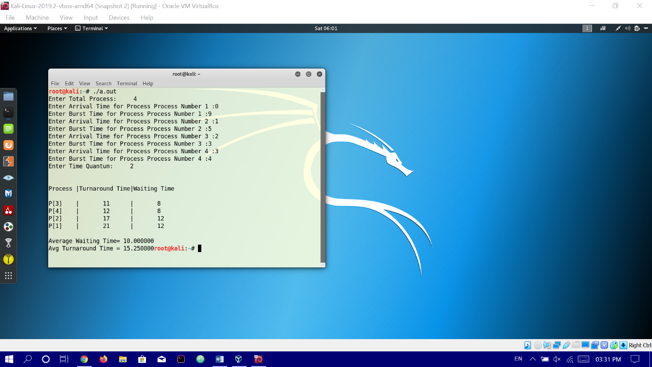

2.
Process | Arrival Time | Burst Time
P1 | 0 | 9
P2 | 1 | 5
P3 | 2 | 3
P4 | 3 | 4
Time Quantum :5
Output:
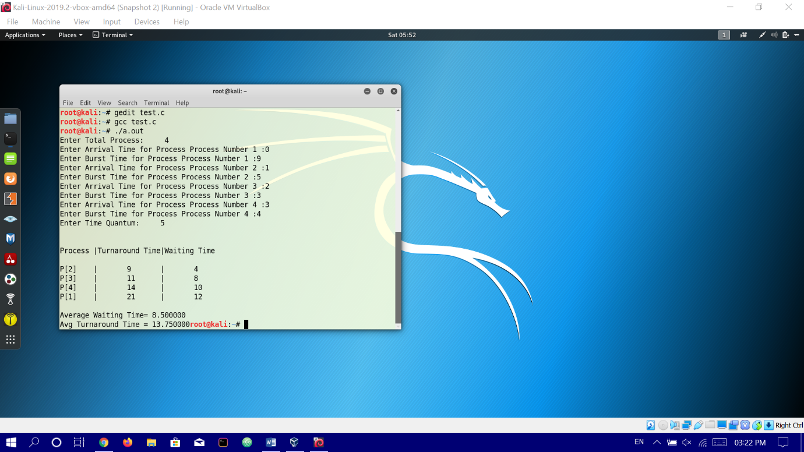

Code Snippet
#include<stdio.h>

int main()
{

int count,j,n,time,remain,flag=0,time_quantum;
int wait_time=0,turnaround_time=0,at[10],bt[10],rt[10];
printf("Enter Total Process:\t ");
scanf("%d",&n);
remain=n;
for(count=0;count<n;count++)
{
printf("Enter Arrival Time and Burst Time for Process Process Number %d :",count+1);
scanf("%d",&at[count]);
scanf("%d",&bt[count]);
rt[count]=bt[count];
}
printf("Enter Time Quantum:\t");
scanf("%d",&time_quantum);
printf("\n\nProcess\t|Turnaround Time|Waiting Time\n\n");
for(time=0,count=0;remain!=0;)
{
if(rt[count]<=time_quantum && rt[count]>0)
{
time+=rt[count];
rt[count]=0;
flag=1;
}
else if(rt[count]>0)
{
rt[count]-=time_quantum;
time+=time_quantum;
}
if(rt[count]==0 && flag==1)
{
remain--;
printf("P[%d]\t|\t%d\t|\t%d\n",count+1,time-at[count],time-at[count]-bt[count]);
wait_time+=time-at[count]-bt[count];
turnaround_time+=time-at[count];
flag=0;
}
if(count==n-1)
count=0;
else if(at[count+1]<=time)
count++;
else
count=0;
}
printf("\nAverage Waiting Time= %f\n",wait_time*1.0/n);
printf("Avg Turnaround Time = %f",turnaround_time*1.0/n);

return 0;
}

