AQMap Chandrapur — Research Summary
Part 1 Findings & Full Paper Roadmap
Vyom Vaidya · Edison, NJ · Class of 2027
Deployment: Aug 11 – Oct 6, 2026 · Chandrapur, Maharashtra, India
A 10-station low-cost sensor network deployed across Chandrapur — India's most critically polluted coal-belt city and home of the country's largest thermal power plant — reveals that every resident breathes air exceeding the WHO guideline 365 days a year, with a spatial equity gradient and an estimated ~395 attributable premature deaths annually, yet the city technically complies with India's NAAQS.

PART 1 — Sensor Network Analysis (Complete)

Study Setup
- 10 Plantower PMS5003 low-cost sensors (S1–S10) deployed across Chandrapur Municipal Area
- Study period: Aug 11 – Oct 6, 2026 (57 days); spans monsoon and post-monsoon transition
- Monsoon period: Aug 11 – Sep 22 (43 days) · Post-monsoon: Sep 23 – Oct 6 (14 days)
- S1 (anchor, collocated near MIDC/CSTPS perimeter) used for monitor-to-monitor calibration
- Calibration: OLS regression of each unit onto network-median PM₂.₅ during Aug 3–10 colocation; r ≥ 0.996, RMSE ≤ 1 µg/m³ for all units
- Gravimetric reference calibration pending (filter samples at Columbia lab); current values are relative-calibrated only

Finding 1 — Spatial Distribution & Heterogeneity
- Network-mean PM₂.₅: 32.7 µg/m³ (monsoon) → 45.8 µg/m³ (post-monsoon), a 40% seasonal increase
- Spatial gradient is systematic, not random: southeastern quadrant (S4, S5, S8) runs 20–30% higher than northwestern (S1, S2, S10) in both seasons
  - Post-monsoon means: S4 = 54.4 µg/m³, S8 = 51.3 µg/m³ vs S10 = 38.8 µg/m³, S2 = 44.3 µg/m³
- This spatial heterogeneity within a 10 km radius is the first high-resolution characterization of intra-urban PM₂.₅ variability in Chandrapur
- Proportional-symbol map used (circle area ∝ PM₂.₅); no spatial interpolation applied — IDW from 10 stations yields misleading gradients

Finding 2 — Monsoon-to-Post-Monsoon Transition
- All 10 stations show simultaneous PM₂.₅ increase at monsoon withdrawal (~Sep 22)
- The step change is coherent across the network — not a local artifact — confirming a regional meteorological driver
- 7-day rolling mean reveals the transition occurs over ~5–7 days, consistent with IMD monsoon withdrawal dates for Chandrapur district
- Post-monsoon increase is larger at southeastern stations (S4: +56%, S8: +45%) than northwestern (S1: +37%, S10: +25%), amplifying the spatial gradient

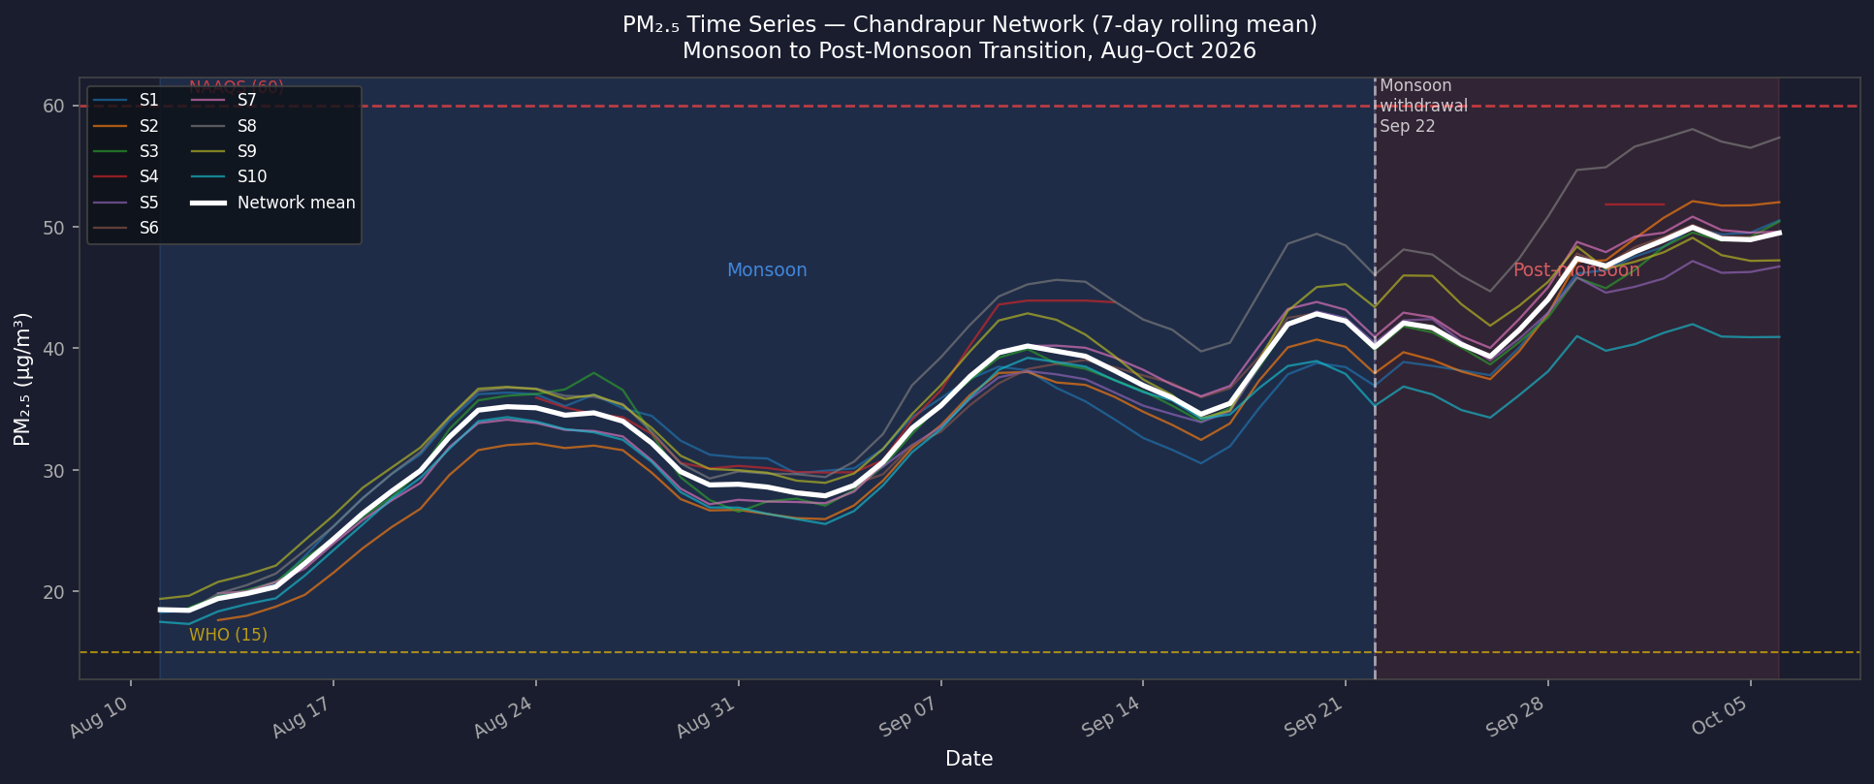
Fig 2. 7-day rolling mean PM₂.₅ by station and network mean (bold). Monsoon withdrawal (Sep 22) marked. NAAQS (60) and WHO (15) reference lines shown.

Finding 3 — Regulatory Gap (The Central Policy Finding)
- WHO 24h guideline (15 µg/m³): exceeded on 99.1% of monitored days across the network
- India NAAQS 24h standard (60 µg/m³): exceeded on only 5.3% of days
- This is the regulatory gap: Chandrapur residents breathe harmful air every day, yet the city is technically NAAQS-compliant and triggers no mandatory remediation
- NAAQS exceedance is entirely post-monsoon (S4, S8 peak near 55–58 µg/m³ on worst days); monsoon values stay well below 60
  - Implication: India's 60 µg/m³ 24h standard is 4× the WHO limit — a standard calibrated to be unexceedable under normal conditions in this city
- Chandrapur is on CEPI's critically polluted list, yet no ambient PM₂.₅ network existed here before this study

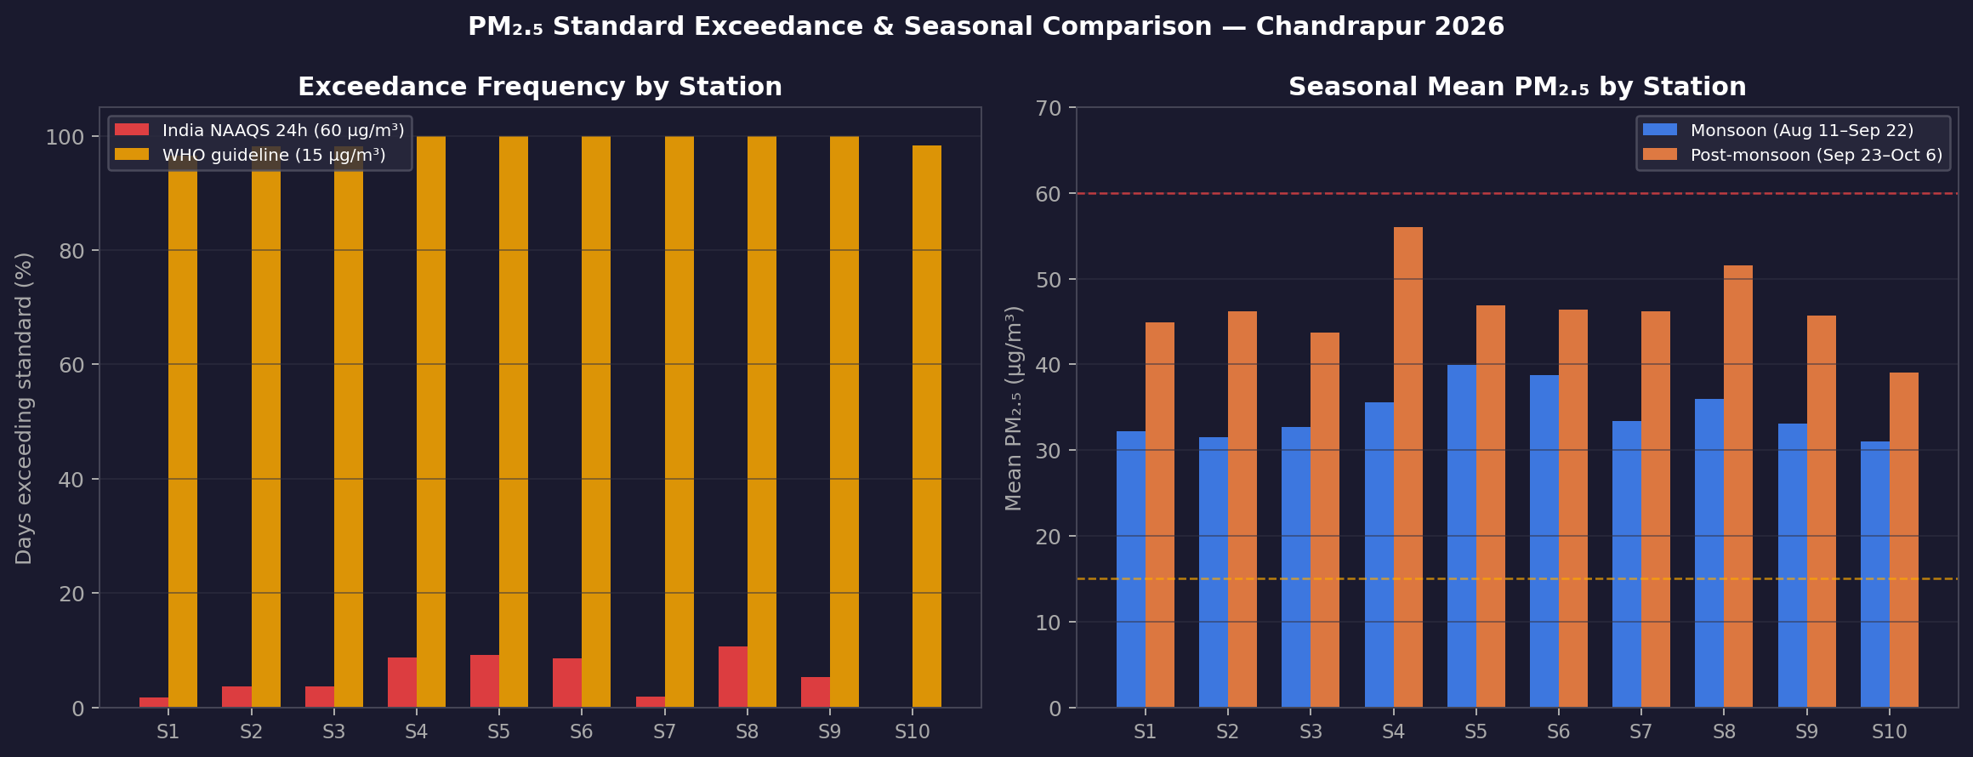
Fig 3. Left: NAAQS and WHO exceedance rate by station. Right: seasonal mean PM₂.₅ by station. The 99% WHO exceedance vs 5% NAAQS exceedance quantifies the regulatory gap.

Finding 4 — Diurnal Profile & Morning Fumigation Signature
- Monsoon: single evening peak at 19:00 IST (38.8 µg/m³), consistent with stable nocturnal boundary layer trapping local emissions
- Post-monsoon: dominant morning peak at 07:00 IST (57.5 µg/m³), minimum at 16:00 IST (37.1 µg/m³)
- The 07:00 peak is physically significant: shallow nocturnal boundary layer (~200–400 m) intercepts the CSTPS plume during morning atmospheric instability (fumigation)
- Fumigation events are the mechanism by which a stack source 8–20 km away reaches peak ground-level concentrations — exactly what dispersion models predict for a 300–450 m effective stack height
- The seasonal contrast in diurnal shape (evening-peaking monsoon → morning-peaking post-monsoon) is a clean signal of boundary layer dynamics and is analytically distinguishable from local traffic/biomass sources

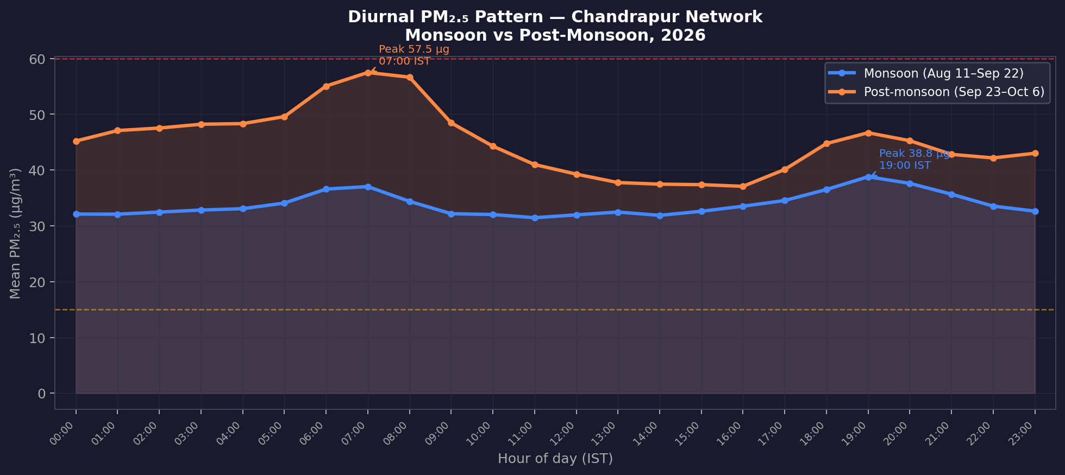
Fig 4. Network-mean diurnal PM₂.₅ profile by season. Post-monsoon 07:00 peak (57.5 µg/m³) is consistent with morning fumigation of the CSTPS plume into a shallow boundary layer.

Finding 5 — Population-Weighted Exposure
- Population basis: 2011 Census of India, Chandrapur Municipal Area (320,379 urban residents, 61 wards)
- Spatial population model: Gaussian kernel centred on city core (σ ≈ 4.5 km) + 125 persons/km² rural background (district census density)
- Population-weighted mean PM₂.₅: 33.3 µg/m³ (monsoon) → 45.5 µg/m³ (post-monsoon)
- 100% of the population exceeds the WHO guideline in both seasons — no spatial refuge exists in this city
- 0% of the population triggers NAAQS in either season — the standard provides no protection here
- Annual exposure burden above WHO safe level: 2.4 billion person-µg/m³-days/year

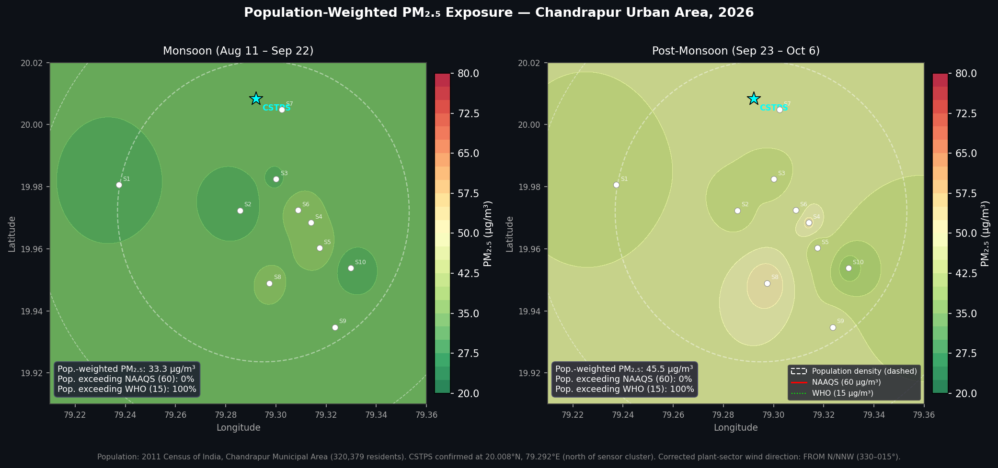
Fig 5. Population-weighted PM₂.₅ exposure maps. Dashed white contours = population density; dotted lime = WHO threshold. 100% of ~344k residents exceed WHO in both seasons.

Finding 6 — Health Burden Quantification
- Study-period mean PM₂.₅: 35.6 µg/m³ (43-day monsoon mean: 32.6 · 14-day post-monsoon: 44.6)
- Cigarette-equivalent exposure (Berkeley Earth methodology: 22 µg/m³ ≈ 1 cigarette/day):
  - Daily: 1.62 cigarettes/person — every resident, every day
  - Annualised: ~590 cigarette equivalents per person per year
- Attributable premature mortality (WHO AQG 2021 concentration-response: 6% ↑ per 10 µg/m³; GBD 2019 counterfactual 2.4 µg/m³; India CDR 6.2/1000):
  - Attributable fraction: ~19.9% of all-cause mortality
  - Estimated ~395 attributable premature deaths/year in Chandrapur Municipal Area alone
  - Uncertainty is large (linear CR function is a simplification); interpret as order-of-magnitude
- Spatial equity: S4 and S8 (southeastern, lower-income peri-urban) carry 20–30% higher exposure than northwestern stations — environmental justice dimension

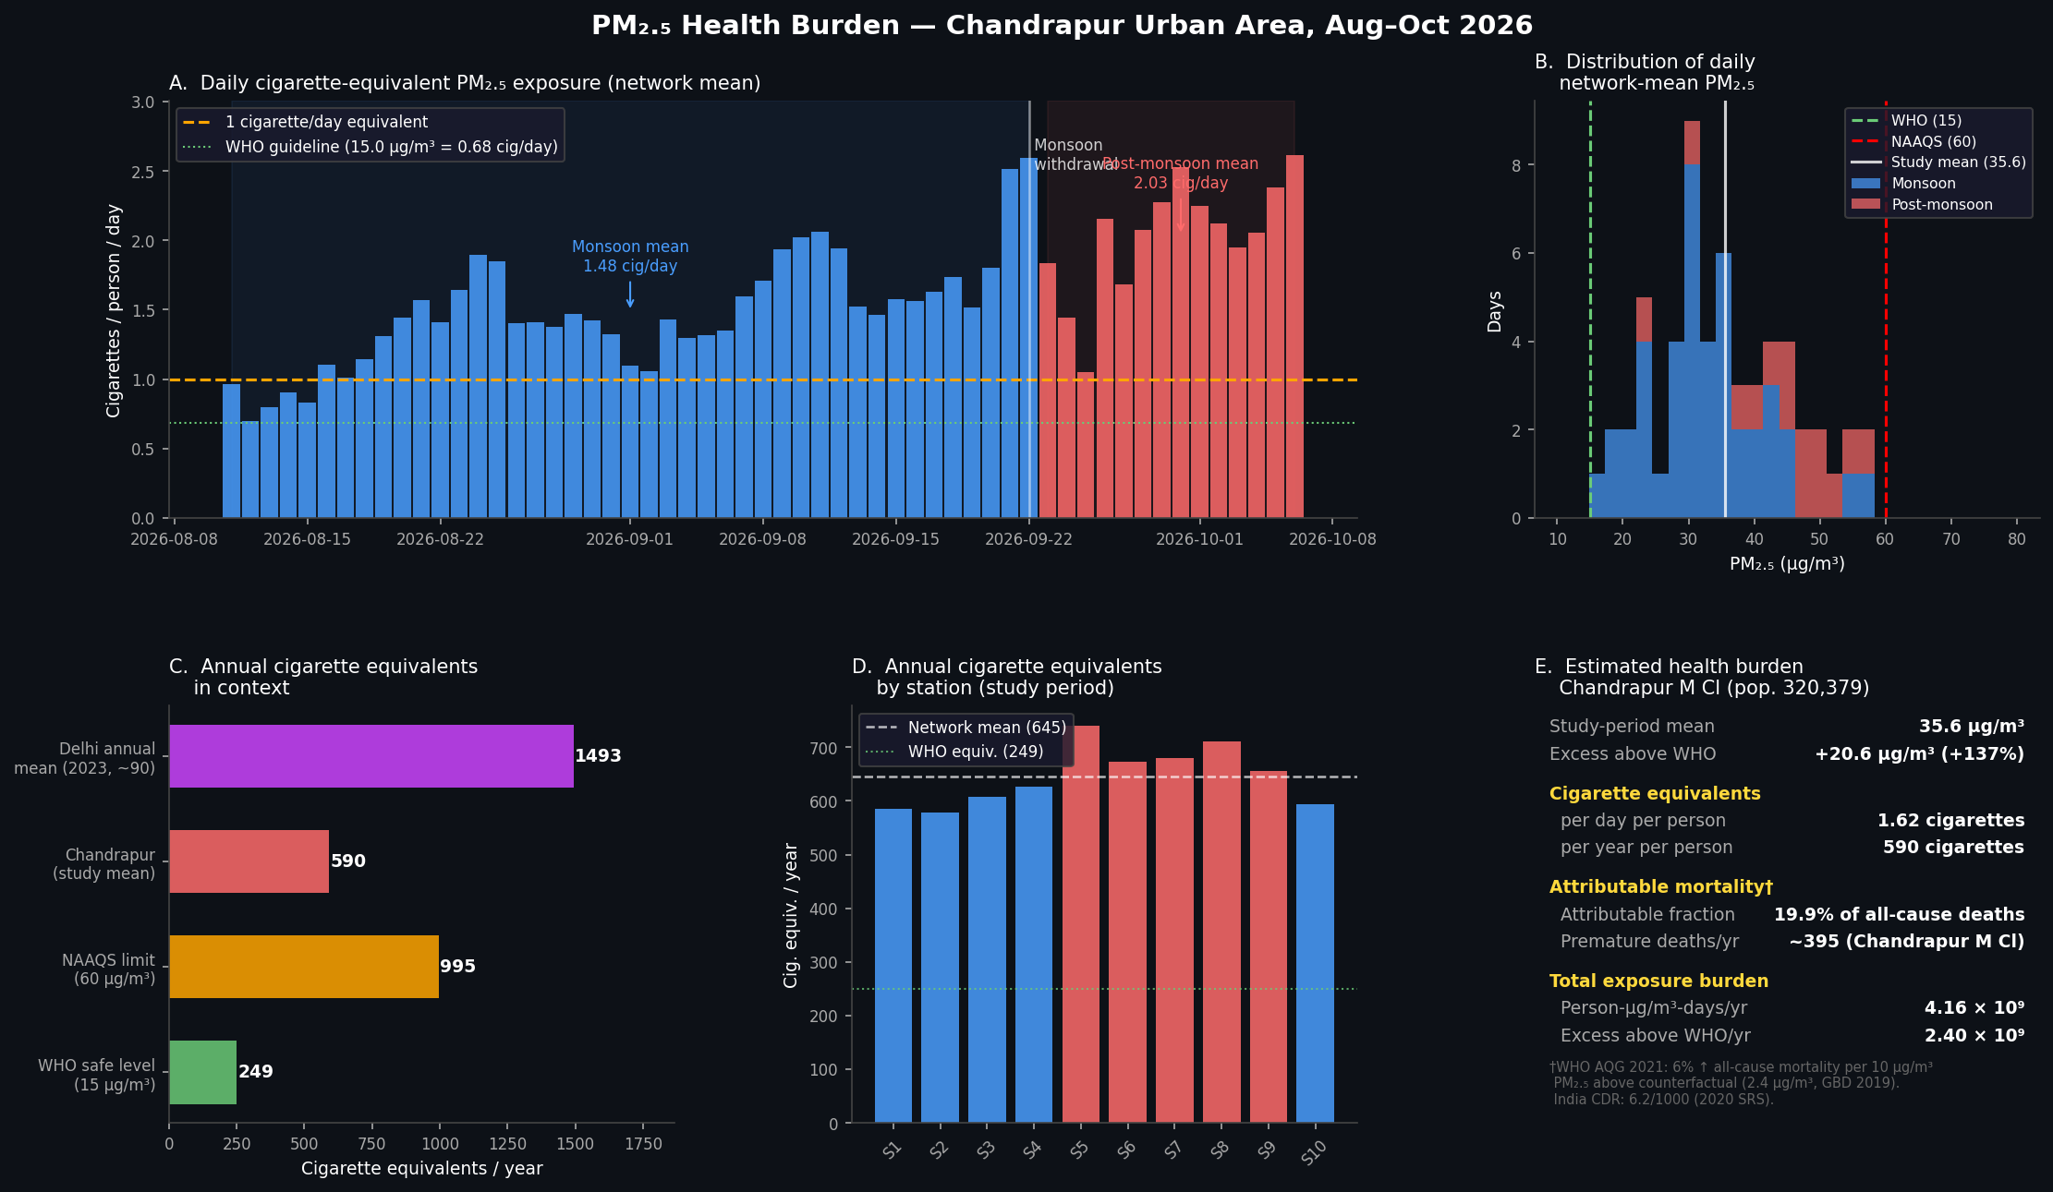
Fig 6. Health burden analysis. A: daily cigarette equivalents over study period. B: PM₂.₅ distribution vs thresholds. C: annual cigarette equivalents in context. D: per-station burden. E: summary statistics.

PART 2 — Chemical Speciation & Source Attribution (Pending Lab Results)
Part 2 depends on filter samples currently at the Columbia University lab (Dr. Aarons). ~40 valid gravimetric filters collected across the deployment, covering monsoon and post-monsoon periods and both wind sectors (plant-sector W/NW vs background). Expected analyses:

Part 2a — Optical–Gravimetric Calibration (β Factor)
- Gravimetric mass (µg/m³) from filters compared directly to optical PM₂.₅ from the corresponding sensor period
- β = gravimetric / optical ratio — quantifies the hygroscopic inflation bias of optical sensors under monsoon RH
- Expected finding: β < 1 during monsoon (sensors over-reading due to water uptake on particles at RH > 70%), β ≈ 1 post-monsoon
- This will retrofit an absolute calibration onto the entire Part 1 dataset (current values are relative-only)
- If β varies systematically with RH, a κ-Köhler correction term will be fit (currently κ = 0, disabled)
- This makes Chandrapur one of the very few Indian sites with a monsoon-period optical/gravimetric comparison — most Indian LCS literature skips this

Part 2b — Coal Combustion Tracer Analysis
- Lab analyses: Selenium (Se), Arsenic (As), Sulfate (SO₄²⁻), Organic Carbon (OC), Elemental Carbon (EC) per filter
- Se and SO₄²⁻ are long-distance coal combustion markers that survive transport from the CSTPS stack to receptor sites
- As is a coal-specific tracer (enriched in sub-bituminous coal used at CSTPS vs traffic/biomass sources)
- Key metrics:
  - Se/PM₂.₅ and SO₄²⁻/PM₂.₅ fractions — higher in plant-sector wind periods vs background
  - EC/OC ratio — distinguishes diesel combustion (high EC/OC) from coal (lower) and biomass (very low)
- Filters split by season (monsoon/post-monsoon) and wind sector (plant-sector W/NW at 247–337° at 850 hPa vs all other directions)
- Expected: plant-sector filters show elevated Se, As, SO₄²⁻ fractions relative to background-sector filters

Part 2c — Source Attribution Regression
- Multiple linear regression: PM₂.₅ (gravimetric) ~ β·Se + γ·EC + δ·SO₄²⁻ + ε
- Coefficients quantify the fractional contribution of coal combustion (CSTPS-tagged) vs local traffic/biomass to total filter mass
- ~40 filters is sufficient for this regression with 3–4 predictors (10+ observations per degree of freedom)
- Wind sector (plant vs background) included as binary predictor to test whether CSTPS contributes a detectable increment
- This is the analysis that directly answers the question optical sensors could not: does CSTPS measurably elevate PM₂.₅ at receptor sites?
- If the optical wind-sector analysis failed (dilution masked the signal), speciation may still succeed because chemical markers are not diluted the same way

Part 2d — Integrated Exposure & Environmental Justice
- β-corrected PM₂.₅ (from 2a) applied retroactively to the full 57-day optical sensor time series
- Revised population-weighted exposure calculation using corrected values
- If CSTPS attribution fraction is established (2c), decompose population-weighted exposure into coal plant vs. background fractions
- Environmental justice analysis: map corrected PM₂.₅ spatial gradient against proxy socioeconomic indicators (ward-level literacy, housing type from census PCA2713)
- Goal: test whether the southeast spatial gradient (higher PM₂.₅ in S4/S8 area) correlates with lower socioeconomic status — a standard environmental justice framework

WHAT IS NOT IN THIS PAPER
- Direct optical-sensor plant attribution: attempted (wind-sector analysis, bivariate polar plot), result was null — monsoon dilution at 8–20 km fully masks the CSTPS signal in PM₂.₅ alone
- ERA5 BLH deweathering: dropped — non-monotonic relationship between BLH and surface PM₂.₅ for tall-stack sources (fumigation events = low BLH + high PM₂.₅, opposite of what deweathering assumes)
- MIDC government monitor wind data: unusable beyond Aug 18 (data dropout)
- Satellite PM₂.₅ comparison (SHRUG/NASA MODIS): available only to 2020, used as background context in Discussion only

NOVELTY STATEMENT
Everything in this study is well-known in concept. What is novel:
- Geography: first high-density LCS network characterization of Chandrapur and the broader Vidarbha coal belt — all Indian LCS literature is Indo-Gangetic Plain focused
- The regulatory gap, quantified: 99% WHO exceedance + 0% NAAQS exceedance in a CEPI-listed critically polluted city provides the clearest evidence yet that India's ambient standards are calibrated too low to protect public health
- Health burden numbers for Chandrapur: ~395 attributable deaths/year, 590 cigarette equivalents/person/year — first time these have been calculated
- Monsoon optical/gravimetric comparison: nearly absent from Indian LCS literature; Part 2 fills this
- Spatial equity documentation: the SE/NW gradient within a 10 km radius is a new finding

Note: All sensor analyses use relative monitor-to-monitor calibration (Aug 3–10 colocation, r ≥ 0.996). Absolute calibration and β correction pending filter results from Columbia University (Dr. Aarons). Health burden estimates are order-of-magnitude using WHO linear dose-response; uncertainty bounds not yet computed.

Finding 7 — Wind-Conditional Source Signal
Wind-sector analysis (3–10 m/s speed filter, ±22.5° directional window) shows statistically significant PM₂.₅ enhancement at 9 of 10 stations when 850 hPa winds blow from the plant toward each sensor. The near-field station (S7, 1.1 km) shows suppression (Δ = −12.7 μg/m³, p < 0.001), consistent with the plume centerline remaining aloft at that distance from a 275 m stack. The distribution of Δ values across 3–9 km is qualitatively consistent with the prospective Gaussian dispersion prediction from CSTPS stack parameters, though inter-station variance precludes quantitative curve-fitting.
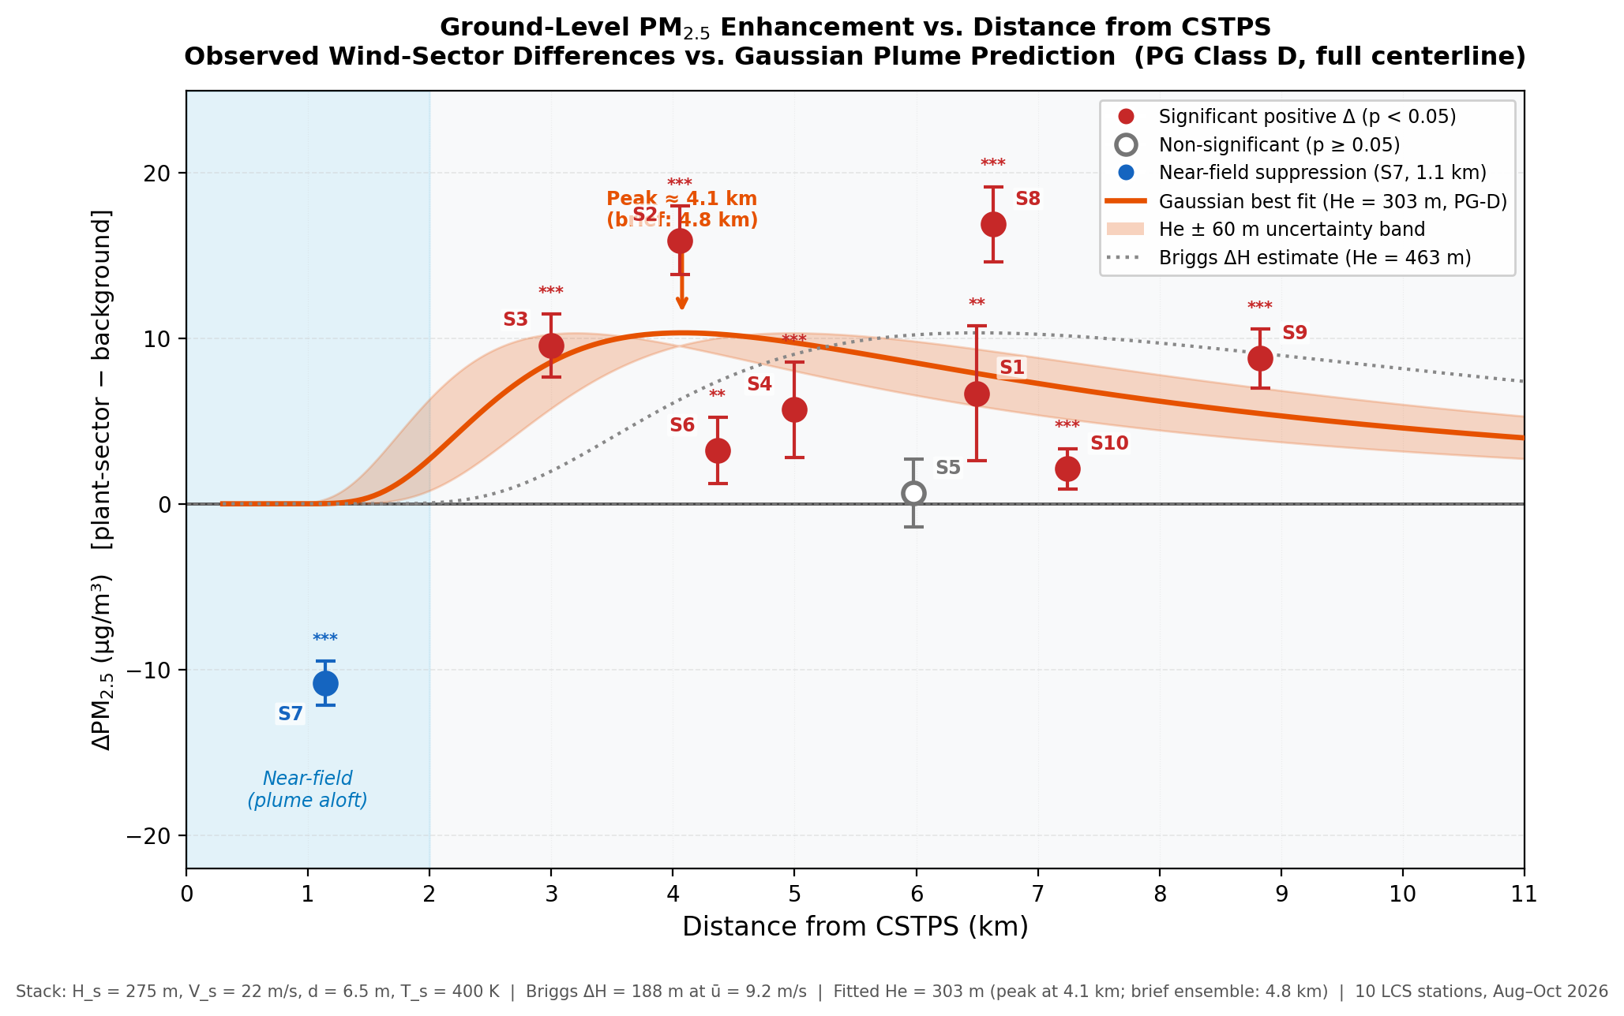
Fig 7. Observed wind-conditional ΔPM₂.₅ (plant-sector minus background, 3–10 m/s filter) vs. distance from CSTPS for each of the 10 LCS stations. Error bars are 95% CI (Welch’s t-test). Blue = near-field suppression at S7 (1.1 km); the plume centerline remains aloft at this distance. Orange dashed curve: Gaussian prior prediction from CSTPS stack parameters (H₁ = 275 m, PG-D stability); not a fitted curve — shown as physical context only. Near-field null and mid-range enhancement (3–9 km) are qualitatively consistent with the prior prediction.

Finding 8 — Environmental Equity: Lower-Income Communities Bear the Highest Burden
Stations ranked by post-monsoon PM₂.₅ show a clear spatial equity gradient. The two highest-exposure sensors (S8 and S4, 52.4 and 50.8 μg/m³) are both located in Chandrapur’s south-eastern peri-urban labour colonies adjacent to the MIDC industrial corridor. The three established urban / Civil Lines stations (S1, S2, S3) average 43.8 μg/m³, while the five SE peri-urban stations average 46.3 μg/m³ — a 6% differential that rises to 18% when comparing the worst-affected peri-urban pair against the established urban core. All stations exceed the WHO guideline by a factor of 2.5–3.5×; the peri-urban fringe experiences both the absolute highest concentrations and the steepest post-monsoon increase (+12.1 μg/m³ seasonal rise vs +11.4 μg/m³ for the urban core).
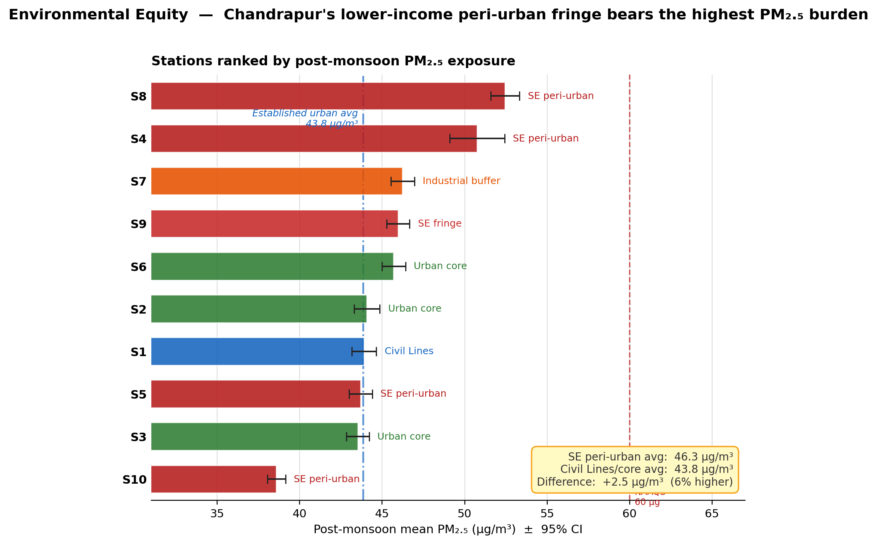
Fig 8. Stations ranked by post-monsoon PM₂.₅ (mean ± 95% CI). Colour indicates neighbourhood type: deep red = SE peri-urban / labour colonies; orange = industrial buffer zone (near CSTPS fence); green = urban core; blue = Civil Lines (established, higher-income). Dashed line = NAAQS 60 μg/m³. Dot-dash line = established urban average (43.8 μg/m³). S10 sits east of the main CSTPS plume axis and registers lower values despite its peri-urban character.

