**Instructions**

The project is a novel approach to generate 3D buildings with semantics (here doors, windows). Machine learning model using decision tree and random forest is used to detect the semantics and then the semantics are being mapped at proper scale to 3D models. The study can be extended to include many other semantics related to buildings combined with actual 3D structure can give planners a tool to try and test various methods such as solar potential analysis at façade level by generating various combination of semantic for a 3D model.

From the below link install SimpleCV and all its component that it will download as well.

<http://sourceforge.net/projects/simplecv/files/latest/download?source=files>

From the below link download opencv and install all the components it may ask during installation

<http://sourceforge.net/projects/opencvlibrary/files/opencv-win/2.4.10/opencv-2.4.10.exe/download>

From the above link download orange library and install each component it may ask during installation

<http://orange.biolab.si/download/windows/>

**Detection and prediction module of windows doors:** Smartcity.py

There are 2 folders training and test folder

Run smartcity.py to perform machine learning to detect windows and doors.

**Detection and prediction module of windows doors:** corner.py

* Run cornerfinal.py and input smart as name of file
* Input 20 as altitude value (do create a 3D model of height 20 meters) to generate a file named finalmodel.kml
* 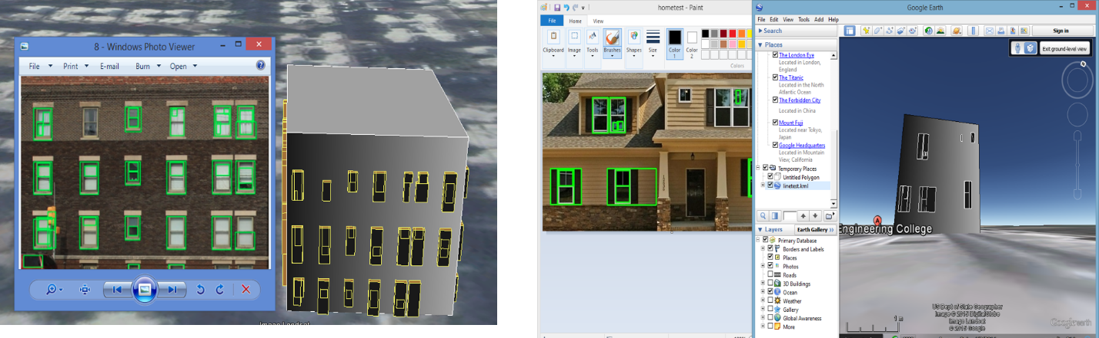Open smart.kml and finalmodel.kml in google earth and you'll see the output something like this: