JDBC
_______________________________________________________________________
JDBC stands java database connectivity it is API or some inbuilt packages, classes and interfaces which help us to connect our java application with database

Architecture of JDBC Program
_______________________________________________________________________________
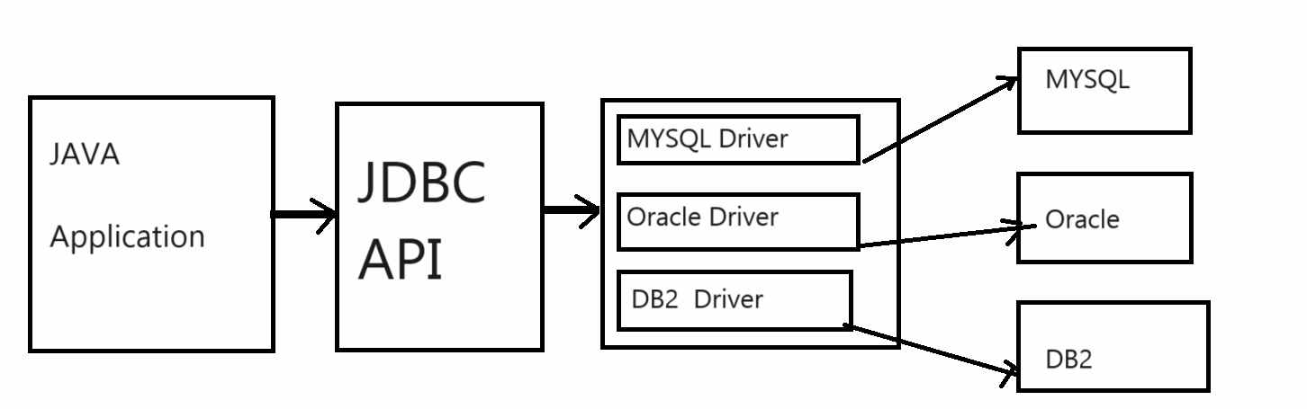
How to works with JDBC or Steps to work with JDBC
________________________________________________________________________________
1. Install any Database application or software like MYSQL, Oracle etc
2. Add java.sql package in application
import java.sql.*;
Because java.sql package is package which contain all classes and interfaces required for JDBC

3. Register the driver with application
_______________________________________________________________________
Q. what is driver?
__________________________________________________________________
driver are the client side adapters which is used for convert your request to protocol for database communication called as driver means we can driver contain some logic or protocol which help us to connect your java application with your database application.

Types of Driver
_________________________________________________________________________
Type1: it is JDBC-ODBC bridge driver
Type2: it is native interface driver or Native API driver (partially java driver)
Type3: it is network Protocol driver (fully java driver)
Type4: it is thin driver (fully java driver)

Note: we will discuss architecture of every driver at the end of topic

Note: We get driver in the form classes means we can say driver are the some inbuilt classes which contain database communication logics means in short we can say if we want to use driver means we use class internally and if we want to use any class we need to create its object means if we want to driver we need to create driver class object.

Now we want to discuss about type-1 driver
Type1 driver is ODBC so ODBC stands for open database connectivity it is concept launch by Microsoft using type1 driver we can connect your java application with any database means we can say type1 driver is database independent driver.
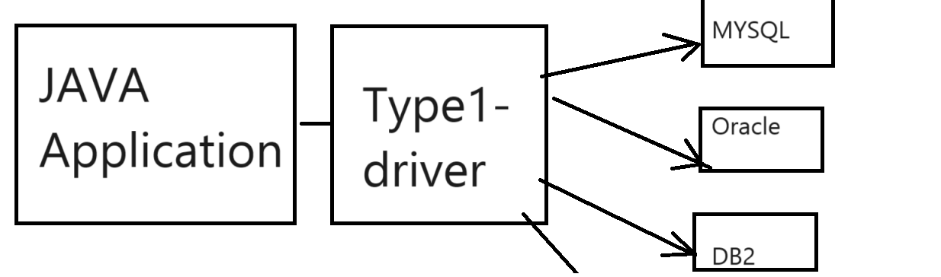
If we want to use this driver practically we have one inbuilt class name as sun.jdbc.odbc.JdbcOdbcDriver
Here sun.jdbc.odbc is package and JdbcOdbcDriver is classname

import sun.jdbc.odbc.*;
JdbcOdbcDriver d = new JdbcOdbcDriver();

Note: Type-1 Driver removed from java version JDK 1.8

Reason or Limitation of Type1 Driver
_____________________________________________________________________
a) Type 1 driver is platform dependent means it works with only windows
b) Type 1 driver design in C and C++
c) Type 1 driver not support to network programming means we cannot connect your application with remote database using type-1 driver

Benefits of Type-1 Driver
____________________________________________________________________________
a) It is present in JDK not need to installed manually or download manually form some other place.
b) It is database independent means using type-1 you can connect your java application with any other database.

Now Here we will use type-4 driver for connect java application with database which is known as thin driver.
This type of driver classes provided by database vendor in the form .jar file means type4 driver class is different for every database.
Example: Suppose Consider we want to connect java application with MYSQL Database using type-4 driver then we need to download the MYSQL Connector.jar file
Suppose consider we have MYSQL 8 then we need to download the .jar mysql-connector-8 version
Q. what is .jar file?
______________________________________________________________________
.jar stands for JAVA Achieve files basically it are collection of packages, classes and interfaces and it contain only .class files.
Q. What is benefit of .jar file?
.jar file help us to create the Reusable API or Reusable classes and interfaces means suppose consider we have some logic or some API and if we want to reuse that API by some other then we can create .jar file and hand over to other for reuse API.
So Now we want to download the mysql connector.jar file for connect our java program with mysql database tool.
You can download mysql connector.jar file using this link
jar-download.com/download-handling.php

If we think about mysql –connector .jar file it contain class which work as driver class name as
com.mysql.cj.jdbc.Driver
Here com.mysql.cj.jdbc is package and Driver is class means if we want to use this driver you have to create its object
com.mysql.cj.jdbc.Driver d = new com.mysql.cj.jdbc.Driver();
Once we create object of Driver class you can register driver with Java application and if we want to register Driver with java application we have one inbuilt class name as DriverManager and its contain one static method name as registerDriver() which help us to register driver with java application.
Syntax: DriverManager.registerDriver(Driver): if we think about this method i.e registerDriver() it contain one parameter name as Driver which is interface from java.sql package and it is implemented all types of driver classes
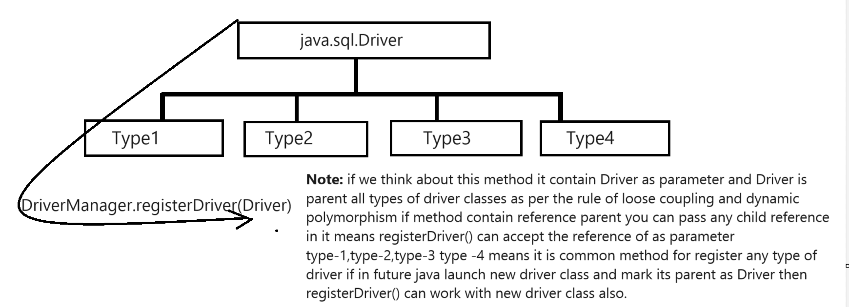

Steps to use the .jar file and register the driver by using eclipse
_______________________________________________________________________________
a) Create Java Project using eclipse.
b) Download the .jar file and store on some location in your system
c) Import .jar file in project using eclipse or add .jar file in project using eclipse.
steps to import .jar files
right click on JRE system library ---- select built-path option – configure build path ---- select class path (not module path) --- click on add external .jar file ---- select .jar file from system and click on apply button

After import .jar we get following type of folder structure
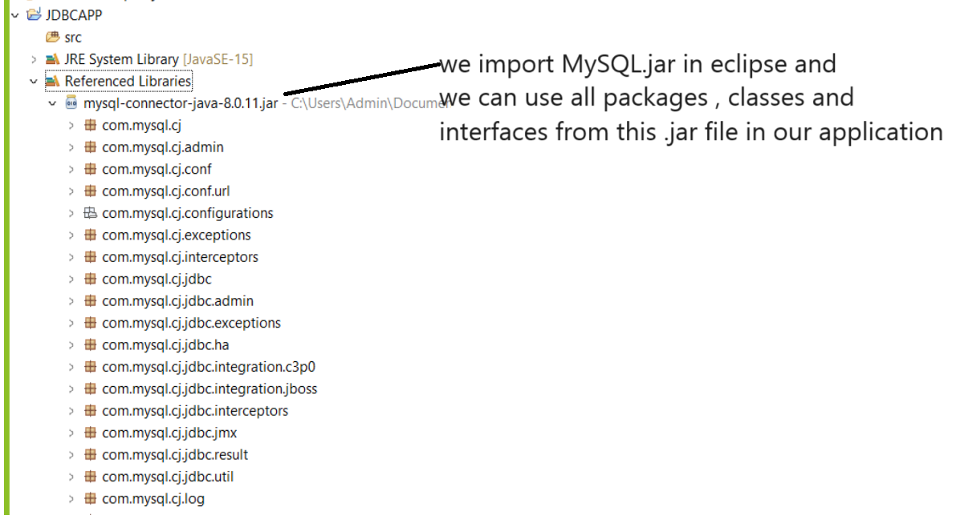
Once we import .jar file you can write code and register driver with java application
package org.techhub;
import java.sql.*;
public class RegisterDriverApp {
public static void main(String[] args) throws SQLException{
com.mysql.cj.jdbc.Driver d= new com.mysql.cj.jdbc.Driver();
DriverManager.registerDriver(d);
System.out.println("Driver Registered Successfully................");
}
}

4. Establish Connection between java application and database application
_________________________________________________________________________
If we want to connect your java application with database application we have interface from java.sql package name as Connection and if we want to create reference of Connection interface for that we have method name as DriverManager.getConnection()
getConnection() is a static method of DriverManager and this method return reference of Connection interface.
Syntax: Connection ref =DriverManager.getConnection(String url,String username,String password);
Parameter details
String url: url means path where we store our database or location where our database is present.
String username: it is our database username
String password: it our database password.

Note: if we use think about MYSQL we have url like as
jdbc:mysql://localhost:portnumber/databasename
Example: jdbc:mysql://localhost:3306/mysql
jdbc:mysql is protocol
localhost or ipaddress: if your database present on same machine where your project exist then use localhost or use id 127.0.0.1 and if your database present on remote machine or on different machine then you can specify ip address other than localhost
3306 it is port number of MYSQL database and it is default and if user change the port number at the time of installation you can specify your port except 3306
mysql is your database and user can give his own database name also.

package org.techhub;
import java.sql.*;
public class RegisterDriverApp {
public static void main(String[] args) throws SQLException{
com.mysql.cj.jdbc.Driver d= new com.mysql.cj.jdbc.Driver();
DriverManager.registerDriver(d);
Connection conn=DriverManager.getConnection("jdbc:mysql://localhost:3306/mysql","root","root");
if(conn!=null) {
System.out.println("Database is connected");
}
else {
System.out.println("Some problem is there................");
}
}
}

5. Work with Database
_________________________________________________________________
If we want to work with database we have some following interfaces given below and classes

Interfaces for work with Database
________________________________________________________________
a. Statement
b. PreparedStatement
c. ResultSet
d. CallableStatement
e. ResultSetMetaData
f. DatabaseMetaData
g. Connection
f. ParameterMetaData
etc
Classes
1. DriverManager
2. Clob
3. Blob

Now we want to discuss about the Statement interface
______________________________________________________________________________
Statement is interface from java.sql package which is used for perform all DDL and DML operation on database like as create, alter, insert, delete, upate etc

Steps to work with Statement interface
_______________________________________________________________________________
a) Add java.sql package in application
import java.sql.*;
b) Create Reference of Statement interface
If we want to create reference of Statement interface we have method name as
createStatement() and it is member of Connection interface and this method return reference of Statement interface
Syntax: Statement ref = connref.createStatement();
Sample code
package org.techhub;
import java.sql.*;
public class InsertApplication {
public static void main(String[] args) throws SQLException{
com.mysql.cj.jdbc.Driver d = new com.mysql.cj.jdbc.Driver();
DriverManager.registerDriver(d);
Connection conn=DriverManager.getConnection("jdbc:mysql://localhost:3306/mysql", "root", "root");
if(conn!=null) {
System.out.println("database is connected");
Statement stmt=conn.createStatement();
}
else {
System.out.println("Some problem is there................");
}
}
}
c) Use its method to execute database statement or queries
________________________________________________________________
int executeUpdate(String sqlStatement): this method can execute the all DDL and DML statement except select like as using executeUpdate you can perform insert,delete, update etc operation.
This method return 1 when operation executed successfully otherwise return 0.

ResultSet executeQuery(String selectStatement): this method can execute the select statement and return reference of ResultSet interface.

Example: We want to create table name as Employee with field id, name and salary and insert record in database table using Java program.

Steps.
_______________________________________________________________________________
a) Open MYSQL
b) Create Database Example: create database jdbcmayjunejuly
c) Use or Select Database: Example: use jdbcmayjunejuly
d) Create table in database Example: create table employee(id int(5),name varchar(200),salary int(5))
f) Write JDBC Program and insert record in database using Statement interface
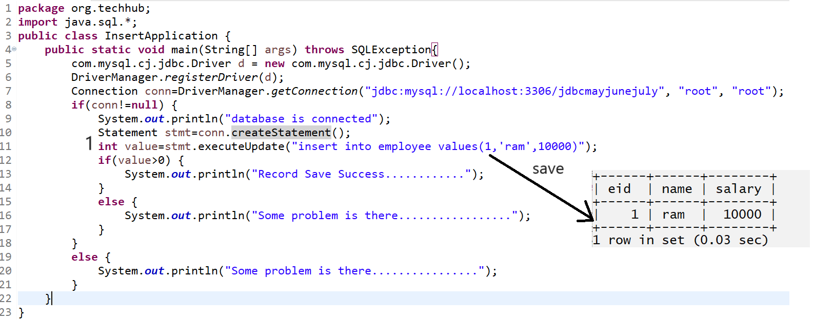

If we think about above code we insert fix data in database table we want to accept the input from keyboard and after that we want to save in database
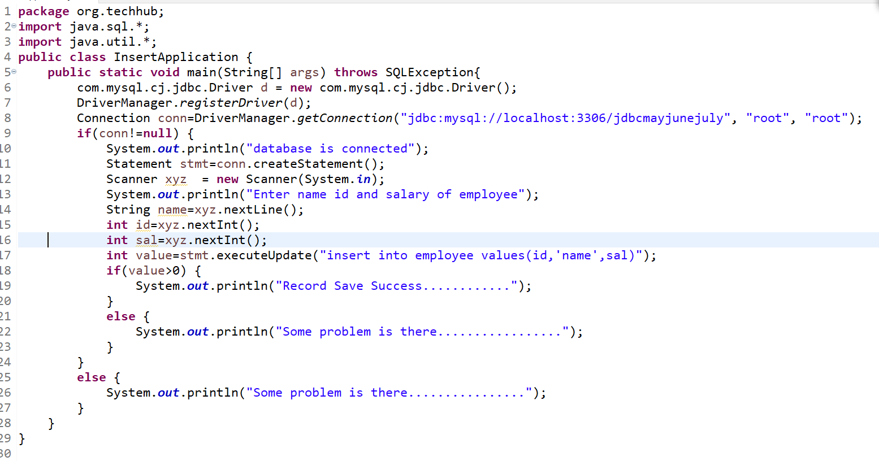
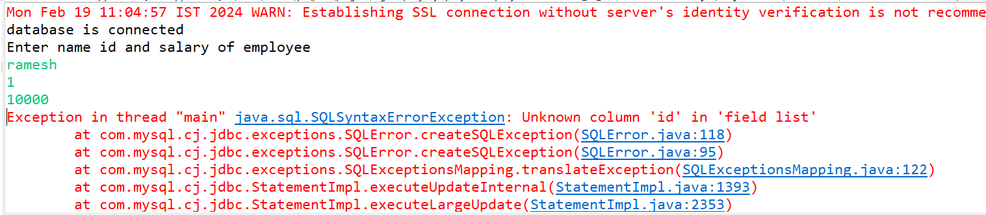
if we think about above code we get exception at run time unknown column id in field list because we pass id as value and id is variable in java application so you cannot pass variable as value in query so when we want to pass run time parameter to SQL statement using JDBC we need to SQL Injection Technique means we need to separate variable from SQL statement using “”+ symbol.

Source Code.
package org.techhub;
import java.sql.*;
import java.util.*;
public class InsertApplication {
public static void main(String[] args) throws SQLException{
com.mysql.cj.jdbc.Driver d = new com.mysql.cj.jdbc.Driver();
DriverManager.registerDriver(d);
Connection conn=DriverManager.getConnection("jdbc:mysql://localhost:3306/jdbcmayjunejuly", "root", "root");
if(conn!=null) {
System.out.println("database is connected");
Statement stmt=conn.createStatement();
Scanner xyz = new Scanner(System.in);
System.out.println("Enter name id and salary of employee");
String name=xyz.nextLine();
int id=xyz.nextInt();
int sal=xyz.nextInt();
int value=stmt.executeUpdate("insert into employee values("+id+",'"+name+"',"+sal+")");
if(value>0) {
System.out.println("Record Save Success............");
}
else {
System.out.println("Some problem is there.................");
}
}
else {
System.out.println("Some problem is there................");
}
}
}
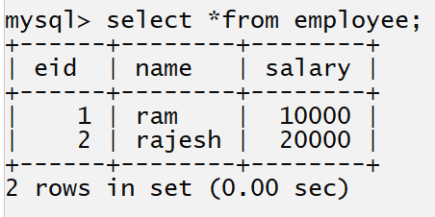

Example: WAP to delete the employee record by using its id.
package org.techhub;
import java.sql.*;
import java.util.*;
public class DeleteEmployeeById {
public static void main(String[] args)throws SQLException {
com.mysql.cj.jdbc.Driver d = new com.mysql.cj.jdbc.Driver();
DriverManager.registerDriver(d);
Connection conn=DriverManager.getConnection("jdbc:mysql://localhost:3306/jdbcmayjunejuly","root","root");
if(conn!=null) {
Statement stmt=conn.createStatement();
Scanner xyz = new Scanner(System.in);
System.out.println("Enter employee id");
int empid=xyz.nextInt();
int value=stmt.executeUpdate("delete from employee where eid="+empid);
if(value>0) {
System.out.println("Record Deleted Success...............");
}
else {
System.out.println("Some problem is there..................");
}
}
else {
System.out.println("Database is not connected");
}

}
}

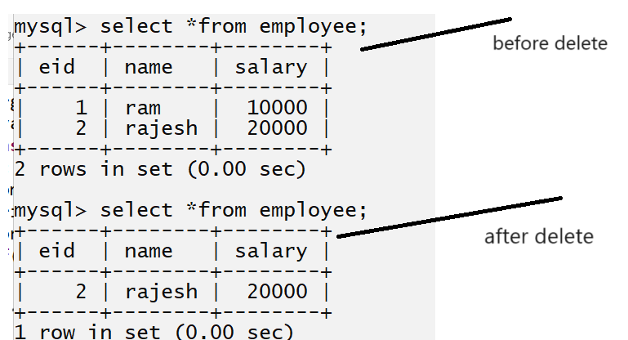

Example: WAP to update the employee name and its salary by using its id.
package org.techhub;
import java.sql.*;
import java.util.*;
public class UpdateEmployeeById {
public static void main(String x[]) throws Exception{
com.mysql.cj.jdbc.Driver d = new com.mysql.cj.jdbc.Driver();
DriverManager.registerDriver(d);
Connection conn=DriverManager.getConnection("jdbc:mysql://localhost:3306/jdbcmayjunejuly", "root", "root");
if(conn!=null) {
Statement stmt=conn.createStatement();
Scanner xyz = new Scanner(System.in);
System.out.println("Enter name id and salary of employee");
String name=xyz.nextLine();
int id=xyz.nextInt();
int sal=xyz.nextInt();
int value=stmt.executeUpdate("update employee set name='"+name+"',salary="+sal+" where eid="+id);
if(value>0) {
System.out.println("employee updated successfully..................");
}
else {
System.out.println("Some problem in employee updation");
}
}
else {
System.out.println("Database is not connected");
}
}
}
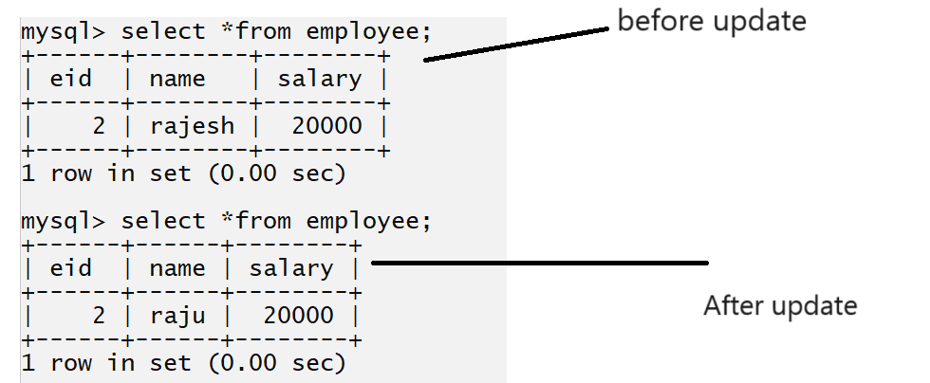

How to select data from database table
_________________________________________________________________________________
If we want to select data from database table we have executeQuery() method of Statement interface
and this method return reference of ResultSet interface.

Q. what is ResultSet interface?
__________________________________________________________________________
ResultSet is an interface from java.sql package which is used for hold data fetch by select query and provide access in java application.
ResultSet maintains cursor/pointer which points to a single row of the query results. Using navigational and getter methods provided by ResultSet, we can iterate and access database records one by one. ResultSet can also be used to update data.

ResultSet is the java.sql.ResultSet interface means the result set of a SQL query. It means a cursor is pointing a row of a table; it points to before the first row.

Methods of ResultSet interface
boolean next(): this method can check data present in database table or not if present return true otherwise return false.
String getString(String columnName): this method can fetch varchar type data from database table using its column name or using column index
or
String getString(int index): this method can fetch varchar data from table using column index.
If we have wild card selection using * in select command then first column consider as first index up to n.
Example: Suppose consider we have Employee table with column
id name salary
and we have select query like as

select *from employee;
Here id has 1 index , name has 2 and salary has 3rd index

Suppose consider if we execute the partial select command then from left to right give index to column means first left column has 1 index up to n

Example: select salary ,name from employee
here salary has 1 index even it is 3rd column in table and name has 2nd index means in partial selection we provide column index from to left it is not dependent on table structure.

int getInt(String columnName): this method can fetch integer type of data using column name
or
int getInt(int index): this method can fetch data of type integer using its column index.

float getFloat(String columnName): this method can fetch data of type float using its column name
or
float getFloat(int index): this method can fetch float type of data using its index.
etc

What are types of ResultSet?
There are three types of ResultSet available. If we do not declare any ResultSet that means we are calling TYPE_FORWARD_ONLY
1 Forward Only (ReseltSet.TYPE_FORWARD_ONLY): cursor can move only forward.
This type of ResultSet instance can move only in the forward direction from the first row to the last row. ResultSet can be moved forward one row by calling the next() method. We can obtain this type of ResultSet while creating Instance of Statement, PreparedStatement or CallableStatement.
Example:
Statement stmt = connref.createStatement(ResultSet.TYPE_FORWARD_ONLY,ResultSet.CONCUR_READ_ONLY);
ResultSet rs = stmt.executeQuery("select * from tbluser");

2. Scroll incentive (ResultSet.TYPE_SCROLL_INSENSITIVE): cursor can move forward and backward but not sensitive.
Scroll Insensitive ResultSet can scroll in both forward and backward directions. It can also be scrolled to an absolute position by calling the absolute() method. But it is not sensitive to data changes. It will only have data when the query was executed and ResultSet was obtained. It will not reflect the changes made to data after it was obtained.
Example: Statement stmt = conn.createStatement(ResultSet.TYPE_SCROLL_INSENSITIVE, ResultSet.CONCUR_READ_ONLY);
ResultSet rs = stmt.executeQuery("select * from tbluser");

3. Scroll Sensitive (ResultSet.TYPE_SCROLL_SENSITIVE): cursor can move forward and backward, but it is sensitive.
Scroll Sensitive ResultSet can scroll in both forward and backward directions. It can also be scrolled to an absolute position by calling the absolute() method. But it is sensitive to data changes. It will reflect the changes made to data while it is open.
Example: Statement stmt = conn.createStatement(ResultSet.TYPE_SCROLL_SENSITIVE, ResultSet.CONCUR_READ_ONLY);
ResultSet rs = stmt.executeQuery("select * from tbluser");

Example: we want to fetch all employee record from employee table using JDBC
package org.techhub;
import java.sql.*;
public class SelectQueryApplication {
public static void main(String[] args)throws SQLException {
com.mysql.cj.jdbc.Driver d = new com.mysql.cj.jdbc.Driver();
DriverManager.registerDriver(d);
Connection conn=DriverManager.getConnection("jdbc:mysql://localhost:3306/jdbcmayjunejuly","root","root");
if(conn!=null) {
Statement stmt=conn.createStatement();
ResultSet rs=stmt.executeQuery("select *from employee");
while( rs.next() )
{
int empId=rs.getInt("eid");

String empName=rs.getString("name");

int empSalary=rs.getInt("salary");

System.out.println(empId+"\t"+empName+"\t"+empSalary);
}
}
else {
System.out.println("Database is not connected");
}
}
}
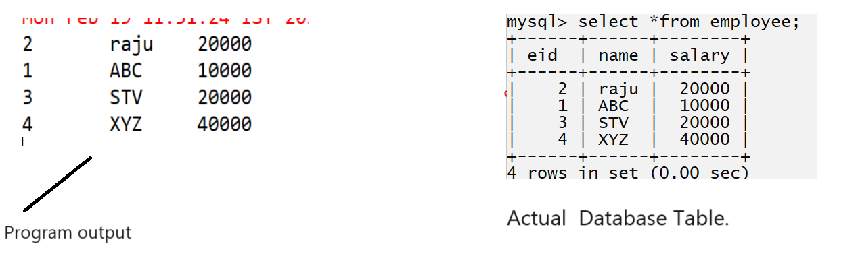

Example: WAP to fetch employee data using its id.
package org.techhub;
import java.sql.*;
import java.util.*;
public class JdbcWithWhereClauseApp {
public static void main(String[] args) throws SQLException{
com.mysql.cj.jdbc.Driver d= new com.mysql.cj.jdbc.Driver();
DriverManager.registerDriver(d);
Connection conn=DriverManager.getConnection("jdbc:mysql://localhost:3306/jdbcmayjunejuly","root","root");
if(conn!=null) {
Statement stmt=conn.createStatement();
Scanner xyz = new Scanner(System.in);
System.out.println("enter employee id");
int id=xyz.nextInt();
ResultSet rs=stmt.executeQuery("select *from employee where eid="+id);
if(rs.next()) {
System.out.println(rs.getInt(1)+"\t"+rs.getString(2)+"\t"+rs.getInt(3));
}
else {
System.out.println("Employee not found");
}
}
else {
System.out.println("database is not connected");
}
}
}

Example: WAP to create table name as register with column id,name , email, contact ,username and password

mysql> create table register(rid int(5) primary key auto_increment,name varchar(200) not null,email varchar(200) not null unique,contact varchar(200) not null unique,username varchar(200) not null unique,password varchar(200) not null unique);
Query OK, 0 rows affected, 1 warning (0.20 sec)

package org.techhub;

import java.util.*;
import java.sql.*;

public class RegisterApplication {
public static void main(String[] args) throws SQLException {
com.mysql.cj.jdbc.Driver d = new com.mysql.cj.jdbc.Driver();
DriverManager.registerDriver(d);
Connection conn = DriverManager.getConnection("jdbc:mysql://localhost:3306/jdbcmayjunejuly", "root", "root");
if (conn != null) {
Scanner xyz = new Scanner(System.in);
System.out.println("Enter name ");
String name = xyz.nextLine();
System.out.println("Enter Email");
String email = xyz.nextLine();
System.out.println("Enter contact");
String contact = xyz.nextLine();
System.out.println("Enter username");
String username = xyz.nextLine();
System.out.println("Enter password");
String password = xyz.nextLine();
Statement stmt = conn.createStatement();
int value = stmt.executeUpdate("insert into register values('0','" + name + "','" + email + "','" + contact
+ "','" + username + "','" + password + "')");
if (value > 0) {
System.out.println("Record Save Success..............");
} else {
System.out.println("Some problem is there.............");
}
} else {
System.out.println("Database not connected");
}
}
}

Example: WAP to verify user present in database or not using its username and password.
package org.techhub;
import java.sql.*;
import java.util.*;
public class LoginVerificationApplication {
public static void main(String[] args)throws SQLException {
com.mysql.cj.jdbc.Driver d = new com.mysql.cj.jdbc.Driver();
DriverManager.registerDriver(d);
Connection conn=DriverManager.getConnection("jdbc:mysql://localhost:3306/jdbcmayjunejuly","root","root");
if(conn!=null) {
Scanner xyz = new Scanner(System.in);
System.out.println("Enter username and password");
String username=xyz.nextLine();
String password=xyz.nextLine();
Statement stmt=conn.createStatement();
ResultSet rs=stmt.executeQuery("select *from register where username='"+username+"' and password='"+password+"'");
if(rs.next()) {
System.out.println("Login Success...............");
}
else {
System.out.println("Login Failed..............");
}

}
else {
System.out.println("Database is not connected");
}
}

}

ResultSet Methods : we have divided ResultSet methods in 4 categories
- Navigational Methods
- Getter/Reader Methods
- Setter/Updater Methods
- Miscellaneous Methods - close() and getMetaData()

1. ResultSet Navigational Methods
- boolean absolute(int row) throws SQLException**:** This method moves ResultSet cursor to the specified row and returns true if the operation is successful.
- void afterLast() throws SQLException**:** This method moves ResultSet cursor to the position after the last row.
- void beforeFirst() throws SQLException**:** This method moves ResultSet cursor to the position before the first row.
- boolean first() throws SQLException: This method moves ResultSet cursor to the first row.
- boolean last() throws SQLException: This method moves ResultSet cursor to the last row.
- boolean next() throws SQLException: This method moves ResultSet cursor to the next row.
- boolean previous() throws SQLException: This method moves ResultSet cursor to the previous row.

Example:
package com.journaldev.examples;
import java.sql.*;
public class ResultSetDemo {

public static void main(String[] args) {
String query = "select empid, firstname, lastname, dob from tblemployee";
Connection conn = null;
Statement stmt = null;
try {
Class.forName("com.mysql.jdbc.Driver");
conn = DriverManager.getConnection("jdbc:mysql://127.0.0.1:3306/empdb", "root", "root");
stmt = conn.createStatement(ResultSet.TYPE_SCROLL_INSENSITIVE, ResultSet.CONCUR_READ_ONLY);
ResultSet rs = stmt.executeQuery(query);
System.out.println("All the rows of table=>");
while (rs.next()) {
// Go to next row by calling next() method
displayData(rs);
}
System.out.println("Now go directly to 2nd row=>");
rs.absolute(2); // Go directly to 2nd row
displayData(rs);
System.out.println("Now go to Previous row=>");
rs.previous();
// Go to 1st row which is previous of 2nd row
displayData(rs);
rs.close();
} catch (Exception e) {
e.printStackTrace();
} finally {
try {
stmt.close();
conn.close();
} catch (Exception e) {
}
}
}
public static void displayData(ResultSet rs) throws SQLException {
System.out.println("empId:" + rs.getInt(1));
System.out.println("firstName:" + rs.getString(2));
System.out.println("lastName:" + rs.getString(3));
System.out.println("dob:" + rs.getDate(4));
System.out.println("");
}
}
Output:
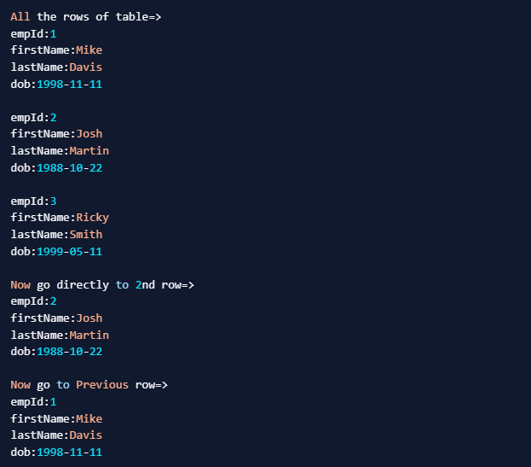

2. ResultSet Getter/Reader Methods
- int getInt(int columnIndex) throws SQLException:
This method returns value of specified columnIndex as int.
- long getLong(int columnIndex) throws SQLException: This method returns value of specified columnIndex as long
- String getString(int columnIndex) throws SQLException: This method returns value of specified columnIndex as String
- java.sql.Date getDate(int columnIndex) throws SQLException: This method returns value of specified columnIndex as java.sql.Date
- int getInt(String columnLabel) throws SQLException: This method returns value of specified column name as int.
- long getLong(String columnLabel) throws SQLException: This method returns value of specified column name as long.
- String getString(String columnLabel) throws SQLException: This method returns the value of the specified column name as String.
- java.sql.Date getDate(String columnLabel) throws SQLException: This method returns the value of the specified column name as java.sql.Date.
- ResultSet contains getter methods that return other primitive datatypes like boolean, float and double. It also has methods to obtain array and binary data from the database.

3. ResultSet Setter/Updater Methods
- void updateInt(int columnIndex, int x) throws SQLException: This method updates the value of specified column of current row with int value.
- void updateLong(int columnIndex, long x) throws SQLException: This method updates the value of the specified column of the current row with long value.
- void updateString(int columnIndex, String x) throws SQLException: This method updates the value of the specified column of the current row with a String value.
- void updateDate(int columnIndex, java.sql.Date x) throws SQLException: This method updates the value of specified column of current row with java.sql.Date value.
- void updateInt(String columnLabel, int x) throws SQLException: This method updates the value of the specified column label of the current row with int value.
- void updateLong(String columnLabel, long x) throws SQLException: This method updates the value of the specified column label of the current row with long value.
- void updateString(String columnLabel, String x) throws SQLException: This method updates the value of the specified column label of the current row with a String value.
- void updateDate(String columnLabel, java.sql.Date x) throws SQLException: This method updates the value of specified columnLabel of current row with java.sql.Date value.
Note: Setter/Updater Methods doesn’t directly update database values. Database values will be inserted/updated after calling the insertRow or updateRow method.
Example:
package com.journaldev.examples;
import java.sql.*;

public class ResultSetUpdateDemo {
public static void main(String[] args) {
String query = "select empid, firstname, lastname, dob from tblemployee";
Connection conn = null;
Statement stmt = null;
try {
Class.forName("com.mysql.jdbc.Driver");
conn = DriverManager.getConnection("jdbc:mysql://127.0.0.1:3306/empdb", "root", "root");
stmt = conn.createStatement(ResultSet.TYPE_SCROLL_INSENSITIVE, ResultSet.CONCUR_UPDATABLE);
ResultSet rs = stmt.executeQuery(query);
System.out.println("Now go directly to 2nd row for Update");
if (rs.absolute(2)) {
// Go directly to 2nd row
System.out.println("Existing Name:" + rs.getString("firstName"));
rs.updateString("firstname", "Tyson");
rs.updateRow();
}
rs.beforeFirst(); // go to start
System.out.println("All the rows of table=>");
while (rs.next()) {
// Go to next row by calling next() method
displayData(rs);
}
rs.close();
} catch (Exception e) {
e.printStackTrace();
} finally {
try {
stmt.close();
conn.close();
} catch (Exception e) {
}
}
}
public static void displayData(ResultSet rs) throws SQLException {
System.out.println("empId:" + rs.getInt(1));
System.out.println("firstName:" + rs.getString(2));
System.out.println("lastName:" + rs.getString(3));
System.out.println("dob:" + rs.getDate(4));
System.out.println("");
}
}
Output:
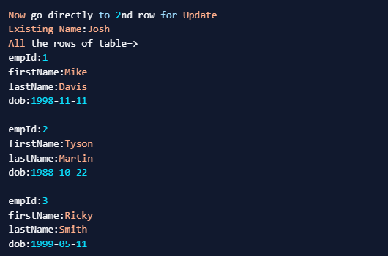

4. ResultSet Miscellaneous Methods
- void close() throws SQLException**:** This method frees up resources associated with ResultSet Instance. It must be called otherwise it will result in resource leakage.
- ResultSetMetaData getMetaData() throws SQLException: This method returns ResultSetMetaData instance. It gives information about the type and property of columns of the query output.

PreparedStatement interface
__________________________________________________________________________

Q. What is PreparedStatement interface?
PreparedStatement interface is used for performing the all DDL and DML operation on database table like as Statement interface.
Prepared Statement is used to execute same SQL statements repeatedly. The prepared statement is compiled only once even though it used "n" number of times.

Q. What is diff between Statement and PreparedStatement?
_____________________________________________________________________________________
Statement | PreparedStatement
It is used when we want to execute query or SQL statement only once | It is recommended when we want to execute SQL Query more than one time.
You cannot pass parameter at run time and for run time parameter need to use SQL injection and it is very tedious task when we have large number of parameter as well as SQL injection is not secure way to pass parameter to database | Using PreparedStatement we can pass run time parameter to SQL statement using methods not need to perform SQL Injections.
It is recommended when we execute create , alter or drop statements | It is recommended for DML statements
Perform is very low | Performance is better
Used for execute static query or normal query | Used for execute dynamic query or run time parameter query
You cannot use Statement for execute binary data like as image , audio etc | You can use to pass binary data to database  Like as storing image in database etc

Note: PreparedStatement is child of Statement interface
How to work with PreparedStatement interface in JDBC
__________________________________________________________________________________
a) Add java.sql package in application
____________________________________________________________
import java.sql.*;
b) Create reference of PreparedStatement interface
_______________________________________________________________________________
If we want to create reference of PreparedStatement interface we have method of Connection name as prepareStatement()

Syntax: PreparedStatement ref = connref.prepareStatement(String sqlStatement);
Example: We have employee table with field id,name and salary and input we want to accept input from keyboard and store in database table using PreparedStatement interface.
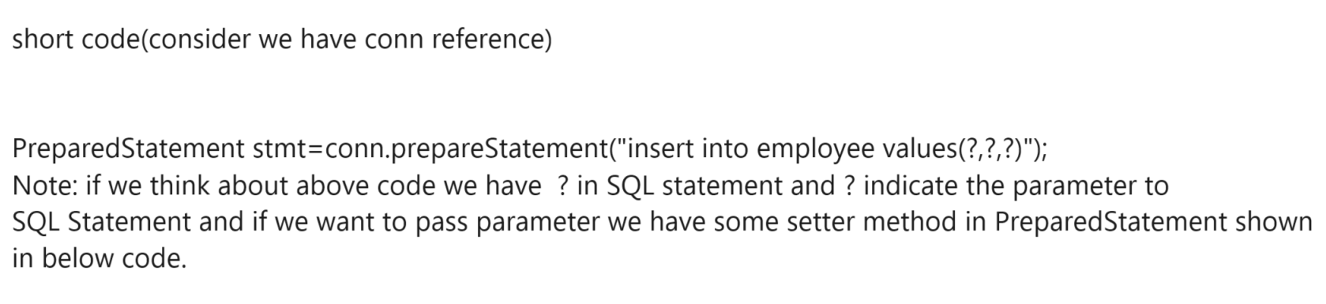
Methods of PreparedStatement interface for pass run time parameter to SQL Statement
____________________________________________________________________________________
void setInt(int index, int data): this method can pass run time integer parameter to table column using its index and index start from 1 and in query first ? mark consider as first parameter from left to right

void setFloat(int index,float data): this method can pass float type of data to SQL Statement
void setString(int index,String data): this method can pass string type of data to SQL statement
void setDouble(int index, double data): this method can pass double type of data to SQL statement
void setLong(int index,long data): this method can pass long type of data to SQL Statement
void setShort(int index,short data)
void setCharacterString(int index,Reader,int length): this method pass character stream data to column
void setBinaryStream(int index,InputStream,int length); this method can pass binary stream data to column
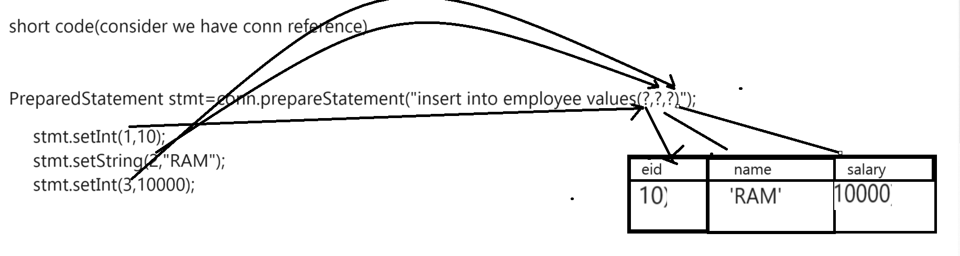
c) Use its executeUpdate() and executeQuery() method for execute DML statements
int executeUpdate():this method help us to execute the all ddl and DML statement except select if statement executed successfully return 1 otherwise return 0
ResultSet executeQuery(): this method can execute only select query.

Example: input name id and salary from keyboard and store in employee table using JDBC with PreparedStatement

package org.techhub;
import java.sql.*;
import java.util.*;
public class PstmtApplication {
public static void main(String[] args)throws SQLException {
com.mysql.cj.jdbc.Driver d = new com.mysql.cj.jdbc.Driver();
DriverManager.registerDriver(d);
Connection conn=DriverManager.getConnection("jdbc:mysql://localhost:3306/jdbcmayjunejuly","root","root");
if(conn!=null) {
Scanner xyz = new Scanner(System.in);
System.out.println("Enter name id and salary of employee");
String name=xyz.nextLine();
int id=xyz.nextInt();
int salary=xyz.nextInt();
PreparedStatement stmt=conn.prepareStatement("insert into employee values(?,?,?)");
stmt.setInt(1, id);
stmt.setString(2, name);
stmt.setInt(3, salary);
int value=stmt.executeUpdate();
if(value>0) {
System.out.println("Employee Added Successfully.............");
}
else {
System.out.println("Some problem is there.....................");
}
}
else {
System.out.println("Database is not connected");
}
}
}

Example: WAP to input delete employee record by using its id using PreparedStatement interface
package org.techhub;
import java.util.*;
import java.sql.*;
public class DeleteEmployeeByIdUsingPstmtApplication {
public static void main(String[] args)throws SQLException {
com.mysql.cj.jdbc.Driver d = new com.mysql.cj.jdbc.Driver();
DriverManager.registerDriver(d);
Connection conn=DriverManager.getConnection("jdbc:mysql://localhost:3306/jdbcmayjunejuly","root","root");
if(conn!=null) {
System.out.println("Connected");
Scanner xyz = new Scanner(System.in);
System.out.println("Enter emplyee id");
int id=xyz.nextInt();
PreparedStatement stmt=conn.prepareStatement("delete from employee where eid=?");
stmt.setInt(1, id);
int value=stmt.executeUpdate();
if(value>0) {
System.out.println("Record Deleted Successfully...............");
}
else {
System.out.println("Some problem is there.................");
}
}
else {
System.out.println("Not Connected");
}
}
}

Example: WAP to change name and salary of employee using its id.
package org.techhub;
import java.sql.*;
import java.util.*;
public class UpdateUsingpstmtapp {
public static void main(String[] args)throws SQLException {
com.mysql.cj.jdbc.Driver d = new com.mysql.cj.jdbc.Driver();
DriverManager.registerDriver(d);
Connection conn=DriverManager.getConnection("jdbc:mysql://localhost:3306/jdbcmayjunejuly","root","root");
if(conn!=null) {
Scanner xyz = new Scanner(System.in);
System.out.println("Enter name id and salaryy of employee");
String name=xyz.nextLine();
int id=xyz.nextInt();
int sal=xyz.nextInt();
PreparedStatement stmt=conn.prepareStatement("update employee set name=?,salary=? where eid=?");
stmt.setString(1, name);
stmt.setInt(2, sal);
stmt.setInt(3, id);
int value=stmt.executeUpdate();
if(value>0) {
System.out.println("Record updated");
}
else {
System.out.println("Record Not Updated");
}
}
else {
System.out.println("Database is not connected");
}
}
}

How to select record from database table using PreparedStatement interface
____________________________________________________________________________________
Example: Fetch all employee data using PreparedStatement
package org.techhub;
import java.sql.*;
public class SelectRecordUsingPstmtApp {
public static void main(String[] args)throws Exception {
//com.mysql.cj.jdbc.Driver d = new com.mysql.cj.jdbc.Driver();
//DriverManager.registerDriver(d);
Class.forName("com.mysql.cj.jdbc.Driver");
Connection conn=DriverManager.getConnection("jdbc:mysql://localhost:3306/jdbcmayjunejuly","root","root");
if(conn!=null) {
PreparedStatement stmt=conn.prepareStatement("select *from employee");
ResultSet rs=stmt.executeQuery();
while(rs.next()) {
System.out.println(rs.getInt("eid")+"\t"+rs.getString("name")+"\t"+rs.getInt("salary"));
}
}
else {
System.out.println("Not Connected");
}
}
}

How to use where clause in select using PreparedStatement interface
_____________________________________________________________________________
when we use where clause in PreparedStatement with select then after where clause parameter pass using PreparedStatement object using its method and before from you can column using ResultSet interface.

Example: WA Program fetch employee name using its id
Your query look like as
select name from employee where eid=?
so as per above query we need to pass eid using PreparedStatement interface and we get name using ResultSet because we use eid after where and we use name before from

package org.techhub;
import java.sql.*;
import java.util.*;
public class SelectRecordUsingPstmtApp {
public static void main(String[] args)throws Exception {
//com.mysql.cj.jdbc.Driver d = new com.mysql.cj.jdbc.Driver();
//DriverManager.registerDriver(d);
Class.forName("com.mysql.cj.jdbc.Driver");
Connection conn=DriverManager.getConnection("jdbc:mysql://localhost:3306/jdbcmayjunejuly","root","root");
if(conn!=null) {
Scanner xyz = new Scanner(System.in);
System.out.println("Enter employee id");
int id=xyz.nextInt();
PreparedStatement stmt=conn.prepareStatement("select name from employee where eid=?");
stmt.setInt(1, id);//where parameter
ResultSet rs=stmt.executeQuery();
while(rs.next()) {
String name=rs.getString("name");//before from parameter
System.out.println(name);
}
}
else {
System.out.println("Not Connected");
}
}
}

Example: WAP fetch use detail name, email and contact from register table using its username and password
package org.techhub;
import java.util.*;
import java.sql.*;
public class TestSelectWithWhere {
public static void main(String[] args) throws Exception{
//com.mysql.cj.jdbc.Driver d = new com.mysql.cj.jdbc.Driver();
//DriverManager.registerDriver(d);
Class.forName("com.mysql.cj.jdbc.Driver");
Connection conn=DriverManager.getConnection("jdbc:mysql://localhost:3306/jdbcmayjunejuly","root","root");
if(conn!=null) {
Scanner xyz = new Scanner(System.in);
System.out.println("Enter username and password");
String username=xyz.nextLine();
String password=xyz.nextLine();
PreparedStatement stmt=conn.prepareStatement("select name,email,contact from register where username=? and password=?");
stmt.setString(1, username);
stmt.setString(2, password);
ResultSet rs=stmt.executeQuery();
if(rs.next()) {
System.out.println(rs.getString("name")+"\t"+rs.getString("email")+"\t"+rs.getString("contact"));
}
else {
System.out.println("Data not found");
}
}
else {
System.out.println("Database is not connected");
}
}
}

CallableStatement interface
_____________________________________________________________________________
CallableStatement interface is used for call database procedure using JDBC.

Steps to work with CallableStatement interface
______________________________________________________________________________

1) Add java.sql package in application
____________________________________________________________________
import java.sql.*;
2) Create Reference of CallableStatement interface and call procedure
____________________________________________________________________________
If we want to create reference of CallableStatement interface we have prepareCall() method of Connection and this method return reference of CallableStatement.

Syntax: CallableStatement ref = connref.prepareCall(“{call procedurename(?,?,?.......?)}”);

Example: We want to create procedure name as saveEmployee and call it using JDBC Program
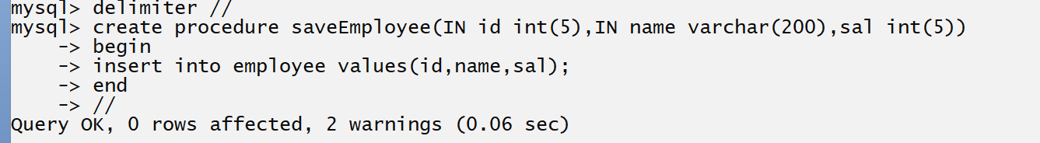
package org.techhub;
import java.sql.*;
import java.util.*;
public class CallProApp {
public static void main(String[] args)throws Exception {
Class.forName("com.mysql.cj.jdbc.Driver");
Connection conn=DriverManager.getConnection("jdbc:mysql://localhost:3306/jdbcmayjunejuly","root","root");
if(conn!=null) {
Scanner xyz =new Scanner(System.in);
System.out.println("Enter name id and salary of employee");
String name=xyz.nextLine();
int id=xyz.nextInt();
int salary=xyz.nextInt();
CallableStatement cstmt=conn.prepareCall("{call saveEmployee(?,?,?)}");
}
else {
System.out.println("Database is not connected");
}

}
}
If we think about above code we have ? in procedure and it is indicate parameter to procedure and if we want to pass parameter to procedure we have setXXX() method of PreparedStatement
All methods of PreparedStatement present in CallableStatement because CallableStatement is child of PreparedStatement

3) Pass parameter to procedure
package org.techhub;
import java.sql.*;
import java.util.*;
public class CallProApp {
public static void main(String[] args)throws Exception {
Class.forName("com.mysql.cj.jdbc.Driver");
Connection conn=DriverManager.getConnection("jdbc:mysql://localhost:3306/jdbcmayjunejuly","root","root");
if(conn!=null) {
Scanner xyz =new Scanner(System.in);
System.out.println("Enter name id and salary of employee");
String name=xyz.nextLine();
int id=xyz.nextInt();
int salary=xyz.nextInt();
CallableStatement cstmt=conn.prepareCall("{call saveEmployee(?,?,?)}");
//set parameter to procedure
cstmt.setInt(1, id);
cstmt.setString(2, name);
cstmt.setInt(3, salary);

}
else {
System.out.println("Database is not connected");
}

}
}

4) execute procedure : if we want to execute the procedure we have execute() method of CallableStatement and this method return false if procedure executed successfully otherwise return true.

boolean execute():

package org.techhub;
import java.sql.*;
import java.util.*;
public class CallProApp {
public static void main(String[] args)throws Exception {
Class.forName("com.mysql.cj.jdbc.Driver");
Connection conn=DriverManager.getConnection("jdbc:mysql://localhost:3306/jdbcmayjunejuly","root","root");
if(conn!=null) {
Scanner xyz =new Scanner(System.in);
System.out.println("Enter name id and salary of employee");
String name=xyz.nextLine();
int id=xyz.nextInt();
int salary=xyz.nextInt();
CallableStatement cstmt=conn.prepareCall("{call saveEmployee(?,?,?)}");
//set parameter to procedure
cstmt.setInt(1, id);
cstmt.setString(2, name);
cstmt.setInt(3, salary);
boolean b=cstmt.execute();
if(!b) {
System.out.println("Procedure executed successfully......");
}
else {
System.out.println("Some problem is there.................");
}
}
else {
System.out.println("Database is not connected");
}

}
}
6. Close the Database Connection

Student Examination
______________________________________________________________________
Objective: Student should give exam on system and system should generate result of exam to students.

Basic Requirement
______________________________________________________________________
1. Add Subjects in Database
2. Add Question under subjects
3. Create Exam Time Table
4. Add Question under exam
5. Add New Student in Database and provide login
6. Student should login to system
7. Attempt exam by students
8. Show the Result of Student

Database Design
____________________________________________________________________

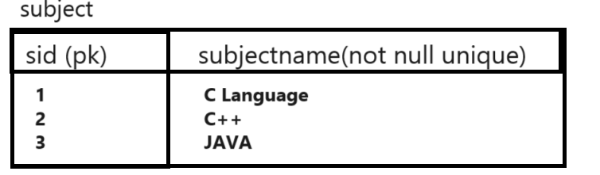
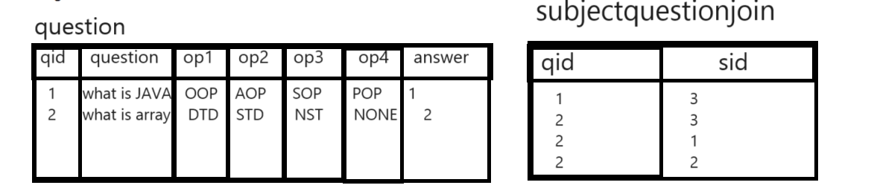

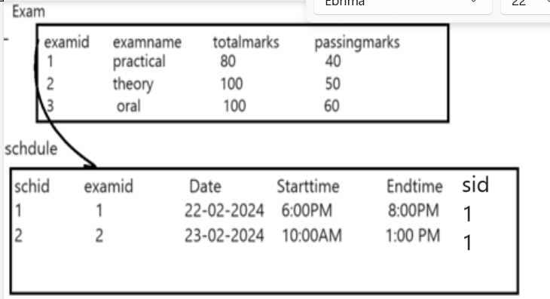
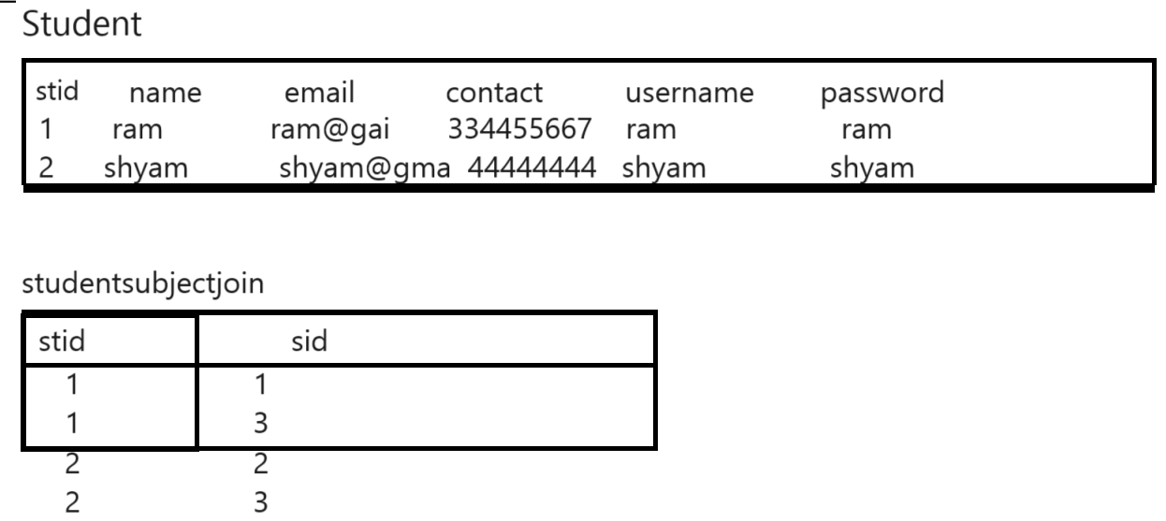

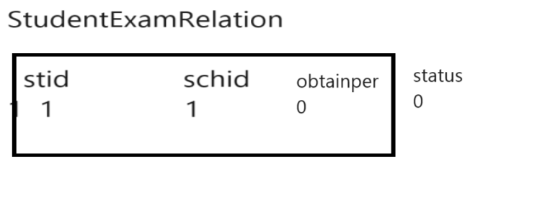

Table Structure
__________________________________________________________
Subject Table
Column Name | Data Type | Size | Constraints
Sid | Int | 5 | Primary key auto_increment
Subjectname | Varchar | 200 | Not null unique

Question Table

Column Name | Data Type | Size | Constraints
Qid | Int | 5 | Primary key auto_increment
Question | Varchar | 4000 | Not null unique
Op1 | Varchar | 200 | Not null
Op2 | Varchar | 200 | Not null
Op3 | Varchar | 200 | Not null
Op4 | Varchar | 200 | Not null
Answer | Int | 5 | Not null

SubjectQuestionJoin
Column Name | Data Type | Size | Constraints
Qid | Int | 5 | Foreign key on delete cascade
Sid | Int | 5 | Foreign key on delete cascade on update cascade

Exam Table
Column Name | Data Type | Size | Constraints
Examid | Int | 5 | Primary key auto_increment
Examname | Varchar | 200 | Not null unique
Totalmarks | Int | 5 | Not null
Passingmarks | Int | 5 | Not null

Schedule Table
Column Name | Data Type | Size | Constraints
Schid | Int | 5 | Primary key auto_increment
Examid | Int | 5 | Foreign key on delete cascade on update cascade
Date | Date |  | Not null
Starttime | Time |  | Not null
Endtime | Time |  | Not null
Sid | Int | 5 | Foreign key on delete cascade on update cascade

Student Table
Column Name | Data Type | Size | Constraints
Stid | Int | 5 | Primary key
Name | Varchar | 200 | Not null
Email | Varchar | 200 | Not null unique
Contact | Varchar | 200 | Not null unique
Username | Varchar | 200 | Not null unique
Password | Varchar | 200 | Not null unique

StudentSubjectJoinTable
Column Name | Data Type | Size | Constraints
Stid | Int | 5 | Foreign key on delete cascade on update cascade
Sid | Int | 5 | Foreign key on delete cascade on update cascade
StudentExamRelation
Column Name | Data Type | Size | Constraints
Stid | Int | 5 | Foreign key on delete cascade on update cascade
Schid | Int | 5 | Foreign key on delete cascade on update cascade
Obtainper | Int | 5,5 | Not null default 0.0
Status | Int | 5 | Default 0

Project Code Architecture
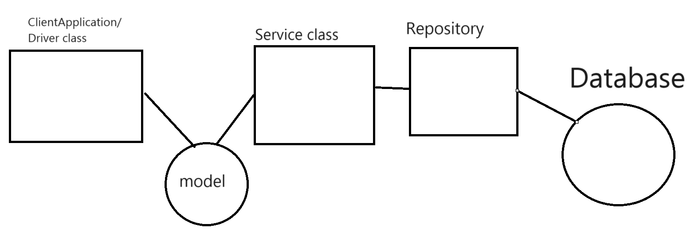

Client Application: ClientApplication means class with main method from user provide the input and get results.

Model: Model class means class with setter and getter method which is used for store data in object and pass to service layer and from service layer pass to repository layer.

Service layer or service class: Service layer or service class is intermediate class which we can use for writing business logics.

Q. What are business logics?
_________________________________________________________________
Business logic may be anything which is dependent on requirement of application

Repository/DAO: Repository is class which is used for write the database query or database logics.

Note: repository class object should be create in service class and repository methods should call from service class and service class object should be create in client application and means service method should call from client and model object also create in client application and pass as parameter to service method from client and from service to repository methods

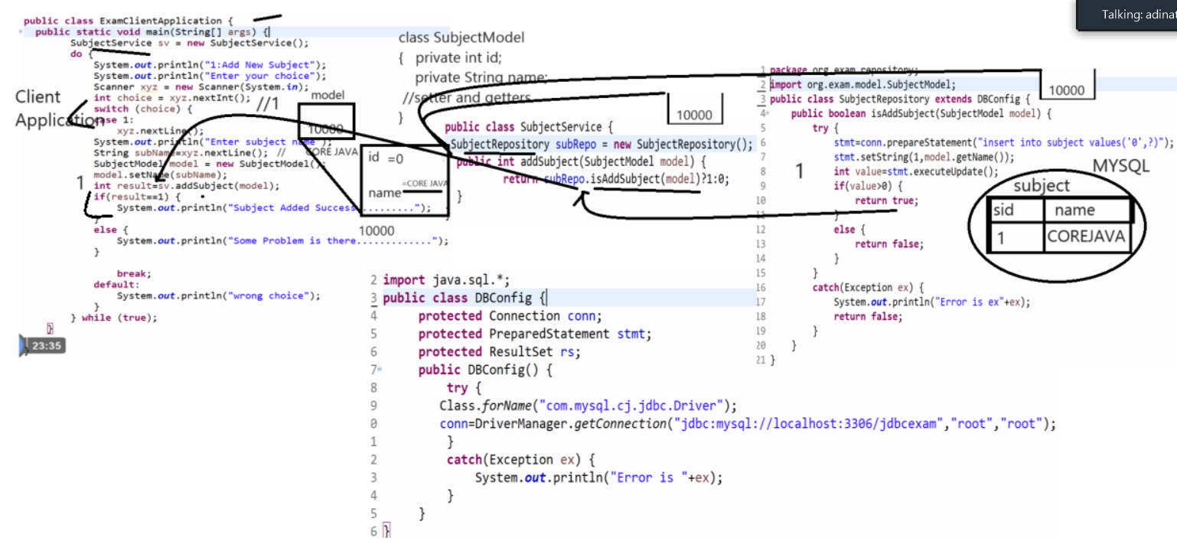

How to load the database credential using .properties file
__________________________________________________________________________________

Q. What is .properties file?
__________________________________________________________________
.properties file is facility in java which is used for store data or store hard coded data required for java application in the form of name and value pair.

Q. Why use .properties file?
Some time if we have hard coded data in application and if your data may be change in future and set your data in java code then drawback is when we want to change data we need to modify java code and again recompile java program and it is not possible every time when your application is running on server so we want to change data hard coded without touching java code as well as without recompile java code then we can set data in .properties file

Note: .properties file use by java developer to write the configuration of java application
Example: database configuration etc

How to store data in .properties file
_____________________________________________________________________
If we want to store data in .properties file we can store in the form of name and value pair.

Syntax: name=value
Example:
driverClassName=com.mysql.cj.jdbc.Driver
userName=root
password=root
url=jdbc:mysql://localhost:3306/jdbcexam

Q. How to load the .properties file in Java Application & get its data?
If we want to load the .properties file Java Application we have Properties class from java.util package

Source code
package org.techhub;
import java.io.FileInputStream;
import java.util.Properties;
import java.io.IOException;
import java.nio.file.FileSystems;
import java.nio.file.Path;
public class PropLoadingApplication {
public static void main(String[] args)throws IOException {
Path currentDirectoryPath = FileSystems.getDefault().getPath("");
String currentDirectoryName = currentDirectoryPath.toAbsolutePath().toString();
String completePath=currentDirectoryName+"\\src\\resources\\db.properties";
System.out.println ("Current Directory = \"" + completePath + "\"");
Properties p = new Properties();
//InputStream
FileInputStream finf = new FileInputStream(completePath);
p.load(finf);
String driverClassName=p.getProperty("driver");
String urlName=p.getProperty("url");
String userName=p.getProperty("user");
String passWord=p.getProperty("pass");
System.out.println(driverClassName);
System.out.println(userName);
System.out.println(passWord);
System.out.println(urlName);
}

}

How to Store CSV file in Database using JDBC?
Q. what is CSV?
_______________________________________________________________
CSV stands for comm separated file means it is simple notepad file and we store data in it by separating commans and if we open this file in excel then every comm consider as column in excel
and new line consider as row in excel.

Q. Why use CSV file?
__________________________________________________________________
1. Upload bulk data in database at time
2. Comma separation consider as column database table
3. It is light weighted format
4. It can open in notepad, wordpad as well as in excel also
5. Not need to use external API for separating data just you can manage data by using string handling

Q. How Create CSV File and store data in it?
________________________________________________________________________
Open notepad and save file using .csv extension and store data in it and separate data by comma
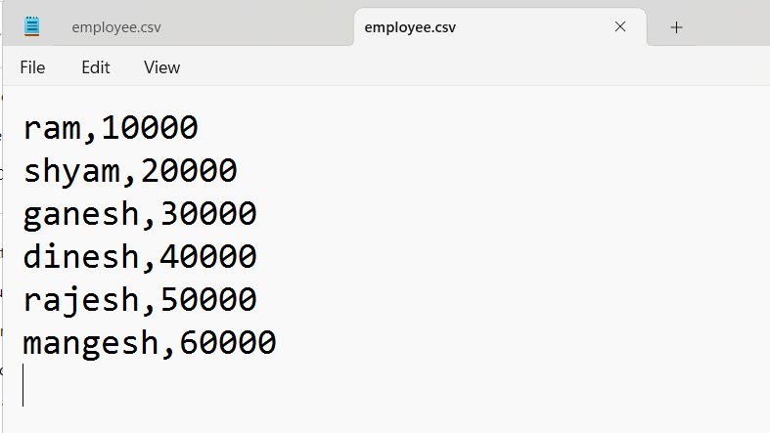

Q. How load CSV file in database using JDBC?
_______________________________________________________________________________

1. Read file in java application by using Reader classes.
Example: You can use BufferedReader class

RowSet | ResultSet
RowSet is present in the javax.sql package | ResultSet is present in the java.sql package
A Row Set can be connected, disconnected from the database. | A ResultSet always maintains the connection with the database.
RowSet is scrollable providing more flexibility | ResultSet by default is always forward only
A Row Set object can be serialized. | It cannot be serialized.
You can pass a Row Set object over the network. | ResultSet object cannot be passed other over the network.
Result Set Object is a JavaBean object.  RowSet using the RowSetProvider.newFactory().createJdb cRowSet() method. | Result Set object is not a JavaBean object  result set using the executeQuery() method
ResultSetBy default, RowSet object is scrollable and updatable. | By default, the ResultSet object is not scrollable or, updatable.
Faster than ResultSet | ResultSet slower than Rowset.

RowSet :
RowSet is an interface in java that is present in the java.sql package. Geek do note not to confuse RowSet with ResultSet.
Note: RowSet is present in package javax.sql while ResultSet is present in package java.sql.
The instance of RowSet is the java bean component because it has properties and a java bean notification mechanism. It is introduced in JDK5. A JDBC RowSet provides a way to store the data in tabular form. It makes the data more flexible and easier than a ResultSet. The connection between the RowSet object and the data source is maintained throughout its life cycle.
RowSets are classified into five categories based on how they are implemented which are listed namely as below:
- JdbcRowSet
- CachedRowSet
- WebRowSet
- FilteredRowSet
- JoinRowSet

The advantage of RowSet is as follows:
- It is easy and flexible to use.
- It is by default scrollable and can be updated by default whereas ResultSet by default is only forwardable and read-only operation is valid there only.
The JDBC RowSet interface is a RowSet extension. It’s a wrapper for the ResultSet object that adds some extra features.
Syntax: Declaration of Jdbc RowSet interface
public interface JdbcRowSet extends RowSet, Joinable

In order to connect RowSet with the database, the RowSet interface provides methods for configuring Java bean properties which are depicted below:
void setURL(String url):
void setUserName(String username):
void setPassword(String password):
Example:
// Java Program to Illustrate RowSet in JDBC
// Importing database
import java.sql.Connection;
import java.sql.DriverManager;
import java.sql.ResultSet;
import java.sql.Statement;
import javax.sql.RowSetEvent;
import javax.sql.RowSetListener;
import javax.sql.rowset.JdbcRowSet;
import javax.sql.rowset.RowSetProvider;

// Main class
class RowSetDemo {
// Main driver method
public static void main(String args[])
{
// Try block to check for exceptions
try {

// Loading and registering drivers
Class.forName("oracle.jdbc.driver.OracleDriver");

// Creating a RowSet
JdbcRowSetrowSet = RowSetProvider.newFactory().createJdbcRowSet();

// Setting URL, username, password
rowSet.setUrl("jdbc:oracle:thin:@localhost:1521:xe");
rowSet.setUsername("root");
rowSet.setPassword("pass");

// Creating a query
rowSet.setCommand("select * from Student");

// Executing the query
rowSet.execute();

// Processing the results
while (rowSet.next()) {
// Print and display commands
System.out.println("RollNo: "+ rowSet.getInt(1));
System.out.println("Name: "+ rowSet.getString(2));
System.out.println("Marks: "+ rowSet.getString(3));
}
}
// Catch block to handle the exceptions
catch (Exception e) {
// Print and display the exception along with
// line number using printStackTrace() method
e.printStackTrace();
}
}
}
Output:
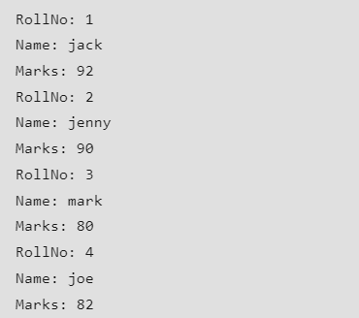

Why would you use setAutoCommit(false) in JDBC?
If you want to turn Off the Auto Commit then set connection.setAutoCommit(false).
Example:
Class.forName(drivers);
Connection dbConnnection=DriverManager.getConnection(connectionURL,username,password);
dbConnection.setAutoCommit(false); //Disabling the Autocommit
Statement selectStatement = dbConnection.createStatement("Select Query");
ResultSet rs = selectStatement.execute();
while(rs.next()){
Statement updateStatement = dbConnection.createStatement("update Query");
//Apply some changes to update record
statement.execute();
dbConnection.commit(); //Mandatory to execute to persist changes into database
}
Disabling Auto-Commit Mode
When a connection is created, it is in auto-commit mode. This means that each individual SQL statement is treated as a transaction and is automatically committed right after it is executed. (To be more precise, the default is for a SQL statement to be committed when it is completed, not when it is executed. A statement is completed when all of its result sets and update counts have been retrieved. In almost all cases, however, a statement is completed, and therefore committed, right after it is executed.)
The way to allow two or more statements to be grouped into a transaction is to disable the auto-commit mode. This is demonstrated in the following code, where con is an active connection: con.setAutoCommit(false);

