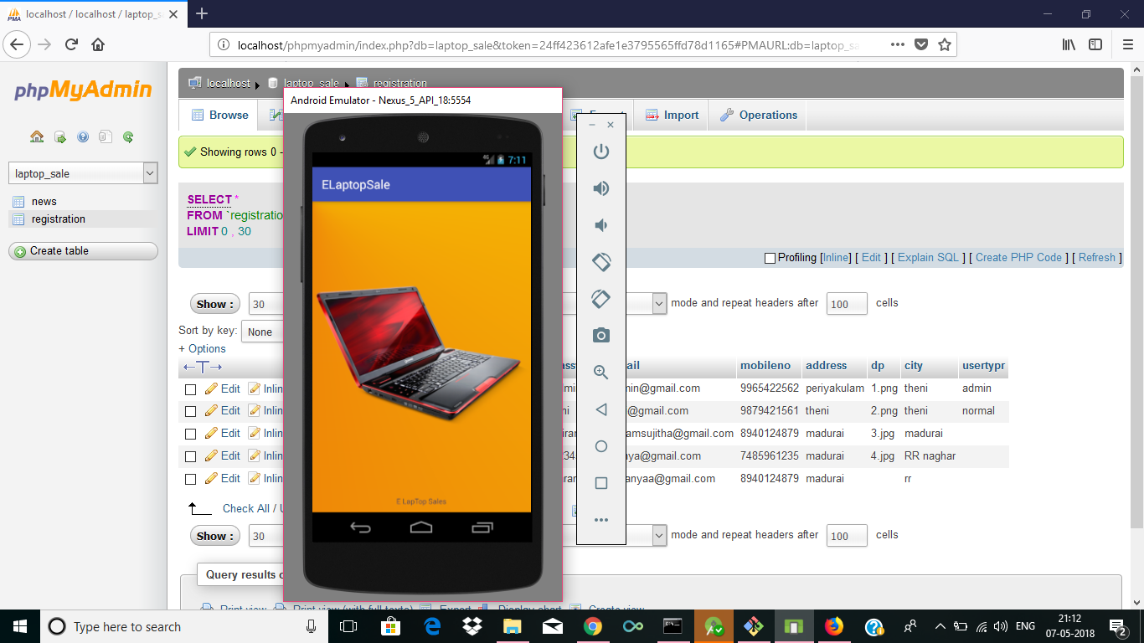

Home page of the application.

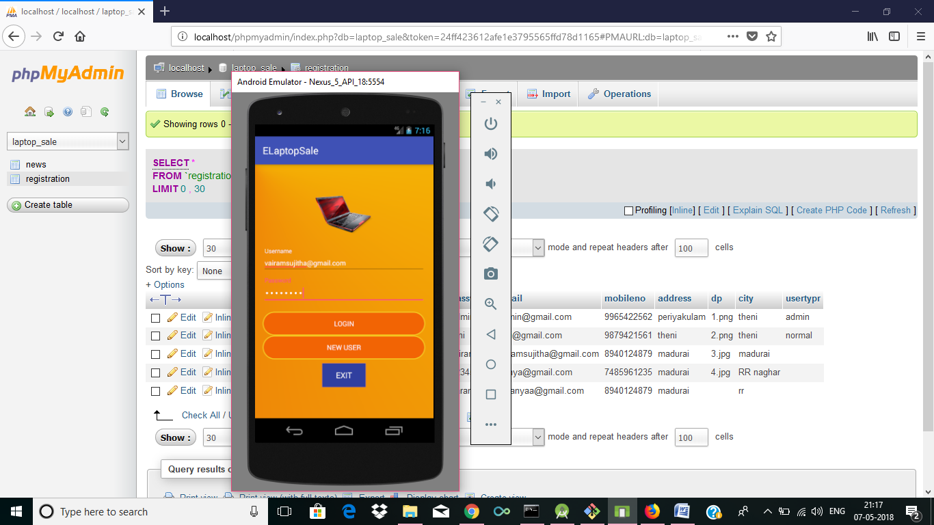

Login page for the existing users.

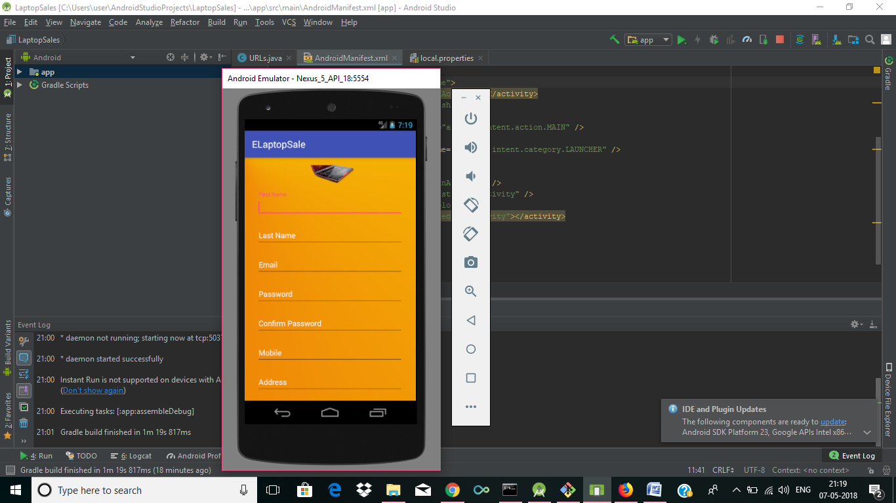

Registration for the new users.

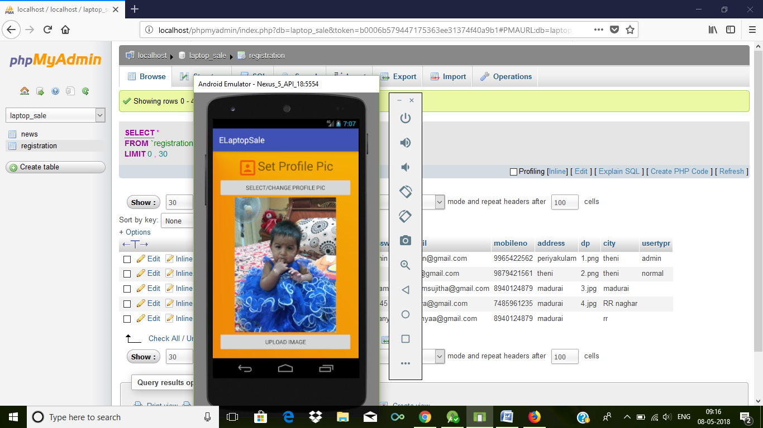

Setting picture for the profile.

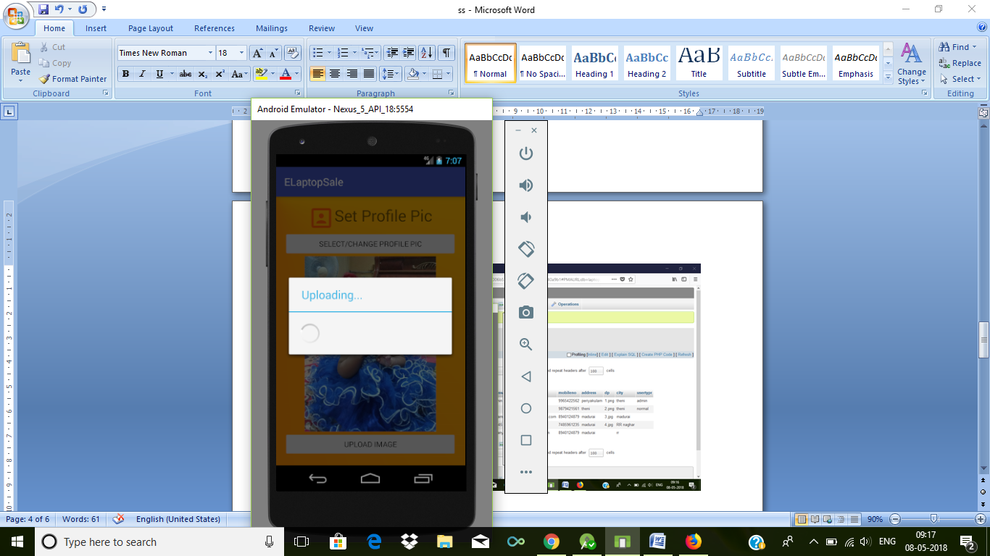

Uploading the profile picture.

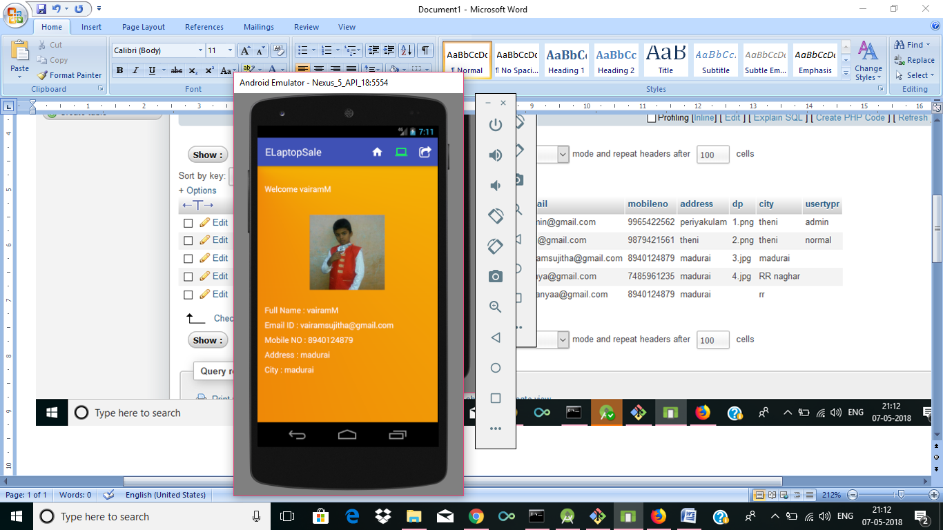

Profile page has been created for the users.

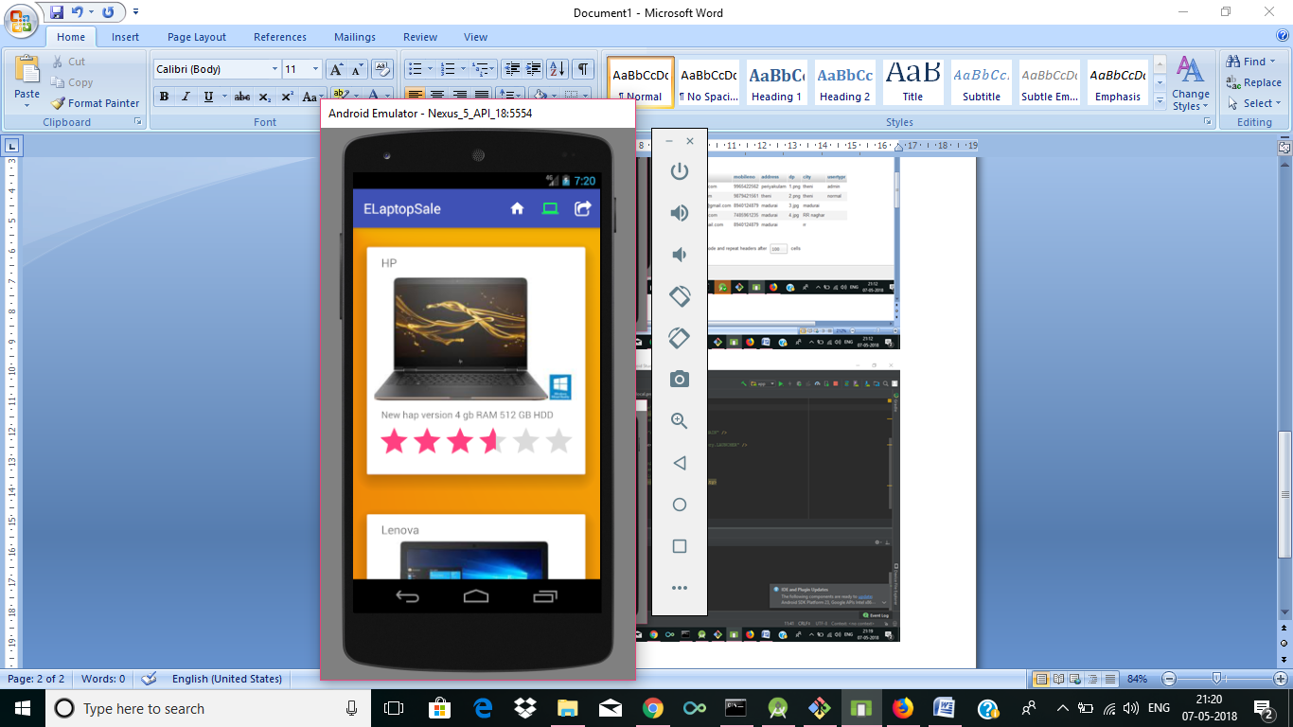

List of laptops can be viewed and purchased according to the ratings.

1 STAR - POOR

2 STAR - FAIR

3 STAR - GOOD

4 STAR - VERY GOOD

5 STAR - EXCELLENT

6 STAR – OUTSTANDING