Data Set Reading
- Take raw_transactions.csv here the Amount is getting Transferred from Source “SG” to “AE” & the amount Value of “50000” is Suspicious.
The raw file is a toy AML dataset, and it is intentionally messy. It contains rows like:
- amount values that are missing or invalid
- transaction_date in mixed formats
- duplicate transaction IDs
- labels written as True False Suspicious Normal etc
transaction_id | amount | source_country | destination_country | transaction_date | is_suspicious
TXN99520 | 50000 | SG | AE | 9/1/2026 | TRUE

Lets use this
df = pd.read_csv("data/raw_transactions.csv")
X = df[["amount"]]
y = df["is_suspicious"]
model = LogisticRegression()
model.fit(X, y)

model = LogisticRegression()
model.fit(X_train, y_train)

The Second line is training based on Amount
So we use Amount and train later we will use other models
In Train_Model.py we will add the Code and check
- Row 1 [1000.0, 1, 0]: A small $1,000 transfer from Singapore to somewhere else. (Low risk: 0.1).
- Row 2 [5000.0, 0, 1]: A medium $5,000 transfer from somewhere else into the UAE. (Medium risk: 0.3).
- Row 3 [12000.0, 1, 1]: A high $12,000 transfer directly from Singapore to the UAE. (High risk: 0.85).
- Row 4 [25000.0, 1, 0]: A massive $25,000 transfer out of Singapore. (Very high risk: 0.9).
- Row 5 [3000.0, 0, 0]: A routine $3,000 transfer between other countries. (Low risk: 0.15).

The Score .765 below is the one that tells how Score got calculated as below and its risky

- Multiply the amount: \(12000 \times 0.00003245 = 0.3894
- Add the baseline: \(-0.0323 + 0.3894 = 0.3571
- Add the Singapore penalty: \(0.3571 + 0.1529 = 0.5100
- Add the UAE penalty: \(0.5100 + 0.2550 = 0.7650
Risk Score=0.765(or 76.5% Risk Penalty)

We had raw_transaction.csv and the data was read , and following JSON file was passed as Input

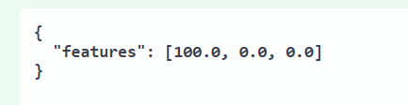

$100 getting transferred from one Country to other Country SG to UAE and the amount here is the one which is Validated

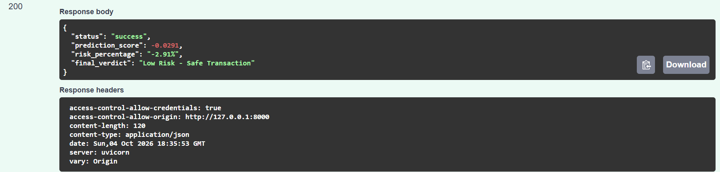

Its within threshold
{
"features": [100.0,0.0,0.0]
}
Another example
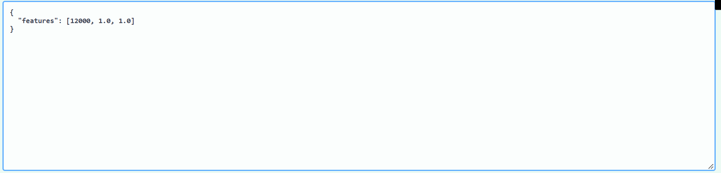

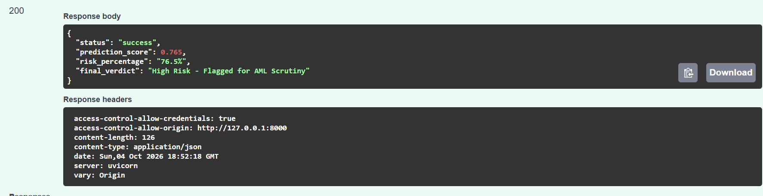

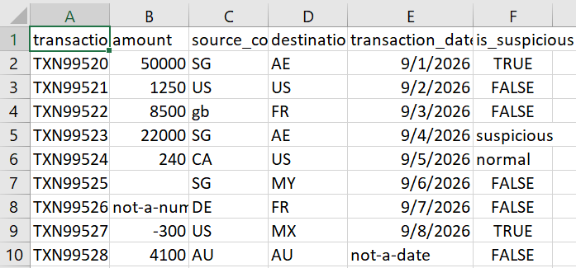

Certain country like AE is high risk that’s why flag suspicious is on if AE and not other country as per AML Transaction rule
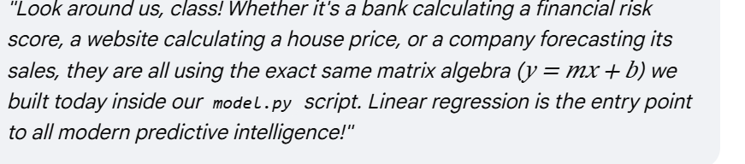

https://www.koenig-solutions.com/blog/10-machine-learning-algorithms-you-need-to-know

