Data Set Reading
- Take raw_transactions.csv here the Amount is getting Transferred from Source “SG” to “AE” & the amount Value of “50000” is Suspicious.
The raw file is a toy AML dataset, and it is intentionally messy. It contains rows like:
- amount values that are missing or invalid
- transaction_date in mixed formats
- duplicate transaction IDs
- labels written as True False Suspicious Normal etc
transaction_id | amount | source_country | destination_country | transaction_date | is_suspicious
TXN99520 | 50000 | SG | AE | 9/1/2026 | TRUE

Lets use this
df = pd.read_csv("data/raw_transactions.csv")
X = df[["amount"]]
y = df["is_suspicious"]
model = LogisticRegression()
model.fit(X, y)

model = LogisticRegression()
model.fit(X_train, y_train)

The Second line is training based on Amount
So we use Amount and train later we will use other models
In Train_Model.py we will add the Code and check
- Row 1 [1000.0, 1, 0]: A small $1,000 transfer from Singapore to somewhere else. (Low risk: 0.1).
- Row 2 [5000.0, 0, 1]: A medium $5,000 transfer from somewhere else into the UAE. (Medium risk: 0.3).
- Row 3 [12000.0, 1, 1]: A high $12,000 transfer directly from Singapore to the UAE. (High risk: 0.85).
- Row 4 [25000.0, 1, 0]: A massive $25,000 transfer out of Singapore. (Very high risk: 0.9).
- Row 5 [3000.0, 0, 0]: A routine $3,000 transfer between other countries. (Low risk: 0.15).

The Score .765 below is the one that tells how Score got calculated as below and its risky

- Multiply the amount: \(12000 \times 0.00003245 = 0.3894
- Add the baseline: \(-0.0323 + 0.3894 = 0.3571
- Add the Singapore penalty: \(0.3571 + 0.1529 = 0.5100
- Add the UAE penalty: \(0.5100 + 0.2550 = 0.7650
Risk Score=0.765(or 76.5% Risk Penalty)

We had raw_transaction.csv and the data was read , and following JSON file was passed as Input

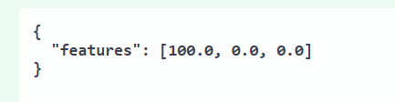

$100 getting transferred from one Country to other Country SG to UAE and the amount here is the one which is Validated

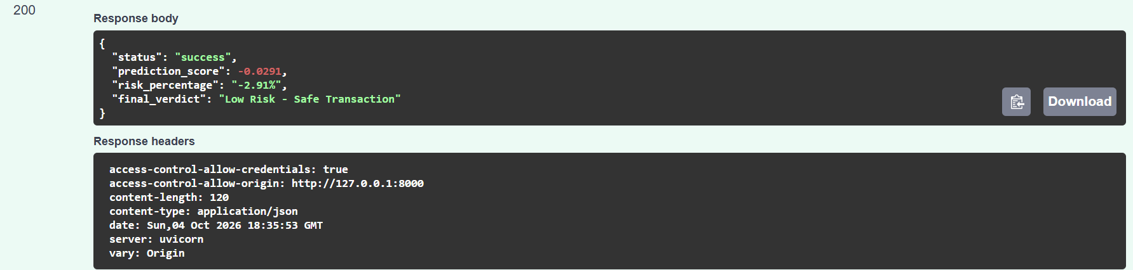

Its within threshold
Another example
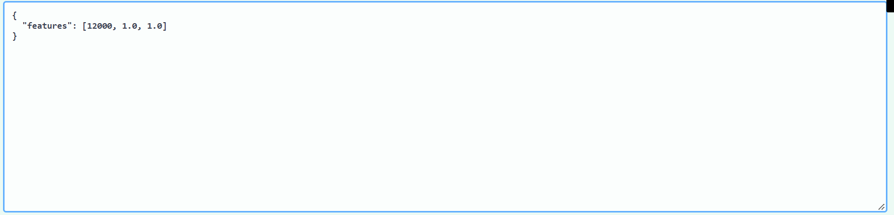

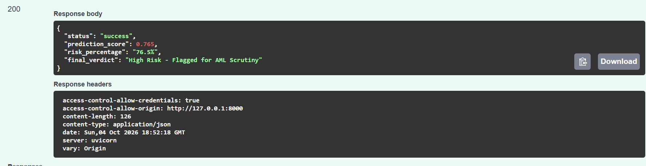

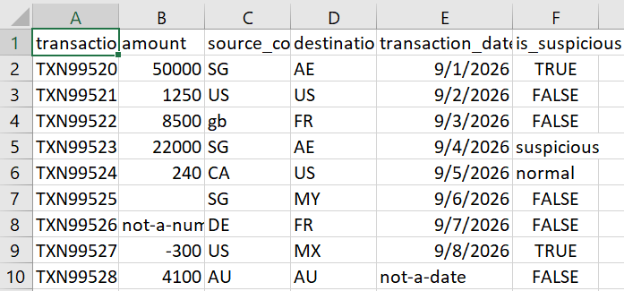

Certain country like AE is high risk that’s why flag suspicious is on if AE and not other country as per AML Transaction rule
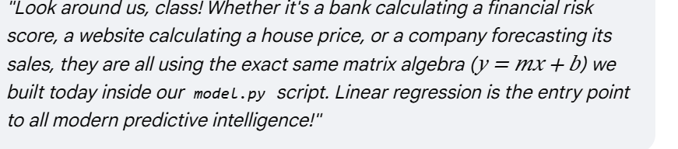

https://www.koenig-solutions.com/blog/10-machine-learning-algorithms-you-need-to-know

