

TUTORIAL 1

SPRING BOOT TUTORIAL 1

1. INTRODUCTION 4

CREATING SPRING BOOT APPLICATION 5

2. SPRING BOOT EXAMPLES 7

1. SPRING BOOT WITH MAVEN AND ECLIPSE EXAMPLE 7

2. SPRING BOOT WITH SPRING INITIALIZR EXAMPLE 11

3. SPRING BOOT –CONFIGURATIONS 18

HOW TO CHANGE SPRING BOOT BANNER TEXT 18

APPLICATION.PROPERTIES 18

4. SPRING BOOT –MVC 20

SPRING BOOT MVC EXAMPLE 20

SPRING BOOT –RESTFUL WEB SERVICE EXAMPLE 24

5. SPRING BOOT –DATABASE 26

SPRING BOOT –JDBC EXAMPLE 26

SPRING BOOT –JPA EXAMPLE 31

JPAREPOSITORY 34

SPRING BOOT –MONGODB REST EXAMPLE 39

REFERENCES 41

3|PAGE

Spring Boot Tutorial

Spring Boot Tutorial provides basic and advanced concepts of Spring Framework. Our Spring Boot Tutorial is designed for beginners and professionals both.
Spring Boot is a spring module that provides the RAD (Rapid Application Development) feature to the spring framework.
Our Spring Boot Tutorial includes all topics of Spring Boot such, as features, project, maven project, starter project wizard, Spring Initializer, CLI, applications, annotations, dependency management, properties, starters, Actuator, JPA, JDBC, etc.

What is Spring Boot
Spring Boot is a project that is built on the top of the Spring Framework. It provides an easier and faster way to set up, configure, and run both simple and web-based applications.
It is a spring module that provides the RAD (Rapid Application Development) feature to the Spring Framework. It is used to create a stand-alone Spring-based application that you can just run because it needs minimal spring configuration.
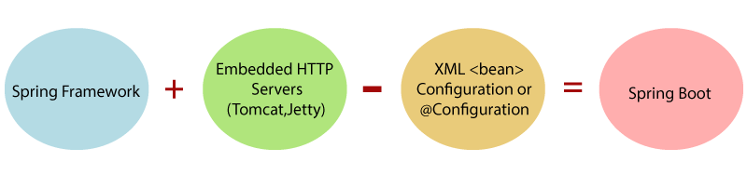
In short, Spring Boot is the combination of Spring Framework and Embedded Servers.
In Spring Boot, there is no requirement for XML configuration (deployment descriptor). It uses convention over configuration software design paradigm that means it decreases the effort of the developer.
We can use Spring STS IDE or Spring Initializr to develop Spring Boot Java applications.
1. Introduction

Spring Boot makes it easy to create stand-alone, production-grade Spring based Applications that you can "just run".


Spring vs SpringBoot

Spring: Spring started as a lightweight alternative to Java Enterprise Edition (J2EE). Spring offered a simpler approach to enterprise Java development, utilizing dependency injection and aspect-oriented programming to achieve the capabilities of EJB with plain old Java objects (POJOs).

But while spring was lightweight in terms of component code, it was heavyweight in terms of configuration. Initially, spring was configured with XML & Spring 2.5 introduced annotation-based component-scanning, even so, there was no escape from configuration.

Spring boot: project is just a regular spring project that happens to leverage Spring Boot starters and auto-configuration. Spring Boot is not a framework, it is a way to ease to create stand-alone application with minimal or zero configurations.

Finally, Spring Boot is just spring. Spring projects would not have any XML configurations as part of it, everything will be handled by the project Spring Boot.


- Create stand-alone Spring applications

- Embed Tomcat, Jetty or Undertow directly (no need to deploy WAR files)

- Provide opinionated 'starter' POMs to simplify your Maven configuration

- Automatically configure Spring whenever possible

- Provide production-ready features such as metrics, health checks and externalized configuration

- Absolutely no code generation and no requirement for XML configuration

We can develop two flavors of Spring-Based Applications using Spring Boot

- Java-Based Applications

- Groovy Application

4|PAGE
Groovy is also JVM language almost similar to Java Language. We can combine both Groovy and Java into one Project. Because like Java files, Groovy files are finally compiled into *.class files only. Both

*.groovy and *.java files are converted to *.class file (Same byte code format).
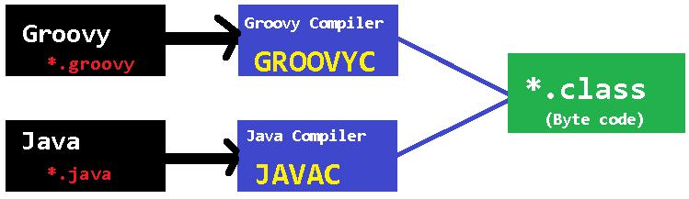

Spring Boot Framework Programming model is inspired by Groovy Programming model. Spring Boot internally uses some Groovy based techniques and tools to provide default imports and configuration.

Creating Spring Boot Application

To create Spring Boot based applications The Spring Team (The Pivotal Team) has provided the following three approaches.

- Using Maven

- Using Spring Initializer (http://start.spring.io/)

- Using Spring STS IDE

- Using Spring Boot CLI Tool


1. Spring Boot using Maven

Add maven dependencies in pom.xml & do maven build

<project>
<parent>

<groupId>org.springframework.boot</groupId>

<artifactId>spring-boot-starter-parent</artifactId> <version>1.5.6.RELEASE</version>
</parent>

<dependencies>
<dependency>
<groupId>org.springframework.boot</groupId>

<artifactId>spring-boot-starter-web</artifactId> </dependency>

</dependencies>

<properties>
<java.version>1.8</java.version>
</properties>

</project>

5|PAGE

2.Spring Initializer

Spring Initializer provides an extensible API to generate quick start projects. It also provides a configurable service: you can see our default instance at https://start.spring.io. It provides a simple web UI to configure the project to generate and endpoints that you can use via plain HTTP.
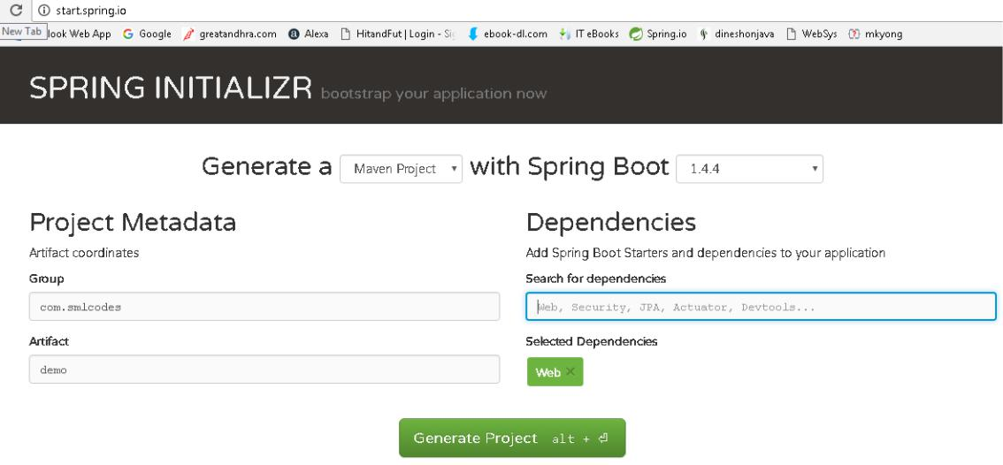

It will generate the Artifact.zip file, extract it and run maven build: mvn clean install package

[INFO] --- spring-boot-maven-plugin:1.4.4.RELEASE:repackage (default) @ SpringBootDemo ---
[INFO] ------------------------------------------------------------------------
[INFO] BUILD SUCCESS

[INFO] ------------------------------------------------------------------------
[INFO] Total time: 01:27 min
[INFO] Finished at: 2017-01-30T18:55:21+05:30
[INFO] Final Memory: 27M/160M

[INFO] ------------------------------------------------------------------------


3.Spring STS IDE

The Spring Tool Suite is an Eclipse-based development environment that is customized for developing spring applications. We can download it from here.
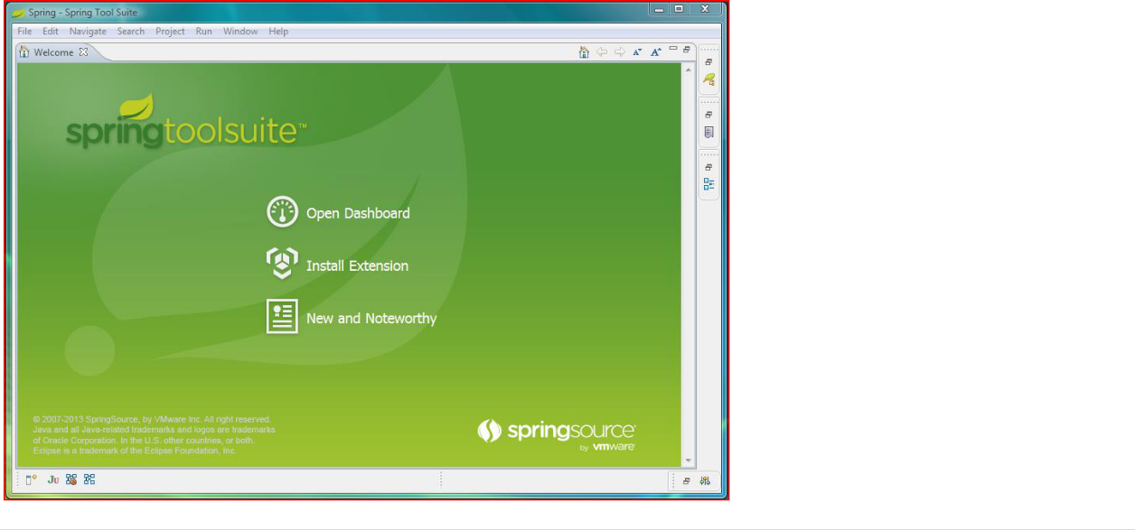

6|PAGE

4.Spring Boot CLI Tool

The Spring Boot CLI is a command line tool that can be used if you want to quickly prototype (creates project Structure) with Spring. It allows you to run Groovy scripts, which means that you have a familiar Java-like syntax, without so much boilerplate code.

You don’t need to use the CLI to work with Spring Boot but it’s definitely the quickest way to get a spring application off the ground.

You can download the Spring CLI distribution from the Spring software repository:

- spring-boot-cli-1.5.0.RELEASE-bin.zip

- spring-boot-cli-1.5.0.RELEASE-bin.tar.gz

SDKMAN! (The Software Development Kit Manager) can be used for managing multiple versions of various binary SDKs, including Groovy and the Spring Boot CLI. Get SDKMAN! from sdkman.io and install Spring Boot with

$ sdk install springboot
$ spring --version

Spring Boot v1.5.0.RELEASE

A simple web application that you can use to test your installation. Create a file called app.groovy as

$ spring run app.groovy

It will take some time when you first run the application as dependencies are downloaded. Subsequent runs will be much quicker.

2. Spring Boot Examples

1.Spring Boot with maven and Eclipse Example
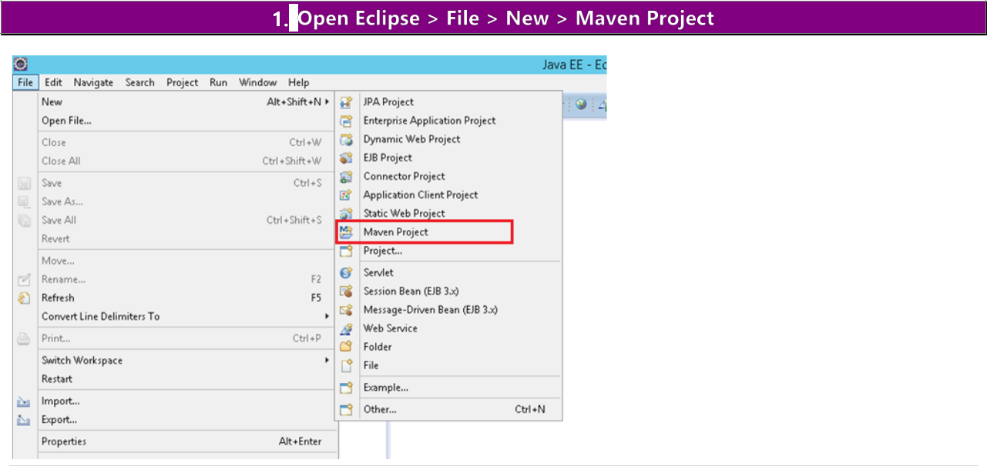

7|PAGE
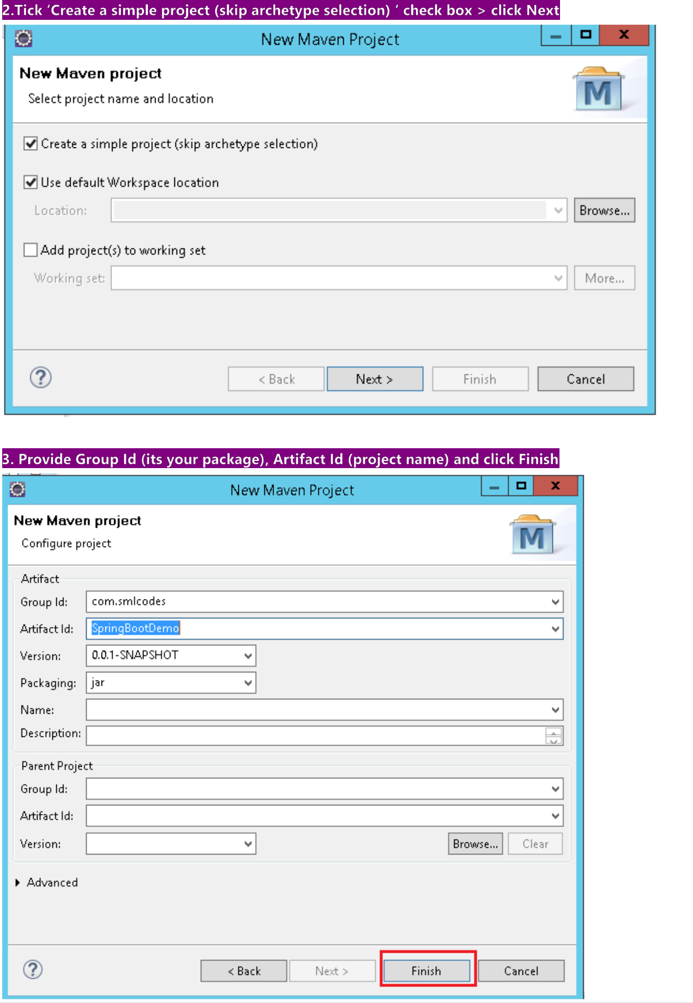

8|PAGE
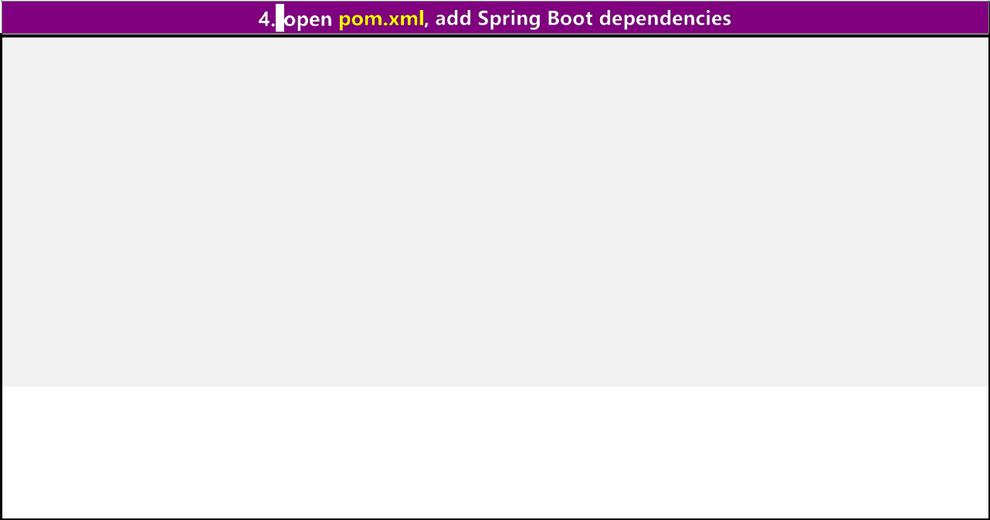
<project>

<modelVersion>4.0.0</modelVersion>
<groupId>com.smlcodes</groupId>

<artifactId>SpringBootDemo</artifactId>
<version>0.0.1-SNAPSHOT</version>
<parent>
<groupId>org.springframework.boot</groupId>

<artifactId>spring-boot-starter-parent</artifactId> <version>1.5.6.RELEASE</version>

</parent>

<dependencies>
<dependency>
<groupId>org.springframework.boot</groupId>

<artifactId>spring-boot-starter-web</artifactId> </dependency>

</dependencies>

<properties>
<java.version>1.8</java.version>

</properties>

</project>

- spring-boot-starter-parent: is an existing project given by spring team which contains Spring Boot supporting configuration data (just configuration data, it won’t download any jars), we have added this in a <parent> tag means, we are instructing Maven to consider
our SpringBootHelloWorld project as a child to it

- spring-boot-starter-web: Starter for building web, including RESTful, applications using Spring MVC. Uses Tomcat as the default embedded container

if you observe the directory structure of the project, it will create a new folder named “Maven Dependencies” which contains all supporting. jars to run the Spring Boot application and the Java version also changed to 1.8.
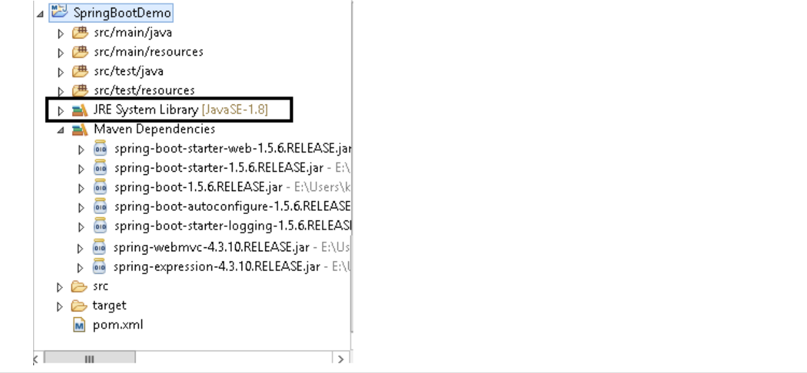

9|PAGE
- If you observe pom.xml, we haven’t included version number for spring-boot-starter-web but maven downloaded some jar files with some version(s) related to spring-boot-starter-web, that’s because of Maven’s parent child relation.

- While adding spring boot parent project, we included version as 1.5.6.RELEASE, so again we no need to add version numbers for the dependencies. As we know spring-boot-starter-parent contains configuration Meta data, this means, it knows which version of dependency need to be downloaded. So we no need to worry about dependencies versions. It will save lot of our time.
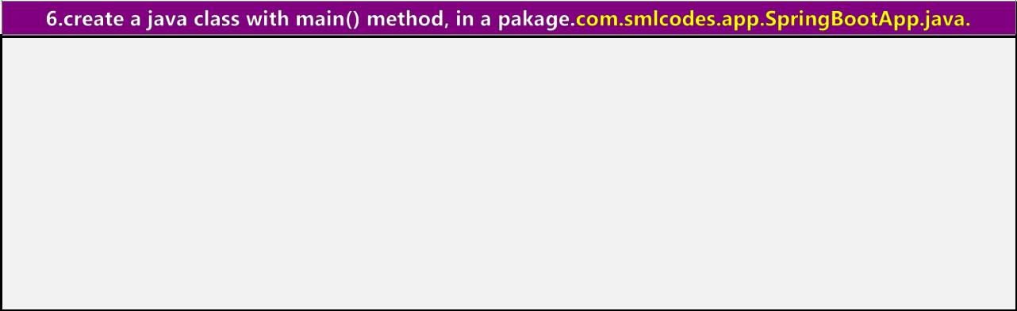

package com.smlcodes.app;

import org.springframework.boot.SpringApplication;

import org.springframework.boot.autoconfigure.SpringBootApplication;

@SpringBootApplication
public class SpringBootApp {

public static void main(String[] args) { SpringApplication.run(SpringBootApp.class, args); System.out.println("****\n Hello, World \n ***");

}

}

- @SpringBootApplication annotation, is the starting point for our Spring Boot application

- SpringApplication.run(SpringBootApp.class, args); it will bootstrapping the application
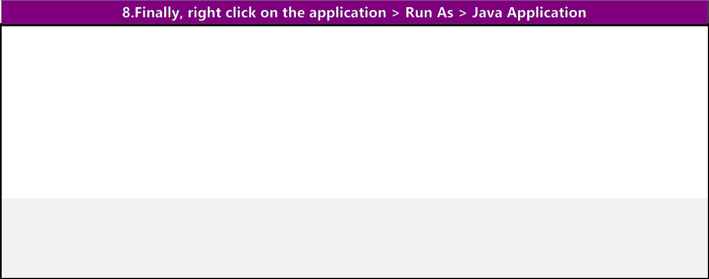

. | ____ | _ | ____
/\\ / ___'_ __ _ _(_)_ __ __ _ \ \ \ \
(()\___|'_|'_||'_\/_`|\\\\
\\/ | ___)||_)|||||||(_|| ))))
' | |____| .__|_| |_|_| |_\__, | / / / /
=========|_|==============|___/=/_/_/_/
:: Spring Boot :: |  |  | (v1.5.6.RELEASE)
2017-09-11 |  | 16:04:04.006 | INFO 6724 --- [ | main]
com.smlcodes.app.SpringBootApp |  |  |  | : Starting SpringBootApp on HYDPCMCSTS with PID 6724
2017-09-11 |  | 16:04:13.444 | INFO 6724 --- [ | main]
com.smlcodes.app.SpringBootApp |  |  |  | : Started SpringBootApp in 10.738 seconds (JVM
running for 12.252)
************
Hello, World

*****************

10|PAGE
2.Spring Boot with Spring Initializr Example

We are using Spring Initializer (https://start.spring.io) to create a template for spring boot application

- Go to https://start.spring.io , Choose Dependencies & Generate Project. Here we are not selecting any dependencies because it is just a Hello world program
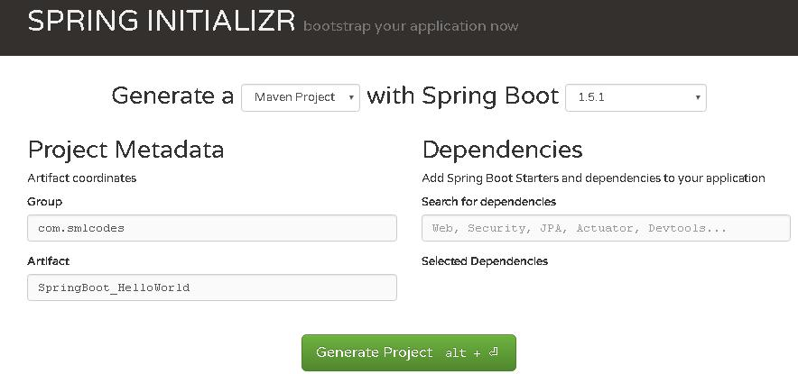

2. Open Eclipse, import→ Maven →Existing Maven Projects → Select Project →Finish
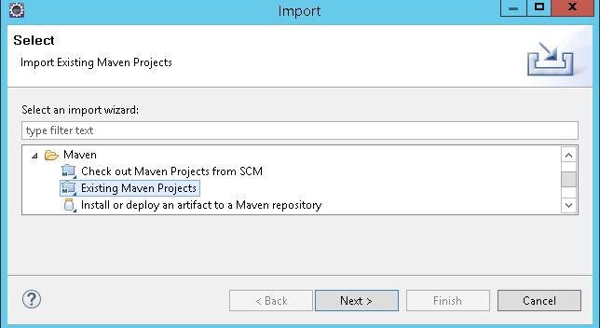

3. The Project structure will be as follows if we open eclipse Package explorer
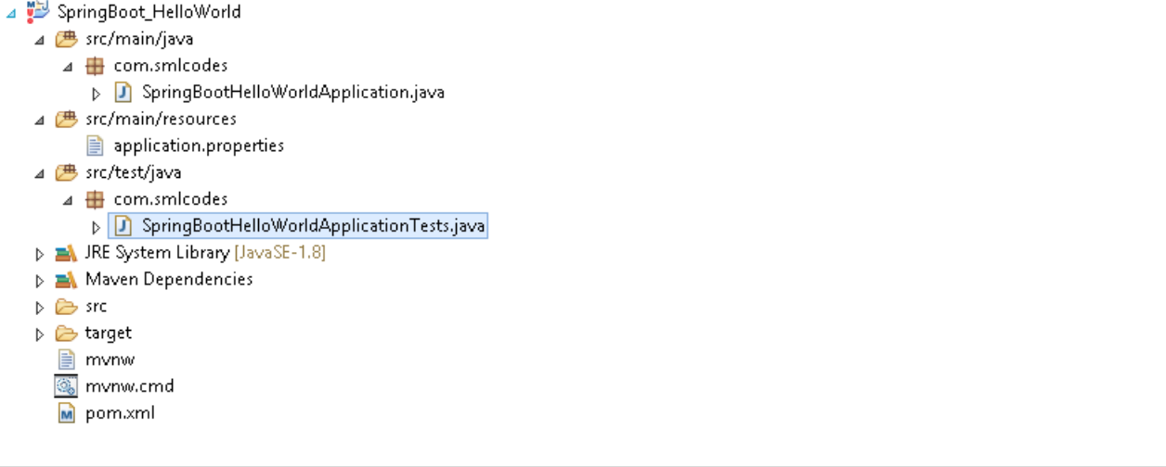

11|PAGE

- If we open the pom.xml it contains only basic dependencies like spring-boot-starter which allows start spring boot application

<dependencies>
<dependency>
<groupId>org.springframework.boot</groupId>

<artifactId>spring-boot-starter</artifactId>
</dependency>
<dependency>
<groupId>org.springframework.boot</groupId>

<artifactId>spring-boot-starter-test</artifactId> <scope>test</scope>

</dependency>

</dependencies>

5. Select Project, Right click Run as→ maven install to download and install the dependencies.
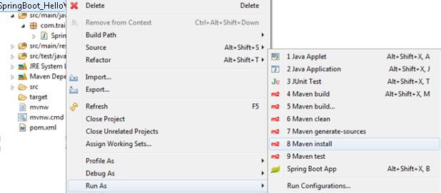

- Spring boot generates the default java class which contains main() method. The main method calls the run method of SpringApplication. This run method bootstraps the application starting spring which will run the embedded Tomcat Server. Let’s add some helloworld message to print

package com.smlcodes;
import org.springframework.boot.SpringApplication;

import org.springframework.boot.autoconfigure.SpringBootApplication;

@SpringBootApplication
public class SpringBootHelloWorldApplication {
public static void main(String[] args) {

SpringApplication.run(SpringBootHelloWorldApplication.class, args);
System.out.println("============================================");
System.out.println("Hello World, Spring Boot!!!!");
System.out.println("============================");
}

}

12|PAGE
7. Select the Java file and right click RunAs → Java Application

/\\ / ___'_ __ _ _(_)_ __ __ _ \ \ \ \
(()\___|'_|'_||'_\/_`|\\\\

\\/ ___)||_)|||||||(_|| ))))
' |____| .__|_| |_|_| |_\__, | / / / /
=========|_|==============|___/=/_/_/_/
:: Spring Boot :: (v1.5.1.RELEASE)
2017-01-31 11:05:32.745 INFO 29596 --- [ main]

s.c.a.AnnotationConfigApplicationContext : Refreshing org.springframework.context.annotation.AnnotationConfigApplicationContext@646007f4: startup date [Tue Jan 31 11:05:32 IST 2017]; root of context hierarchy

2017-01-31 | 11:05:43.108 | INFO | 29596 | --- [ | main]
o.s.j.e.a.AnnotationMBeanExporter |  |  |  |  | : Registering beans for JMX exposure on startup
2017-01-31 | 11:05:43.200 | INFO | 29596 | --- [ | main]
c.s.SpringBootHelloWorldApplication |  |  |  |  | : Started SpringBootHelloWorldApplication in 12.855
seconds (JVM running for |  | 16.094)

============================================ Hello World, Spring Boot!!!! ============= ===============

- We can also run this application from the command line using the jar file that is generated. To get the jar file, select pom.xml right click RunAs → Maven Build (2nd one), goals=package, Apply & Run
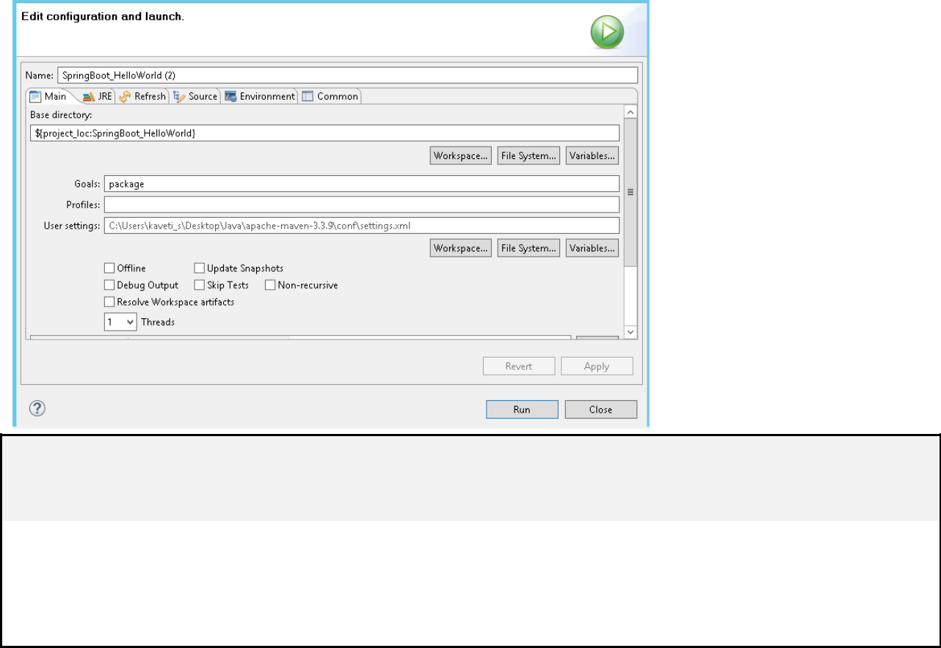

[INFO] Scanning for projects
[INFO] --------------------------------------------------------------------
[INFO] Building SpringBoot_HelloWorld 0.0.1-SNAPSHOT
[INFO] ----------------------------------------------------------------------

C:\Users\kaveti_s\Desktop\Downloads\SpringBoot_HelloWorld\SpringBoot_HelloWorld\target\SpringB oot_HelloWorld-0.0.1-SNAPSHOT.jar

[INFO] --- spring-boot-maven-plugin:1.5.1.RELEASE:repackage (default) @ SpringBoot_HelloWorld
[INFO] -------------------------------------------------------------------
[INFO] BUILD SUCCESS

[INFO] -------------------------------------------------------------------

- Open command line and go to the folder where your project is located. Next, move to the target folder and then type java -jar <<filename>>.jar.

java -jar SpringBoot_HelloWorld-0.0.1-SNAPSHOT.jar

13|PAGE
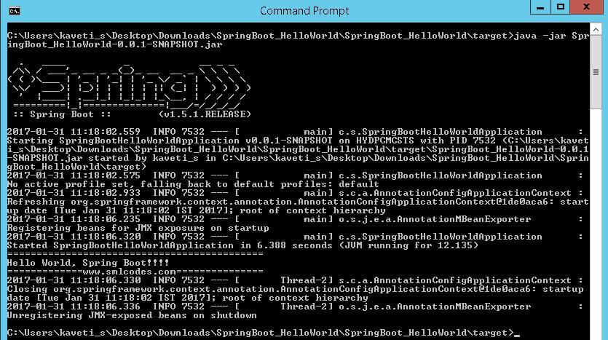

- We place the all the required Spring boot starters in pom.xml which are requires for implementing Spring Boot application. On loading project, the all required starter dependencies are added automatically to the project

- By running Spring Boot main class, at @SpringBootApplication line it will do the Auto configuration things, it will automatically add all required annotations to Java Class ByteCode.

- On Executing main() method SpringApplication.run() used to bootstrap and launches Spring Boot application.


1. Spring Boot Starters

Spring boot Starters are the one-stop-shop for all the Spring and related technology that we need. For example, if you want to get started using Spring and JPA for database access, just include the spring-boot-starter-data-jpa dependency in your project, and you are good to go.

All official starters follow a similar naming pattern; spring-boot-starter-*, where * is a particular type of application. The following are the some of the application starters are provided by Spring Boot under the org.springframework.boot group

14|PAGE
 |  | Name |  |  |  |  |  |  |  |  |  |  |  |  |  | Description
 |  |  |  |  |  |  |  |  |  |  |  |  |  |  | Starter for using Spring Web Services
 | spring-boot-starter-web-services
 |  |  |  |  |  |  |  |  |  |  |  |  |  |  | Starter for building web, including RESTful, applications using Spring
 | spring-boot-starter-web
 |  |  |  |  |  |  |  |  |  |  |  |  |  |  | MVC. Uses Tomcat as the default embedded container
 |  |  |  |  |  |  |  |  |  |  |  |  |  |  | Starter for testing Spring Boot applications with libraries including
 | spring-boot-starter-test
 |  |  |  |  |  |  |  |  |  |  |  |  |  |  | JUnit, Hamcrest and Mockito
 |  |  |  |  |  |  |  |  |  |  |  |  |  |  | Starter for using JDBC with the Tomcat JDBC connection pool
 | spring-boot-starter-jdbc
 |  |  |  |  |  |  |  |  |  |  |  |  |  |  | Starter for building RESTful web applications using JAX-RS and Jersey.
 | spring-boot-starter-jersey
 |  |  |  |  |  |  |  |  |  |  |  |  |  |  | An alternative to |  |  | spring-boot-starter-web
 |  |  |  |  |  |  |  |  |  |  |  |  |  |  | Aspect-oriented programming with Spring AOP and AspectJ
 | spring-boot-starter-aop
 |  |  |  |  |  |  |  |  |  |  |  |  |  |  | Starter for using Spring Security
 | spring-boot-starter-security
 |  |  |  |  |  |  |  |  |  |  |  |  |  |  | Starter for using Spring Data JPA with Hibernate
 | spring-boot-starter-data-jpa
 |  |  |  |  |  |  |  |  |  |  |  |  |  |  | Core starter, including auto-configuration support, logging,YML
 | spring-boot-starter

In above Example we used spring-boot-starter & spring-boot-starter-test Starters which are configure in pom.xml

<dependencies>
<dependency>

<groupId>org.springframework.boot</groupId>
<artifactId>spring-boot-starter</artifactId>
</dependency>

<dependency>
<groupId>org.springframework.boot</groupId>
<artifactId>spring-boot-starter-test</artifactId>
<scope>test</scope>
</dependency>
</dependencies>

2.@SpringBootApplication Annotation

This annotation marks the class as a spring bean, configures the application by adding all the jars based on the dependencies and also scans the other packages for spring beans.

Spring Boot developers always have their main class annotated with @Configuration, @EnableAutoConfiguration and @ComponentScan.

1. @Configuration – Specifies this class as a spring bean

- @EnableAutoConfiguration – This tells how you want to configure Spring, based on the jar dependencies that you have added. & also Enable / Disable auto configuration

3. | @ComponentScan |  | – is to scan other packages for spring beans.
4. |  |  | - used to import additional configuration classes
4. | @Import
5. |  |  |  | annotation to load XML configuration files
5. | @ImportResource |  | - | annotation to load XML configuration files

15|PAGE
import org.springframework.boot.SpringApplication;

import org.springframework.boot.autoconfigure.EnableAutoConfiguration; import org.springframework.context.annotation.ComponentScan; import org.springframework.context.annotation.Configuration;

@Configuration
@EnableAutoConfiguration
@ComponentScan

public class Application {

public static void main(String[] args) { SpringApplication.run(Application.class, args);

}
}

Since these annotations are so frequently used together Spring Boot provides a convenient @SpringBootApplication as an alternative. The @SpringBootApplication annotation is equivalent to

using @Configuration, @EnableAutoConfiguration and @ComponentScan with their default attributes.

The original @SpringBootApplication annotation class is defined as below

package org.springframework.boot.autoconfigure; @Target(ElementType.TYPE)
@Retention(RetentionPolicy.RUNTIME)
@Documented
@Inherited

@Configuration
@EnableAutoConfiguration
@ComponentScan
public @interface SpringBootApplication {
Class<?>[] exclude() default {};

String[] excludeName()default{};

@AliasFor(annotation = ComponentScan.class, attribute = "basePackages")
String[] scanBasePackages() default {};

@AliasFor(annotation = ComponentScan.class, attribute = "basePackageClasses") Class<?>[] scanBasePackageClasses()default{};

}


3 SpringApplication Class

SpringApplication class is used to bootstrap and launch a Spring application from a Java main method. By default, class will perform the following steps to bootstrap your application:

- Create an appropriate ApplicationContext instance (depending on your classpath)

- Register a CommandLinePropertySource to expose command line arguments as Spring properties

- Refresh the application context, loading all singleton beans

- Trigger any CommandLineRunner beans

In most circumstances the static run(Object, String[]) method can be called directly from your main method to bootstrap your application:

public static void main(String[] args) { SpringApplication.run(MySpringConfiguration.class, args);

}

16|PAGE

4. Embaded Servlet containers

The following embedded servlet containers are supported out of the box.By default we will get Tomcat

 | Name |  |  | Servlet Version |  |  | Java Version
Tomcat 8 |  |  | 3.1 |  |  |  | Java 7+
 | Tomcat 7 |  |  | 3.0 |  |  | Java 6+
Jetty 9.3 |  |  | 3.1 |  |  |  | Java 8+
 | Jetty 9.2 |  |  | 3.1 |  |  | Java 7+
Jetty 8 |  |  | 3.0 |  |  |  | Java 6+
 | Undertow 1.3 |  |  | 3.1 |  |  | Java 7+

5. Spring Boot Profiles (@Profile Annotation)

Spring Profiles provide a way to segregate parts of your application configuration and make it only available in certain environments. Any @Component or @Configuration can be marked with @Profile to limit when it is loaded

@Configuration
@Profile("production")
public class ProductionConfiguration {

// ...

}

In the normal Spring way, you can use a spring.profiles.active Environment property to specify which profiles are active. You can specify the property in any of the usual ways, for example you could include it in your application.properties:spring.profiles.active=dev,hsqldb or specify on the command line using the switch --spring.profiles.active=dev,hsqldb.


6. Spring Boot Actuator

Spring Boot provides actuator to monitor and manage our application. Actuator is a tool which has HTTP endpoints. When application is pushed to production, you can choose to manage and monitor your application using HTTP endpoints.

To get production-ready features, we should use spring-boot-actuator module. We can enable this feature by adding it to the pom.xml file.

<dependencies>
<dependency>

<groupId>org.springframework.boot</groupId> <artifactId>spring-boot-starter-actuator</artifactId>

</dependency>

</dependencies>

17|PAGE
3. Spring Boot –Configurations

How to change Spring Boot Banner Text

The banner that is printed on startup can be changed by adding a banner.txt file to src\main\resources folder or your classpath, or by setting banner.location to the location of such a file.

You can also add a banner.gif, banner.jpg or banner.png image file to your classpath, or set a

banner.image.location property. Images will be converted into an ASCII art representation and printed above any text banner.

//Default Banner
. | ____ | _ | ____
/\\ / ___'_ __ _ _(_)_ __ |  |  | ___\\\\
(()\___|'_|'_||'_\/_`|\\\\
\\/ | ___)| |_)| | | | | || (_| | |  |  | ))))
' | |____| .__|_| |_|_| |_\__, | / / / /
=========|_|==============|___/=/_/_/_/
:: Spring Boot :: |  |  | (v1.5.1.RELEASE)
2017-02-01 14:07:22.957 |  | INFO 72716 --- [ |  | main] c.s.SpringBootHelloWorldApplication

- Go to any ANCII Text generator website & generate your logo. for ex: http://patorjk.com/

- Create banner.txt under Proj_Home\src\main\resources, paste the logo text

- Refresh the project & run Spring Boot Application.the banner will change as below

2017-02-01 14:07:22.957 INFO 72716 --- [ main]
c.s.SpringBootHelloWorldApplication

application.properties

Spring Boot provides a very neat way to load properties for an application. we can define properties in application.properties (PROJ_HOME\src\main\resources\application.properties) file the following way

db.name=smlcodesdb
db.username=smlcodes

db.password=wEB20R1XPJtg9

In traditional Spring application would have loaded up the properties in the following way

public class SmlcodesPropTest {
@Value("${db.name}") //dbname is KEY here

private String dbname;

@Value("${db. username }")

private String server_port;

18|PAGE
In Spring boot it takes application.properties file to define a bean that can hold all the related properties in following way

@ConfigurationProperties(prefix = "db")
@Component
public class DBConfig {

public String dbname;
public String username;
public String password;

public String getDbname() {
return dbname;
}
public void setDbname(String dbname) {
this.dbname = dbname;
}

public String getUsername() {

return username;
}
public void setUsername(String username) {
this.username = username;

}
public String getPassword() {
return password;
}
public void setPassword(String password) {
this.password = password;

}

}

@ConfigurationProperties is used to bind and validate some external Properties. If we want to validate before going to use, we have to place @Validated & place type of validation on the filed

@ConfigurationProperties(prefix="foo")
@Validated

public class FooProperties {

@NotNull
private InetAddress remoteAddress;

// ... getters and setters

}

19|PAGE
4. Spring Boot –MVC

In old Spring MVC lets you create special @Controller or @RestController beans to handle incoming HTTP requests. Methods in your controller are mapped to HTTP using @RequestMapping annotations.

SpringMVC example @RestController to serve JSON data

@RestController
@RequestMapping(value="/users")
public class SmlCodesRestController {

@RequestMapping(value="/{user}", method=RequestMethod.GET)
public User getUser(@PathVariable Long user) {
// ...
}

@RequestMapping(value="/{user}/customers", method=RequestMethod.GET)
List<Customer> getUserCustomers(@PathVariable Long user) {
// ...
}

@RequestMapping(value="/{user}", method=RequestMethod.DELETE)
public User deleteUser(@PathVariable Long user) {

// ...
}

}

Spring Boot MVC Example
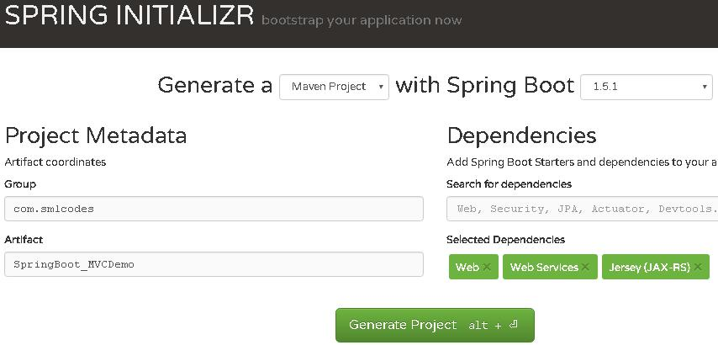

Extract, import to eclipse as Existing Maven project, & Run as→ maven install

If we see the Folder Structre

- all index, welcome files must be placed unter →resources\static\

- all the result pages must be placed under→resources\templates\

20|PAGE
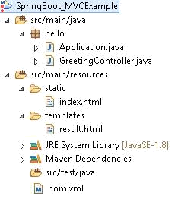

1. Choose the SpringBoot Stater Dependencies and place in pom.xml & build the project.

<?xml version="1.0" encoding="UTF-8"?>
<project xmlns="http://maven.apache.org/POM/4.0.0"
xmlns:xsi="http://www.w3.org/2001/XMLSchema-instance"

xsi:schemaLocation="http://maven.apache.org/POM/4.0.0 http://maven.apache.org/xsd/maven-4.0.0.xsd">

<modelVersion>4.0.0</modelVersion>

<groupId>SpringBoot_MVCExample</groupId>
<artifactId>gs-serving-web-content</artifactId>
<version>SpringBoot_MVCExample</version>

<parent>

<groupId>org.springframework.boot</groupId>

<artifactId>spring-boot-starter-parent</artifactId> <version>1.5.1.RELEASE</version>

</parent>

<dependencies>
<dependency>
<groupId>org.springframework.boot</groupId>

<artifactId>spring-boot-starter-test</artifactId> <scope>test</scope>

</dependency>
</dependencies>

<properties>
<java.version>1.8</java.version>
</properties>

<build>
<plugins>
<plugin>
<groupId>org.springframework.boot</groupId>
<artifactId>spring-boot-maven-plugin</artifactId>
</plugin>
</plugins>

</build>

</project>

21|PAGE
2. Create index.html to provide user input

///SpringBoot_MVCExample/src/main/resources/static/index.html <h2>Spring Boot MVC Example</h2>

<form method="get" action="/hello">

<h3>Enter Your name : <input type="text" name="name"></h3> <button type="submit">Enter</button>

</form>

3. Create Controller to hadle request given by user (/hello)

package hello;

import org.springframework.stereotype.Controller; import org.springframework.ui.Model;

import org.springframework.web.bind.annotation.RequestMapping; import org.springframework.web.bind.annotation.RequestParam;

@Controller
public class GreetingController {

@RequestMapping("/hello")

public String greeting(@RequestParam(value="name", required=false, defaultValue="World") String name, Model model) {

model.addAttribute("name", name);
return "result";
}

}

Here Model is a interface which conatins some usefull method to return result data to result page

4. Create result.html template to display the Results given by Controller

<!DOCTYPE HTML>
<html xmlns:th="http://www.thymeleaf.org">

<body>

<h1><p th:text="'Hello, ' + ${name} + '!'" /></h1> </body>

</html>

5. Create Application.java to Start & Run Spring Boot Application

package hello;
import org.springframework.boot.SpringApplication;
import org.springframework.boot.autoconfigure.SpringBootApplication;

@SpringBootApplication

public class Application {

public static void main(String[] args) { SpringApplication.run(Application.class, args);
}

}

- Strat the Application by Run as→ Java Application (Application.java)

. | ____ | _ |  | ____
/\\ / ___'_ __ _ _(_)_ __ __ _ \ \ \ \
(()\___|'_|'_||'_\/_`| |  |  |  |  | \\\\
\\/ | ___)| |_)| | |  | | | | | || (_| | | ))))
' | |____| .__|_| |  | |_|_| | |_\__, | | ////
=========|_|==============|___/=/_/_/_/

:: Spring Boot :: (v1.5.1.RELEASE)

2017-02-02TomcatEmbeddedServletContainer : Tomcat started on port(s): 8080

22|PAGE
7. Open browser, access localhost:8080 the Output should be as below
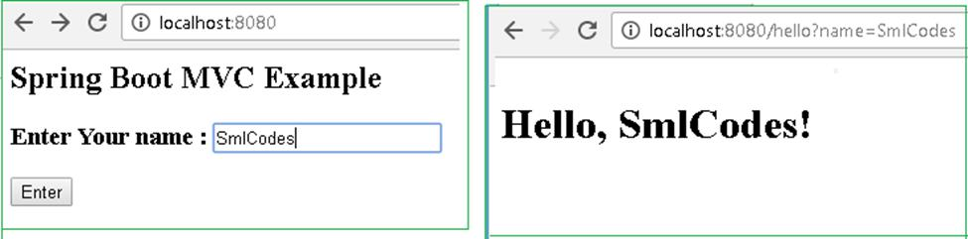

- On Running Applicatio.java, Spring Boot Engine Starts and reads the all files in the projects and autowires the data and auto configures the Controller details

- On submitting the form, Spring Boot Searchers for controller classes which are annotated with

@Controller

- compairs (“/hello”) path with controller @RequestMapping("/hello"), if matches execute the business logic method and it returns the resultpage name(“result”)

4.SpringBoot Engine Searches the appropriate resultpage template having “result” as page name & displays the result.html page to the user


1. Model Interface

Model interface designed for adding attributes to the model. Allows for accessing the overall model as a java.util.Map.
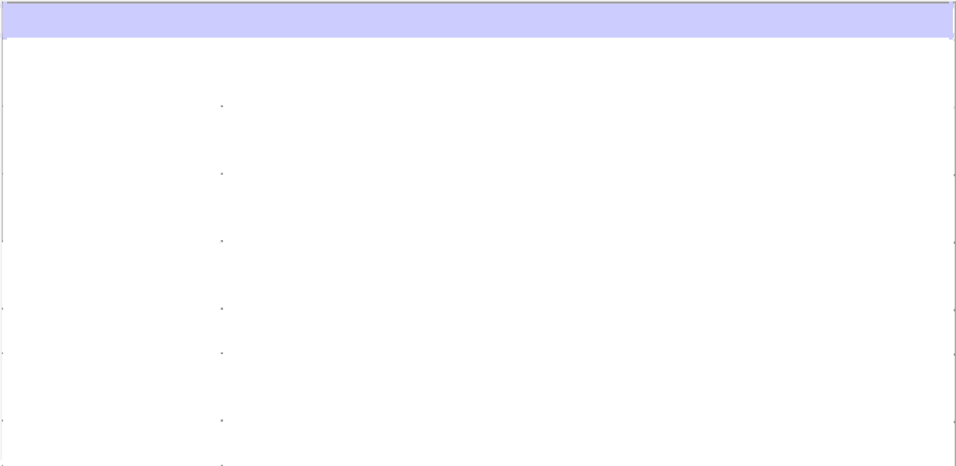

Method Summary

 | Model |  |  |  |  |  |  | addAllAttributes(Collection<?> attributeValues)
 |  |  |  |  |  |  |  | Copy all attributes in the supplied Collection into this Map,
 | Model |  |  |  |  |  |  | addAllAttributes(Map<String,?> attributes)
 |  |  |  |  |  |  |  | Copy all attributes in the supplied Map into this Map.
 | Model |  |  |  |  |  |  | addAttribute(Object attributeValue)
 |  |  |  |  |  |  |  | Add the supplied attribute to this Map using a generated name.
 | Model |  |  |  |  |  |  | addAttribute(String attributeName, Object attributeValue)
 |  |  |  |  |  |  |  | Add the supplied attribute under the supplied name.
 | Map | < | String | , | Object | > |  | asMap() - |  | Return the current set of model attributes as a Map.
 | boolean |  |  |  |  |  |  | containsAttribute(String attributeName)
 |  |  |  |  |  |  |  | Does this model contain an attribute of the given name?
Model |  |  |  |  |  |  |  | mergeAttributes(Map<String,?> attributes)

23|PAGE

2. Static Content

By default, Spring Boot will serve static content from a directory called /static (or /public or /resources or /META-INF/resources)

You can also customize the static resource locations using spring.resources.static-locations (replacing the default values with a list of directory locations).

If you do this the default welcome page detection will switch to your custom locations, so if there is an index.html in any of your locations on startup, it will be the home page of the application.

Spring Boot –RESTful Web Service Example

To work with webservices in SpringBoot we have to use two annotations

- @RestController: tells Spring Boot to consider this class as REST controller

- @RequestMapping: used to register paths inside it to respond to the HTTP requests.

The @RestController is a stereotype annotation. It adds @Controller and @ResponseBody annotations to the class.
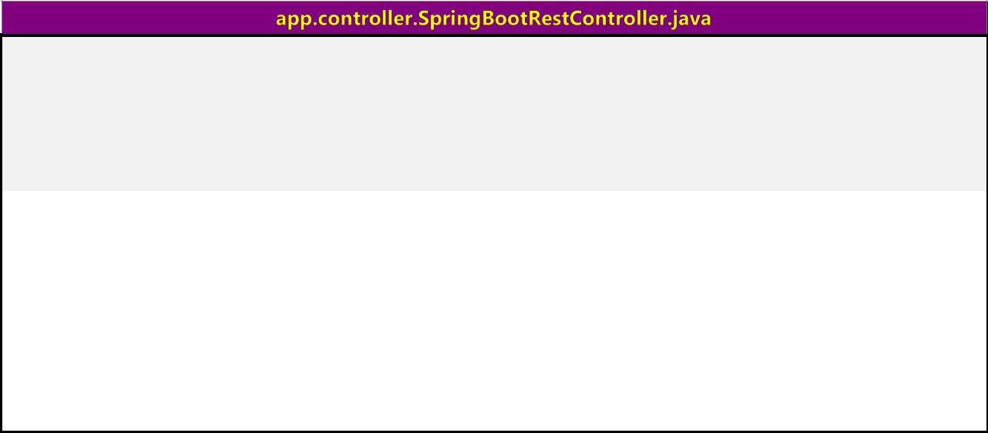

package app.controller;

import org.springframework.web.bind.annotation.RestController; import org.springframework.web.bind.annotation.RequestMapping;

@RestController
public class SpringBootRestController {

@RequestMapping("/")
public String welcome() {
return "Spring Boot Home Page";

}

@RequestMapping("/hello")
public String myData() {
return "Smalcodes : Hello Spring Boot";
}

}

24|PAGE
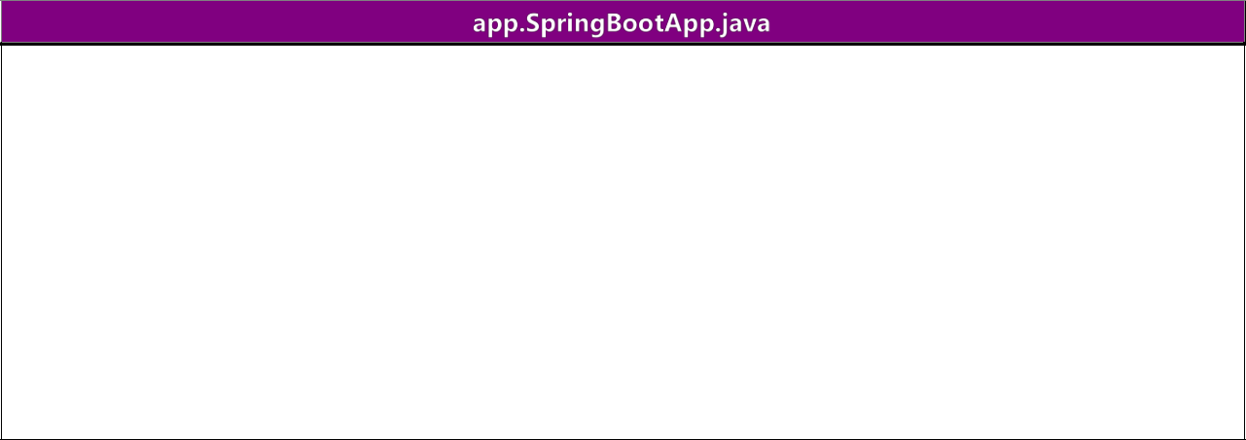
package app;

import org.springframework.boot.SpringApplication;

import org.springframework.boot.autoconfigure.SpringBootApplication;

@SpringBootApplication
public class SpringBootApp {
public static void main(String[] args) {

SpringApplication.run(SpringBootApp.class, args);

}
}

Create pom.xml same as fisrt example.

Test the Application

Right click on project > Run as >Java Application >select SpringBootApp
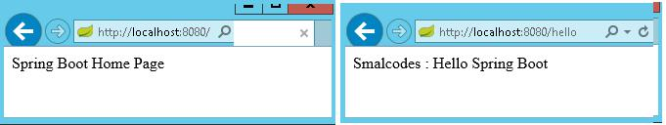

- In above Spring Boot main application class in app package and controller class

in app.controller. While starting our application, SpringBootApp class will scan all the components under that package. As we have created our controller class in app.controller which is inside app package, our controller was registered by spring boot.

- If you create the controller class outside of the main package, lets say com.smlcodes.controller, If you run the application it gives 404 error.To resolve this, we have to

add @ComponentScan annotation in our Spring Boot main class, as below

@SpringBootApplication

@ComponentScan(basePackages="smlcodes.controller")
public class SpringBootApp {

public static void main(String[] args) { SpringApplication.run(SpringBootApp.class, args);

}

}

25|PAGE
5. Spring Boot –Database

Spring Boot –JDBC Example

Spring Boot provides starter and libraries for connecting to our application with JDBC. Spring JDBC dependencies can be resolved by using either spring-boot-starter-jdbc or spring-boot-starter-data-jpa spring boot starters.



1.Create project Structure

To create project go to https://start.spring.io/ and add JDBC,MySQL,JPA dependencies to the Project.
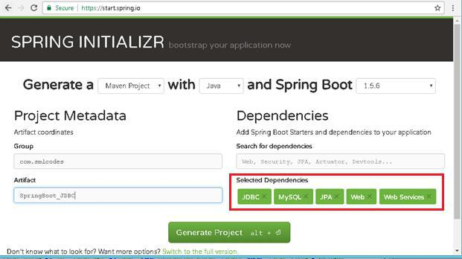

Configure DataSource (application. properties)

DataSource and Connection Pool are configured in application.properties file using prefix spring.datasource. Spring boot uses javax.sql.DataSource interface to configure DataSource



spring.datasource.url=jdbc:mysql://localhost:3306/springdb?useSSL=false
spring.datasource.username=root

spring.datasource.password=root

spring.datasource.driver-class-name=com.mysql.jdbc.Driver

26|PAGE

Model Class(model.Student.java)

Find the MySQL table used in our example.

CREATE TABLE `student` (
`sno` INT(11) NOT NULL,

`name` VARCHAR(50) NULL DEFAULT NULL,
`address` VARCHAR(50) NULL DEFAULT NULL,
PRIMARY KEY (`sno`)
)
COLLATE='latin1_swedish_ci'
ENGINE=InnoDB

;

Create Student class with table properties

package app.model;

public class Student {
private int sno;
private String name;
private String address;

public Student() {
super();
}

public Student(int sno, String name, String address) { super();

this.sno = sno;
this.name = name;
this.address = address;
}

public int getSno() {
return sno;
}

public void setSno(int sno) {
this.sno = sno;
}

public String getName() {
return name;

}

public void setName(String name) {
this.name = name;
}

public String getAddress() {
return address;
}

public void setAddress(String address) {
this.address = address;
}

}

27|PAGE
DAO Class with JdbcTemplate (StudentDAO.java)

- JdbcTemplate is the central class to handle JDBC. It executes SQL queries and fetches their results. To use JdbcTemplate.

- JdbcTemplate dependency injection using @Autowired with constructor.


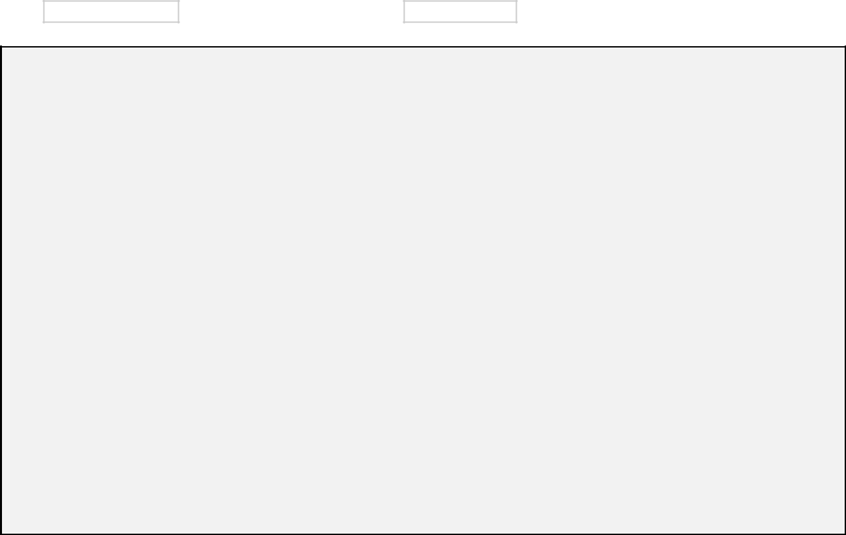

package app.dao;

import java.util.List;

import org.springframework.beans.factory.annotation.Autowired; import org.springframework.jdbc.core.JdbcTemplate;

import org.springframework.stereotype.Repository; import app.model.Student;

@Repository
public class StudentDAO {

@Autowired
private JdbcTemplate template;

public List<Student> findAll() {

List<Student> result = template.query("SELECT sno,name, address FROM Student", new StudentRowMapper());

return result;
}

public void addStudent(int sno, String name, String address) {
template.update("INSERT INTO Student(sno,name, address) VALUES (?,?,?)", sno, name, address);

}

}


RowMapper Class

Spring JDBC provides RowMapper interface that is used to map row with a java object. We need to create our own class implementing RowMapper interface to map row with java object. Find the sample code to implement RowMapperinterface.

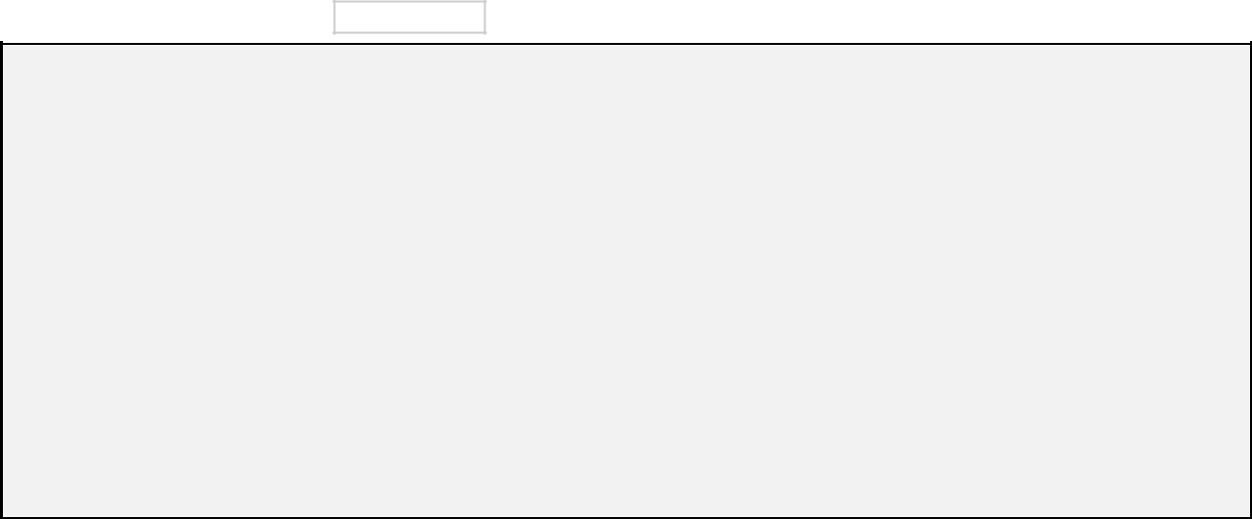

package app.dao;
import java.sql.ResultSet;
import java.sql.SQLException;
import org.springframework.jdbc.core.RowMapper;

import app.model.Student;

public class StudentRowMapper implements RowMapper<Student> { @Override

public Student mapRow(ResultSet rs, int rowno) throws SQLException {

- TODO Auto-generated method stub Student s = new Student(); s.setSno(rs.getInt("sno")); s.setName(rs.getString("name")); s.setAddress(rs.getString("address")); return s;
}

}

28|PAGE

SpringBootJdbcController.java

package app.controller;
import org.springframework.web.bind.annotation.RestController;
import app.dao.StudentDAO;
import app.model.Student;
import java.util.Iterator;

import java.util.List;

import org.springframework.beans.factory.annotation.Autowired; import org.springframework.web.bind.annotation.RequestMapping; import org.springframework.web.bind.annotation.RequestParam;

@RestController
public class SpringBootJDBCController {

@Autowired
private StudentDAO dao;

@RequestMapping("/jdbc")
public String welcome() {
return "Spring Boot Home Page";
}

@RequestMapping("/insert")

public String insert(@RequestParam("sno") int sno, @RequestParam("name") String name, @RequestParam("address") String adr) {

System.out.println(" ************** Inside Method ************");

dao.addStudent(sno, name, adr);
return "Data Inserted";
}

@RequestMapping("/select")
public String select() {

String result="";
List<Student> list = dao.findAll();
Iterator<Student> itr = list.iterator();
while (itr.hasNext()) {
Student s = (Student) itr.next();
result = result+ s.getSno()+", ";

result = result+ s.getName()+", ";
result = result+ s.getAddress()+" <br>";
}
System.out.println("Result : "+result);
return result;

}

}

SpringBootApp.java

package app;

import org.springframework.boot.SpringApplication;
import org.springframework.boot.autoconfigure.SpringBootApplication;

@SpringBootApplication
public class SpringBootApp {

public static void main(String[] args) { SpringApplication.run(SpringBootApp.class, args);

}
}

29|PAGE
Static/index.jsp

<a href="/select">SELECT</a><br />

<h1>Insert Form</h1>
<form action="/insert">
Sno: <input name="sno" type="text" /> <br>

Name: <input name="name" type="text" /> <br> Address: <input name="address" type="text" /> <br> <input type="submit" value="INSERT" /> <br>

</form>
</body>
</html>

Rightclikc on Project> Runas> Java Application
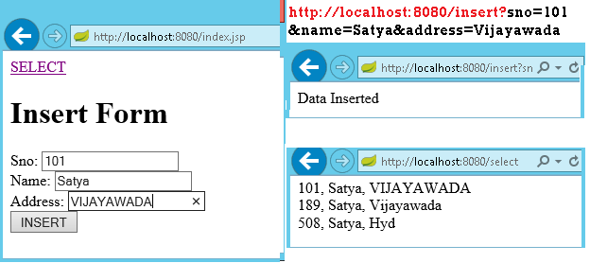

We can discard RowMapper class if we write following code in StudentDAO class it self.

@Repository
public class StudentDAO {

@Autowired
private JdbcTemplate template;

public List<Student> findAll() {

List<Student> result = template.query("SELECT sno,name, address FROM Student",
(rs, rowNum) -> new Student(rs.getInt("sno"),

rs.getString("name"), rs.getString("address")));
return result;

}

public void addStudent(int sno, String name, String address) {
template.update("INSERT INTO Student(sno,name, address) VALUES (?,?,?)",
sno, name, address);
}

}

30|PAGE
Spring Boot –JPA Example

Spring Boot provides spring-boot-starter-data-jpa starter to connect Spring application with relational database efficiently. You can use it into project POM (Project Object Model) file.


JPA Annotations

By default, each field is mapped to a column with the name of the field. You can change the default name via @Column (name="newColumnName").

The following annotations can be used.

 | @Entity |  |  | Marks java class to a Table name
 | @Table(name="tabname") |  |  | Provides table name, when table name & class names are different .
 | @Id |  |  | Identifies the unique ID of the database entry
@GeneratedValue |  |  |  | Together with an ID this annotation defines that value is generated automatically.
 | @Transient |  |  | Field will not be saved in database

The central interface in Spring Data repository abstraction is Repository (probably not that much of a surprise). It takes the domain class to manage as well as the id type of the domain class as type arguments.


CrudRepository

The CrudRepository provides sophisticated CRUD functionality for the entity class that is being managed

public interface CrudRepository<T, ID extends Serializable> extends Repository<T, ID> {

<S extends T> S save(S entity);

- findOne(ID primaryKey); Iterable<T> findAll(); Long count();

void delete(T entity);

boolean exists(ID primaryKey);

// … more functionality omitted.

}


PagingAndSortingRepository

On top of the CrudRepository there is a PagingAndSortingRepository abstraction that adds additional methods to ease paginated access to entities:

public interface PagingAndSortingRepository<T, ID extends Serializable> extends CrudRepository<T, ID> {

Iterable<T> findAll(Sort sort);
Page<T> findAll(Pageable pageable);

}

31|PAGE
1. create an entity class that contains the information of a single Student entry

package app.entity;

import javax.persistence.Column;
import javax.persistence.Entity;
import javax.persistence.GeneratedValue;
import javax.persistence.GenerationType;

import javax.persistence.Id;
import javax.persistence.Table;

@Entity
@Table(name = "student")
public class Student {

@Id
@GeneratedValue(strategy = GenerationType.AUTO)

private int sno;

@Column(name = "name")
private String name;

@Column(name = "address")
private String address;

public Student() {
super();
}

public Student(int sno, String name, String address) { super();

this.sno = sno;
this.name = name;

this.address = address;
}

//Setters & getters

}

We can create the repository that provides CRUD operations for Student objects by using one of the following methods:

- Create an interface that extends the CrudRepository interface.

- Create an interface that extends the Repository interface and add the required methods to the created interface.

package app.repository;

import org.springframework.data.repository.CrudRepository; import app.entity.Student;

public interface StudentRepository extends CrudRepository<Student, String>{

}

32|PAGE
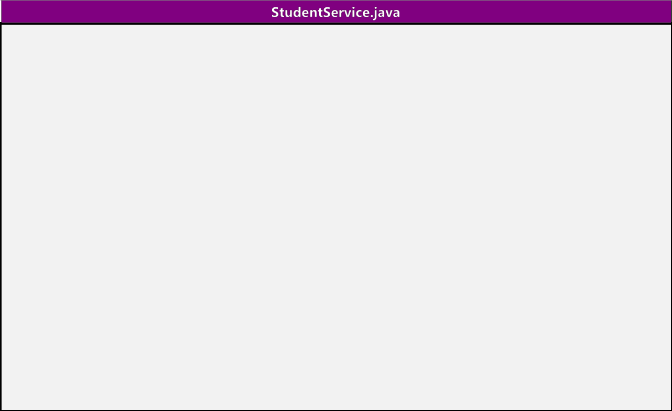
package app.service;

@Service
public class StudentService {

@Autowired
private StudentRepository repository;

public List<Student> getAllStudents() {
List<Student> studentRecords = new ArrayList<>();
repository.findAll().forEach(studentRecords::add);
return studentRecords;
}

public Student getStudent(String id) {
return repository.findOne(id);
}

public void addStudent(Student studentRecord) {
repository.save(studentRecord);

}

public void delete(String id) {
repository.delete(id);
}

}
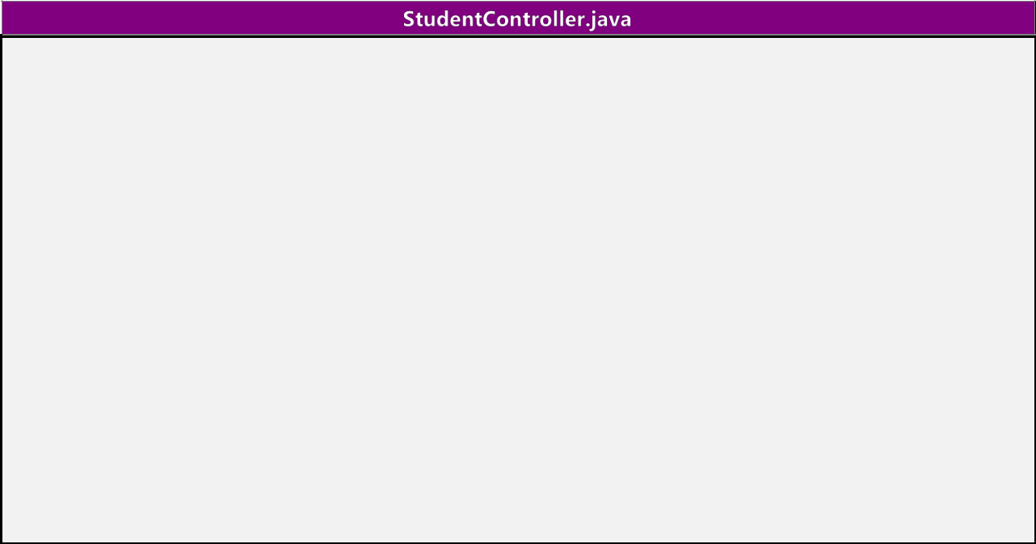

package app.controller;

@RestController

public class StudentController {
@Autowired

private StudentService studentService;

@RequestMapping("/")
public List<Student> getAllStudent() {
return studentService.getAllStudents();
}

@RequestMapping(value = "/add", method = RequestMethod.POST)
public void addStudent(@RequestBody Student student) {
studentService.addStudent(student);
}

@RequestMapping(value = "/get/{id}", method = RequestMethod.GET)
public Student getStudent(@PathVariable String id) {

return studentService.getStudent(id);
}

}
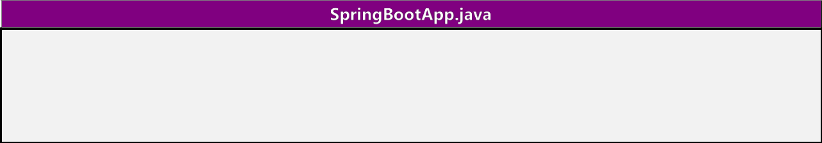

@SpringBootApplication
public class SpringBootApp {

public static void main(String[] args) { SpringApplication.run(SpringBootApp.class, args);
}

}

33|PAGE
http://localhost:8080/ -get All Srudents
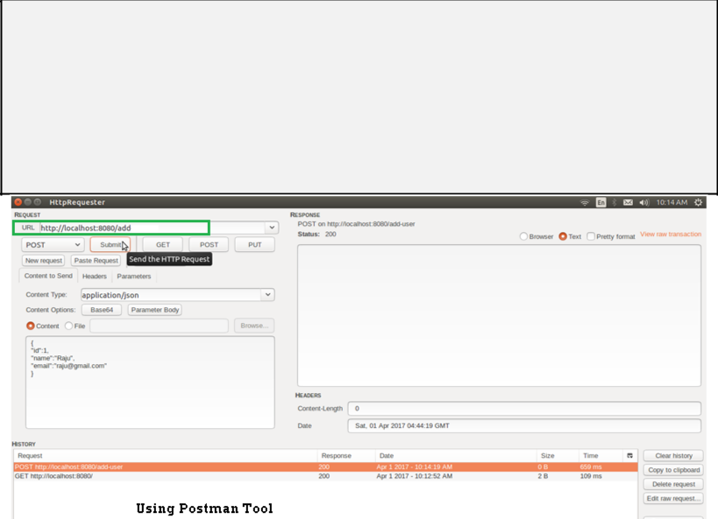

[
{

"sno": 189,
"name": "Satya",
"address": "Vijayawada"

},
{
"sno": 508,
"name": "Satya",
"address": "Hyd"
}

]

JpaRepository

JpaRepository provides some JPA related method such as flushing the persistence context and delete record in a batch. JpaRepository extends PagingAndSortingRepository which in turn extends CrudRepository.

Their main functions are:

- CrudRepository mainly provides CRUD functions.

- PagingAndSortingRepository provide methods to do pagination and sorting records.

- JpaRepository provides some JPA related method such as flushing the persistence context and delete record in a batch.

Because of the inheritance mentioned above, JpaRepository will have all the functions of CrudRepository and PagingAndSortingRepository.

34|PAGE
Custom Queries

Spring Data JPA provides three different approaches for creating custom queries with query methods.

Each of these approaches is described in following.

Using Method Name

- Spring Data JPA has a built in query creation mechanism which can be used for parsing queries straight from the method name of a query method.

- The method names of your repository interface are created by combining the property names

of an entity object and the supported keywords.

public interface PersonRepository extends Repository<User, Long> {

List<Person> findByEmailAddressAndLastname(EmailAddress emailAddress, String lastname);

// Enables the distinct flag for the query

List<Person> findDistinctPeopleByLastnameOrFirstname(String lastname, String firstname); List<Person> findPeopleDistinctByLastnameOrFirstname(String lastname, String firstname);

- Enabling ignoring case for an individual property
List<Person> findByLastnameIgnoreCase(String lastname);

- Enabling ignoring case for all suitable properties
List<Person> findByLastnameAndFirstnameAllIgnoreCase(String lastname, String firstname);

// Enabling static ORDER BY for a query

List<Person> findByLastnameOrderByFirstnameAsc(String lastname); List<Person> findByLastnameOrderByFirstnameDesc(String lastname);

}

JPA Named Queries

Spring Data JPA provides also support for the JPA Named Queries. You have got following alternatives for declaring the named queries:

- You can use either named-query XML element or @NamedQuery annotation to create named queries with the JPA query language.

- You can use either named-native-query XML element or @NamedNative query annotation to create queries with SQL if you are ready to tie your application with a specific database platform.

The only thing you have to do to use the created named queries is to name the query method of your repository interface to match with the name of your named query. See below Example code

@Entity

@NamedQuery(name = "Person.findByName", query = "SELECT p FROM Person p WHERE LOWER(p.lastName) = LOWER(?1)")

@Table(name = "persons")
public class Person {

@Id
@GeneratedValue(strategy = GenerationType.AUTO)

private Long id;

35|PAGE
@Column(name = "creation_time", nullable = false)

private Date creationTime;

@Column(name = "first_name", nullable = false)
private String firstName;

}

The relevant part of my PersonRepository interface looks following

public interface PersonRepository extends JpaRepository<Person, Long> {

//A list of persons whose last name is an exact match with the given last name. public List<Person> findByName(String lastName);

}

@Query Annotation

- The @Query annotation can be used to create queries by using the JPA query language and to bind these queries directly to the methods of your repository interface.

- When the query method is called, Spring Data JPA will execute the query specified by the @Query annotation

- If there is a collision between the @Query annotation and the named queries, the query specified by using @Query annotation will be executed

public interface ProductRepository
extends CrudRepository<Product, Long> {
@Query("FROM Product")
List<Product> findAllProducts();

}

You may use positional parameters instead of named parameters in queries. Positional

parameters are prefixed with a question mark (?) followed the numeric position of the parameter in the

query. The Query.setParameter(integer position, Object value) method is used to set the parameter values.

public List findWithName(String name) {
return em.createQuery(

“SELECT c FROM Customer c WHERE c.name LIKE ?1”)
.setParameter(1, name)
.getResultList();

}

Automatic Query Generation

The <jpa:repositories/> has an option query-lookup-strategy which defaults to “create-if-not-found” which will generate queries for us.The default is “create-if-not-found“. Other options are “create” or “use-declared-query“.

<jpa:repositories base-package="com.gordondickens.myapp.repository"

query-lookup-strategy="create-if-not-found"/>

36|PAGE
To create a find method that effectively does @Query("FROM Product p where p.productId =:productId")

public interface ProductRepository extends CrudRepository<Product, Long> {
...

@Query
Product findByProductId(String productId);

...

Student.java

package app.entity;

@Entity
@Table(name = "student")

public class Student {

@Id
@GeneratedValue(strategy = GenerationType.AUTO)
private int sno;

@Column(name = "name")
private String name;

@Column(name = "address")
private String address;

@Override
public String toString() {
String str = "Student[" + "Sno: " + getSno() + ", Name:" + getName() + ", " +
"Address : " + getAddress() + "]";

return str;
}
//Setters & getters

}

StudentRepository.java

public interface StudentRepository extends CrudRepository<Student, Long> {

List<Student> findBySno(int sno);

List<Student> findByName(String name);

// custom query example and return a stream

@Query("select c from Student c where c.address = :address") Stream<Student> findByAddress(@Param("address") String address);

}

37|PAGE
Application.java

package app;

@SpringBootApplication
public class Application implements CommandLineRunner {

@Autowired
DataSource dataSource;

@Autowired

StudentRepository repository;

public static void main(String[] args) throws Exception { SpringApplication.run(Application.class, args);

}

@Transactional(readOnly = true)
@Override

public void run(String... args) throws Exception {

System.out.println("DATASOURCE = " + dataSource);

System.out.println("\n1.findAll()...");

for (Student student : repository.findAll()) { System.out.println(student);

}

System.out.println("\n2.findByName(String name)..."); for (Student student : repository.findByName("Satya")) {
System.out.println(student);

}

System.out.println("\n3.findByAddress(@Param(\"name\"))...");

try (Stream<Student> s =repository.findByAddress("Vijayawada")) { s.forEach(x -> System.out.println(x)); System.out.println("Done!");

exit(0);
}
}
}

1.findAll()...
Student[Sno: 0, Name:null, Address : null]
Student[Sno: 101, Name:Satya, Address : VIJAYAWADA]

Student[Sno: 102, Name:Satya, Address : Vijayawada]
Student[Sno: 147, Name:kumar, Address : Hyderabad]

Student[Sno: 189, Name:Satya, Address : Vijayawada]
Student[Sno: 508, Name:Satya, Address : Hyd]

2.findByName(String name)...
Student[Sno: 101, Name:Satya, Address : VIJAYAWADA]
Student[Sno: 102, Name:Satya, Address : Vijayawada]
Student[Sno: 189, Name:Satya, Address : Vijayawada]
Student[Sno: 508, Name:Satya, Address : Hyd]

4.findByAddress(@Param("name") String name)... Student[Sno: 101, Name:Satya, Address : VIJAYAWADA] Student[Sno: 102, Name:Satya, Address : Vijayawada] Student[Sno: 189, Name:Satya, Address : Vijayawada]

38|PAGE
Spring Boot –MongoDB REST Example
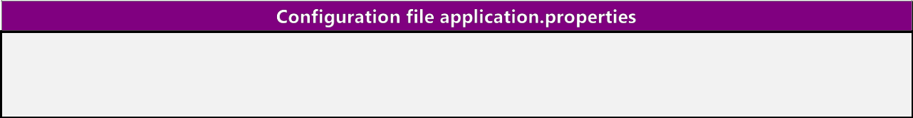

- Create new database : ‘smlcodes’ spring.data.mongodb.database=smlcodes spring.data.mongodb.host=localhost spring.data.mongodb.port=27017

We need to model our documents. Let’s call ours ‘Booking’ and give it a make, model, and description. Here is our Java class to accomplish this

package smlcodes.repository;
import org.springframework.data.annotation.Id;

import org.springframework.data.mongodb.core.mapping.Document;

@Document

public class Student{

@Id
String sno;
String name;
String address;

public String getSno() {
return sno;
}
public void setSno(String sno) {
this.sno = sno;
}

public String getName() {
return name;
}
public void setName(String name) {
this.name = name;

}
public String getAddress() {
return address;
}
public void setAddress(String address) {
this.address = address;

}

}

- @Id- id provided by Mongo for a document.

- @Document- provides a collection name.

BookingRepository.java

The MongoRepository provides basic CRUD operation methods and also an API to find all documents in the collection.

@Transactional

public interface StudentRepository extends MongoRepository<Student, String> { public Student findBySno(int sno);

}

39|PAGE
BookingController.java

package smlcodes.controller;

@RestController
@RequestMapping("/student")
public class StudentController {

@Autowired
StudentRepository studentRepository;

@RequestMapping("/create")

public Map<String, Object> create(Student student) { student = studentRepository.save(student);

Map<String, Object> dataMap = new HashMap<String, Object>();
dataMap.put("message", "Student created successfully");
dataMap.put("status", "1");
dataMap.put("student", student);

return dataMap;

}

@RequestMapping("/read")

public Map<String, Object> read(@RequestParam int sno) { Student student = studentRepository.findBySno(sno); Map<String, Object> dataMap = new HashMap<String, Object>(); dataMap.put("message", "Student found successfully"); dataMap.put("status", "1");

dataMap.put("student", student);
return dataMap;

}

@RequestMapping("/readall")
public Map<String, Object> readAll() {
List<Student> students = studentRepository.findAll();
Map<String, Object> dataMap = new HashMap<String, Object>();

dataMap.put("message", "Student found successfully");
dataMap.put("totalStudent", students.size());
dataMap.put("status", "1");
dataMap.put("students", students);
return dataMap;

}

}

SpringBootMongoDbApplication.java

@SpringBootApplication
public class SpringBootMongoDbApplication {

public static void main(String[] args) {
SpringApplication.run(SpringBootMongoDbApplication.class, args);
}

}

http://localhost:8080/student/create?sno=101&name=Satya&address=HYDERABAD
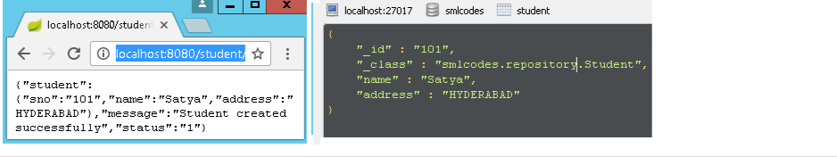

40|PAGE
References

- http://sivalabs.in/2016/03/springboot-working-with-jdbctemplate/

- https://www.javatpoint.com/spring-boot-jpa

- https://www.petrikainulainen.net/programming/spring-framework/spring-data-jpa-tutorial-part-two-crud/

- https://www.dineshonjava.com/spring-boot-and-mongodb-in-rest-application/

- https://spring.io/guides/gs/spring-boot/#scratch

- http://docs.spring.io/autorepo/docs/spring-boot/current/reference/html/(best)

- http://www.dineshonjava.com/2016/06/introduction-to-spring-boot-a-spring-boot-complete-guide.html#.WI7wB1N965t

- http://websystique.com/spring-boot-tutorial/

- https://www.mkyong.com/tag/spring-boot/

- (Best)Helloworld : http://www.shristitechlabs.com/introduction-to-spring-boot/

- https://www.mkyong.com/spring-boot/spring-boot-spring-data-mongodb-example/

- https://tests4geeks.com/spring-data-boot-mongodb-example/

- https://avaldes.com/building-a-realtime-angularjs-dashboard-using-spring-rest-and-mongodb-part-1/

- Final:https://www.callicoder.com/spring-boot-mongodb-angular-js-rest-api-tutorial/

41|PAGE

