MICROSERVICES
Let us explore the concepts of microservices through a use-case on Mediamore.com.
Mediamore is an entertainment company which provides streaming media and videos online. It consists of various genres of TV Shows in different languages. Like many other companies mediamore started its journey with a monolithic architecture.
Let us now explore the monolithic framework of mediamore.

Monolithic Architecture

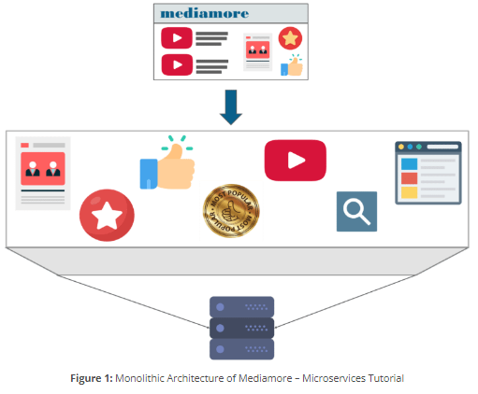
Refer to the above diagram. We can infer that all the features such as the search, user-info, recommendations, video playlist and others are put on a single database using single code.
Now, let me tell you the challenges faced by the developers while using a monolithic framework by using some scenarios.

Challenges of Monolithic Architecture
Scenario 1:
Scalability: Let’s assume that the developers want to update the playlist according to most popular tv shows and also simultaneously want to update all videos to HD quality.
The developers cannot scale the application simultaneously. New instances of the same application have to be created every time a new feature has to be developed or deployed.
Scenario 2:
Agility: Assume that developers want to make immediate changes in the application.
The monolithic application can definitely accommodate these changes. But, the problem here is that the developers have to rebuild the code for every small change.
Scenario 3:
Hybrid Technologies: Suppose developers of this application are comfortable with various technologies like JAVA, C++,.NET, C#.
Even though they are comfortable with various technologies, they still have to build large and complex applications on a single technology.
Scenario 4:
Fault Tolerance: Let’s suppose that a specific feature is not working in the application.
The complete system goes down because of this problem. In order to tackle this problem, the application has to be re-built, re-tested and also re-deployed.
So, how did the developers of mediamore overcome these complexities?
Developers thus decided to re-architect their monolithic application into multiple individual deployable components, called as microservices.
Here lies the million dollar question!

What is Microservices?
Microservices is an architecture wherein all the components of the system are put into individual components, which can be built, deployed, and scaled individually or independently.
1. Monolithic Application:--
A Project which holds all modules together and converted as one Service (one .war file).
=>All most every project in real time is implemented using this format only.
=>In this case, if no. of users are getting increased, then to handle multiple request (load) use LBS (Load Balancing Server).
=>But few modules needs Extra load, not all. In this case other modules get memory which is waste (no use). Hence reduces performance of server (application).

**Consider Project P1 is having 2 modules M1(Register), M2(Login) and their runtime memories are M1=50 MB, M2=50 MB.
=>Here, End user Register only onetime (first time) and login is mostly used module.
->Consider Application needs 100MB size in server as register 50MB and Login 50MB.
->To handle multiple client request multiple instances of sample App must be provided using Load balancing server with Load Register.

Diagram: -- Load Balancing is done using Servers looks like.

=>In above example, M2 Module is getting fewer (100) requests from Client. So, max 2 instances are may be enough. Other 2 instances (memories) are no use. It means near 100MB memory is not used, which impacts server performance.

2. Microservices: -- It is an independent deployment component.
=>It is a combination of one (or more) modules of a Projects runs as one Service.
=>To avoid monolithic Limitations like memory and time (performance) problems use this design.

Nature of Microservices:--
1>Every Service must be implemented using Web services concept.

2>One or multiples module as one Project.

3> Every Service must be independent (One service should not effect another one, like for code modifications, version upgrades, downtime for few servers… etc).

4>It should able to communicate with any type of client (Mobile, Web based, 3rd party).

5>Every Services should able to communicate with each other Micro service, It is also called as “Intra Communication”.

6>Required Services must be supported for Dynamic Load Balancing (i.e. one service runs in multiple instances) based on click request.

7>Every micro service should support able to read input data from External Configuration Server [Config Server](Dynamic inputs using (_.properties/_.yml), with GIT/Config Server).

8>Service communication (Chain of execution) problems should be able to solve using Circuite Breaker [Find other possible…].

9>All Servers must be accessed to Single Entry known as Gateway Service [ Proxy Gateway or API Gateway], It supports securing, metering and Routing.
Microservice Generic Architecture:--

=>This design provides ability to communicate any kind of client application.
Ex: -- Android, Angular, RFID, Web, 3rd party, Swings… etc.
=>Eureka is an R & D server which supports Microservices register, discover with each other for intra communication.
=>Every Microservice should get registered with Eureka using one Service ID (one or more instance ID).
=>For consumer application using Discovery client, get URI and make http Request to producer Application.
Component Names:--
1>Service Registry & Discovery = Eureka
2>Load Balancing Server = Ribbon /LoadingBalancing
3>Circuite Breaker = Hystrix
4>API Gateway = Zuul
5>Config Server = GitHub
6>Secure Server = OAuth2
7>Log and Trace = Zipkin + Sleuth
8>Message Queues = Kakfa
9>Declarative Rest Client = Feign
10>Integration Service = Camel
11>Production Ready Endpoint = Actuator
12>Metrics UI = Admin (Server/Client)
13>Cloud Platform = PCF, Docker
With Deploy services

SOA (Service Oriented Architecture):--
=>It is a Design Pattern used to create communication links between multiple services providers and Consumers (users).
Components of SOA:--
a>Service Registry and Discovery [Eureka]
b>Service Provider [Webservice Provider]
c>Service Consumer [Webservice Client]

Operations:--
1>Publish
2>Discover
3>Link Details of Provider
4>Query Description (Make Http Request).
5>Access Service (Http Response).
Implementing MicroService Application Using Spring Cloud:--

Design #1:-- A Simple Rest WebService using Spring Boot.

=>This application is implemented using Spring Boot Restful webservices which provides Tightly coupled design, It means any changes in provider application effects consumer application, specially server changes port no changes, context changes etc.
=>This design will not support load balancing.
=>It is implemented using RestController and RestTemplate

Step#1:- Create Provider Application (Dependencies: web only)
Group Id : com.app
ArtifactId : AdminServiceProvider
Version : 1.0

#1. Folder Structure of AdminServiceProvider:--

Step #2:- Define one RestController (AdminServiceProvider.java):--
package com.app.controller;
import org.springframework.web.bind.annotation.GetMapping;
import org.springframework.web.bind.annotation.RequestMapping;
import org.springframework.web.bind.annotation.RestController;
@RestController
@RequestMapping("/provider")
public class AdminServiceProvider {
@GetMapping("/show")
public String showMsg() {
return "Hello";
}
}

Step #3:- Create Consumer Application (Dependencies : web only)
GroupId : com.app
ArtifactId : AdminServiceConsumer
Version : 1.0

#2. Folder Structure of AdminServiceConsumer:--

Step #4:- Define Consumer (call) code (AdminConsumer.java):--
package com.app.consumer;
import org.springframework.boot.CommandLineRunner;
import org.springframework.http.ResponseEntity;
import org.springframework.stereotype.Component;
import org.springframework.web.client.RestTemplate;
@Component
public class AdminConsumer implements CommandLineRunner {
public void run (String... args) throws Exception {
RestTemplate rt = new RestTemplate();
ResponseEntity<String> resp = rt.getForEntity("http://localhost:2019/provider/show", String.class);
System.out.println(resp.getBody());
System.exit(0);
}
}

Execution flow SCREEN:--
=>First Run provider (Starter), then consumer and enter below URL
1>http://localhost:2019/provider/show
#1 PROVIDER SCREEEN:--
CONSUMER SCREEN:--

3. MicroService Design and Implementation using Spring Cloud
(Netflix Eureka Registry & Discovery):--
=>Registry and Discovery server hold details of all Client (Consumer/Producer) with its serviced and Instance Id.
=>Netflix Eureka is one R & D Server.
=>Use default port no is 8761.

Design#1:- [Basic – No Load Balancing]

Step #1: Create Eureka Server: -- Create one Spring Boot Starter Project with Dependencies: Eureka Server

GroupId : com.app
ArtifactId : EurekaServerApp
Version : 1.0

Eureka Server Dependencies:--
<dependency>
<groupId>org.springframework.cloud</groupId>
<artifactId>spring-cloud-starter-netflix-eureka-server </artifactId>
</dependency>

#3. Folder Structure of Eureka Server:--
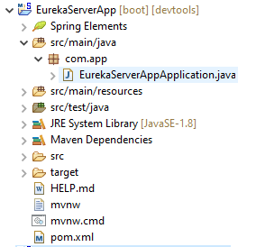

Step#2:- At Starter class level add Annotation @EnableEurekaServer Annotation:-

package com.app;
import org.springframework.boot.SpringApplication;
import org.springframework.boot.autoconfigure.SpringBootApplication;
import org.springframework.cloud.netflix.eureka.server.EnableEurekaServer;
@SpringBootApplication
@EnableEurekaServer
public class EurekaServerApp {
public static void main(String[] args) {
SpringApplication.run(EurekaServerApp.class, args);
System.out.println("Eureka Server Executed:");
} }

Step #3:- In application.properties add keys
server.port=8761
eureka.client.register-with-eureka=false
eureka.client.fetch-registry=false

Step #4:- Run starter class and Enter URL http://localhost:8761 in browser
NOTE:-- Default port no of Eureka Server is 8761.

Screen Short of Eureka Server Dashboard:--

4. Spring Boot Provider (Producer) Application:--
=>Every client service should get registered with Eureka and implement load balancing in case of multiple request processing.

Step #1:- Create one Spring starter App with web and Eureka Discovery Client dependencies

GroupId : com.app
ArtifactId : StudentServiceProvider
Version : 1.0
Eureka Discovery Client Dependencies:--
<dependency>
<groupId>org.springframework.cloud</groupId>
<artifactId>spring-cloud-starter-netflix-eureka-client </artifactId>
</dependency>
4. Folder Structure of Provider Application:--
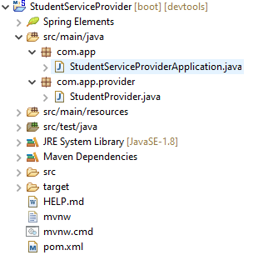
Step #2:- Add below annotation at Starter class level @EnableEurekaClient (given by Netflix) or @EnableDiscoveryClient (given by Spring Cloud) both are optional.

Spring Starter class (StudentServiceProviderApp.java):--
package com.app;
import org.springframework.boot.SpringApplication;
import org.springframework.boot.autoconfigure.SpringBootApplication;
import org.springframework.cloud.netflix.eureka.EnableEurekaClient;

@SpringBootApplication
@EnableEurekaClient
public class StudentServiceProviderApp {
public static void main(String[] args) {
SpringApplication.run(StudentServiceProviderApp.class, args);
System.out.println("Student Service provider");
}
}

Step #3:- In application.properties file
server.port=9800
spring.application.name=STUDENT-PROVIDER
eureka.client.serviceUrl.defaultZone=http://localhost:8761/eureka

Step #4:- Define one Provider Controller (StudentProvider):--
package com.app.provider;
import org.springframework.web.bind.annotation.GetMapping;
import org.springframework.web.bind.annotation.RequestMapping;
import org.springframework.web.bind.annotation.RestController;
@RestController
@RequestMapping("/provider")
public class StudentProvider {
@GetMapping("show")
public String showMsg() {
return "Hello from Provider";
}
}

Execution Order:- (RUN Starter Classes)
1. EUREKA SEVER
2. PROVIDER APPLICATION
=>Goto eureka dashboard and check for application
=>Click on url and add /provider/show PATH

#1 Screen Short of Eureka Server Dashboard:--
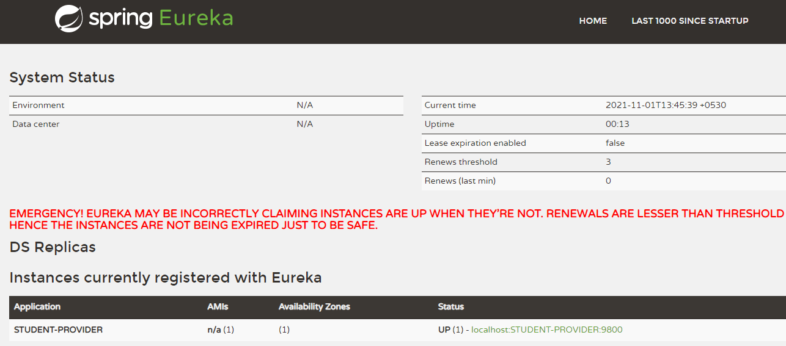

#2 Screen Short of Provider Application:--
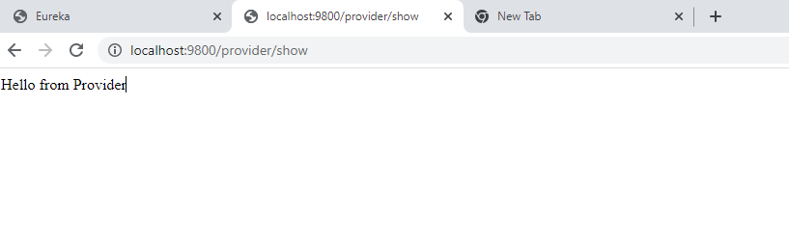
Work flow of Eureka and Producer:--
Step#1:- On startup Eureka server, one Registry is created (it is like a Map).
Step#2:- Every client is identified using serviced and their servers are identified using Instance Id (URI).
Step#3:- Client identifies R & D using Service-url and it is enabled by using @EnableEurekaClient.
Step#4:- Client gets registered first and then fetches the registry (copy).
5. Consumer Application:-- In general Spring Boot application, by using any HTTP Client code, Consumer makes request based on URL (static/hard coded) given in code.

=>This application need to be registered first with R & D server then fetch service registry using any one client component. Given as
a>Discovery Client
b>Load Balancing Client (Feign client)

=>Every client component need “Service-Instance” object to communicate with producer application.

=>In general, one instance means One-service where application is running.

=>Every instance must have:
1. Service Id : Project Name
2. Instance Id : Server Instance name)
3. URI : Host, Port, …etc)
4. MetaData : (Headers, Cookies, Sessions…)
5. Current Load Factor… etc.

*** Hard coding: -- Providing a direct value to a variable in .java file or fixed value.
Ex: - int a = 5;
=>It provides always same output for multiple runs.

=>By using RestTemplate with URL (hard coded) we can make request. But it will not support.
a>If provider IP/PORT number gets changed.
b>Load Balancing Implementation.

=>So, we should use Dynamic Client that gets URL at runtime based on Application name registered in “Registry and Discovery Server (Eureka)”.

=>Discovery Client is used to fetch Instance based on Application Name and we can read URI of provider at runtime.

=>RestTemplate uses URI (+path) = URL and makes Request to Provider and gets ResponseEntity which is given back to the Consumer.

Simple Web Service Example:--

Microservices Example:--

=>If one Application is moved from one Server to another server then URI gets changed (Paths remain same).

=>If one Project is running in 3 Server then current Project is having 3 instances. All these are store in R & D Server and we can fetch details as: List<ServiceInstance>

=>Consider one example producer application running in server 192.168.0.1 (IP).

Consumer code:--

Step #1:- Create one Spring Starter Project using Dependencies web, Eureka Discovery.
GroupId : com.app
ArtifactId : StudentServiceConsumer
Version : 1.0

#5. Folder Structure of Consumer Application:--

Step #2:- At Starter class level add Annotation either @EnableEurekaClient or @EnableDiscoveryClient (both are optional)

Step #3:- In application.properties file
server.port=9852
spring.application.name=STUDENT-CONSUMER
eureka.client.serviceUrl.defaultZone=http://localhost:8761/eureka

Step #4:- Define Consumer code with RestTemplate and DiscoveryClient:--

StudentConsumer.java:--

package com.app.consumer;
import java.util.List;
import org.springframework.beans.factory.annotation.Autowired;
import org.springframework.cloud.client.ServiceInstance;
import org.springframework.cloud.client.discovery.DiscoveryClient;
import org.springframework.http.ResponseEntity;
import org.springframework.web.bind.annotation.GetMapping;
import org.springframework.web.bind.annotation.RestController;
import org.springframework.web.client.RestTemplate;
@RestController

public class StudentConsumer{

@Autowired
private DiscoveryClient client; //Where DiscoveryClient is a n Instance

@GetMapping("/consume")

public String consumeData ()
{
RestTemplate rt = new RestTemplate();

List<ServiceInstance> list=client.getInstances("STUDENT-PROVIDER");

ResponseEntity<String> resp =rt.getForEntity(list.get(0).getUri()+"/provider/show", String.class);

return "FROM CONSUMER=>" +resp.getBody();

}
}

Execution order:--
#1 Run Starter classes in order:--
Eureka server App, Student Provider App, Student Consumer App

6. Load Balancing in Spring Cloud:--

=>To handle multiple requests made by any HTTP client (or consumer) in less time, one provider should run as multiple instances and handle request in parallel. Such concept is called as Load Balancing.

=>Spring cloud has provided one Interface “Load Balance Client” which is used to define LBS (Load balancing server) Register.

=>This register holds Load factor over Instances and stores in a map format based on Service ID. Load factor also called as current load over level over any instance.

=>Load balancing is to make request handling faster (reduce waiting time in queue).

Step to implement Load Balancing:--

a>Create one provider application.

b>Register and provider as multiple instances in Registry & Discovery [Eureka] server every instance with unique ID.

Ex: -- P1-58266, P2-2353424, P3-740986 etc.

c>Define consumer with any one Load Balancing Component (Ex:-- Ribbon, Feign).

d>Ribbon chooses one Provider URL, based on instance Id with the help of LBS register which maintains request count.

e>Consumer will uses paths to URL and makes Request using “RequestClient”.
[Ex: - LoadBalancerClient (I) or @FeignClient]

f>ResponseEntity is returned by Provider to Consumer.

5.1 Ribbon: -- It is a Netflix component provided for spring boot cloud Load Balancing.
=>It is also called as Client side load Balancing. It means Consumer App, reads URI (which one is free) using LBS register.

=>Ribbon should be enabled by every Consumer.
=>Spring cloud uses LoadBalancerClient (I) for choose an invoice process.
=>Its implementation is provided by Ribbon
=>Netflix has provided one Impl class for above Interface (LoadBalancerClient).
It supports creating, updating, choosing, etc of a LBS Register and Instances details.

Consider below Example for Ribbon:--
=>Then two projects are created here. Order Application and Invoice Application.
=>Both apps contain their Service Producer codes (RestController).
=>This time child Producer will become ChildConsumer in ParentProducer application.
=>ChildConsumer and childProducer codes communicate using HTTP protocols.

NOTE: -- Ribbon at Consumer side

=>Consumer Application (Invoice Producer) needs LoadBalancerClient which is provided by Netflix-Ribbon. Below dependency must be provided in pom.xml

<dependency>
<groupId>org.springframework.cloud</groupId>
//<artifactId>spring-cloud-starter-netflix-ribbon</artifactId> -- Deprected
//<artifactId>spring-cloud-starter-loadbalancer</artifactId>
</dependency>
=>By default application behaves as ServiceId and InstanceId, but this time to provide multiple InstanceIds use below key in properties file.

eureka.instance.instance-id=

Example: application.properties:--
spring.application.name=ORDER-PROVIDER
eureka.instance.instance-id=${spring.application.name}: ${random.value}

Coding Steps:--

Step#1:- In provider, define Instance Id for Provider Application using key.
“eureka.instance.intance-id”.
If not provided default is taken as Spring App name.
Ex: [Add in application.properties]
eureka.instance.instance-id=${spring.application.name}: ${random.value}

Step#2:- In consumer, add dependency for Ribbon and use LoadBalancerClient (Autowired) and call choose (“App-Name”) method to get serviceInstance (for URI)

Consumer Execution flow for Request:--
APPLICATION #1:- Configure Eureka Server Dependencies: Eureka Server only

application.properties:--
server.port=8761
eureka.client.register-with-eureka=false
eureka.client.fetch-registry=false

APPLICATION#2:- Create Order Service Provider Application (Child) Dependencies: Eureka Discovery Cilent, Web.

#6. Order Service Provider:--

application.properties:--
server.port=9800
spring.application.name=ORDER-PROVIDER
eureka.client.serviceUrl.defaultZone=http://localhost:8761/eureka

# to create multiple instances
eureka.instance.instance-id=${spring.application.name}:${random.value}

=>If no instance-id is provided then application name (service Id) behaves as instance Id.

#1. Starter class:--

package com.app;
import org.springframework.boot.SpringApplication;
import org.springframework.boot.autoconfigure.SpringBootApplication;
import org.springframework.cloud.client.discovery.EnableDiscoveryClient;
@SpringBootApplication
@EnableDiscoveryClient
public class OrderServiceProviderApp
{
public static void main(String[] args)
{
SpringApplication.run(OrderServiceProviderApp.class, args);
}
}

#2. Controller:--
package com.app.controller;
import org.springframework.beans.factory.annotation.Value;
import org.springframework.web.bind.annotation.GetMapping;
import org.springframework.web.bind.annotation.RequestMapping;
import org.springframework.web.bind.annotation.RestController;

@RestController
@RequestMapping("order")
public class OrderProvider {
@Value("${server.port}")
private String port;

@GetMapping("/status")
public String getOrderStatus() {
return "FINISHED:\"Hello from Order Provider\":"+port;
}
}

APPLICATION#3:- Define Invoice Service Consumer (Parent):--
Dependencies: Eureka Discovery, Web, loadbalancer

#7. Invoice Service Consumer:--
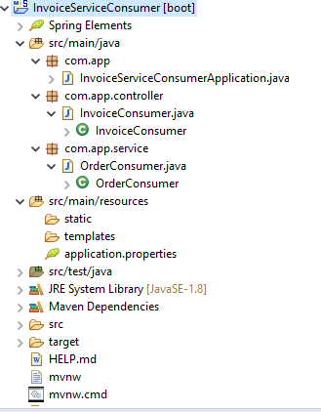
application.properties:--
server.port=8800
spring.application.name=INVOICE-CONSUMER
eureka.client.serviceUrl.defaultZone =http://localhost:8761/eureka

#1. Consumer starter class:--
#2. Consumer code(OrderConsumer.java):--
package com.app.service;
import org.springframework.beans.factory.annotation.Autowired;
import org.springframework.cloud.client.ServiceInstance;
import org.springframework.cloud.client.loadbalancer.LoadBalancerClient;
import org.springframework.http.ResponseEntity;
import org.springframework.stereotype.Service;
import org.springframework.web.client.RestTemplate;
@Service
public class OrderConsumer {

@Autowired
private LoadBalancerClient client;
public String getStatus() {
String path="/order/status";
//Choose Service instance based on SID
ServiceInstance instance=client.choose("ORDER-PROVIDER");
//Read URI from instance
String uri=instance.getUri().toString();
//Make http Request
RestTemplate rt = new RestTemplate();
ResponseEntity <String> resp=rt.getForEntity(uri+path, String.class);
return "CONSUMER=>"+resp.getBody();

} }

#2 Controller code (InvoiceProvider):--
package com.app.controller;
import org.springframework.beans.factory.annotation.Autowired;
import org.springframework.web.bind.annotation.GetMapping;
import org.springframework.web.bind.annotation.RequestMapping;
import org.springframework.web.bind.annotation.RestController;
import com.app.service.OrderConsumer;
@RestController
@RequestMapping("/invoice")
public class InvoiceConsumer {
@Autowired
private OrderConsumer consumer;
@GetMapping("/info")
public String getOrderStatus() {
return consumer.getStatus();
}
}
Execution:--
a>Start Eureka Server
b>Run OrderProvider starter class 3 times
*** Change every time Port number like : 9800,9801, 9802
c>Run InvoiceConsumer Starter class
d>Goto Eureka server Dashboad and Execute Invoice Consumer Instance and
type full URL http://localhost:8800/invoice/info

Spring Cloud Config Server:--

It is also called as Configuration Server. In Spring Boot/Cloud Projects, it contains files like : Properties files [application.properties]
=>In every application (Microservice) properties/yml file contain setup related keys like. (Database, ORM, Batch, Email, AOP, Security, Eureka Server, Gateway… etc) in the form of key=value.

=>In some cases Key=Value need to be changed or new key=value need to be added. At this time, we should
->Stop the Server (Application)
->Open/find application.properties file
->add External key=value pairs or do modifications.
->save changes [save file]
->Re-build file [re-create jar/war]
->Re-Deploy [re-start server]
=>In case of multiple microservices these common keys related for every Project.
And this is done in All related Project [Multiple Microservices] which is repeated task for multiple applications.
=>**In this case, Config Server concepts is used
**To avoid this repeated (or lengthy) process use application.properties this is placed outside of your Project i.e. known as “config Server”.

=>Writing common properties only one time outside of all project.
=>Easy to modify common properties (one place to modify properties files that effects all projects).
=>Every service instances not required to stop restart for effect for properties file modifications (Refresh Scope).

=>Config server Process maintains three (3) properties file. Those are:
a>One in = Under Project (Microservice)
b>One in = Config Server (link file)
c>One in = Config server (External-github) also called as Source file.

Types of Config Server:--
Spring Cloud has provided Setup and support for configuration properties. It can be handled in two ways. Those are
a>Native Config Server
b>External Config Server

a>Native Config Server:-- It is also called as local file placed in Config server only. In this case one properties file is created inside folder System (or drive).
Ex:-- D:/abc/myapp(Or Under config server location file).

b>External Config Server:-- In this case properties file is placed outside the Config server. Ex: GIT (github).
=> Here, Properties file is placed in External and accesses using its URL. It is also called as Global Location.
**”GIT HUB” is used in this process.

=>In Consumer/Producer Project we should add Config Client dependency which gets config server details at runtime.

=>Config server runs at default port=8888.

Step to implements Spring Cloud Config Server-Native & External:--

Step#1:- Create Spring Boot Starter Project for “Config-Server” with dependency : Config Server.
Config Server Dependency:--
<dependency>
<groupId>org.springframework.cloud</groupId>
<artifactId>spring-cloud-config-server</artifactId>
</dependency>
GroupId : org.app
ArtifactId : Config-Server
Version : 1.0

Step#2.a:- Native application.properties:-- Create folder “myapp-config” under src/main/resources.
server.port=8888
spring.profiles.active=native
spring.cloud.config.server.native.search-locations=classpath:/myapp-config

Case#2.b:- External application.properties
server.port=8888
spring.cloud.config.server.git.uri=https://github.com/javabyraghu/configserverex

Step#3:- Create sub folder “myapp-config” in src/main/resources folder.
=>Create file under “myapp-config” application.properties inside this folder. It behaves like source
Having ex key: eureka.client.serviceUrl.defaultZone=http://localhost:8761/eureka
Or

Create Git Project “configserverex” and create application.properties inside this. Place above key and save file.

Step#4:- Provider include resource code in pom.xml to consider properties files to be loaded into memory.
<resources>
<resource>
<filtering>true</filtering>
<directory>src/main/resources</directory>
<includes>
<include>*.properties</include>
<include>myapp-config</include>
</includes>
</resource>
</resources>

Step to configure External Config Server (only modifications):--
Step#1:- In Config Server Project, delete folder myapp-config
Step#2:- In Config Server Project modify application.properties with Git URI
server.port=8888
spring.cloud.config.server.git.uri=https://github.com/########

Step#3:- In config Server Project, in pom.xml delete line
<include>myapp-config </include>

Step#4:- Create git account and create externalconfigserverex Repository. Under this create file application.properties.

Config Server with Provider/Consumer Execution flow [External Source]:--

=>On Startup ConfigServer (CS) Application it will goto External Source (Git) and read __.properties (or) __.yml file having key=value pairs.

=>Then Provider/Consumer Application (On Startup) will try to read k=v from Config Server and merge with our application.properties.

=>If same key is found in both Config Server and Provider/Consumer App, then 1st priority is : Config Server.

=>After fetching all required props then Provider gets registered with Eureka Server.

=>Every Microservices( must have below dependency in pom.xml.
<dependency>
<groupId>org.springframework.cloud</groupId>
<artifactId>spring-cloud-starter-config</artifactId>
</dependency>

=>It behaves as Config Client connected to Config Server.
=>Above Config Client dependency will search forConfig Server in a default location given as : (key = value)

spring.cloud.config.uri=http://localhost:8888

=>To modify above location (IP or PORT) provide this key in Config Client setup using bootstrap.properties.

Q>What is bootstrap.properties in Spring Boot (cloud) Programming?
Ans:-- Our Project (child Project) contains input keys in application.properties, in same way Parent Project also maintains one Properties file named as : bootstrap.properties which will be loaded before our application.properties.

Q>What is the difference between application.properies file and bootstrap.properties file?
Ans:-- application.properties file is use to provide input to our application, where bootstrap.properties file is used to provide Input to parent project (or Configuration Setup) which gets run before our application.

Execution Order:-- 1>bootstrap.properties 2>application.properties

Order:-- Parent Project-loads bootstrap.properties /.yml or
Project-loads application.properties /.yml
->We can override this file in our project to provide key-values to be loaded by Parent Project.
**By default Config Server runs on http://localhost:8888 even config client also takes this as default location.
**To modify this IP/PORT use bootstrap.properties file in Our Project.
**In this bootstrap.properties file override key : spring.cloud.config.uri to any other location where Config Server is running.

Coding Changes for Config Server and Provider/Consumer Apps:--

Step#1:- Open application.properties file in Config Server Project and modify port number.
server.port =9999

Step#2:- In Provider/Consumer Project, create file bootstrap.properties under src/main/resources

Step#3:- Add key=value in bootstrap.properties file
spring.cloud.config.uri=http://localhost:8888
=>By default Config client will not get updates or modification from Config Server after starting client + microservice.
=>Only first time config Client fetch the data even to get new Modification after starting Client (without-Restart) use Annotation : @RefreshScope

=>At Config Server application add below dependency in pom.xml.
<dependency>
<groupId>org.springframework.boot</groupId>
<artifactId>spring-boot-starter-web</artifactId>
</dependency>

=>In application.properties (in Config Server) provide Native or External configuration details. This file is also called as Link file.
server.port=8888
spring.cloud.config.uri=http://localhost:8888
spring.cloud.config.server.git.uri=https://gitlab.com/#

Q>Which class will load bootstrap.properties file for config Server URI fetching?
Ans:-- ConfigServicePropertySourceLocator will read config server input by default from http://localhost:8888.
=>It is only first execution step in provider Consumer Project.

Provider/Consumer Application:--
Create any Microservice application with Dependencies : Web, Eureka Discovery, Config- Client.

Folder Structure of Microservice with bootstrap

Step#1:- Starter class
package com.app;
import org.springframework.boot.SpringApplication;
import org.springframework.boot.autoconfigure.SpringBootApplication;
import org.springframework.cloud.client.discovery.EnableDiscoveryClient;
import org.springframework.cloud.context.config.annotation.RefreshScope;
@SpringBootApplication
@EnableDiscoveryClient
@RefreshScope //Get updates from Config Server Automatically
public class OrderServiceProviderApp {

public static void main(String[] args) {
SpringApplication.run(OrderServiceProviderApp.class, args);
}
}
Step#2:- Controller class.
package com.app.controller;
import org.springframework.beans.factory.annotation.Value;
import org.springframework.web.bind.annotation.GetMapping;
import org.springframework.web.bind.annotation.RequestMapping;
import org.springframework.web.bind.annotation.RestController;
@RestController
@RequestMapping("/order")
public class OrderService {
@Value("${my.app : Hello Default One}")
private String port;
@GetMapping("/status")
public String getOrderStatus() {
return "FINISHED : :"+port;
}
}
Step#3:-1>application.properties:--
server.port=7800
spring.application.name=ORDER-PROVIDER
eureka.client.serviceUri.defaultZone=http://localhost:8761/eureka
eureka.instance.instance-id=${spring.application.name}:${random.value}
management.endpoints.web.exposure.include=*

2>bootstrap.properties:--
spring.cloud.config.uri=http://localhost:8888

Execution Order:--
1. Eureka Server
2. Config Server
3. MicroServices (Order)

=>Enter URL : http://192.168.100.27:7800/order/status

=>To enable refresh concept for microservices application (Order-APP), follow below steps.

***INSIDE ORDER-APP only.
<dependency>
<groupId>org.springframework.boot</groupId>
<artifactId>spring-boot-starter-actuator</artifactId>
</dependency>

