Infosys Springboard Virtual Internship 6.0 Completion Report

Team Details
Start date : 13th-Oct-2025
Name: Vaishnavi Ambhore
Internship Duration: 8 Weeks

Project Title:

NeuroFleetX - AI-Driven Urban Mobility Optimization

2. Project Objective
The main objective of this project was to build an intelligent route-optimization system capable of generating the shortest and fastest route between two locations. The goal was to understand backend–API communication, optimize geospatial data handling, and build a real-world logistics solution suitable for delivery, transportation, and fleet-management industries.

3. Project description in detail
Describe the internship project in detail. Include your approach, technology used, impact of this project in real world implementation.

4. Timeline Overview
Week | Activities Planned | Activities Completed
Week 1
  Build landing page with UI
  Completed landing page with responsive UI
Week 2 |  | Created login page for first portal
  Create login page
Week 3 | Add vehicle Booking | Completed Vehicle Booking
Week 4 |  | Built Fleet Manager Portal
  Build Driver Portal
Week 5 | Build Admin Portal | Completed Admin Portal
Week 6 |  | Created Customer Portal + Routed all portals
  Connect all portals and setup routing
Week 7 |  | Completed major debugging and UI corrections
  Bug fixing & feature refinement
Week 8
  Final completion, PPT & polishing
  Completed entire project + prepared PPT

5a. Key Milestones
Milestone | Description | Date Achieved
Project Kickoff | Requirements & project scope finalized | Week 1
Prototype/First Draft |  | Week 4
  Basic UI + API request working
Mid-Term Review
  Integrated backend with ORS successfully
  Week 5
Final Submission | Final working model + UI polish | Week 8
Presentation |  | Week 8
  Presented workflow, output, error handling

5b. Project execution details
The project execution followed an iterative and structured workflow:
• Requirement Analysis
Identified urban mobility challenges and prepared module-wise features.
• Frontend Development
Built responsive UI for Landing Page, Login, Booking, Customer Portal, Driver Portal, and Admin Portal.
• Backend Development (Spring Boot)
- Developed REST APIs for login, registration, bookings, vehicle data, and route handling
- Used controllers, services, and repositories
- Implemented validations and error handling
- Connected backend with database
• Route Optimization
Integrated routing API (ORS/Google Maps) using Spring Boot’s RestTemplate / WebClient.
Parsed geospatial data to compute shortest & fastest route.
• Portal Integration
Connected Customer, Driver, Fleet Manager, and Admin portals using role-based routes and API calls.
• Testing & Debugging
Used Postman for API testing.
Fixed routing issues, backend errors, and UI alignment problems.
• Final Deployment Preparation
Cleaned UI, improved workflow, and prepared PPT for final submission.

6. Snapshots / Screenshots
Include relevant visuals such as screenshots of work done, dashboards, code snippets, or designs.
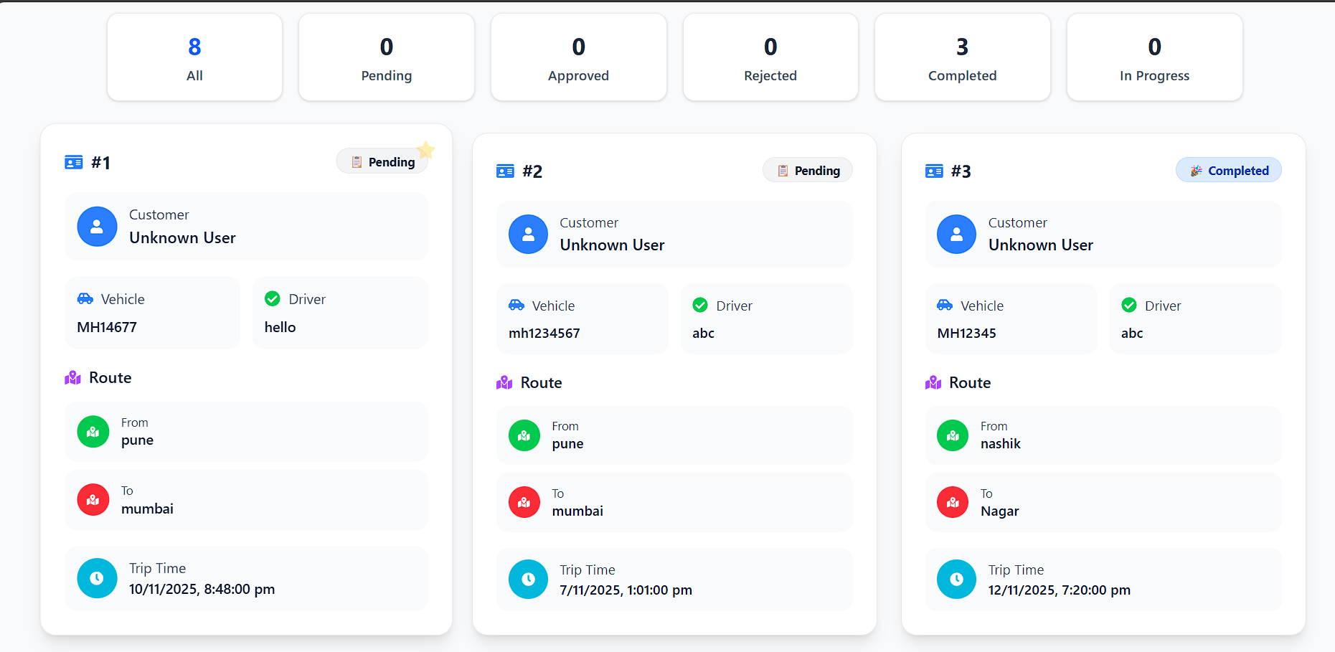
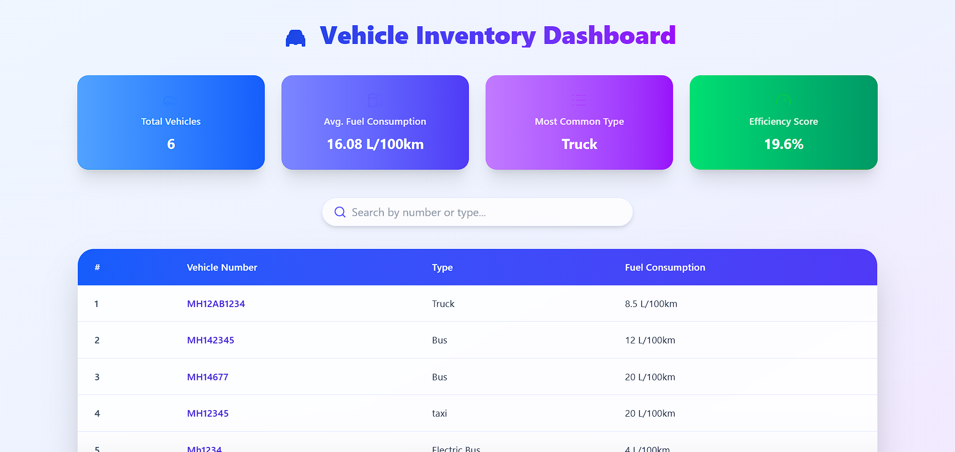

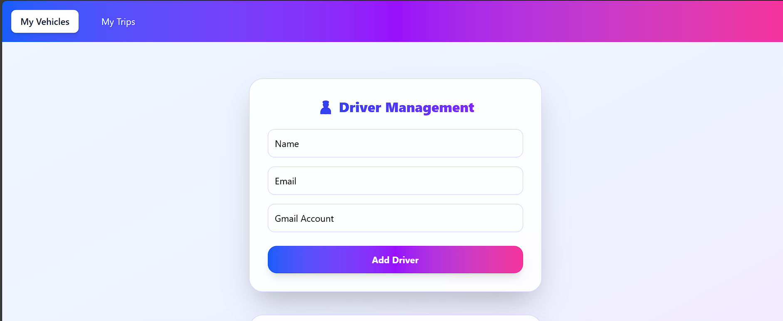

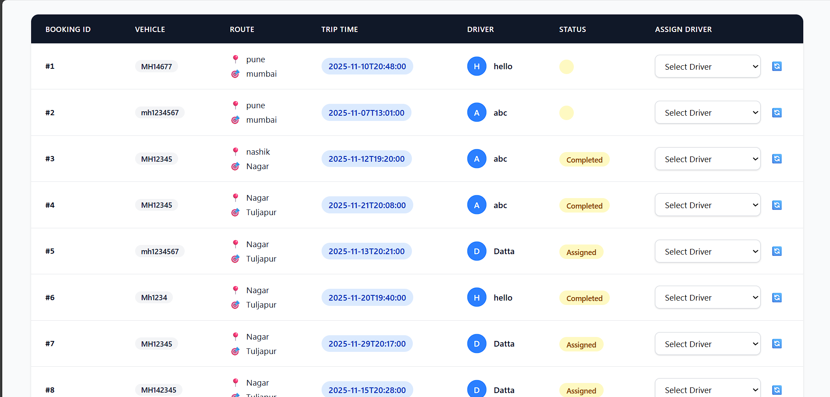

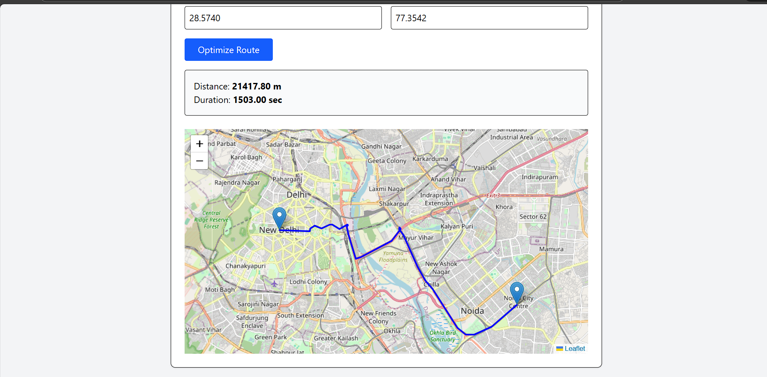

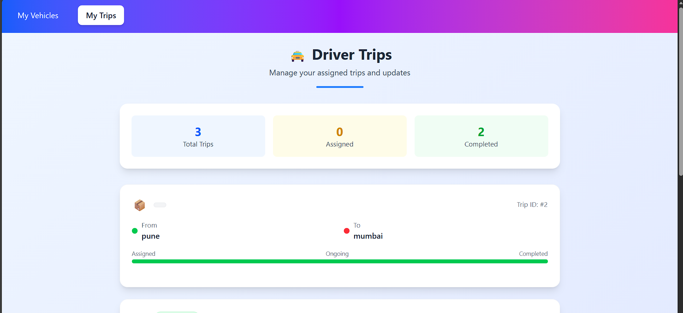

7. Challenges Faced
Technical Challenges
- Integrating ORS API and handling geospatial responses.
- Maintaining consistent UI across multiple portals.
- Managing state and routing errors in React.
Operational Challenges
- Coordinating multiple modules within the 8-week timeline.
- Ensuring proper testing of all portals.
Resolution
- Used Postman extensively to debug API issues.
- Broke tasks into smaller modules to stay on track.
- Conducted iterative testing every week to avoid final-stage errors.

8. Learnings & Skills Acquired
Technical Skills
- Frontend development with React.js
- Efficient styling using Tailwind CSS
- API handling (GET, POST, routing APIs)
- Backend creation using Springboot
- Geospatial data handling
- MySql database operations
- Version control with Git & GitHub
Soft Skills
- Team collaboration
- Time management
- Problem-solving
- Technical presentation skills

9. Testimonials from team
This internship gave us hands-on experience with real-world projects. We learned how modern fleet-management systems work and gained confidence in building full-stack solutions.

10. Conclusion
The Infosys Springboard Virtual Internship provided valuable industry-level exposure. Working on NeuroFleetX enhanced our full-stack development skills and gave us practical experience in smart mobility systems. This project aligns strongly with our career goals in software development and AI-driven solutions.

11. Acknowledgements
We sincerely thank Infosys Springboard, our mentors, and team members for their continuous support, guidance, and valuable learning opportunities throughout this internship journey.

