Outputs:-

Table: CARD_INFO:-

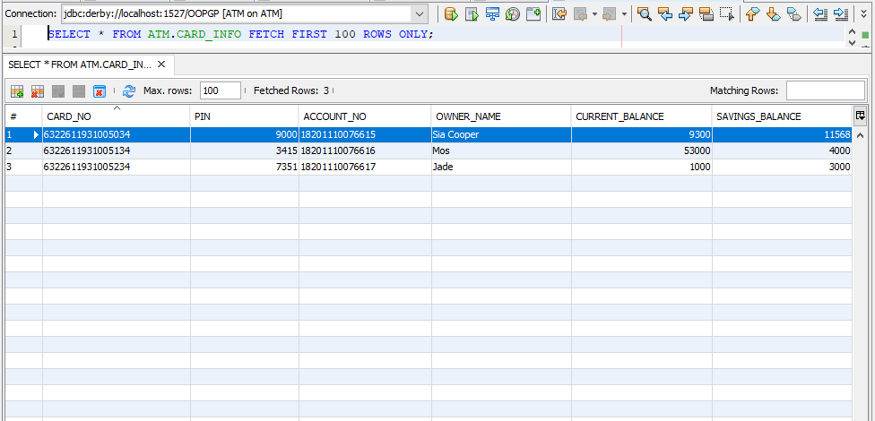

1.Enter incorrect pin:

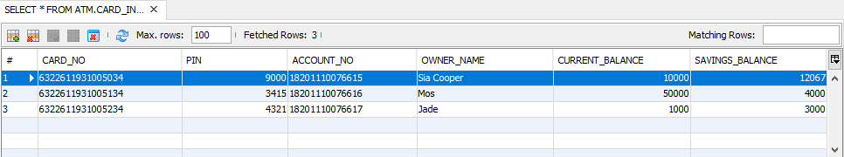

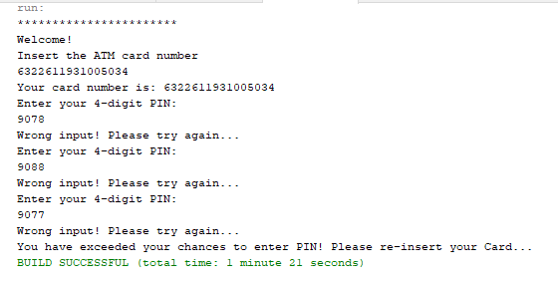

* Not entering 16 digit card number:

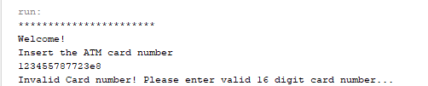

* Not entering valid card number:

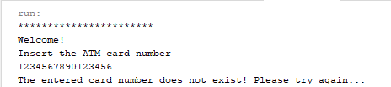

2.Entering correct pin:

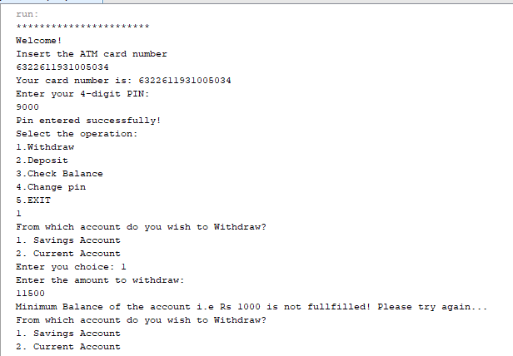

3.Entering incorrect amount of money to withdraw (Savings account):



4.Entering correct amount of money to withdraw (Savings account):

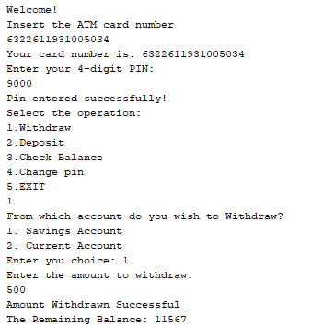

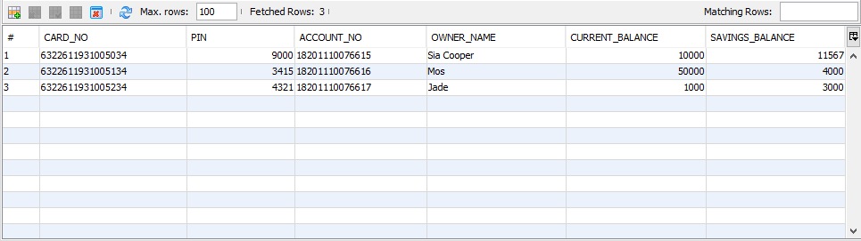

5.Entering incorrect amount of money to withdraw(Current account):

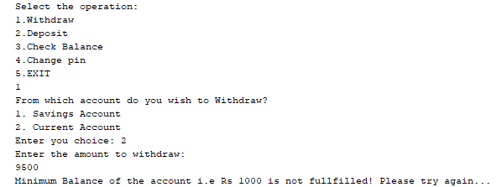

6.Entering correct amount of money to withdraw(Current account):

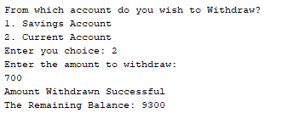

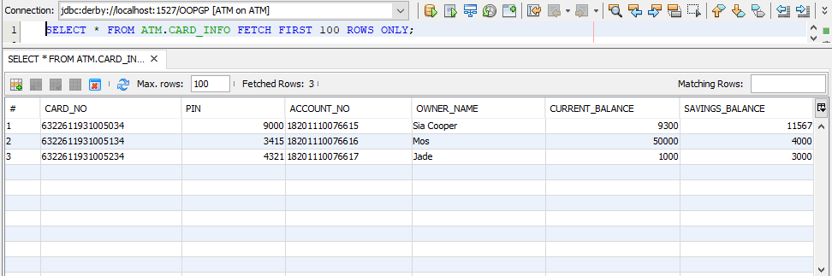

7.Deposit correct amount of money(Savings account):

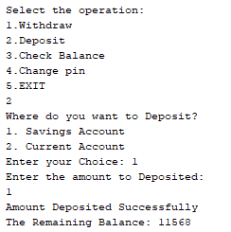

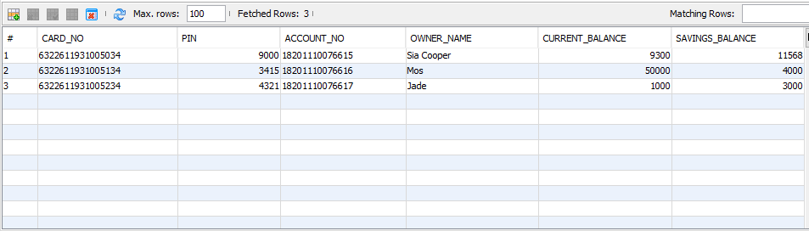

8.Deposit incorrect amount of money(Savings account):

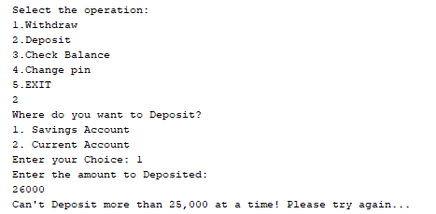

9.Deposit correct amount of money(Current account):

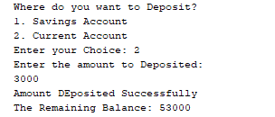

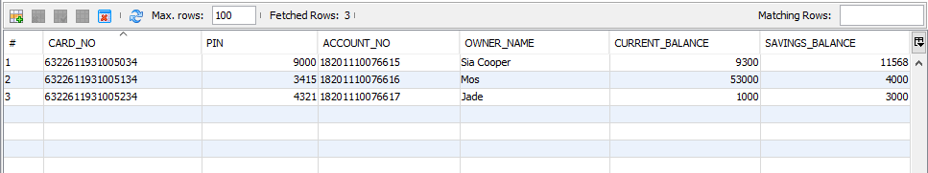

10.Deposit incorrect amount of money(Current account):

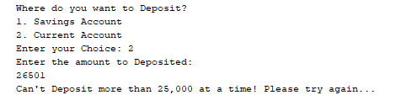

11. Check balance:

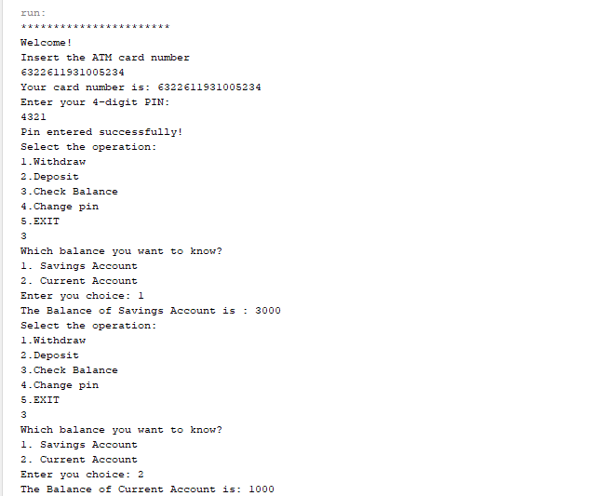

12. Change pin:

(successful operation)

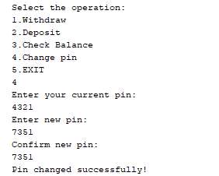

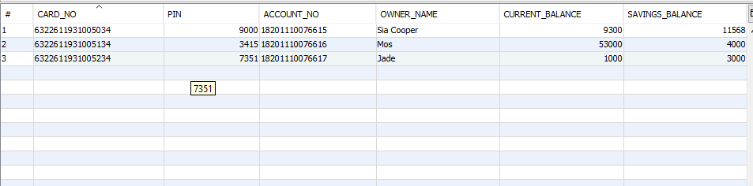

(unsuccessful operation):

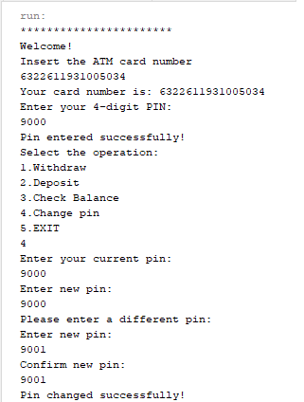

13.Exiting the system:

