VPC, Subnet, IGW, Route Table
Create VPC
- First create a VPC using vpc only
- Give a name tag
- Enable Ipv4 CIDR block with IP in some range - 10.10.0.0/16
- IPv6 CIDR block – no
- Keep everything default and click on create vpc
Create subnet
- VPC ID
- Select the VPC created recently from the drop-down .
- Subnet settings
- Give a subnet name and select 1 or 2 availability zone
- IPv4 VPC CIDR block will show the vpc ip/cidr - - 10.10.0.0/16
- Need to enter manually IPv4 subnet CIDR block - 10.10.0.0/24 – based on the no. IP requirements for project/organization (24,26…)
- Click on create subnet
Internet Gateway
- Click on Internet Gateway
- Give a name and click on create
Create route table
- Give a name and select vpc and click create
In case of Public subnet we should allow to IGW
Click on Route Tables from left menu
RoutesEdit routesAdd route igw (0.0.0.0/0)
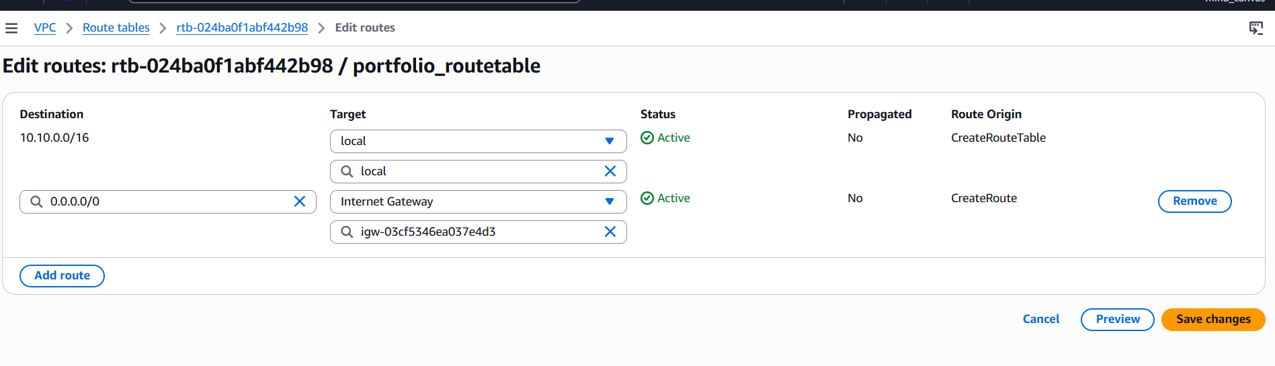
Network connectivity in private ec2 is achieved using NAT gateway
- Click on Nat Gateway – create give a name and save.
- We need to add this NAT to private route table – similar to IGW .
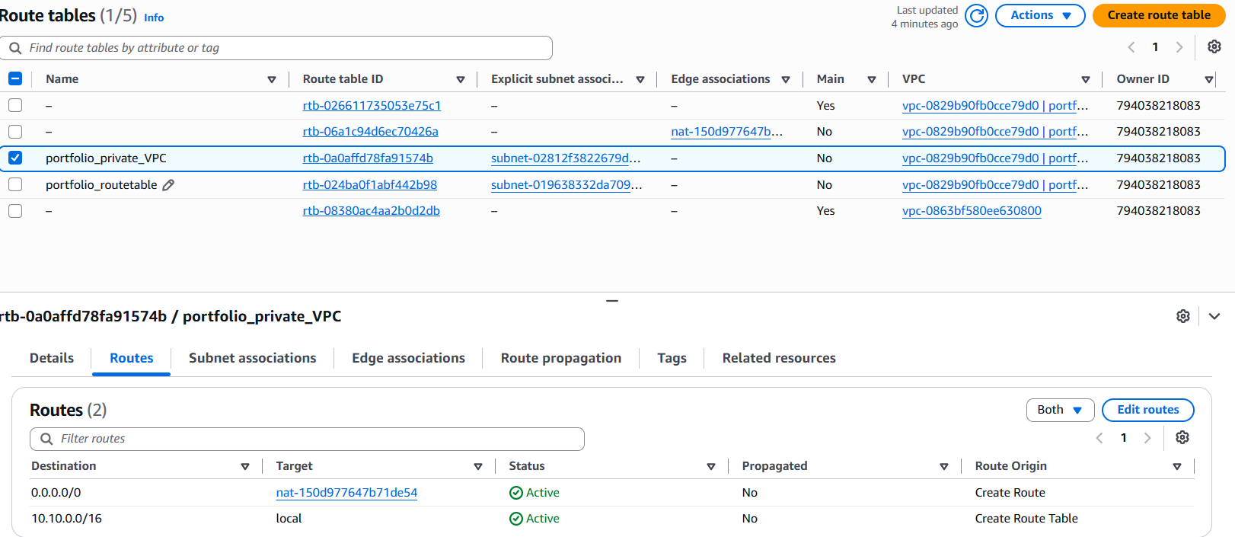
Click on edit routes and add from the drop-down list it also uses same as IGW (0.0.0.0/0) and save.
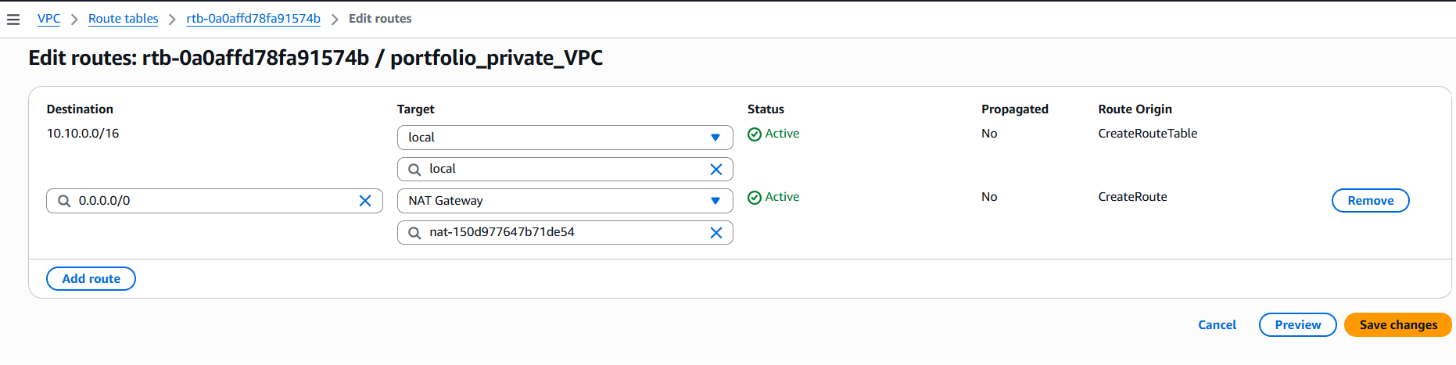

Steps to connect from Public ec2 to private ec2
Few pre-requisites to login to private ec2 from public ec2
- Key pair “ .pem “ file has to be in common for both instances if not have a copy of both keypair files in local
- Two options are there to have the public.key into public ec2 instance
- We can copy it from local desktop to public ec2 using powershell and below commands
- icacls.exe portfolio_key.pem /reset
- icacls.exe portfolio_key.pem /grant:r "$($env:USERNAME):R"
- icacls.exe portfolio_key.pem /inheritance:r
- scp -i portfolio_key.pem portfolio_key.pem ec2-user@13.127.157.240:/home/ec2-user/
This copies the pem file directly from local desktop to public ec2 instance in the specified path
- we can switch to root and create a file with .pem as type and copy the content of the key pair from local to the newly created file using below commands .
- sudo su
- nano key.pem
- Copy the text from the .csv file locally downloaded file in to key.pem and Ctrl+s and ctrl+x (save and exit)
- Check the permission of the pem file . It should be chmod 400 file . ,which means only read access to the file ,else change it .
- Now we can connect to private ec2 via below commands
ssh -i /home/ec2-user/portfolio_key.pem ec2-user@10.10.1.176 (this is the private ip)
- To copy a file from public ec2 to private ec2
scp -i /home/ec2-user/portfolio_key.pem /home/ec2-user/test.txt ec2-user@10.10.1.176:/home/ec2-user/
- To come out of private ec2 – type exit and crosscheck by seeing the hostname ip of public and private ec2

