**Personal Blog on IBM Cloud Static Web Apps**

**Design Thinking:**

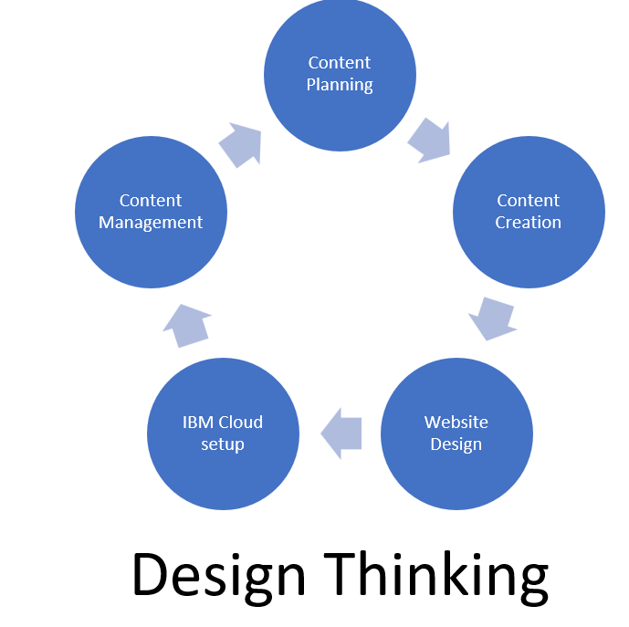

Content planning:

*Understand your audience: Who are your target readers?

*What are their interests and pain points?

*Explore competitors: Analyze other personal blogs to identify strengths and weaknesses.

*Collect user feedback: If you have an existing blog, gather feedback to understand user needs.

Content creation:

*Clearly define the problem you want to address. For example, it could be "Creating a personal blog that engages readers and provides valuable content."

*Create a user persona: Develop a detailed profile of your ideal reader, including demographics, goals, and challenges.

*Define success metrics: What key performance indicators (KPIs) will help you measure the blog's success? Examples include page views, engagement, and subscriber growth.

Website Design:

*Brainstorm ideas for your personal blog. Think about content themes, visual design, and interactive elements.

*Consider different features and functionalities. How can you make your blog stand out?

*Don't discard any idea at this stage; the goal is to generate a variety of possibilities.

IBM cloud setup:

Step 1: Create Your Blog

*Create a new directory for your blog project on your local machine.

*Initialize your static site generator .

*Choose a theme and configure your blog content and settings following the instructions provided by your static site generator.

*Build your static site.

Step 2: Set Up IBM Cloud

*Log in to your IBM Cloud account using the CLI.

*Target the appropriate resource group and region.

Step 3: Create a GitHub Repository

*Create a new GitHub repository to host your blog source code. Initialize a Git repository in your blog folder, commit your code, and push it to GitHub.

Step 4: Create an IBM Cloud Static Web App

*Create a Static Web App in IBM Cloud.

*Configure your Static Web App. You'll need to specify your GitHub repository URL and branch, as well as other settings like build command and output directory.

*Deploy your static site to IBM Cloud.

*Once the deployment is complete, you will receive a URL for your static blog. You can access it in your web browser.

Step 5: Configure DNS (Optional)

*If you want to use a custom domain for your blog, configure the DNS settings accordingly by creating a CNAME record that points to the URL of your IBM Cloud Static Web App.

Step 6: Update Your Blog

*To update your blog, make changes to your local code, commit the changes, and push them to your GitHub repository.

*The IBM Cloud Static Web App service will automatically rebuild and redeploy your site based on the changes in your repository.

Content Management:

*Based on the feedback and insights from testing, refine and improve your blog.

*Incorporate additional features and content as you iterate.

*Ensure the blog is responsive and works well on various devices and browsers.

Problem Definition:

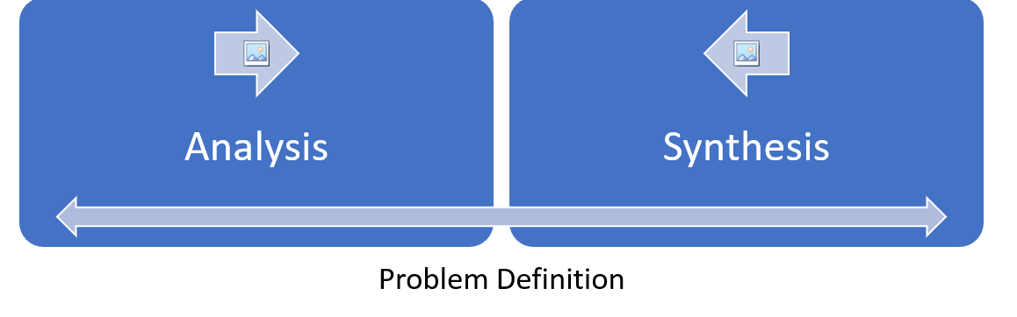

Analysis:

User Research:

*Conduct surveys, interviews, or use analytics tools to understand your target audience's preferences, behaviors, and pain points.

*Analyze competitors' blogs to identify design trends, content strategies, and areas where you can differentiate yourself.

Content Analysis:

*Assess the types of content you plan to publish and categorize them (e.g., articles, videos, infographics).

*Determine the frequency and consistency of content updates.

Performance Evaluation:

*Use website performance testing tools to evaluate loading times, server response times, and overall website speed.

*Check for any bottlenecks or issues that might affect user experience.

Synthesis:

User Personas:

*Create detailed user personas based on your research findings to guide your design and content decisions.

Content Strategy:

*Develop a content strategy that aligns with your target audience's interests and needs.

*Define content categories, posting schedules, and themes.

Design Concepts:

*Synthesize design ideas from your research to create design concepts that reflect your blog's identity and meet user preferences.

*Experiment with color palettes, typography, and layout options.

Performance Optimization Plan:

*Based on performance analysis, develop a plan to optimize loading times and overall website performance.

*Consider techniques such as image compression and caching.