Personal Travel Blog using static web apps

## **Create a bucket configured for public access**

Creating a bucket for a static website will require public access. There are a number of options for configuring public access. Specifically, using the ObjectReader [IAM role](https://cloud.ibm.com/docs/cloud-object-storage?topic=cloud-object-storage-iam) will prevent the listing of the contents of the bucket while still allowing for the static content to be viewed on the internet. If you want to allow the viewing of the listing of the contents, use the ContentReader [IAM role](https://cloud.ibm.com/docs/cloud-object-storage?topic=cloud-object-storage-iam) for your bucket.

### Create a bucket

Once you login to the Console and after you create an instance of IBM Cloud Object Storage, you can create a bucket. Click on the button labeled "Create bucket" and choose from the options as shown in Figure 1. Select the card that reads "Customize your bucket."

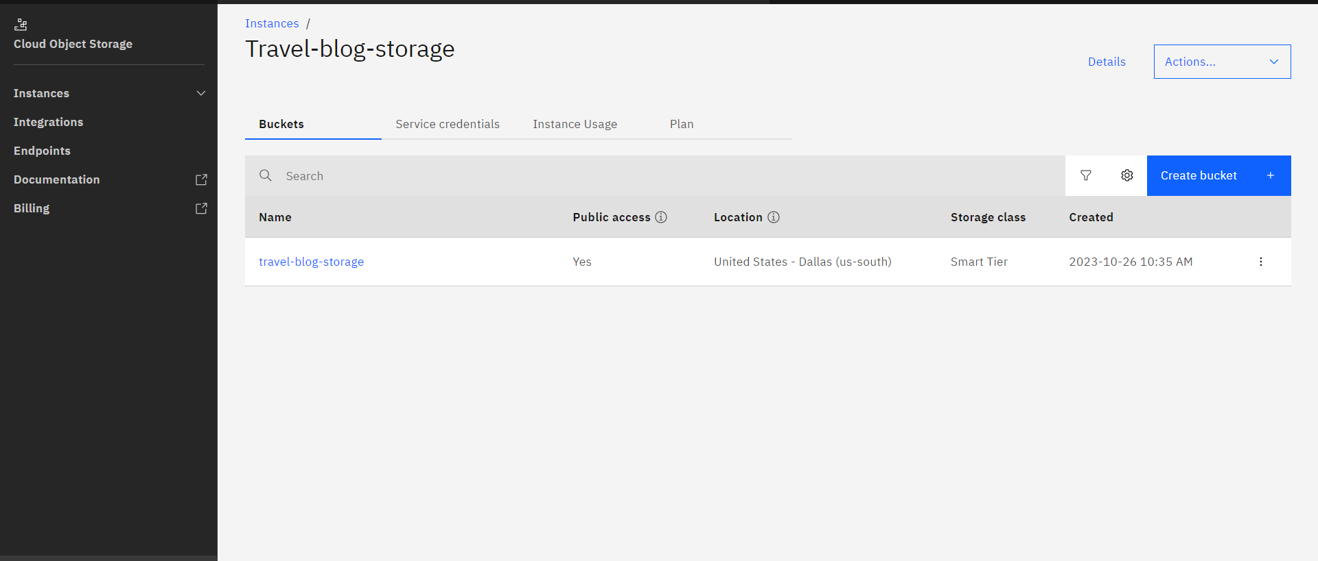

**Setting public access**

In all scenarios for this tutorial, you will want to use the UI at the Console to allow public access to your new website.

When creating a bucket for hosting Static Website content, there is an option to enable public access as part of the bucket creation process. See Figure 3 for the option to enable public access to your bucket. For the explanation of the options for the "index document" and "error document" as shown, find more below in the section Configure the options for your website. You may complete the basic configuration with this step, before uploading content to your bucket as shown in the next step.Enable public access.

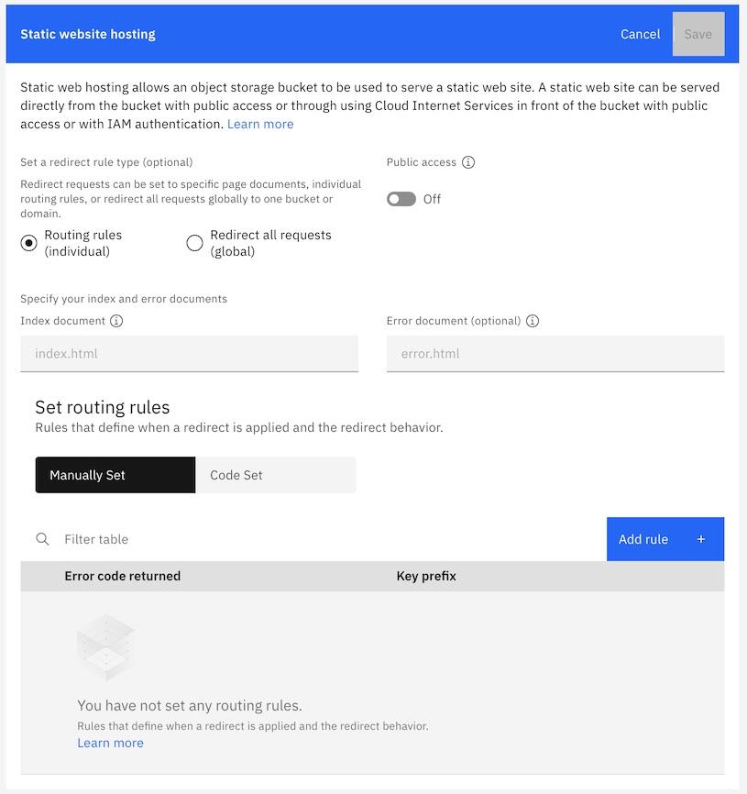

## **Upload content to your bucket**

## The content of your hosted static website files focuses naturally on information and media. A popular approach to creating content for static websites are open source generators listed at [StaticGen](https://www.staticgen.com/). For the purpose of this tutorial, we only need two files:

* An index page, typically written in HTML and named index.html, that loads by default for visitors to your site
* An error page, also in HTML and here named error.html; typically the error page is loaded when a visitor tries to access an object that isn't present or doesn't have public access

Other files, like images, PDFs, or videos, can also be uploaded to your bucket (but this tutorial will focus only on a minimum set of requirements).

You may have already completed the basic configuration for hosting your static website. Files can be uploaded directly in the Console once you've named and configured your bucket. Note the step is optional as shown in Figure 4, and can occur at any point before the testing of your new hosted website.

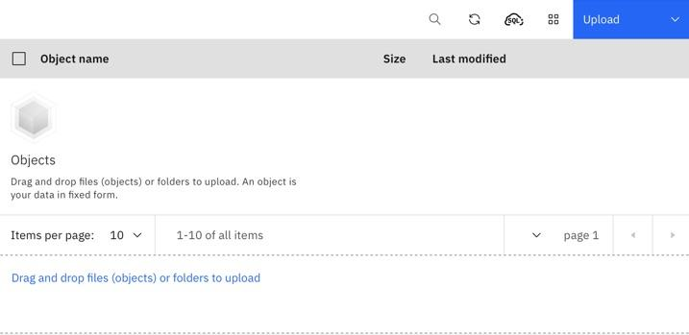

**Uploading Website Contents:**

Create the folder with HTML contents and CSS files and upload files to deploy the website.

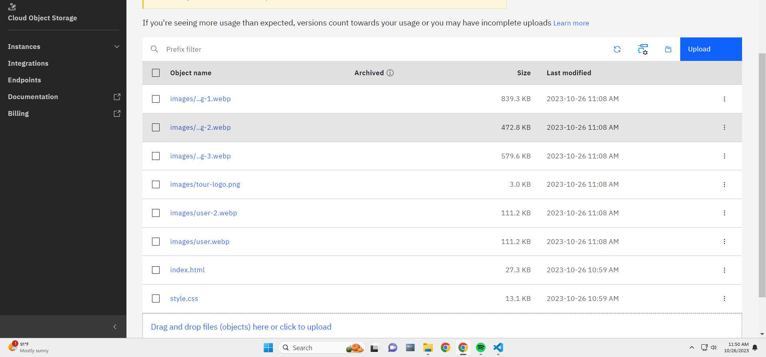

**Generating The website link:**

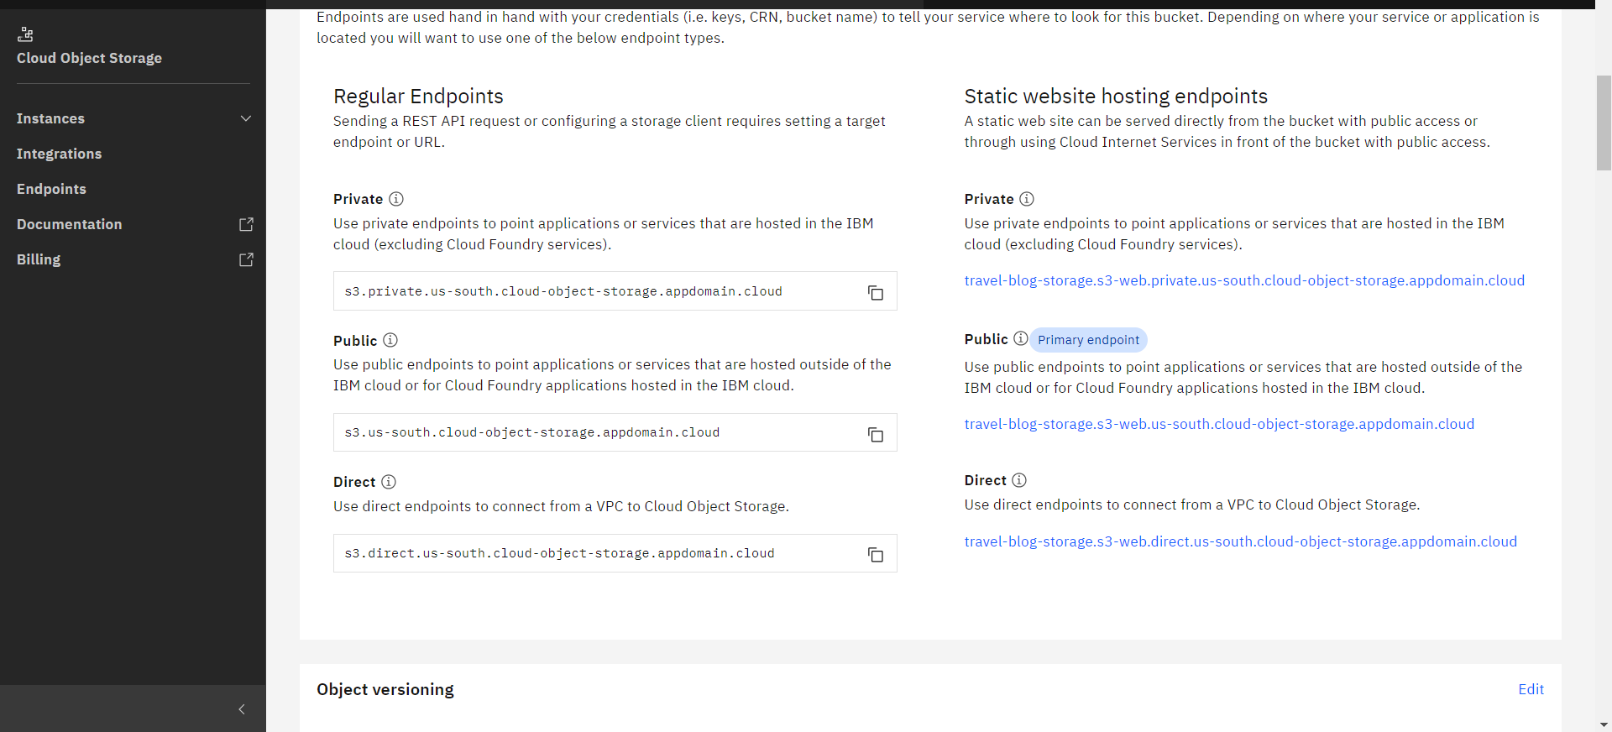

**Static web link:**

[**https://travel-blog-storage.s3-web.us-south.cloud-object-storage.appdomain.cloud/**](https://travel-blog-storage.s3-web.us-south.cloud-object-storage.appdomain.cloud/)

