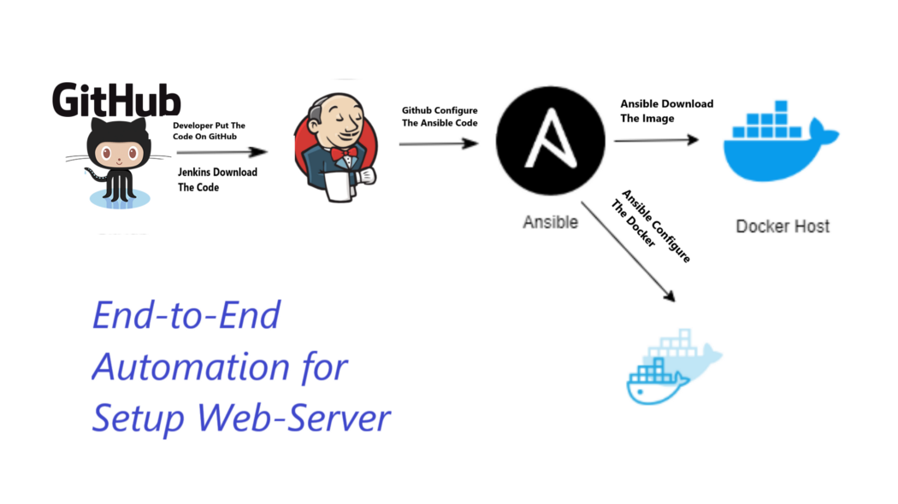

Install plugins : Ansible , [Build Pipeline,](https://plugins.jenkins.io/build-pipeline-plugin" \t "http://3.84.92.178:8080/pluginManager/_blank) Maven Integration.

Add Global Tool Configuration: Git credentials, Java & Maven home path and Ansible execution path.

1. **Write the code on local and push it to git.**

Git and maven installed

Create a maven web project: mvn archetype:generate -DgroupId=com.sample.webproject -DartifactId=SampleWebApp -DarchetypeArtifactId=maven-archetype-webapp -DinteractiveMode=false

SampleWebApp/

├── pom.xml

└── src

└── main

├── resources

└── webapp

├── index.jsp

└── WEB-INF

└── web.xml

git init

git add .

git commit -m "first commit"

git branch -M main

git remote add origin <https://github.com/vikas99341/jenkins-ansible-> integration.git

git push -u origin main

1. **Integrate git and Jenkins**

systemctl enable Jenkins

service Jenkins status

write the code and run it

1. **Install Ansible on the Jenkins server**

Install ansible plugin

Change global tool configuration details

1. **Run the job**

https://github.com/vikas99341/jenkins-ansible-integration