**BY:**

Personal Blog on IBM Cloud Static Web Apps

**M.Vaishale**

**PHASE 2: Innovation**

**Project Definition:**

The project is to create a personal travel blog hosted on IBM Cloud Static Web Apps. The goal is to share travel adventures, tips, and captivating photos to inspire others to explore the world and create unforgettable memories. This involves designing the blog structure, creating engaging content, setting up the IBM Cloud Static Web Apps, and ensuring ease of updating the blog.

**Abstract:**

Our Project is a captivating personal travel blog hosted on IBM Cloud Static Web Apps. This blog is an immersive window into the adventures, insights, and captivating moments experienced by an avid explorer. From the pristine beaches of Bali to the bustling streets of Tokyo, every blog post is a narrative that takes readers on a visual journey through picturesque destinations and shares invaluable travel tips.

The blog's IBM Cloud Static Web Apps hosting ensures seamless updates, making it easy for the author to chronicle their ongoing adventures. With engaging content, stunning photography, and insightful travel guides, Our Project inspires readers to embark on their own journeys and discover the beauty of the world.

Explore the world through the eyes of a passionate traveler, and let our project be your guide to forging unforgettable memories and igniting your own wanderlust.

**There are 2 major steps in our Project:**

* Creation and Designing of the Blog
* Deployment of the blog using IBM cloud services

**Creation and Designing of the Blog:**

* As Initial step, We will be creating a blog which focuses on sharing the experience and igniting the wanderlust spirit within people by sharing our experience as a form of blog which can reach wider range of audiences.
* In the next step we will be creating our blog using a blogging platform either with wordpress.com or blogger.com.
* As the next step we will be registering our domain name as needed for better access throughout the internet.
* After setting up my blog and creating the blog pages as required,we will be uploading or induce our content within the blog.
* Then we have created social media profiles for our blog on platforms like Facebook, Twitter, Instagram, and Pinterest. We will share our blog posts and engage with our audience.
* Now our blog is designed and ready for deployment.

**Deployment of the blog using IBM cloud services:**

Since our blog is a Static website we will carry out the process of hosting our Blog according to that method.

Hosting static websites on IBM Cloud uses [Cloud Object Storage](https://www.ibm.com/cloud/object-storage) (COS) and [Cloud](https://www.ibm.com/cloud/cloud-internet-services) [Internet Services](https://www.ibm.com/cloud/cloud-internet-services) (CIS) (with [Page Rules](https://cloud.ibm.com/docs/infrastructure/cis?topic=cis-use-page-rules) and [Edge Function](https://cloud.ibm.com/docs/infrastructure/cis?topic=cis-edge-functions)s). These services provide the following features needed to serve static websites.

* **Auto-serving static assets from provider-managed HTTP service (Cloud Object Storage).**
* **Custom domain support to serve content from user-controlled domain name (CIS - Page Rules).**
* **Conﬁgurable Index and Error documents (CIS - Edge Functions).**

Here are the steps needed to host a static website on IBM Cloud by combining those services.

# Serving static assets

IBM Cloud Object Storage is a scalable storage solution for cloud applications. Files are managed through a [RESTful HTTP API](https://cloud.ibm.com/docs/services/cloud-object-storage?topic=cloud-object-storage-compatibility-api) and stored in user-deﬁned collections called “buckets”. Bucket ﬁles are returned as HTTP responses from [HTTP GET requests](https://cloud.ibm.com/docs/services/cloud-object-storage?topic=cloud-object-storage-compatibility-api&compatibility-api-object).

COS supports an optional “*anonymous read-only access*” [setting for buckets](https://cloud.ibm.com/docs/services/cloud-object-storage?topic=cloud-object-storage-iam-public-access). This means all ﬁles in the bucket will be accessible using anonymous HTTP GET requests.

Putting HTML, CSS and JS ﬁles in a public bucket allows static websites to be served directly by COS. Users are charged for bandwidth used and HTTP requests

received for all bucket ﬁles.

Create IBM Cloud Object Storage instance

*If you already have an instance of Cloud Object Storage you can skip this step…*

* Provision [a new instance](https://cloud.ibm.com/catalog/services/cloud-object-storage) of IBM Cloud Object Storage

Create IBM Cloud Object Storage Bucket

* Open the COS instance from the [Resource List](https://cloud.ibm.com/resources).
* [Create a new COS bucket](https://cloud.ibm.com/docs/services/cloud-object-storage?topic=cloud-object-storage-getting-started&gs-create-buckets) to host the static site ﬁles.
  + Choose a Bucket name
  + Choose the Resiliency, Location and Storage Class options for the bucket.

*Any choices for these options can be used - it does not affect the static site hosting capability. For more details on what they mean, please see this* [*documentation*](https://cloud.ibm.com/docs/services/cloud-object-storage?topic=cloud-object-storage-classes)*.*

Upload Static Assets To Bucket

* [Upload static ﬁle assets](https://cloud.ibm.com/docs/services/cloud-object-storage?topic=cloud-object-storage-upload) to the new bucket.

Enable Public Access to bucket ﬁles

* Click the *“Access Policies”* menu item from the bucket level menu.
* Click the “*Public Access*” tab from the bucket access policy page.
* Check the Access Group drop-down has “*Public Access*” option selected.
* Click the “*Create access policy*” and then “*Enable*” on the pop menu.

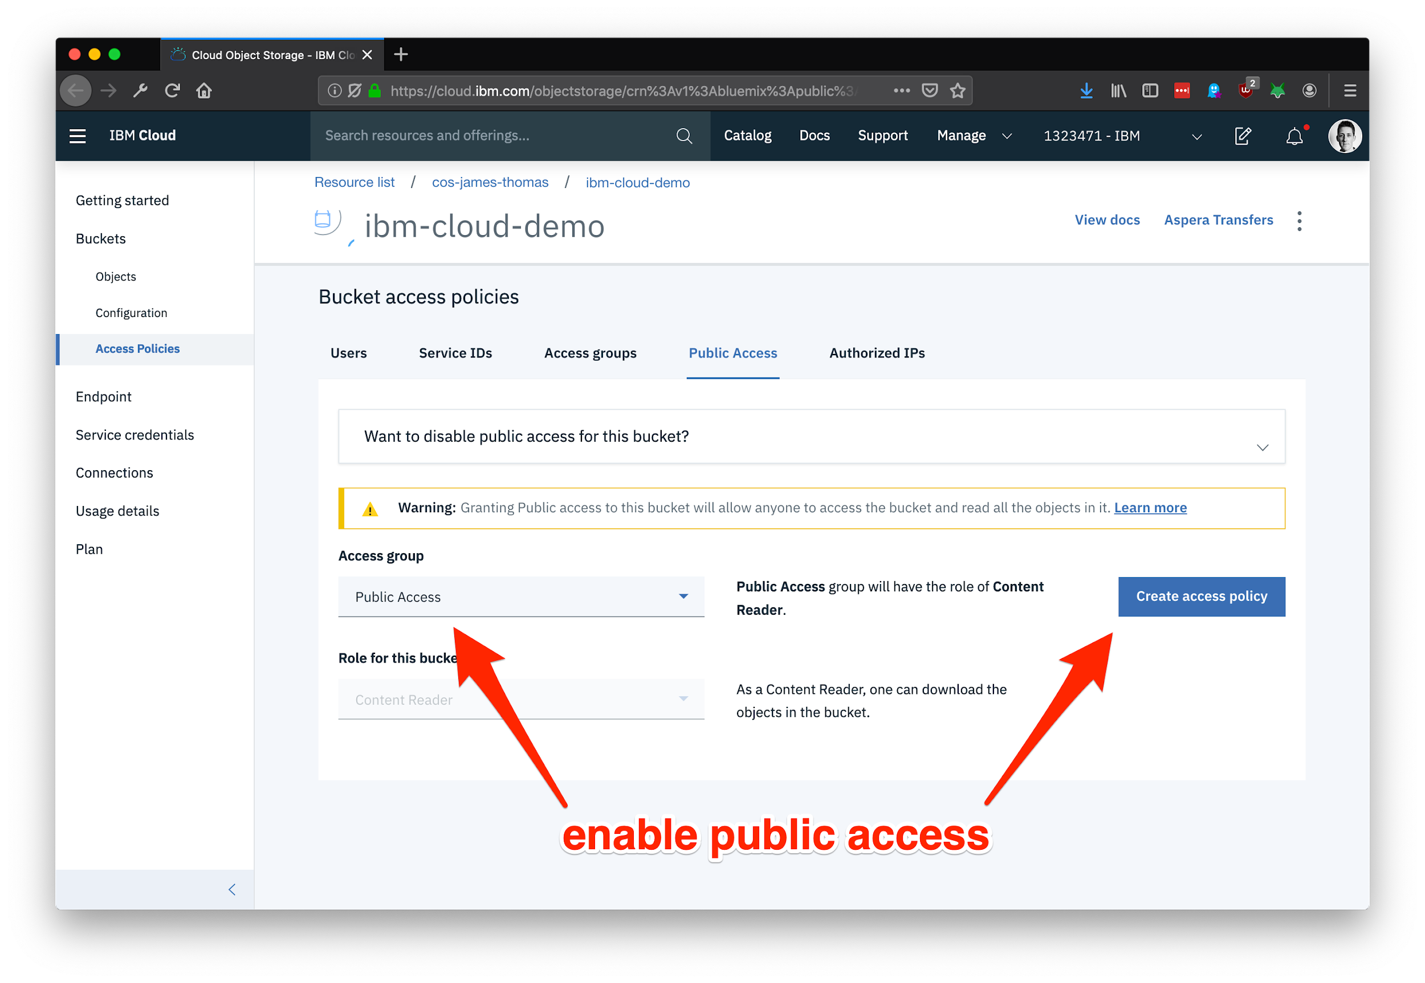

Check bucket ﬁles are accessible

Bucket ﬁles should now be accessible using the service endpoint URL, bucket id and ﬁle names. COS supports providing the bucket name in the URL path or a sub-domain on the service endpoint.

* Open the “*Conﬁguration*” panel on the bucket page.
* Retrieve the **public endpoint** shown, e.g.

s3.<REGION>.cloud-object-storage.appdomain.cloud

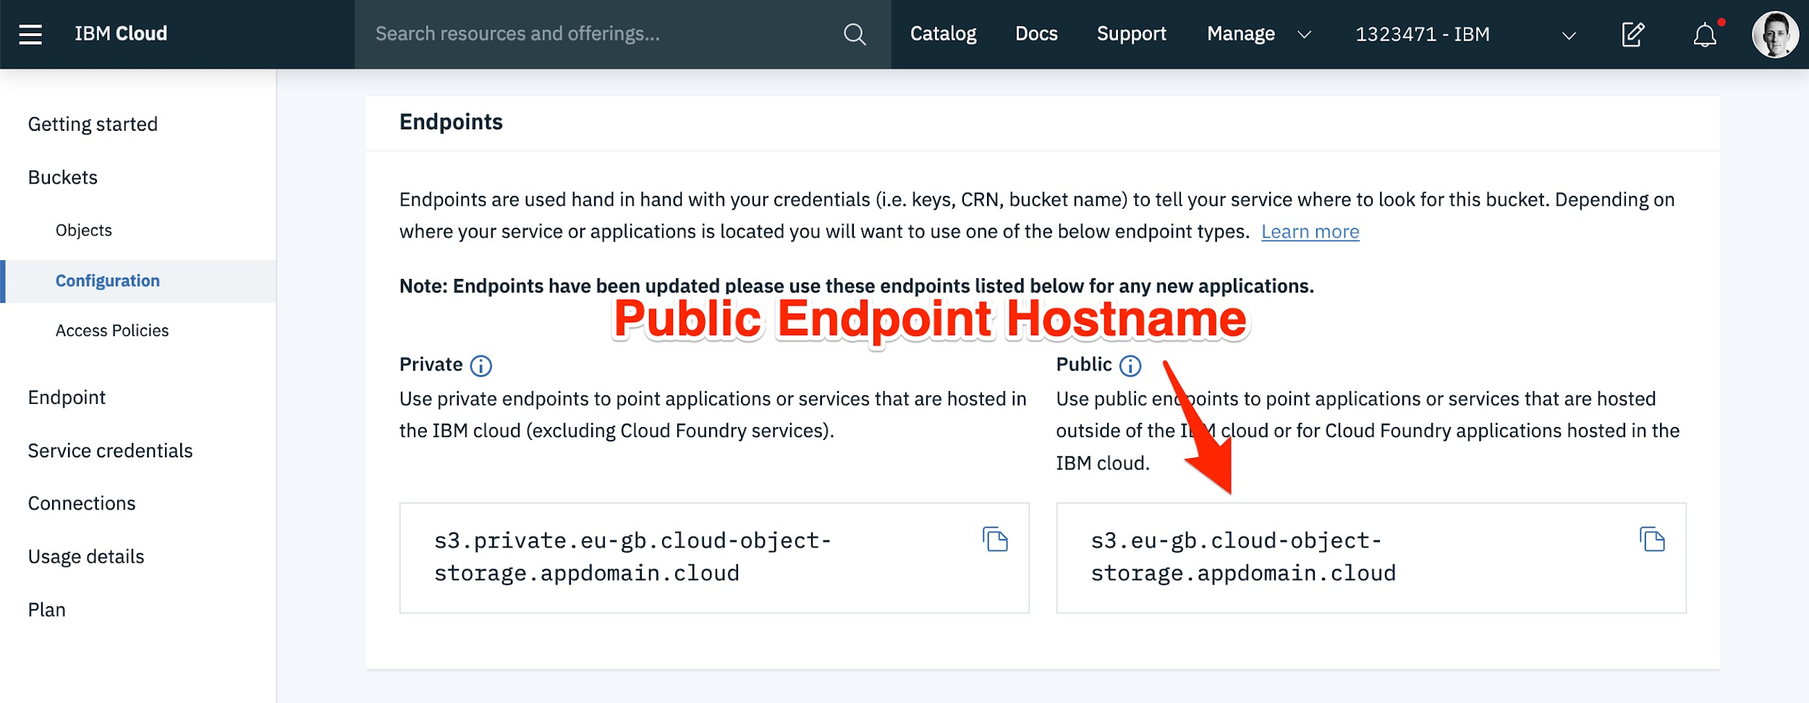

**Bucket ﬁles (like index.html) should now be accessible by a web browser.** COS supports both HTTP and HTTPS traﬃc. Bucket ﬁles are available using the following URLs.

vhost addressing

<BUCKET_NANME>.s3.eu-gb.cloud-object-storage.appdomain.cloud

/index.html

url path addressing

s3.<REGION>.cloud-object-storage.appdomain.cloud/<BUCKET_NAN ME>/index.html

Bucket ﬁles can now be referenced directly in external web applications. COS buckets are often used to store large application assets like videos or images. **For hosting an entire website, it is often necessary to serve content from a custom domain name, rather than the COS bucket hostname.**

# Custom domain support

Cloud Internet Services Page Rules can [automatically conﬁgure custom domain](https://cloud.ibm.com/docs/infrastructure/cis?topic=cis-resolve-override-cos) support for COS buckets.

[CNAME](https://en.wikipedia.org/wiki/CNAME_recor) DNS records are created to alias the custom domain to the COS bucket hostname. All traﬃc to the custom domain will then be forwarded to the COS service.

When COS serves ﬁles from bucket sub-domains, the HTTP Host [request header](https://stackoverflow.com/questions/43156023/what-is-http-host-header) [value](https://stackoverflow.com/questions/43156023/what-is-http-host-header) to determine the bucket name. With CNAME DNS records, this header value will still refer to the custom domain, rather than the bucket sub-domain. This ﬁeld

needs to be dynamically updated with the correct value.

Create IBM Cloud Internet Services instance

* Provision a new instance of [Cloud Internet Services](https://cloud.ibm.com/catalog/services/internet-services).

Register Custom Domain name with Cloud Internet Services

* Follow the [documentation](https://cloud.ibm.com/docs/infrastructure/cis?topic=cis-getting-started&add-configure-your-domain) on how to register a custom domain with Cloud Internet Services.

*This process involves delegating name server control for the domain over to IBM Cloud Internet Services.*

Conﬁgure Page Rules and DNS records (automatic)

Cloud Internet Services [can automatically set up](https://cloud.ibm.com/docs/infrastructure/cis?topic=cis-resolve-override-cos) Page Rules and DNS records needed to forward custom domain traﬃc to COS buckets. This automatically exposes the bucket as bucket-name.your-domain.com. If you want to change this default sub-domain name, follow the manual steps in the next section.

* Click the Performance drop-down menu and click the “*Page Rules*” link.
* Click the “*Create rule*” button from the table.
* Select the Rule Behaviour Setting as “*Resolve Override with COS*”
* Select the correct COS instance and bucket.
* Click the “*Create*” button.

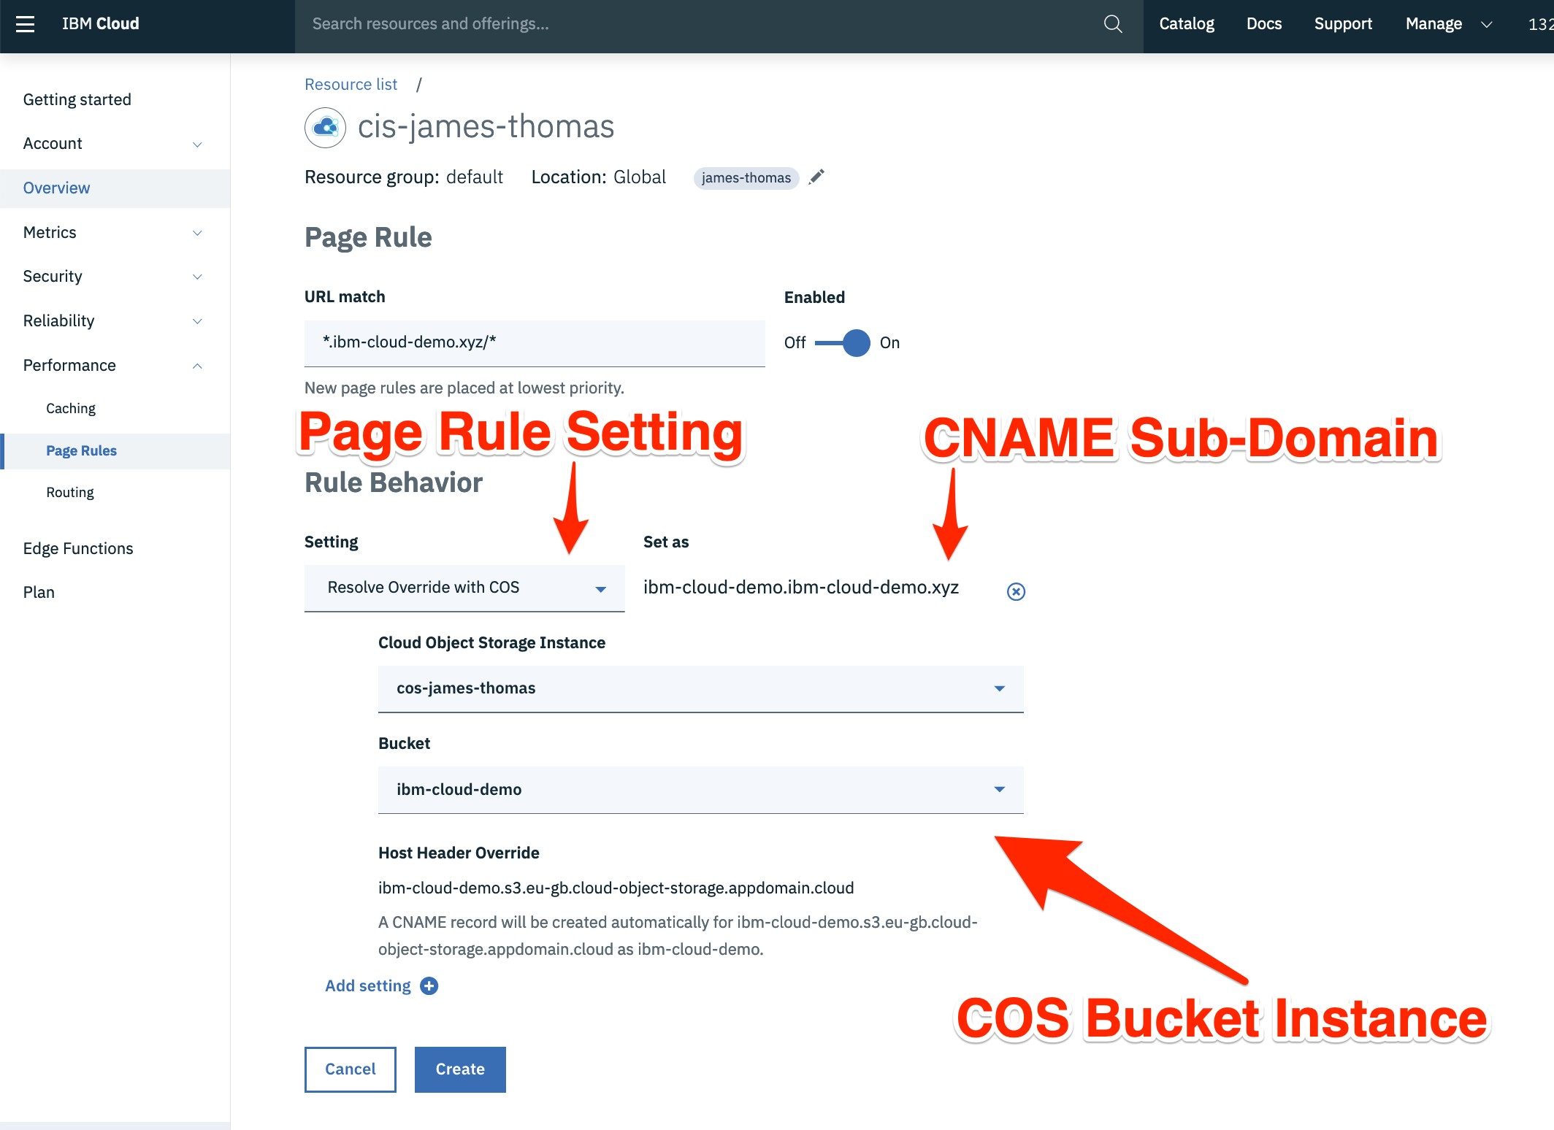

**Once DNS records have propagated, bucket ﬁles should be accessible using the custom domain**: http(s)://<CUSTOM_DOMAIN>/index.html.

Conﬁgure Page Rules and DNS records (manual)

*These steps only need following if you haven’t done the section above….*

Create the Page Rule to modify the HTTP host header.

* Click the Performance drop-down menu and select the “*Page Rules*” link.
* Click the “*Create rule*” button from the table.
* Set the URL match ﬁeld to be <SUB_DOMAIN>.<CUSTOM_DOMAIN>/*
* Select the Rule Behaviour Setting as “*Host Header Override*” as the custom bucket

sub-domain:<BUCKET_NANME>.<REGION>.eu-gb.cloud-object-stor age.appdomain.cloud

Create the DNS CNAME record to forward traﬃc to COS.

* Click the Reliability drop-down menu and click the “*DNS*” menu entry.
* Add a new DNS record with the following values.
  + **Type:** *CNAME*
  + **Name:** *<custom subdomain host>*
  + **TTL:** *Automatic*
  + **Alias Domain Name:** *<COS bucket sub-domain>*

*Name* is the sub-domain on the custom domain (e.g. www) through which the COS bucket will be accessible. *Alias Domain Name* is the COS bucket sub-domain from above, e.g.

<BUCKET_NANME>.<REGION>.eu-gb.cloud-object-storage.appdomain

.cloud

* Once the record is added, set the Proxy ﬁeld to true. This is necessary for the page rules to work.

**Once DNS records have propagated, bucket ﬁles should be accessible using the custom domain.**

# Conﬁgurable Index and Error pages

COS will now serve static assets from a custom sub-domain, where ﬁle names are explicitly included in the URL, e.g. http(s)://<CUSTOM_DOMAIN>/index.html. This works ﬁne for static websites with two exceptions, the default document for the web site and the error page.

When a user visits the COS bucket sub-domain without an explicit ﬁle path (http(s)://<CUSTOM_DOMAIN>), the COS service will return the [bucket ﬁle list](https://cloud.ibm.com/docs/services/cloud-object-storage?topic=cloud-object-storage-compatibility-api-bucket-operations&compatibility-api-list-objects-v2), rather than the site index page. Additionally, if a user requests a missing ﬁle, COS returns an [XML error message](https://cloud.ibm.com/docs/services/cloud-object-storage?topic=cloud-object-storage-compatibility-common&compatibility-errors) rather than a custom error page.

Both issues can be resolved using [Edge Functions](https://www.ibm.com/cloud/blog/edge-computing-for-serverless-applications?mhsrc=ibmsearch_a&mhq=edge%20functions), a new feature in Cloud Internet Services.

Edge Functions

[Edge functions](https://cloud.ibm.com/docs/infrastructure/cis?topic=cis-edge-functions) are JavaScript source ﬁles deployed to Cloudﬂare’s Edge locations. They can dynamically modify HTTP traﬃc passing through Cloudﬂare’s network (for domains you control). Custom edge functions are triggered on conﬁgurable URL routes. Functions are passed the incoming HTTP request and control the HTTP response returned.

Add Edge Function to provide Index & Error Documents

Using a custom edge function, HTTP traﬃc to the custom sub-domain can be modiﬁed to support Index and Error documents. Incoming HTTP requests without an explicit ﬁle name can be changed to use the index page location. HTTP 404

responses returned from COS can be replaced with a custom error page.

* Open the “*Edge Functions*” page from the Cloud Internet Services instance homepage.
* Click the “*Create*” icon on the “*Actions*” tab.
* Enter “*route-index-and-errors*” in the action name ﬁeld.
* Paste the following [source code](https://gist.github.com/jthomas/3c6c1db53e6f8ae7e70e2238b8c3374b) into the action body section.

*The INDEX_DOCUMENT and ERROR_DOCUMENT values control the index and error pages used to redirect requests. Replace these values with the correct page locations for the static site being hosted.*

const INDEX_DOCUMENT = 'index.html' const ERROR_DOCUMENT = '404.html'

addEventListener('fetch', event => {

event.respondWith(handleRequest(event.request))

})

async function handleRequest(request) {

const url = new URL(request.url)

// if request is a directory path, append the index document.

if (url.pathname.endsWith('/')) {

url.pathname = `${url.pathname}${INDEX_DOCUMENT}`

request = new Request(url, request)

}

let response = await fetch(request)

// if bucket file is missing, return error page.

if (response.status === 404) {

url.pathname = ERROR_DOCUMENT

request = new Request(url, request)

response = await fetch(request)

response = new Response(response.body, {

status: 404,

statusText: 'Not Found',

headers: response.headers

})

}

return response

}

* Click the “*Save*” button.

Set up Triggers for Edge Function

* Select the “*Triggers*” panel from the Edge Functions page.
* Click the “*Add trigger*” icon.
* Set the Trigger URL to http://<SUB_DOMAIN>.<CUSTOM_DOMAIN>/*.
* Select the “*route-index-and-errors*” action from the drop-down menu.
* Click the “*Save*” button.

Test Index and Error Pages

Having set up the trigger and edge function, HTTP requests to the root path on the custom sub-domain will return the index page. Accessing invalid bucket ﬁles will also return the error page, rather than the COS error response.

* Conﬁrm that http://<SUB_DOMAIN>.<CUSTOM_DOMAIN>/ returns the same page as

http://<SUB_DOMAIN>.<CUSTOM_DOMAIN>/index.html

* Conﬁrm that

http://<SUB_DOMAIN>.<CUSTOM_DOMAIN>/missing-page.html returns the error page. This should be different to the XML error response returned by visiting

<BUCKET_NANME>.s3.<REGION>.cloud-object-storage.appdomai n.cloud/missing-page.html.

**If this all works - the site is working! IBM Cloud is now hosting a static website using Cloud Object Storage and Cloud Internet Services with Page Rules and Edge Functions.** 🎉🎉🎉

# Summary

Static web sites can be hosted on IBM Cloud using Cloud Object Storage and Cloud Internet Services.

Cloud Object stores page ﬁles needed to render the static website. Anonymous bucket ﬁle access means ﬁles are accessible as public HTTP endpoints, without

having to run infrastructure to serve the assets.

Cloud Internet Services forwards HTTP traﬃc from a custom domain to the bucket hostname. DNS CNAME records are used to resolve the sub-domain as the custom bucket hostname. Page Rules override HTTP request headers to make this work. Edge Functions are used to implement conﬁgurable Index and Error documents, by dynamically modifying in-ﬂight requests with custom JavaScript.

Hosting static web sites using this method can be much cheaper (and easier) than traditional infrastructure. Developers only get charged for actual site usage, based on bandwidth and HTTP requests.

**So thus our blog has been deployed in the internet using our IBM cloud services.**