SOFTWARE ENGINEERING LAB 1
Name: Vaishali Krishnan SRN:PES1UG24AM313 SEC: F

Requirements Table
Req ID | Type | Description | Priority | Acceptance Criteria | Why we need the FR/NFR ( rationale )
FR-001 | Functional | The system shall allow patients to grant time bounded access permissions for specific diagnostic records to verified clinic doctors | High | Pass: The selected doctor can access only the permitted records during the specified time period, and access is automatically revoked after expiry. Fail: The doctor can access records after the consent expiry time. | Ensures that patients have direct control over who can access their medical records and for how long.
FR-002 | Functional | The system shall allow patients to view a list of all active and past consent permissions, including their status and expiry time | Medium | Pass: The patient can view all consent permissions with correct status such as Active, Revoked, or Expired.  Fail: Any consent record is missing or displays incorrect information. | Provides transparency and helps patients manage their health data permissions.
FR-003 | Functional | The system shall allow patients to revoke an active consent permission at any time | High | Pass: Access is revoked immediately, and the clinic doctor cannot access the associated records after revocation.  Fail: The doctor can still access records after consent has been revoked. | Allows patients to withdraw access whenever they choose.
FR-004 | Functional | The system shall notify the relevant clinic doctor when a patient's consent is granted, modified, or revoked | Medium | Pass: The doctor receives a notification within 2 minutes of a consent change.  Fail: The notification is not received or is delayed beyond 3 minutes. | Keeps healthcare providers informed about changes affecting their access permissions.
FR-005 | Functional | The system shall allow clinic administrators to verify doctor identities and manage the registry of verified doctors before access requests are approved. | High | Pass: Only doctors marked as verified can be selected for patient consent or request access to patient records.  Fail: An unverified doctor is able to obtain access to patient records. | Prevents unauthorized individuals from accessing sensitive medical information.
NFR-001 | Non-Functional (Security & Audit) | The system shall permanently record all consent grant, revoke, and access events in an append-only audit trail. | High | Pass: Audit records cannot be modified or deleted and contain the event type, user details, and timestamp.  Fail: An audit record can be altered, deleted, or is incomplete. | Ensures accountability, traceability, and compliance with health data security requirements.
NFR-002 | Non-Functional (Performance) | The system shall support at least 5,000 concurrent users with an average response time of less than 2 seconds for consent-related operations. | Medium | Pass: Under a simulated load of 5,000 concurrent users, at least 95% of consent-related requests complete within 2 seconds.  Fail: Response times exceed 2 seconds for more than 5% of requests | Management of a large volume of patients in short durations enables productivity and caters to the needs of multiple individuals at a fast rate

Use Case diagram in draw.io
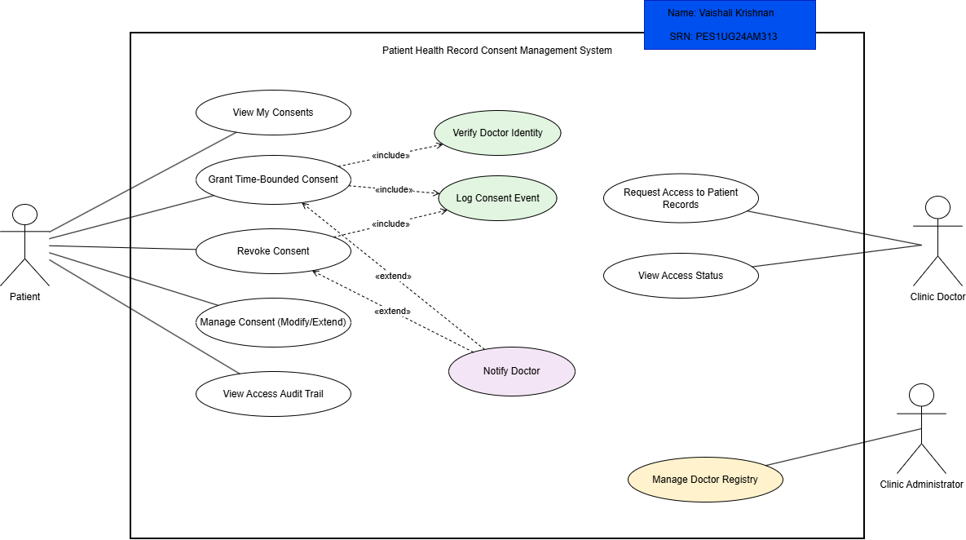

Use case document flow :

Use Case: Grant Time-Bounded Access Consent
Use Case ID : UC-01
Primary Actor : Patient
Supporting Actors: Clinic Doctor, Clinic Administrator
Description: Allows a patient to grant a verified doctor access to selected medical records for a specific period.
Preconditions :
- The patient is authenticated.
- The doctor is registered and verified.
- Medical records are available for sharing.
Postconditions:
- Consent is granted with an expiry time.
- The doctor can access only the permitted records.
- The event is recorded in the audit trail and the doctor is notified.
Main Success Scenario:
- The patient selects “Grant Consent.”
- The system displays available doctors and medical records.
- The patient selects a verified doctor and records to share.
- The patient specifies the access duration, such as 24 hours.
- The system verifies the doctor's identity.
- The system creates the consent with the specified expiry time.
- The system logs the event and notifies the doctor.
- The system displays a confirmation message.
Alternate Flow A1: Doctor Not Verified
- The system detects that the selected doctor is not verified.
- The system displays an error message.
- The patient selects another doctor or cancels the process.
Alternate Flow A2: Consent Revoked Before Expiry
- The patient selects an active consent and chooses “Revoke Consent.”
- The system immediately removes the doctor's access.
- The system logs the revocation, notifies the doctor, and updates the status to Revoked.

