**Actors Prompt:**

An engineer is working on a set of user stories enclosed between triple back ticks.

``` As a user, I want to contact the administrators, so that I can give feedback or ask for help.

As an admin, I want to add recycling center information, so that I can keep the database up-to-date over time.

As an admin, I want to view user error logs, so that I can fix or review any issues that are being faced by users of the system.

As an admin, I want to onboard recycling centers on the platform, so that I can increase information accuracy.

As a superuser, I want to update the recycling center information, so that I can provide the latest information about the recycling center.

As a superuser, I want to view users' stats, so that I can view in real-time how many users have visited my recycling center information and their recyclable waste.

He created an initial goal model with the intentional elements enclosed between triple quotes:

'''

- 'Actors':

-admin

-superuser

-user

-recycling facility representative

- recycling facility

- 'Goals':

-onboard operations conducted

-onboard recycling centers

-add operations conducted

-recycling center information conducted

-view operations conducted

-view user error logs

-have operations conducted

-have a dashboard

-view operations conducted

-view users’ stats

-update operations conducted

-update the recycling center information

-reply operations conducted

-user questions replied

-contact operations conducted

-contact the administrators

-update operations conducted

-update my information

-communicate operations conducted

-the site admin communicated

'''

The created model is missing many intentional elements. Let us refine the goal model step by step. First, can you list all 'Actors' for the user stories enclosed between triple back ticks. An initial set of actors are added in the enclosed between triple quotes. You must also identify any missing and implicit actors. It is critical that you answer only as a bulleted list and do not include any explanation.

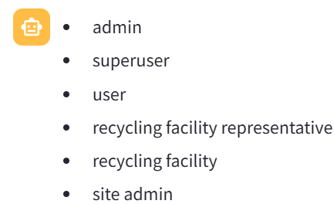

**Goals**

The initial goal model does not contain all the stakeholder’s objectives or goals that are conveyed in the user stories enclosed between triple back ticks. Identify any goals explicitly mentioned in the user stories enclosed between triple back ticks as well as any implicit goals. It is critical that you answer only as a bulleted list and do not include any explanation.

1. Contact the administrators
2. Give feedback or ask for help
3. Add recycling center information
4. Keep the database up-to-date over time
5. View user error logs
6. Fix or review any issues faced by users
7. Onboard recycling centers on the platform
8. Increase information accuracy
9. Update the recycling center information
10. Provide the latest information about the recycling center
11. View users' stats
12. View in real-time how many users have visited recycling center information and their recyclable waste.

Older Goals:

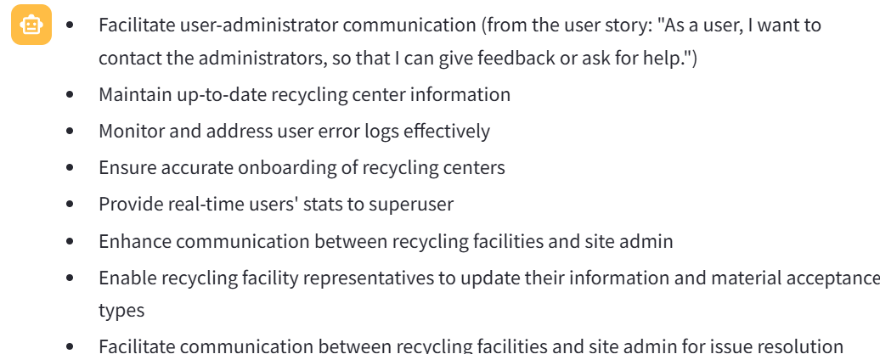

**Tasks for Goals**

Please provide a detailed breakdown of tasks for each of the following goals, created in the previous response. It is critical that you answer only as a bulleted list that adheres to the following format.

<a goal>: <a hyphenated list of tasks to achieve the goal>

Do not include any explanation.

* Onboard operations conducted:
  + Create onboarding process
  + Develop onboarding forms
  + Train admins on onboarding procedures
* Onboard recycling centers:
  + Collect recycling center information
  + Verify recycling center details
  + Add recycling center to the platform
* Add operations conducted:
  + Develop data entry interface
  + Implement data validation checks
  + Store added information securely
* Recycling center information conducted:
  + Update recycling center details
  + Ensure accuracy of information
  + Display information clearly
* View operations conducted:
  + Design user interface for viewing
  + Implement filtering and sorting options
  + Provide search functionality
* View user error logs:
  + Capture error log data
  + Analyze error log entries
  + Address and resolve reported errors
* Have operations conducted:
  + Establish communication channels
  + Provide user support
  + Monitor system performance
* Have a dashboard:
  + Define dashboard components
  + Customize dashboard layout
  + Ensure data visualization is user-friendly
* View users' stats:
  + Collect user interaction data
  + Generate statistical reports
  + Display user statistics visually
* Update operations conducted:
  + Develop update functionality
  + Notify users of updates
  + Manage update deployment
* Update the recycling center information:
  + Verify update source
  + Validate update content
  + Reflect changes in database
* Reply operations conducted:
  + Implement user feedback form
  + Monitor incoming queries
  + Respond to user inquiries
* User questions replied:
  + Establish response protocol
  + Provide accurate information
  + Maintain user satisfaction
* Contact operations conducted:
  + Create contact form
  + Receive and route messages
  + Ensure timely responses
* Update operations conducted:
  + Define update process
  + Implement version control
  + Communicate updates to stakeholders
* Communicate operations conducted:
  + Establish communication channels
  + Promote system updates
  + Gather user feedback

**Soft Goals**

Next, there are no soft goals in the initial goal model. Please suggest soft goals. Note you must identify any soft goals explicitly mentioned in the user stories enclosed between triple back ticks as well as any implicit soft goals. It is critical that you answer only as a bulleted list and do not include any explanation.

1. Increase user satisfaction
2. Enhance system usability
3. Improve data accuracy
4. Ensure timely response to user inquiries
5. Maintain system reliability
6. Enhance user experience
7. Foster user engagement

**Tasks for Soft Goals**

Next, the initial goal model misses different tasks that can be undertaken to achieve goals and soft goals.

Please provide a detailed breakdown of tasks for each soft goal created in the previous response. You can generate a variable number of tasks for soft goals. It is critical that you answer only as a bulleted list that adheres to the following format.

<a soft goal>: <list of tasks to achieve the soft goal>

Do not include any explanation.

1. Increase user satisfaction:
   * Conduct user surveys for feedback
   * Implement user-friendly interface design
   * Provide efficient customer support channels
   * Regularly review and improve user experience
2. Enhance system usability:
   * Conduct usability testing with target users
   * Implement intuitive navigation features
   * Ensure consistent design elements across the system
   * Provide clear instructions and tooltips
3. Improve data accuracy:
   * Implement data validation checks
   * Ensure data integrity through regular audits
   * Establish data quality standards
   * Implement mechanisms for error detection and correction
4. Ensure timely response to user inquiries:
   * Define response time service level agreements
   * Implement automated response systems
   * Train support staff on efficient communication
   * Monitor and track response times
5. Maintain system reliability:
   * Implement redundancy measures for critical components
   * Regularly conduct system performance tests
   * Establish backup and recovery procedures
   * Monitor system uptime and performance metrics
6. Enhance user experience:
   * Personalize user interactions based on preferences
   * Implement gamification elements for engagement
   * Provide seamless transitions between system features
   * Continuously gather user feedback for improvements
7. Foster user engagement:
   * Implement interactive features such as forums or chats
   * Encourage user-generated content
   * Create loyalty programs or incentives for users
   * Analyze user behavior to tailor engagement strategies

**Contribution Links**

The Contributionrelationship statement describes how softgoals, task, believes, or links contribute to the satisficing of another intentional element. The five categories of Contribution Links are enclosed between triple dollar symbols.

$$$ MAKE : The contribution of the contributing element is positive and sufficient. BREAK : The contribution of the contributing element is negative and sufficient. HELP : The contribution of the contributing element is positive but not sufficient. HURT : The contribution of the contributing element is negative but not sufficient. EQUAL : There is equal contribution in both directions. $$$

Please suggest different contribution links to link all the intentional elements such as, goals, soft goals, Tasks, and Resources that you identified. Note you must identify any contributions links that explicitly mentioned in the user stories enclosed between triple back ticks as well as any hidden contribution links. It is critical that you answer only as a bulleted list that adheres to the following format.

<Contribution Link Category>::<Source intentional elements> : <Destination intentional elements>

*MAKE*::*Ensuretimelyresponsetouserinquiries*:*Maintainsystemreliability*

*MAKE*::*Improvedataaccuracy*:*Maintainsystemreliability*

*HELP*::*Enhancesystemusability*:*Increaseusersatisfaction*

*HELP*::*Enhancesystemusability*:*Enhanceuserexperience*

*HELP*::*Ensuretimelyresponsetouserinquiries*:*Enhanceuserexperience*

*HELP*::*Ensuretimelyresponsetouserinquiries*:*Increaseusersatisfaction*

*HELP*::*Ensuretimelyresponsetouserinquiries*:*Improvedataaccuracy*

*EQUAL*::*Improvedataaccuracy*:*Enhancesystemusability*

*EQUAL*::*Ensuretimelyresponsetouserinquiries*:*Ensuretimelyresponsetouserinquiries*

**Dependencies Links**

The Dependency statement of GRL describes an intentional relationship between two actors, i.e., one actor (the Depender) depends on another actor (the Dependee) on something (the Dependum). Noite that the dependum is optional.

Please suggest different Dependency links to link all the intentional elements such as, goals, soft goals, Tasks, and Resources that you identified. Note you must identify any Dependency links that explicitly mentioned in the user stories enclosed between triple back ticks as well as any hidden Dependency links. It is critical that you answer only as a bulleted list that adheres to the following format.

<Depender> DEPENDES-ON <Dependee> FOR <Dependum>

* 'onboard operations conducted' DEPENDS-ON 'add recycling center information' FOR 'database update'
* 'onboard recycling centers' DEPENDS-ON 'increase information accuracy' FOR 'platform accuracy'
* 'view user error logs' DEPENDS-ON 'fix or review user issues' FOR 'system functionality'
* 'update the recycling center information' DEPENDS-ON 'reflect changes in database' FOR 'accurate information'
* 'view users' stats' DEPENDS-ON 'real-time user behavior data' FOR 'dashboard accuracy'
* 'reply user questions' DEPENDS-ON 'user inquiries' FOR 'user satisfaction'

**Resources**

**Not used because Dependum identified in the previous prompt are the resources.**

A resource is an (physical or informational) entity, with which the main concern is whether it is available. The initial goal model with the intentional elements enclosed between triple quotes does not have resources. Identify resources that are explicitly mentioned in the user stories enclosed between triple back ticks as well as any implicit resources. It is critical that you answer only as a bulleted list and do not include any explanation.

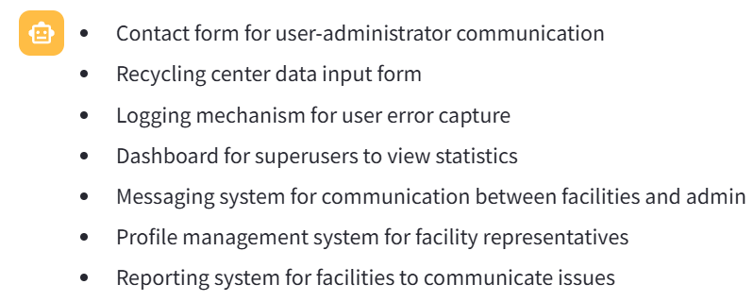

**Decomposition Links**

DECOMPOSITON statement provides the ability to define what other elements need to be achieved or available in order for a task to perform. Note that only Task and Goal can be decomposed into goal, task, resource, and softgoal. A Task Decomposition Structure shows the essential components of a task, which include subtasks that must be performed, subgoals that must be achieved, resources that must be accessible, and softgoals that must be satisfied. Similarly, a Goal Decomposition Structure connects a goal with its sub-goals directly, which is a short hand form of one Goal Means_Ends Structure and the related Task Decomposition Structure.  The three categories of Decomposition Links are enclosed between triple dollar symbols.

$$$ AND DECOMPOSITON: The relations between the dependent elements are “AND”. Each of the sub-components are necessary. OR DECOMPOSITON : The relations between the contributing elements are “OR”. Any of the sub-components is sufficient. XOR DECOMPOSITON: The relations between the contributing elements are “XOR”. Either of the sub-components are necessary, but not both. $$$

Please suggest different Decomposition links to link all the intentional elements such as, goals, soft goals, Tasks, and Resources that you identified. Note you must identify any Decomposition links that explicitly mentioned in the user stories enclosed between triple back ticks as well as any hidden Decomposition links. It is critical that you answer only as a bulleted list that adheres to the following format.

< Decomposition Type>::<Source intentional elements> : <Destination intentional elements>

*ANDDECOMPOSITION*::′*viewusererrorlogs*′:′*fixorreviewuserissues*′

*ANDDECOMPOSITION*::′*updatetherecyclingcenterinformation*′:′*reflectchangesindatabase*′

*ORDECOMPOSITION*::′*viewusers*′*stats*′:′*real*−*timeuserbehaviordata*′,′*dashboardaccuracy*′

**Generate XML using Fewshot examples:**

Please create an XML that includes all the outputs that you generated so far. An example of the right output is shown between triple back ticks.

```

<?xml version='1.0' encoding='ISO-8859-1'?>

<grl-catalog catalog-name="URNspec" description="" author="vaish">

<element-def>

<intentional-element id="72" name="Car objects" description="" type="Ressource" decompositiontype="And"/>

<intentional-element id="80" name="Easy to use" description="" type="Softgoal" decompositiontype="And"/>

<intentional-element id="82" name="Realistic simulation" description="" type="Softgoal" decompositiontype="And"/>

<intentional-element id="84" name="Simple design" description="" type="Softgoal" decompositiontype="And"/>

<intentional-element id="88" name="Generate cars" description="" type="Goal" decompositiontype="And"/>

<intentional-element id="96" name="Create new cars" description="" type="Task" decompositiontype="And"/>

<intentional-element id="98" name="Keep same cars" description="" type="Task" decompositiontype="And"/>

</element-def>

<link-def>

<contribution name="Contribution105" description="" srcid="96" destid="82" contributiontype="Unknown" quantitativeContribution="0" correlation="false"/>

<contribution name="Contribution106" description="" srcid="96" destid="84" contributiontype="Unknown" quantitativeContribution="0" correlation="false"/>

<decomposition name="Decomposition111" description="" srcid="96" destid="88"/>

<decomposition name="Decomposition114" description="" srcid="98" destid="88"/>

<dependency name="Dependency116" description="" dependerid="88" dependeeid="72"/>

</link-def>

<actor-def>

<actor id="11" name="Traffic Simulator" description=""/>

</actor-def>

<actor-IE-link-def>

<actorContIE actor="11" ie="72"/>

<actorContIE actor="11" ie="80"/>

<actorContIE actor="11" ie="82"/>

<actorContIE actor="11" ie="84"/>

<actorContIE actor="11" ie="88"/>

<actorContIE actor="11" ie="96"/>

<actorContIE actor="11" ie="98"/>

</actor-IE-link-def>

</grl-catalog>

```