**Actors Prompt:**

An engineer is working on a set of user stories enclosed between triple back ticks.

``` As an app developer, I want to deploy a new version of a dataset type as part of an app artifact, without affecting other datasets of this type.

As an app developer, I want to explore a dataset instance of a type that was deployed as part of an app.

As an app developer, I want to ensure that when I deploy an artifact without creating an app this will not create any dataset types or instances.

As an app developer, I want to share a dataset type across multiple applications that include the dataset type's code in their artifacts.

As an app developer, I want to ensure that when I deploy a new version of an app that includes a shared dataset type that all dataset instances created by this app start using the new code but all dataset instances created by other apps remain unchanged.

As an app developer, I want to ensure that when I deploy a new version of an app that includes an older version of a dataset type deployed by another app and I expect that the dataset instances created by this app use the dataset type code included in this app.```

He created an initial goal model with the intentional elements enclosed between triple quotes:

‘’’

- 'Actors':

-app developer

-dataset developer

-user

-plugin developer

- 'Goals':

-share operations conducted

-explore operations conducted

-ensure operations conducted

-deploy operations conducted

-deploy operations conducted

-include operations conducted

-ensure operations conducted

-a dataset type shared

-ensure an artifact

-ensure a new version

-explore a dataset instance

-deploy a new version

-deploy a dataset type

-the code included

-ensure a dataset

'''

The created model is missing many intentional elements. Let us refine the goal model step by step. First, can you list all 'Actors' for the user stories enclosed between triple back ticks. An initial set of actors are added in the enclosed between triple quotes. You must also identify any missing and implicit actors. It is critical that you answer only as a bulleted list and do not include any explanation.

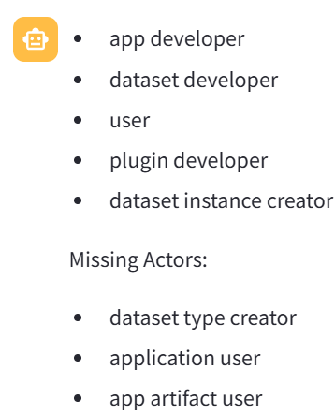

**Goals**

The initial goal model does not contain all the stakeholder’s objectives or goals that are conveyed in the user stories enclosed between triple back ticks. Identify any goals explicitly mentioned in the user stories enclosed between triple back ticks as well as any implicit goals. It is critical that you answer only as a bulleted list and do not include any explanation.

* Share dataset types across multiple applications
* Explore dataset instances
* Ensure artifact deployment without affecting other datasets
* Ensure new artifacts do not create any dataset types or instances
* Ensure dataset instances use new code in new app versions
* Ensure dataset instances use correct code in older app versions

**Tasks for Goals**

Please provide a detailed breakdown of tasks for each of the following goals, created in the previous response. It is critical that you answer only as a bulleted list that adheres to the following format.

<a goal>: <a hyphenated list of tasks to achieve the goal>

Do not include any explanation.

* Share dataset types across multiple applications:
  + Develop mechanism to package dataset types for sharing
  + Implement version control for dataset types
  + Define access control mechanisms for shared dataset types
* Explore dataset instances:
  + Implement data exploration feature in the application
  + Ensure users can view details of dataset instances
* Ensure artifact deployment without affecting other datasets:
  + Conduct thorough testing of artifact deployment process
  + Implement isolation mechanisms for dataset types
* Ensure new artifacts do not create any dataset types or instances:
  + Implement checks to prevent unintended dataset creation
  + Verify no new dataset instances are created during artifact deployment
* Ensure dataset instances use new code in new app versions:
  + Develop mechanism to update dataset instances with new code
  + Implement version compatibility checks for dataset instances
* Ensure dataset instances use correct code in older app versions:
  + Implement backward compatibility mechanism for dataset instances
  + Conduct testing to verify correct code usage in older app versions

**Soft Goals**

Next, there are no soft goals in the initial goal model. Please suggest soft goals. Note you must identify any soft goals explicitly mentioned in the user stories enclosed between triple back ticks as well as any implicit soft goals. It is critical that you answer only as a bulleted list and do not include any explanation.

* Ensure seamless integration of shared dataset types across applications
* Maintain backward compatibility for dataset instances
* Enhance data exploration experience for users
* Improve artifact deployment process efficiency
* Ensure data security during artifact deployment
* Enhance user experience when exploring dataset instances

**Tasks for Soft Goals**

Next, the initial goal model misses different tasks that can be undertaken to achieve goals and soft goals.

Please provide a detailed breakdown of tasks for each soft goal created in the previous response. You can generate a variable number of tasks for soft goals. It is critical that you answer only as a bulleted list that adheres to the following format.

<a soft goal>: <list of tasks to achieve the soft goal>

Do not include any explanation.

* Ensure seamless integration of shared dataset types across applications:
  + Develop standardized data sharing protocols
  + Implement data mapping mechanisms
  + Conduct compatibility testing across applications
* Maintain backward compatibility for dataset instances:
  + Implement version control for dataset instances
  + Develop conversion tools for older dataset formats
  + Ensure data integrity during conversion process
* Enhance data exploration experience for users:
  + Implement advanced search capabilities
  + Develop data visualization tools
  + Conduct user experience testing for data exploration features
* Improve artifact deployment process efficiency:
  + Automate artifact deployment procedures
  + Implement rollback mechanisms for deployment errors
  + Conduct performance testing of deployment process
* Ensure data security during artifact deployment:
  + Implement data encryption protocols
  + Conduct vulnerability assessments for deployment processes
  + Define access control measures for deployed artifacts
* Enhance user experience when exploring dataset instances:
  + Implement user-friendly interface for dataset exploration
  + Develop interactive features for dataset viewing
  + Conduct usability testing with end users

**Contribution Links**

The Contributionrelationship statement describes how softgoals, task, believes, or links contribute to the satisficing of another intentional element. The five categories of Contribution Links are enclosed between triple back-ticks symbols.

``` MAKE : The contribution of the contributing element is positive and sufficient. BREAK : The contribution of the contributing element is negative and sufficient. HELP : The contribution of the contributing element is positive but not sufficient. HURT : The contribution of the contributing element is negative but not sufficient. EQUAL : There is equal contribution in both directions. ```

Please suggest different contribution links to link all the intentional elements such as, goals, soft goals, Tasks, and Resources that you identified. Note you must identify any contributions links that explicitly mentioned in the user stories enclosed between triple back ticks as well as any hidden contribution links. It is critical that you answer only as a bulleted list that adheres to the following format.

<Contribution Link Category>::<Source intentional elements> : <Destination intentional elements>

* HELP: Share dataset types across multiple applications : Ensure seamless integration of shared dataset types across applications
* MAKE: Maintain backward compatibility for dataset instances : Ensure dataset instances use correct code in older app versions
* HELP: Enhance data exploration experience for users : Explore dataset instances
* MAKE: Improve artifact deployment process efficiency : Ensure artifact deployment without affecting other datasets
* HELP: Ensure data security during artifact deployment : Improve artifact deployment process efficiency
* MAKE: Enhance user experience when exploring dataset instances : Enhance data exploration experience for users

**Dependencies Links**

The Dependency statement of GRL describes an intentional relationship between two actors, i.e., one actor (the Depender) depends on another actor (the Dependee) on something (the Dependum). Noite that the dependum is optional.

Please suggest different Dependency links to link all the intentional elements such as, goals, soft goals, Tasks, and Resources that you identified. Note you must identify any Dependency links that explicitly mentioned in the user stories enclosed between triple back ticks as well as any hidden Dependency links. It is critical that you answer only as a bulleted list that adheres to the following format.

<Depender> DEPENDES-ON <Dependee> FOR <Dependum>

* 'Ensure seamless integration of shared dataset types across applications' DEPENDS-ON 'Implement version control for dataset types' FOR 'efficient sharing mechanism'
* 'Maintain backward compatibility for dataset instances' DEPENDS-ON 'Implement conversion tools for older dataset formats' FOR 'data integrity during conversion'
* 'Enhance data exploration experience for users' DEPENDS-ON 'Implement data visualization tools' FOR 'improved user experience'
* 'Improve artifact deployment process efficiency' DEPENDS-ON 'Automate artifact deployment procedures' FOR 'streamlined process'
* 'Ensure data security during artifact deployment' DEPENDS-ON 'Implement data encryption protocols' FOR 'secure deployment process'
* 'Enhance user experience when exploring dataset instances' DEPENDS-ON 'Implement user-friendly interface for dataset exploration' FOR 'improved user satisfaction'

**Resources**

**Not used because Dependum identified in the previous prompt are the resources.**

A resource is an (physical or informational) entity, with which the main concern is whether it is available. The initial goal model with the intentional elements enclosed between triple quotes does not have resources. Identify resources that are explicitly mentioned in the user stories enclosed between triple back ticks as well as any implicit resources. It is critical that you answer only as a bulleted list and do not include any explanation.

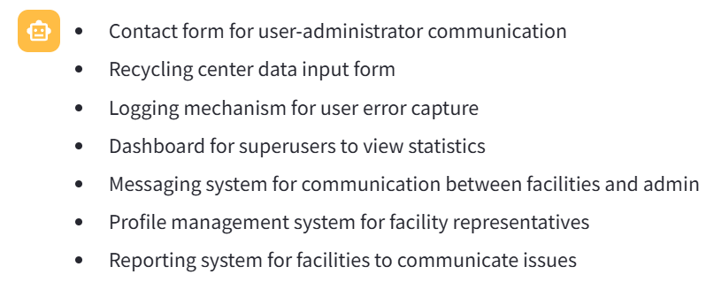

**Decomposition Links**

DECOMPOSITON statement provides the ability to define what other elements need to be achieved or available in order for a task to perform. Note that only Task and Goal can be decomposed into goal, task, resource, and softgoal. A Task Decomposition Structure shows the essential components of a task, which include subtasks that must be performed, subgoals that must be achieved, resources that must be accessible, and softgoals that must be satisfied. Similarly, a Goal Decomposition Structure connects a goal with its sub-goals directly, which is a short hand form of one Goal Means_Ends Structure and the related Task Decomposition Structure.  The three categories of Decomposition Links are enclosed between triple back-tick symbols.

``` AND DECOMPOSITON: The relations between the dependent elements are “AND”. Each of the sub-components are necessary. OR DECOMPOSITON : The relations between the contributing elements are “OR”. Any of the sub-components is sufficient. XOR DECOMPOSITON: The relations between the contributing elements are “XOR”. Either of the sub-components are necessary, but not both. ```

Please suggest different Decomposition links to link all the intentional elements such as, goals, soft goals, Tasks, and Resources that you identified. Note you must identify any Decomposition links that explicitly mentioned in the user stories enclosed between triple back ticks as well as any hidden Decomposition links. It is critical that you answer only as a bulleted list that adheres to the following format.

< Decomposition Type>::<Source intentional elements> : <Destination intentional elements>

* AND DECOMPOSITION::Ensure seamless integration of shared dataset types across applications : Implement version control for dataset types, Develop standardized data sharing protocols, Define access control mechanisms for shared dataset types
* OR DECOMPOSITION::Maintain backward compatibility for dataset instances : Implement conversion tools for older dataset formats OR Develop mechanism for version control for dataset instances
* XOR DECOMPOSITION::Enhance data exploration experience for users : Implement advanced search capabilities XOR Develop data visualization tools

**Generate XML using Fewshot examples:**

Please create an XML that includes all the outputs that you generated so far. An example of the right output is shown between triple back ticks.

```

<?xml version='1.0' encoding='ISO-8859-1'?>

<grl-catalog catalog-name="URNspec" description="" author="vaish">

<element-def>

<intentional-element id="72" name="Car objects" description="" type="Ressource" decompositiontype="And"/>

<intentional-element id="80" name="Easy to use" description="" type="Softgoal" decompositiontype="And"/>

<intentional-element id="82" name="Realistic simulation" description="" type="Softgoal" decompositiontype="And"/>

<intentional-element id="84" name="Simple design" description="" type="Softgoal" decompositiontype="And"/>

<intentional-element id="88" name="Generate cars" description="" type="Goal" decompositiontype="And"/>

<intentional-element id="96" name="Create new cars" description="" type="Task" decompositiontype="And"/>

<intentional-element id="98" name="Keep same cars" description="" type="Task" decompositiontype="And"/>

</element-def>

<link-def>

<contribution name="Contribution105" description="" srcid="96" destid="82" contributiontype="Unknown" quantitativeContribution="0" correlation="false"/>

<contribution name="Contribution106" description="" srcid="96" destid="84" contributiontype="Unknown" quantitativeContribution="0" correlation="false"/>

<decomposition name="Decomposition111" description="" srcid="96" destid="88"/>

<decomposition name="Decomposition114" description="" srcid="98" destid="88"/>

<dependency name="Dependency116" description="" dependerid="88" dependeeid="72"/>

</link-def>

<actor-def>

<actor id="11" name="Traffic Simulator" description=""/>

</actor-def>

<actor-IE-link-def>

<actorContIE actor="11" ie="72"/>

<actorContIE actor="11" ie="80"/>

<actorContIE actor="11" ie="82"/>

<actorContIE actor="11" ie="84"/>

<actorContIE actor="11" ie="88"/>

<actorContIE actor="11" ie="96"/>

<actorContIE actor="11" ie="98"/>

</actor-IE-link-def>

</grl-catalog>

```