**Actors Prompt:**

An engineer is working on a set of user stories enclosed between triple back ticks.

``` As a legalofficer, I want to know about data sensitivity, so that I can establish sharing options.

As an IT staff member, I want to have an estimate of the produced data volume, so that I can plan the overall storage consumption.

As an administrator, I want to know who funded the project and their requirements, so that I can track the funder specific obligations.

As an archivemanager, I want to know the legal status of data, so that I can apply the legal requirements accordingly.

As an archivemanager, I want to know in advance the conservation period of data, so that I can better organize the service by adapting the preservation actions.

As a data manager, I want to document all rights necessary for managing the data, so that I can curate and preserve the data. ```

He created an initial goal model with the intentional elements enclosed between triple quotes:

‘’’

- 'Actors':

-IT staff member

-administrator

-legal office

-data manager

-metadata manager

Archive manager

- 'Goals':

-know operations conducted

-have operations conducted

-document operations conducted

-know data types

-have an estimate

-know the data

-document all rights

-know the project

-know data sensitivity

-have a short description

-know the legal status

'''

The created model is missing many intentional elements. Let us refine the goal model step by step. First, can you list all 'Actors' for the user stories enclosed between triple back ticks. An initial set of actors are added in the enclosed between triple quotes. You must also identify any missing and implicit actors. It is critical that you answer only as a bulleted list and do not include any explanation.

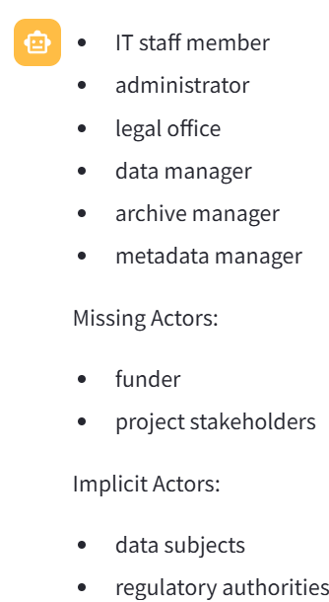

**Goals**

The initial goal model does not contain all the stakeholder’s objectives or goals that are conveyed in the user stories enclosed between triple back ticks. Identify any goals explicitly mentioned in the user stories enclosed between triple back ticks as well as any implicit goals. It is critical that you answer only as a bulleted list and do not include any explanation.

* know about data sensitivity
* have an estimate of the produced data volume
* know who funded the project and their requirements
* know the legal status of data
* know in advance the conservation period of data
* document all rights necessary for managing the data

Implicit Goals:

* establish sharing options
* plan the overall storage consumption
* track the funder specific obligations
* apply legal requirements accordingly
* better organize the service by adapting preservation actions
* curate and preserve the data

**Tasks for Goals**

Please provide a detailed breakdown of tasks for each of the following goals, created in the previous response. It is critical that you answer only as a bulleted list that adheres to the following format.

<a goal>: <a hyphenated list of tasks to achieve the goal>

Do not include any explanation.

* know about data sensitivity:
  + Identify sensitive data categories
  + Define data sensitivity levels
  + Classify data based on sensitivity
* have an estimate of the produced data volume:
  + Collect data production statistics
  + Analyze data growth trends
  + Estimate future data volume
* know who funded the project and their requirements:
  + Review project funding documentation
  + Interview project funders
  + Document funder requirements
* know the legal status of data:
  + Research data regulations
  + Consult legal experts
  + Document data legal status
* know in advance the conservation period of data:
  + Identify data retention regulations
  + Determine data storage requirements
  + Establish data preservation timeline
* document all rights necessary for managing the data:
  + Identify data management rights
  + Document data access permissions
  + Define data ownership rights
* Establish sharing options:
  + Define data sharing permissions
  + Implement secure sharing methods
* Plan the overall storage consumption:
  + Assess current storage capacity
  + Project future storage needs
  + Optimize storage utilization
* Track the funder specific obligations:
  + Identify key funder requirements
  + Monitor compliance with funding terms
* Apply legal requirements accordingly:
  + Interpret legal regulations
  + Implement necessary data handling procedures
* Better organize the service by adapting preservation actions:
  + Develop preservation strategies
  + Implement data archival processes
* Curate and preserve the data:
  + Establish data curation standards
  + Implement data preservation techniques

**Soft Goals**

Next, there are no soft goals in the initial goal model. Please suggest soft goals. Note you must identify any soft goals explicitly mentioned in the user stories enclosed between triple back ticks as well as any implicit soft goals. It is critical that you answer only as a bulleted list and do not include any explanation.

Explicit Soft Goals:

* Ensure data sensitivity
* Optimize data storage

Implicit Soft Goals:

* Enhance data security
* Maintain data integrity
* Comply with legal regulations
* Improve data accessibility

**Tasks for Soft Goals**

Next, the initial goal model misses different tasks that can be undertaken to achieve goals and soft goals.

Please provide a detailed breakdown of tasks for each soft goal created in the previous response. You can generate a variable number of tasks for soft goals. It is critical that you answer only as a bulleted list that adheres to the following format.

<a soft goal>: <list of tasks to achieve the soft goal>

Do not include any explanation.

* Ensure data sensitivity:
  + Conduct data sensitivity analysis
  + Implement data encryption measures
  + Establish access control policies
* Optimize data storage:
  + Perform data storage assessment
  + Implement data compression techniques
  + Utilize data deduplication methods
  + Monitor storage capacity and usage
* Enhance data security:
  + Implement data encryption methods
  + Establish multi-factor authentication
  + Conduct regular security audits
* Maintain data integrity:
  + Implement data validation procedures
  + Ensure data accuracy through validation checks
* Comply with legal regulations:
  + Review and update data compliance policies
  + Monitor regulatory changes and adapt systems accordingly
* Improve data accessibility:
  + Implement user-friendly data access interfaces
  + Provide secure data sharing options
  + Enhance search capabilities for data retrieval

**Contribution Links**

The Contributionrelationship statement describes how softgoals, task, believes, or links contribute to the satisficing of another intentional element. The five categories of Contribution Links are enclosed between triple back-ticks symbols.

``` MAKE : The contribution of the contributing element is positive and sufficient. BREAK : The contribution of the contributing element is negative and sufficient. HELP : The contribution of the contributing element is positive but not sufficient. HURT : The contribution of the contributing element is negative but not sufficient. EQUAL : There is equal contribution in both directions. ```

Please suggest different contribution links to link all the intentional elements such as, goals, soft goals, Tasks, and Resources that you identified. Note you must identify any contributions links that explicitly mentioned in the user stories enclosed between triple back ticks as well as any hidden contribution links. It is critical that you answer only as a bulleted list that adheres to the following format.

<Contribution Link Category>::<Source intentional elements> : <Destination intentional elements>

* MAKE::know about data sensitivity : Ensure data sensitivity
* HELP::have an estimate of the produced data volume : Optimize data storage
* MAKE::know who funded the project and their requirements : Comply with legal regulations
* HELP::know the legal status of data : Enhance data security
* MAKE::know in advance the conservation period of data : Maintain data integrity
* HELP::document all rights necessary for managing the data : Improve data accessibility

**Dependencies Links**

The Dependency statement of GRL describes an intentional relationship between two actors, i.e., one actor (the Depender) depends on another actor (the Dependee) on something (the Dependum). Noite that the dependum is optional.

Please suggest different Dependency links to link all the intentional elements such as, goals, soft goals, Tasks, and Resources that you identified. Note you must identify any Dependency links that explicitly mentioned in the user stories enclosed between triple back ticks as well as any hidden Dependency links. It is critical that you answer only as a bulleted list that adheres to the following format.

<Depender> DEPENDES-ON <Dependee> FOR <Dependum>

* know about data sensitivity DEPENDS-ON IT staff member FOR data sensitivity analysis
* Optimize data storage DEPENDS-ON data manager FOR data storage assessment
* Comply with legal regulations DEPENDS-ON administrator FOR legal compliance review
* Enhance data security DEPENDS-ON metadata manager FOR security audit implementation
* Maintain data integrity DEPENDS-ON archive manager FOR data validation procedures
* Improve data accessibility DEPENDS-ON data manager FOR user-friendly interface implementation
* Find session information DEPENDS-ON Provide clear and detailed session information for attendees

**Resources**

**Not used because Dependum identified in the previous prompt are the resources.**

A resource is an (physical or informational) entity, with which the main concern is whether it is available. The initial goal model with the intentional elements enclosed between triple quotes does not have resources. Identify resources that are explicitly mentioned in the user stories enclosed between triple back ticks as well as any implicit resources. It is critical that you answer only as a bulleted list and do not include any explanation.

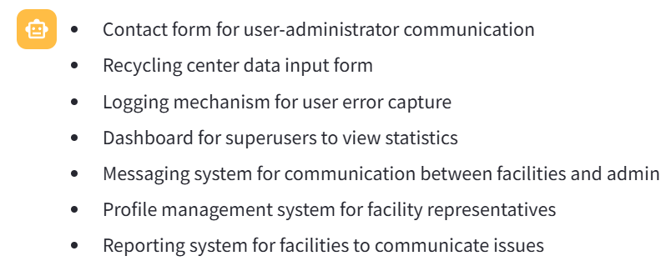

**Decomposition Links**

DECOMPOSITON statement provides the ability to define what other elements need to be achieved or available in order for a task to perform. Note that only Task and Goal can be decomposed into goal, task, resource, and softgoal. A Task Decomposition Structure shows the essential components of a task, which include subtasks that must be performed, subgoals that must be achieved, resources that must be accessible, and softgoals that must be satisfied. Similarly, a Goal Decomposition Structure connects a goal with its sub-goals directly, which is a short hand form of one Goal Means_Ends Structure and the related Task Decomposition Structure.  The three categories of Decomposition Links are enclosed between triple back-tick symbols.

``` AND DECOMPOSITON: The relations between the dependent elements are “AND”. Each of the sub-components are necessary. OR DECOMPOSITON : The relations between the contributing elements are “OR”. Any of the sub-components is sufficient. XOR DECOMPOSITON: The relations between the contributing elements are “XOR”. Either of the sub-components are necessary, but not both. ```

Please suggest different Decomposition links to link all the intentional elements such as, goals, soft goals, Tasks, and Resources that you identified. Note you must identify any Decomposition links that explicitly mentioned in the user stories enclosed between triple back ticks as well as any hidden Decomposition links. It is critical that you answer only as a bulleted list that adheres to the following format.

< Decomposition Type>::<Source intentional elements> : <Destination intentional elements>

* AND DECOMPOSITION::know about data sensitivity : Identify sensitive data categories AND Define data sensitivity levels
* AND DECOMPOSITION::have an estimate of the produced data volume : Collect data production statistics AND Analyze data growth trends
* AND DECOMPOSITION::know who funded the project and their requirements : Review project funding documentation AND Interview project funders
* AND DECOMPOSITION::know the legal status of data : Research data regulations AND Consult legal experts
* AND DECOMPOSITION::know in advance the conservation period of data : Identify data retention regulations AND Determine data storage requirements
* AND DECOMPOSITION::document all rights necessary for managing the data : Identify data management rights AND Document data access permissions

**Generate XML using Fewshot examples:**

Please create an XML that includes all the outputs that you generated so far. An example of the right output is shown between triple back ticks.

```

<?xml version='1.0' encoding='ISO-8859-1'?>

<grl-catalog catalog-name="URNspec" description="" author="vaish">

<element-def>

<intentional-element id="72" name="Car objects" description="" type="Ressource" decompositiontype="And"/>

<intentional-element id="80" name="Easy to use" description="" type="Softgoal" decompositiontype="And"/>

<intentional-element id="82" name="Realistic simulation" description="" type="Softgoal" decompositiontype="And"/>

<intentional-element id="84" name="Simple design" description="" type="Softgoal" decompositiontype="And"/>

<intentional-element id="88" name="Generate cars" description="" type="Goal" decompositiontype="And"/>

<intentional-element id="96" name="Create new cars" description="" type="Task" decompositiontype="And"/>

<intentional-element id="98" name="Keep same cars" description="" type="Task" decompositiontype="And"/>

</element-def>

<link-def>

<contribution name="Contribution105" description="" srcid="96" destid="82" contributiontype="Unknown" quantitativeContribution="0" correlation="false"/>

<contribution name="Contribution106" description="" srcid="96" destid="84" contributiontype="Unknown" quantitativeContribution="0" correlation="false"/>

<decomposition name="Decomposition111" description="" srcid="96" destid="88"/>

<decomposition name="Decomposition114" description="" srcid="98" destid="88"/>

<dependency name="Dependency116" description="" dependerid="88" dependeeid="72"/>

</link-def>

<actor-def>

<actor id="11" name="Traffic Simulator" description=""/>

</actor-def>

<actor-IE-link-def>

<actorContIE actor="11" ie="72"/>

<actorContIE actor="11" ie="80"/>

<actorContIE actor="11" ie="82"/>

<actorContIE actor="11" ie="84"/>

<actorContIE actor="11" ie="88"/>

<actorContIE actor="11" ie="96"/>

<actorContIE actor="11" ie="98"/>

</actor-IE-link-def>

</grl-catalog>

```