SAPIENT | INTERACTIVE | India Studio

Coding Exercise

Exercise
This exercise requires you to create Shopping Bag module for an Ecommerce web application. The attached images (desktop.jpg and mobile.jpg) represent a responsive layout with the desktop and mobile views. Task from you is to create a HTML5 – responsive layout to meet the requirements using CSS3 media queries, using div-based layout.
The focus should be, to apply a well thought out solution to create a structure, which is robust and scalable in the time frame provided. It’s ok if you are not able to complete the assignment.
You should target to complete the JS functionalities as per the following priority. You must complete at least 2 of the following features. HTML/CSS & RWD is mandatory to be accomplished.
- Discount logic
- Modal Window
- Templating engine
- Modal window updates on main page

All supporting assets are provided with this packet, you are however free to use any additional framework you are comfortable using.
You can also approach this as independent sets –and target developing only one of the versions – if you are not well versed with responsive design.
Guidelines
- Use HTML5 that validates W3C guidelines.
- This should work across IE9+ and the latest version of Firefox & Chrome. (Should gracefully degrade for old browsers)
- The markup should be semantic
- Follow the basic accessibility guidelines
- Use OOJS for all JS functionality
- We expect you to write a custom code, with or without the use of any JS library/Framework, however you are free to use plugins to build the functionality
- Please follow any JavaScript Pattern for writing your JS code.

Requirement for some key functionality:

- HTML/CSS:
Create dynamic Shopping cart layout using HTML 5 and should be following W3c Standard, semantic coding and representing certain features of HTML5.
- Responsiveness:
Layout should be responsive and degrade gracefully on various devices like IPhone or IPad. (Please use google Chrome Emulator for validating responsive layout).
- Templating Engine:
On first load Shopping bag should have some items. Using JSON feed and some Templating engine should fill in items in the shopping back.
- Open modal window:
On click of “Edit” link, following overlay opens up and overlay should be based on custom JQuery /JavaScript using JSON feeds and on click of “View Details”, its details will be shown in Overlay as follows. Same flow to be recreated as in case of Edit item.

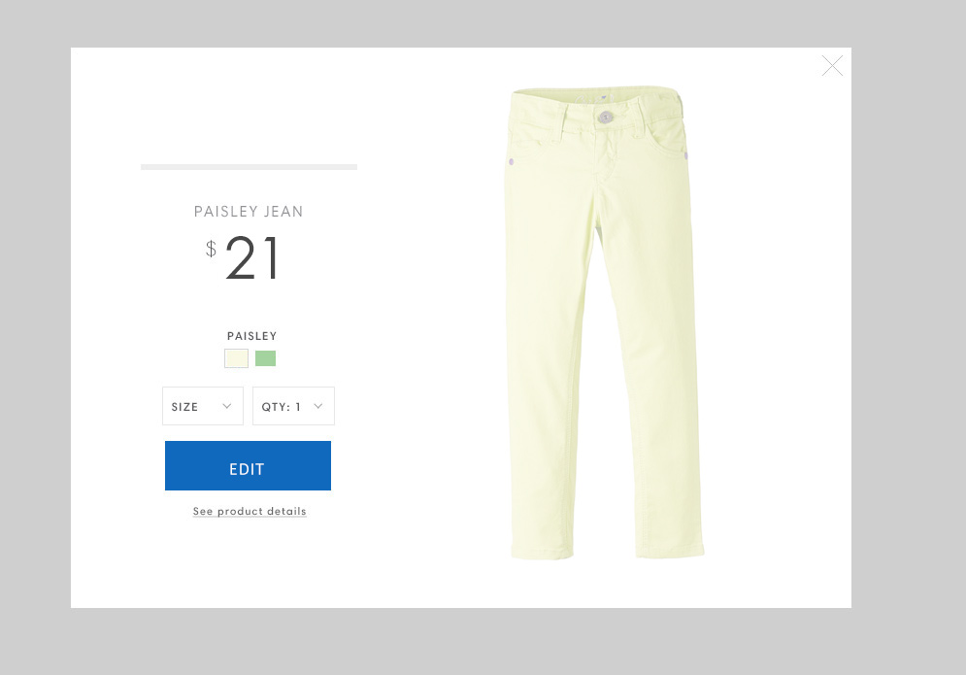

- Modal window updates:
On click of “Edit” button in an overlay, the updated item should reflect the change on main page and Overlay should be closed. Overlay data should be injected in to the DOM through an Ajax call & JSON as response.

- Discount logic:
Promotion code should automatically apply to the cart based on following criteria.
  - 3 items in cart - 5% discount on subtotal amount
  - 3-6 items in cart - 10% discount on subtotal amount
  - Above 10 items in cart – 25% discount on subtotal amount

Note:
- You can use any font, which is very close to the font used in the images.
- All the images required for this exercise are available in assets folder.
- Basic JSON required for templating is also available in assets folder, you can also use the json service at:
  - http://jsonp.afeld.me/?url=https://api.myjson.com/bins/19ynm&callback=callbackFN

