**1. Display Train Table Content.**

**Select * from train;**

In ORACLE:

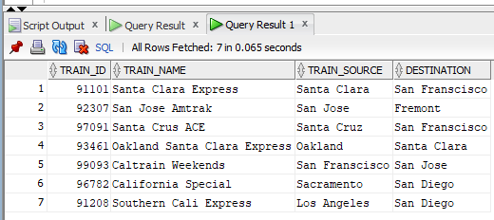

ORACLE EXPLAIN PLAN:

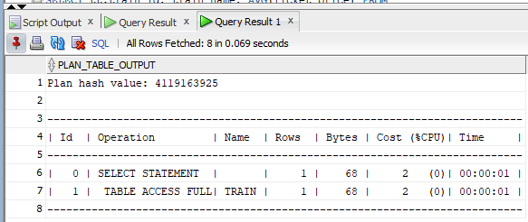

In HIVE:

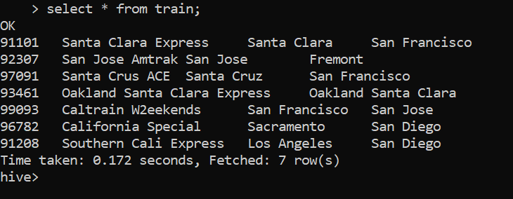

**2. Display all passenger details( Sorted by passenger name)**

**select DISTINCT(passenger_id),passenger_name,age,t.train_id,t.train_name**

**From passenger p, train t**

**where t.train_id=p.train_id**

**order by passenger_name;**

In ORACLE:

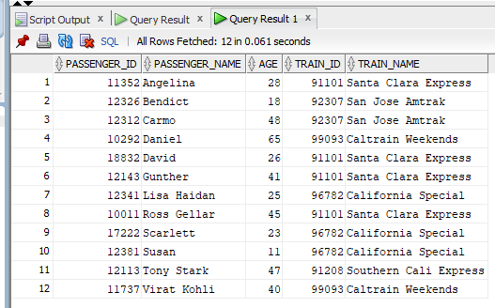

ORACLE EXPLAIN TOOL:

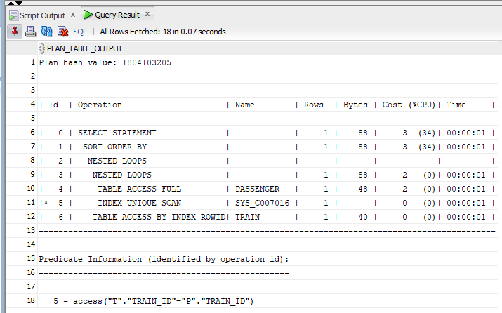

In HIVE:

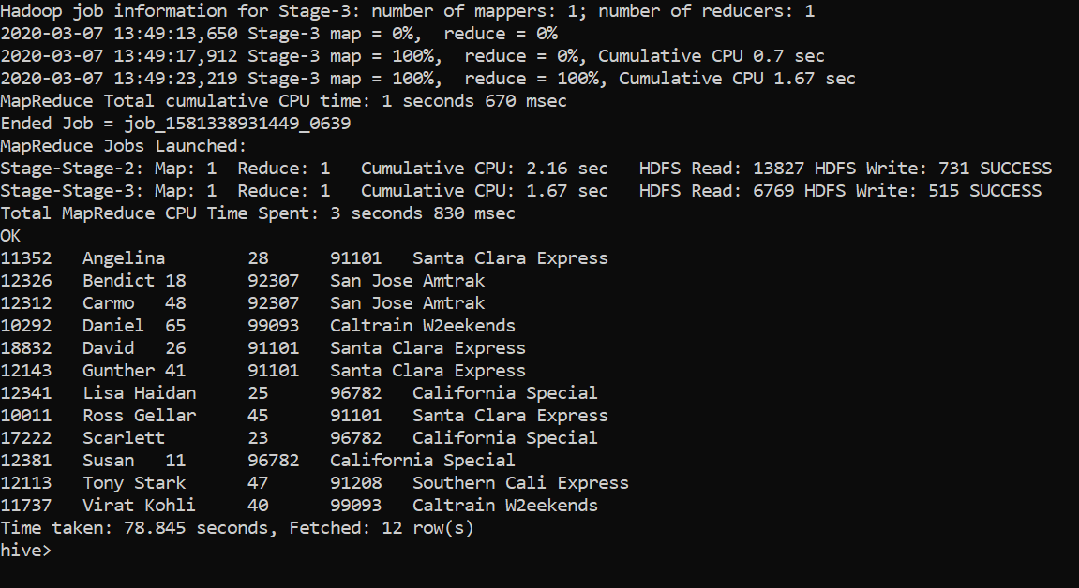

**3. Display Trains passing through San Francisco(Nested Queries)**

**SELECT train_name FROM train**

**WHERE train_id IN**

**(SELECT route.train_id FROM route**

**WHERE route.route_point="San Francisco");**

In ORACLE:

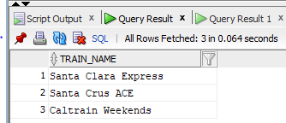

ORACLE EXPLAIN PLAN:

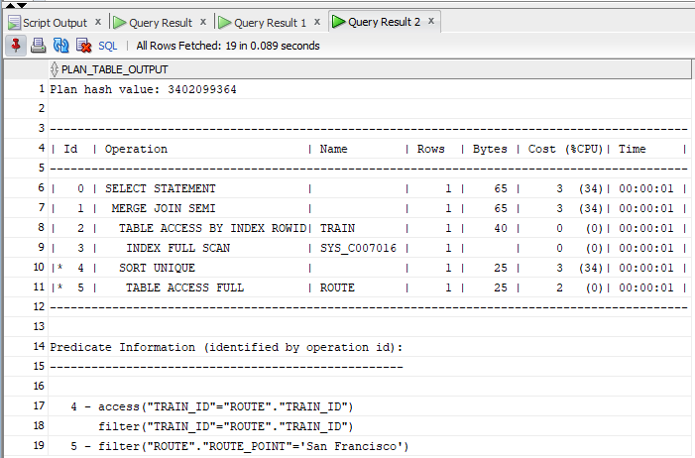

In HIVE:

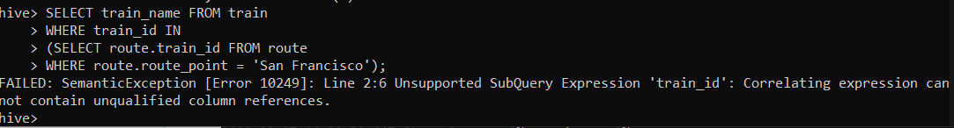

Explicitly mention the column which we are referring to.

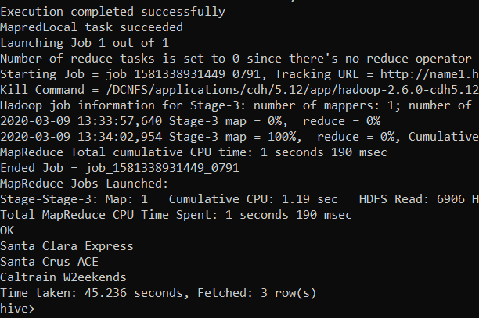

**4. Top 4 trains having maximum booked reservations**

**Oracle:**

**SELECT Train_name, booked_count FROM Train t**

**INNER JOIN TrainStatus ts ON**

**t.train_id = ts.train_id**

**ORDER BY Booked_count DESC) tr**

**WHERE ROWNUM < 5 ;**

**HIVE:**

**SELECT Train_name, booked_count FROM Train t**

**INNER JOIN TrainStatus ts ON**

**t.train_id = ts.train_id**

**ORDER BY Booked_count DESC limit 4;**

In ORACLE:

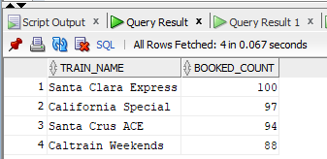

ORACLE EXPLAIN TOOL:

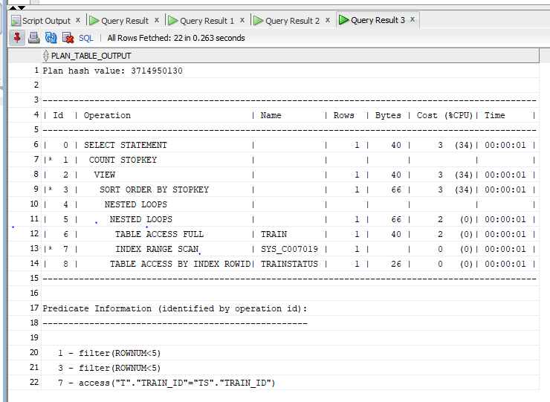

In HIVE:

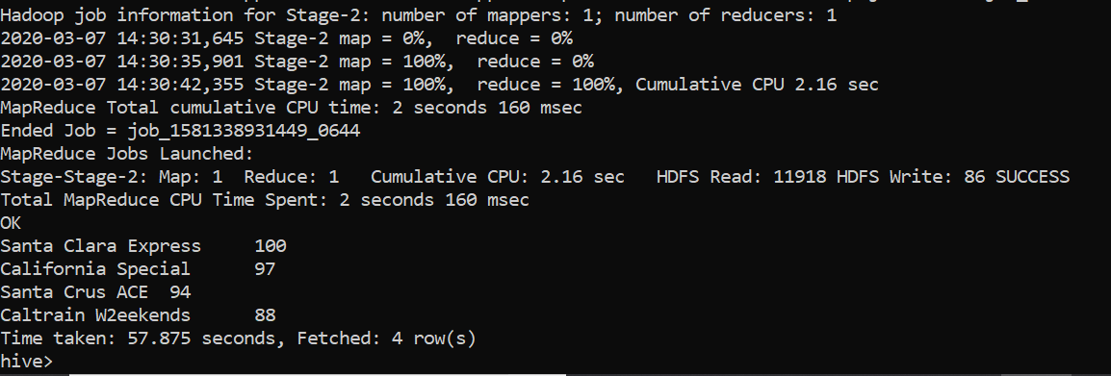

**5. Count number of Train Stops for each train**

**SELECT train_id train_name, count(*) Stops**

**FROM train T**

**JOIN**

**route r**

**ON r.train_id = t.train_id**

**GROUP BY t.train_id, t.train_name, Date(arrival_time);**

IN ORACLE:

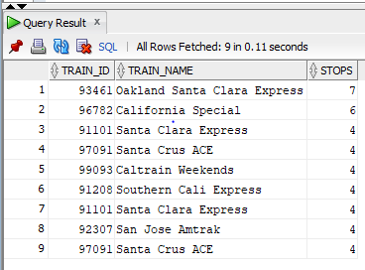

ORACLE EXPLAIN TOOL:

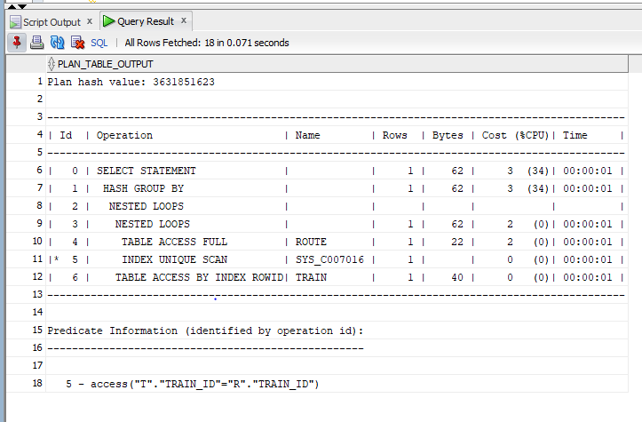

In HIVE:

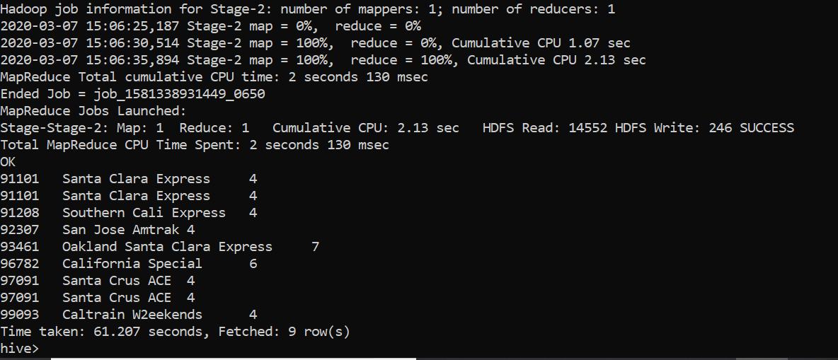

**6. Calculate male to female ratio**

**with q1 as ( SELECT COUNT(*) AS total_count FROM Passenger),**

**q2 as (SELECT gender,COUNT(*) as gender_count FROM Passenger GROUP BY**

**gender)**

**select gender,gender_count/total_count as Sex_Ratio from q1,q2;**

In ORACLE:

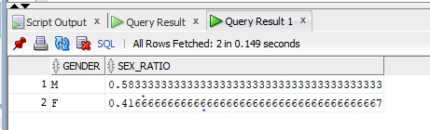

ORACLE EXPLAIN TOOL:

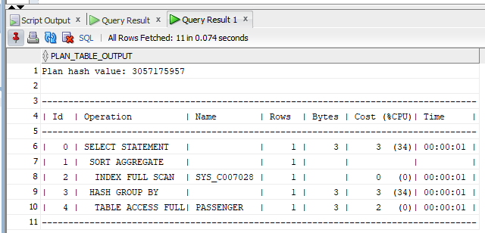

In HIVE:

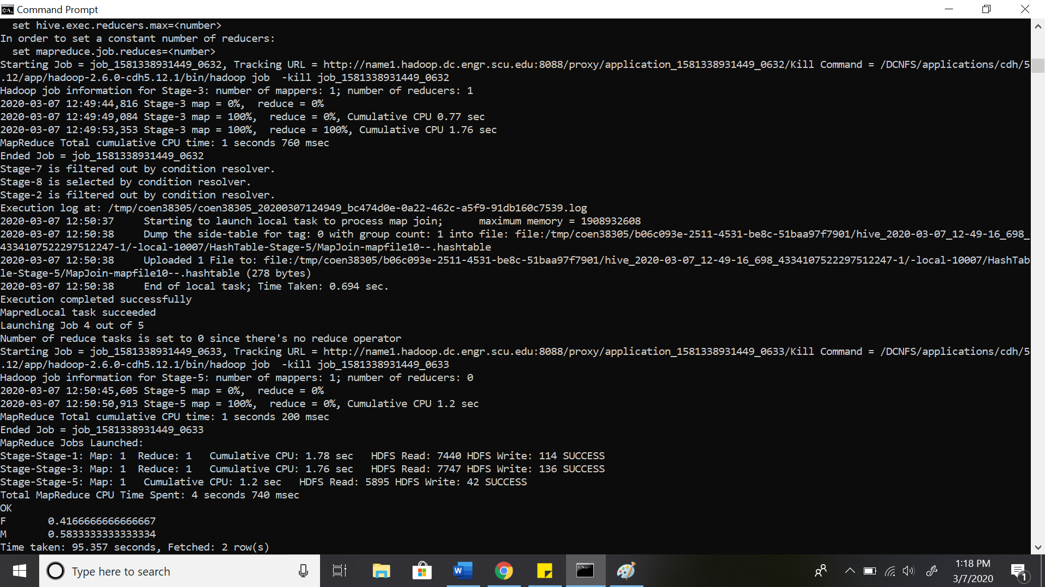

**7. Display Trains scheduled between 12AM to 12PM**

**In ORACLE:**

**SELECT DISTINCT train_name, r.* FROM route r**

**LEFT JOIN Train t**

**ON t.train_id = r.train_id**

**Where TO_Char(Arrival_time,'hh24')**

**between 0 AND 11;**

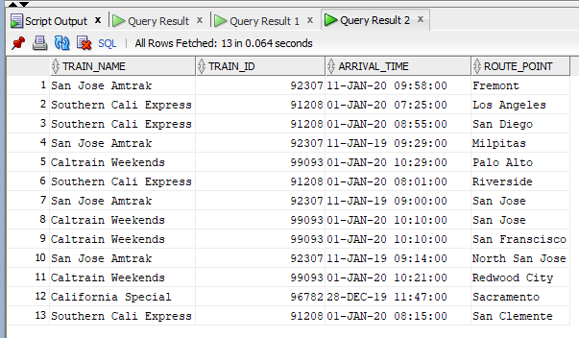

ORACLE EXPLAIN PLAN:

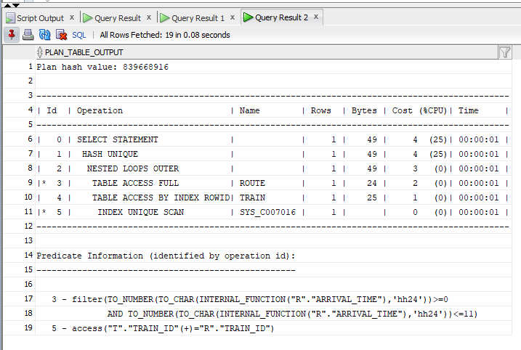

**In HIVE:**

**Select t.train_id, train_name, arrival_time, route_point from route r**

**join train t on t.train_id = r.train_id**

**where HOUR(arrival_time) between 0 AND 11**



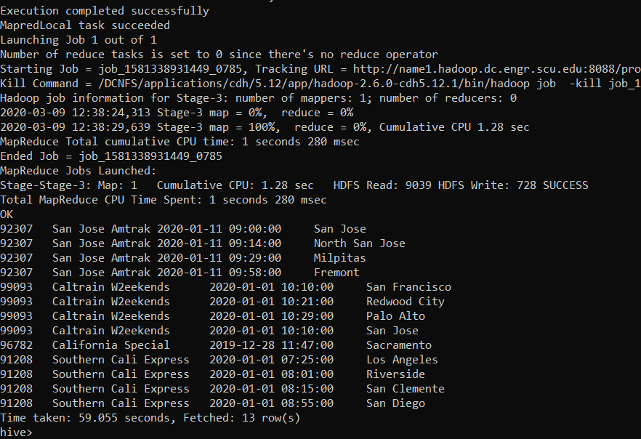

8. 3 Way Join

**9. Display Passenger and train details combined where ticket price is equal to 35 (4 Way Join)**

**SELECT DISTINCT(Passenger_name), Train_name, Ticket_price, ti.Ticket_id, Ticket_status, Status_date FROM Passenger p**

**INNER JOIN Train t ON t.train_id = p.train_id**

**INNER JOIN Ticket ti ON p.ticket_id = p.ticket_id**

**INNER JOIN TrainStatus ts ON t.train_id = ts.train_id**

**WHERE Ticket_price = 35**

In ORACLE:

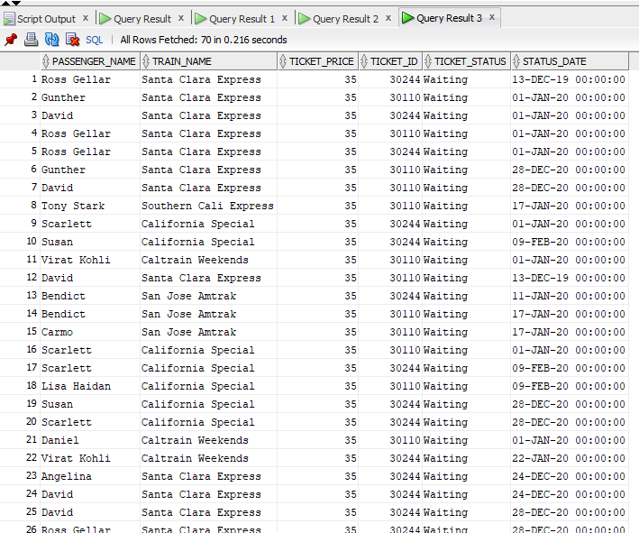

ORACLE EXPLAIN PLAN:

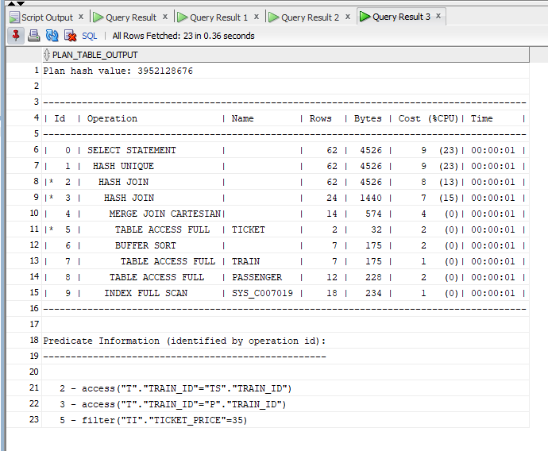

In HIVE:

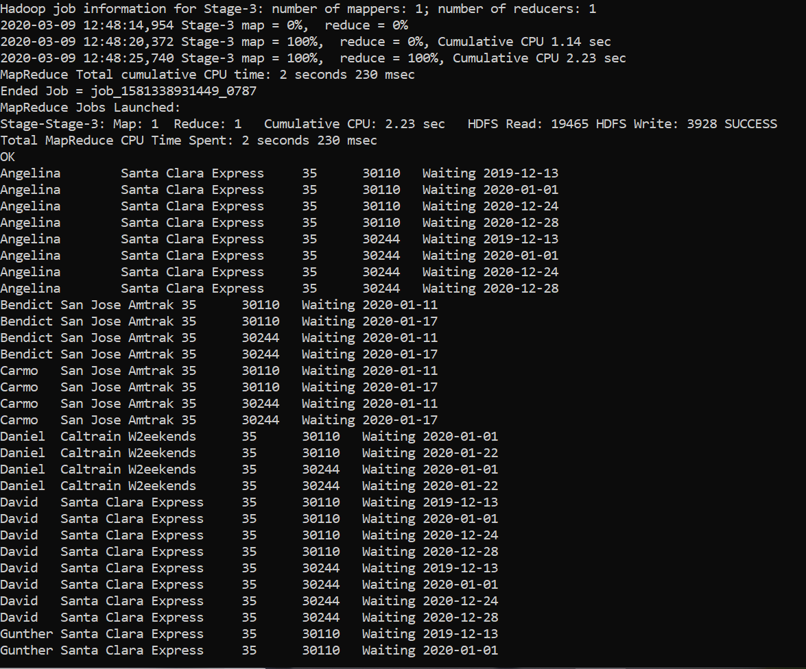

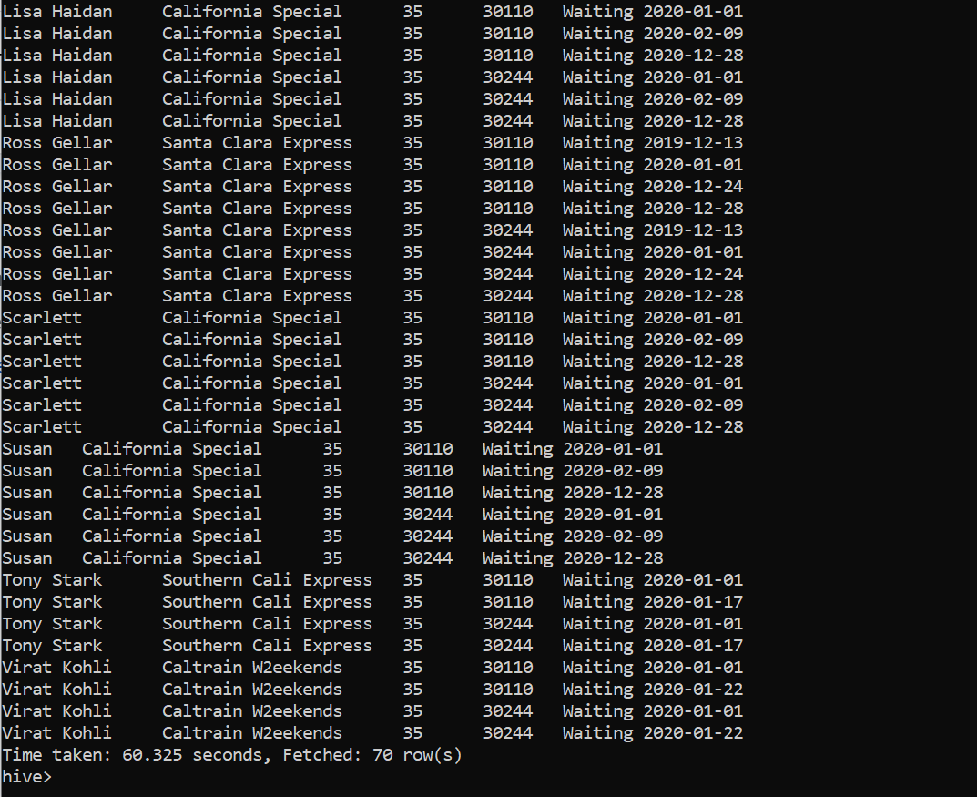

**10. Average ticket price of Each train (Select query in From clause)**

**SELECT tt.train_id, train_name, AVG(Ticket_price) FROM**

**(SELECT t.train_id, train_name, ticket_id FROM train t**

**LEFT JOIN passenger p ON t.train_id = p.train_id)**

**tt**

**LEFT JOIN ticket ti ON**

**tt.ticket_id = ti.ticket_id**

**GROUP BY tt.train_id,train_name;**

In ORACLE:

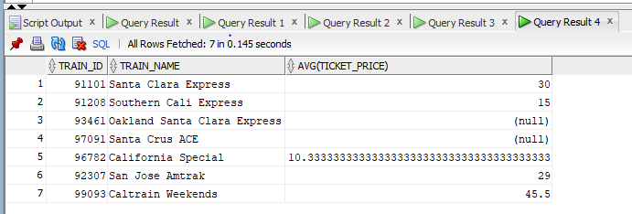

ORACLE EXPLAIN PLAN:

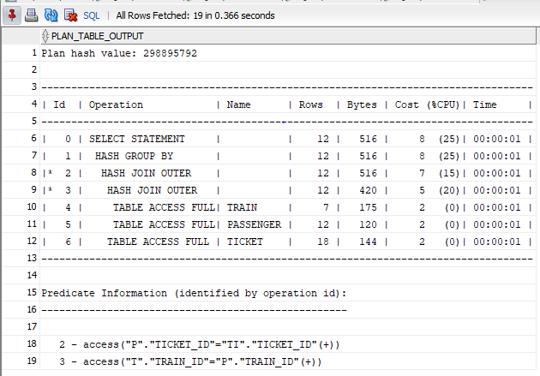

In HIVE:

