ASSIGNMENT – 39
MACHINE LEARNING
In Q1 to Q11, only one option is correct, choose the correct option:
1. Which of the following methods do we use to find the best fit line for data in Linear Regression?
A) Least Square Error B) Maximum Likelihood
C) Logarithmic Loss D) Both A and B
Ans : A) Least Square Error
2. Which of the following statement is true about outliers in linear regression?
A) Linear regression is sensitive to outliers B) linear regression is not sensitive to outliers
C) Can’t say D) none of these
Ans : A) Linear regression is sensitive to outliers
3. A line falls from left to right if a slope is ______?
A) Positive B) Negative
C) Zero D) Undefined
Ans : B) Negative

4. Which of the following will have symmetric relation between dependent variable and independent variable?
A) Regression B) Correlation
C) Both of them D) None of these
Ans : B) Correlation

5. Which of the following is the reason for over fitting condition?
A) High bias and high variance B) Low bias and low variance
C) Low bias and high variance D) none of these
Ans : C) Low bias and high variance
6. If output involves label then that model is called as:
A) Descriptive model B) Predictive modal
C) Reinforcement learning D) All of the above
Ans : B) Predictive modal

7. Lasso and Ridge regression techniques belong to _________?
A) Cross validation B) Removing outliers
C) SMOTE D) Regularization
Ans : D) Regularization

8. To overcome with imbalance dataset which technique can be used?
A) Cross validation B) Regularization
C) Kernel D) SMOTE
Ans : D) SMOTE

9. The AUC Receiver Operator Characteristic (AUCROC) curve is an evaluation metric for binary
classification problems. It uses _____ to make graph?
A) TPR and FPR B) Sensitivity and precision
C) Sensitivity and Specificity D) Recall and precision
Ans : A) TPR and FPR

10. In AUC Receiver Operator Characteristic (AUCROC) curve for the better model area under the
curve should be less.
A) True B) False
Ans : B) False

11. Pick the feature extraction from below:
A) Construction bag of words from a email
B) Apply PCA to project high dimensional data
C) Removing stop words
D) Forward selection
Ans : A) Construction bag of words from a email

In Q12, more than one options are correct, choose all the correct options:

12. Which of the following is true about Normal Equation used to compute the coefficient of the Linear
Regression?
A) We don’t have to choose the learning rate.
B) It becomes slow when number of features is very large.
C) We need to iterate.
D) It does not make use of dependent variable.
Ans : A) We don’t have to choose the learning rate.
B) It becomes slow when number of features is very large.

Q13 and Q15 are subjective answer type questions, Answer them briefly.

13. Explain the term regularization?
Ans : Regularization is one of the most important concepts of machine learning. It is a technique to prevent the model from overfitting by adding extra information to it.
Sometimes the machine learning model performs well with the training data but does not perform well with the test data. That means the model is not able to predict the output when deals with unseen data by introducing noise in the output, and hence the model is called overfitted. This problem can be deal with the help of a regularization technique.
This technique can be used in such a way that it will allow to maintain all variables or features in the model by reducing the magnitude of the variables. Hence, it maintains accuracy as well as a generalization of the model.
It mainly regularizes or reduces the coefficient of features toward zero.
"In regularization technique, we reduce the magnitude of the features by keeping the same number of features."

14. Which particular algorithms are used for regularization?
Ans : Algorithms are used for regularization :
Ridge Regression (L2 Regularization)
Its goal is to solve problems of data overfitting and when the data suffers from multicollinearity .
A standard linear or polynomial regression model will fail in the case where there is high collinearity (the existence of near-linear relationships among the independent variables) among the feature variables.
Ridge Regression adds a small squared bias factor to the variables. Such a squared bias factor pulls the feature variable coefficients away from this rigidness, introducing a small amount of bias into the model but greatly reducing the variance.
ADD FORMULEAS OF BOTH

15. Explain the term error present in linear regression equation?
Ans : Error term in linear regression is basically difference between Predicted value by model and Actual observed result .
Error also known as residual. It is represented by the letters e, ε, or u. These residuals will play a significant role in judging the usefulness of a model.

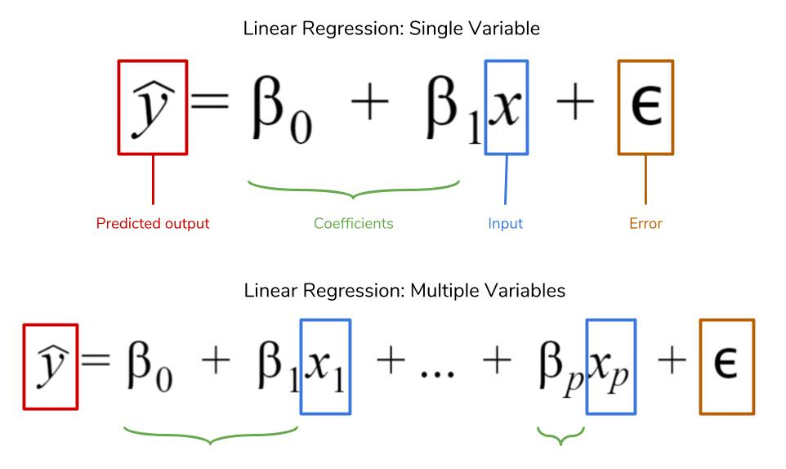term
If our collection of residuals are small, that means the model does a good job at predicting . Conversely, if these residuals are generally large, that means model is a poor estimator
If a model is heteroskedastic, a common problem in interpreting statistical models correctly, the variance of the error term in a regression model varies widely.
I don’t know if my model is accurate or not, so I need to calculate my error metrics to check if my model is even any good!

