STATISTICS WORKSHEET-1
Q1 to Q9 have only one correct answer. Choose the correct option to answer your question.

1. Bernoulli random variables take (only) the values 1 and 0.
a) True
b) False
Ans :a) True

2. Which of the following theorem states that the distribution of averages of iid variables, properly normalized, becomes that of a standard normal as the sample size increases?
a) Central Limit Theorem
b) Central Mean Theorem
c) Centroid Limit Theorem
d) All of the mentioned
Ans :a) Central Limit Theorem

3. Which of the following is incorrect with respect to use of Poisson distribution?
a) Modeling event/time data
b) Modeling bounded count data
c) Modeling contingency tables
d) All of the mentioned
Ans :b) Modeling bounded count data

4. Point out the correct statement.
a) The exponent of a normally distributed random variables follows what is called the log- normal distribution
b) Sums of normally distributed random variables are again normally distributed even if the variables are dependent
c) The square of a standard normal random variable follows what is called chi-squared
distribution
d) All of the mentioned
Ans :d) All of the mentioned

5. ______ random variables are used to model rates.
a) Empirical
b) Binomial
c) Poisson
d) All of the mentioned
Ans :c) Poisson

6. 10. Usually replacing the standard error by its estimated value does change the CLT.
a) True
b) False
Ans :b) False

7. 1. Which of the following testing is concerned with making decisions using data?
a) Probability
b) Hypothesis
c) Causal
d) None of the mentioned
Ans :b) Hypothesis

8. 4. Normalized data are centered at______and have units equal to standard deviations of the
original data.
a) 0
b) 5
c) 1
d) 10
Ans :a) 0

9. Which of the following statement is incorrect with respect to outliers?
a) Outliers can have varying degrees of influence
b) Outliers can be the result of spurious or real processes
c) Outliers cannot conform to the regression relationship
d) None of the mentioned
Ans :c) Outliers cannot conform to the regression relationship
WORKSHEET
Q10and Q15 are subjective answer type questions, Answer them in your own words briefly.

10. What do you understand by the term Normal Distribution?
Ans :
A graphical representation of a normal distribution is sometimes called a bell curve because of its flared shape.
Curve is defined by mean and standard deviation.The curve will be centered and symmetric around the mean and stretched by the standard deviation.
In a normal distribution,
mean=mode= median .
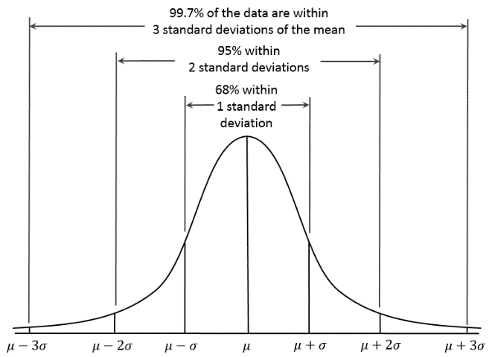
According to Imperical rule maximum data falls in 3 std deviation of mean.
in 1st std deviation 68% data falls
2nd std deviation 95% data falls
3rd std deviation 99.7% data falls

11. How do you handle missing data? What imputation techniques do you recommend?
Ans : While analyzing data we often find some data is missing , we directly can’t delete the data coz it makes model bias and can affect the efficiency of how the model performs.
There are many ways in which we can handle missing data.
Imputation is the process of replacing missing values with substituted data. It is done as a preprocessing step.
Imputation:
- Normal Imputaion :
If we have ‘X’ feature which is having missing values . Depending on the data type of the feature we can use following methods to replace the missing values.
Methods | Feature(X) Data type
Mean | numerical
Median | numerical
Mode | categorical

- Random Sample Imputation : It consists of taking observations from dataset , and we use these observations to replace NAN value
It should be used when , It is assumed data are missing completely at random
- Imputation Method for categorical columns
- Prediction of missing values like by using any of the algorithm Linear Regression Model
Annova test
- Using Algorithm that supports missing values
- KNN
- Naïve Bayes

12. What is A/B testing?
Ans : It is way to compare the two versions of a variable to find out which performs better in a controlled environment.
It is one of the most widely used statistical tool .
Eg . devide the product in two parts A and B.
Here make some significant changes in B like change packaging , images etc. and keep A as constant
Now , on the basis of response from customer groups who used A and B respectively , you try to decide which is performing better

Working of A/B testing : -
- Make Hypothesis = hypothesis is basically a assumption a concept not yet verified but if truewould explain certain facts.
We make 2 hypothesis 1) Null hypothesis 2) Alternative hypothesis .
Null hypothesis(H0) states that there is no diffrence between the contrl and variant groups .
Alternative hypothesis (H1) : It challenges the null hypothesis
- Create control group and Test group once we are ready with our null and Alternate hypothesis.
Control group will receive controlled (unchanged)data and test group will receive changed (variance)data.
- Conduct A/B testing and collect the data : Calculate the conversion rate on the both groups .
Though conversion rate of Null is better than Alternate hypothesis we can’t just accept Null and reject Alternate hypothesis ,To reject our Null hypothesis we have to prove statistical significance of our test.
There are two types of errors that may occur 1) Type 1 error :we reject the null hypothesis when it is true.
2) Type II error : we failed to reject null hypothesis when it is false
To avoid these error we must calculate statistical significance of our test. TO do this we use two sample T-test , it is most commonly used in hypothesis testing
Significance level alpha ,is the probability of rejecting the null hypothesis when it is true, generally we use alpha= 0.05
P value :it is probability that the difffrence between two values is just because of random chance.
P value is evidence against Null hypothesis .
The smaller the p-value stronger the chances to reject the H0 .For the significance level of .05 if the p_value is lesser than it . we reject Null hypothesis .

13. Is mean imputation of missing data acceptable practice?
Ans : Mean imputation is the practice of replacing null values in a data set with the mean of the data. Mean imputation is generally bad practice because it doesn’t take into account feature correlation. Leads to an underestimate of the standard deviation .It preserves mean of the given data.

14. What is linear regression in statistics?
Ans : Linear regression is Supervised machine learning algorithm which tries to find out best possible linear regression between Input (independent ,label) variable and output(target ,response ,dependent) variable(feature).
Suppose X – Independent Feature
Y – dependent Feature Then Linear regression equation is
Y= a + bx + e
Where a – intercept
b – coefficient (the slope)
e – regression residual error

y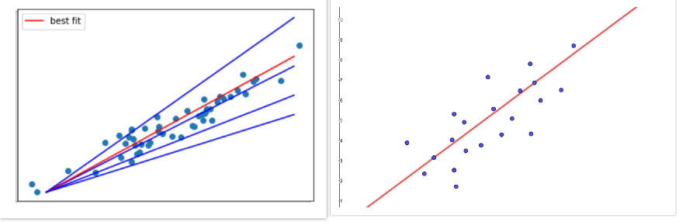
X à
In linear regresssion will try to plot best fit line in such a way that the distance between actual data point and line is least . As shown in above fig. red line is best fit line than the other blue lines .
Goal of linear regression is finding out values of ‘a’ and ‘b’ to predict the target value for the given input.
Types of linear regression:
- Simple linear regression
- Multiple linear regression
The simple linear regression method finds the relationship between a single independent variable and one dependent variable.
The multiple linear regression method finds the relationship between two or more independent variables and one dependent variable.
Assumption of linear regression:
- Linear relationship between dependent and independent variable .
- Multicollinearity
- Homoscedasticity
Methods used to solve linear regression:
- Simple linear regression : used to find out best relationship between one Independent variable and one dependent variable
- Ordinary least squares regression (normal equation) : : used to find out best relationship between more than one Independent variable and one dependent variable
- Gradient descent : it is commonly used methods to solve linear regression problems. It's used when there are one or more inputs and involves optimizing the value of coefficients by minimizing the model's error iteratively.
In this method we take random values for every coefficient. For every pair of input and output values, the sum of the squared errors is calculated.

15. What are the various branches of statistics?
Ans : Branches Of Statistics
- Descriptive Statistics : It consists of organizing and summarizing data .
- Inferential Statistics :Technique to use the information collected from the sample , to bring decisions, or predict a defined population.
Descriptive Statistics : It has 2 parts
- Central tendency measures : It helps to calculate distribution center of value. Tendancy measures are :
Mean : m= Sum of the terms/numbers of terms
Median: It is value of the middle term of dataset
To solve the median, there are two formulas;
When n is odd,
(n+1 / 2)th observation
When n is even,
median=(n/2)th + (n/2+ 1)th observation / 2
Mode: Most frequently occured value in datasset .
- Variability measures : It hepls us to analyze the distribution that is spreading from a specific data set. Some of the variables of variability include quartiles, ranges, variances, and standard deviation.
Inferential Statistics : Diffrent types of Inferential Statistics
- Regression analysis: It is used to estimate relation between dependent and independent variables. Diffrent models are Linear regression , multi linear regression .
- Analysis of variance (ANOVA): It distributes observed variance data into various components. A one-way ANOVA is applied for three or more data groups to gain information about the relationship between the dependent and independent variables.
- Statistical significance (t-test): It is used to determine a significant difference between the means of two groups related to particular features. A t-test studies the t-statistic, the t-distribution values, and the degree of freedom to learn the statistical significance.
- Correlation analysis: This method is used to find the relationship between two variables or datasets and discover how strong the relationship may be.

