**Assignment on Data Types**

1.The smallest data type is______and its size is _______bits.

1. short, 8 b. byte, 8 (ANS) c. short, 16 d. short, 16

2.Size of int in java.

1. 16bit b. 32bit (ANS) c. 64bit d. Depends on the execution environment.

3.In java int,short,byte and long all of these are .

1. Signed (ANS) b. unsigned c. none of the above d. all of the above

4.Determine the output of the following program.

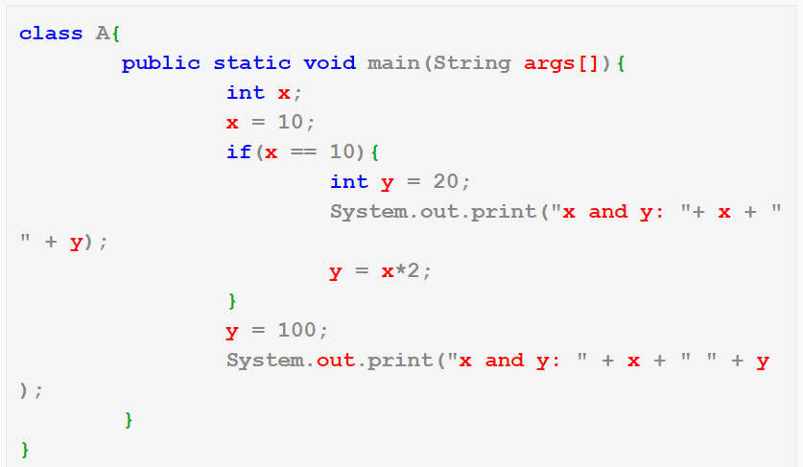

A.10 20 10 20

1. 10 20 20 100

c.error(ANS)

d.10 20 10 10

5.Determine the output of the following program.

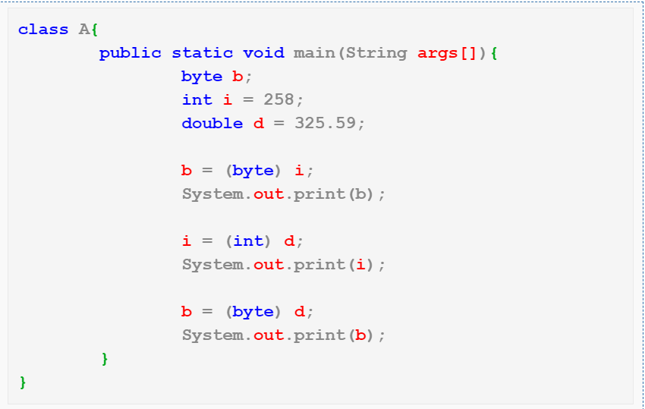

1. 2 325 69 (ANS)
2. b.252 658 234
3. c.258 325 325
4. d.error

6.Determine the output of the following program.

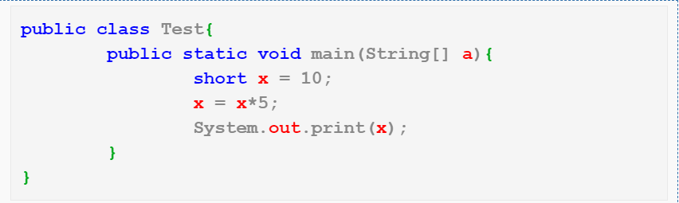

A.50(ANS) b.compilation error c.10 d.None of the above

7.In java,the word **true** is____

a.Boolean literal(ANS)

b.Same as value 1 c.java keyword d.same as value 0

8.Char data type cannot store which value?

A.digit(ANS) b.String c.alphabet d.letter

9.Default value of boolean datatype is

A.True

B.False(ANS)

c.0

d.1

10.How many primitive datatype are there in java.

A.5

b.10

c.8(ANS)

d.7