Q1. Using AdventureWorks - List all the employees show name and department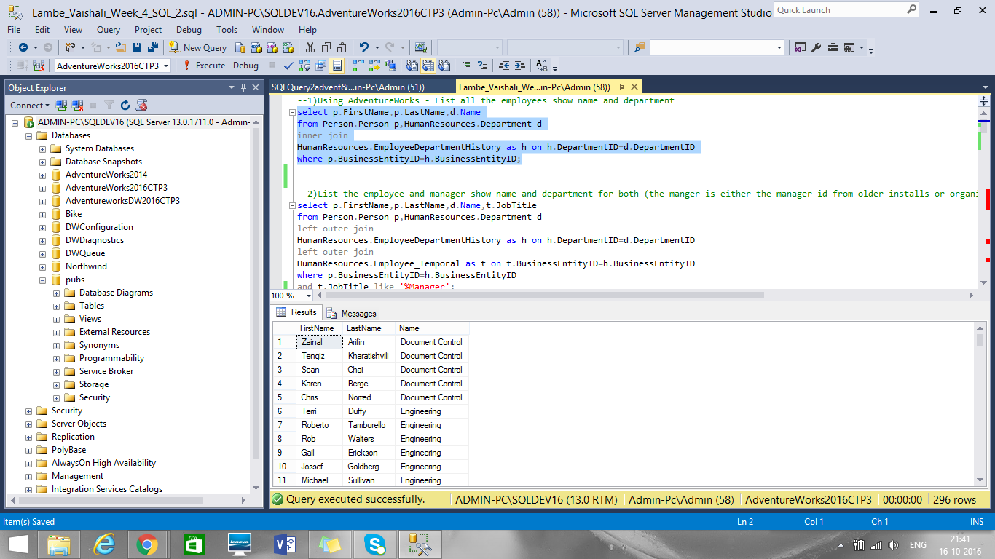

Q2. List the employee and manager show name and department for both (the manger is either the manager id from older installs or organization level)

Two ways as professor told 1. Employees with their managers 2. Only managers

Employee and managers

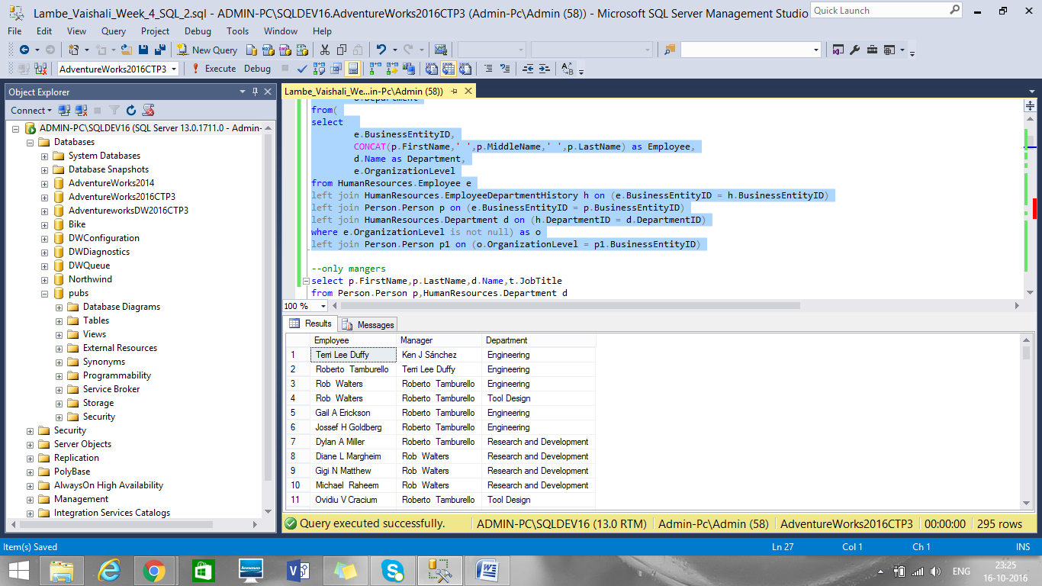

Only managers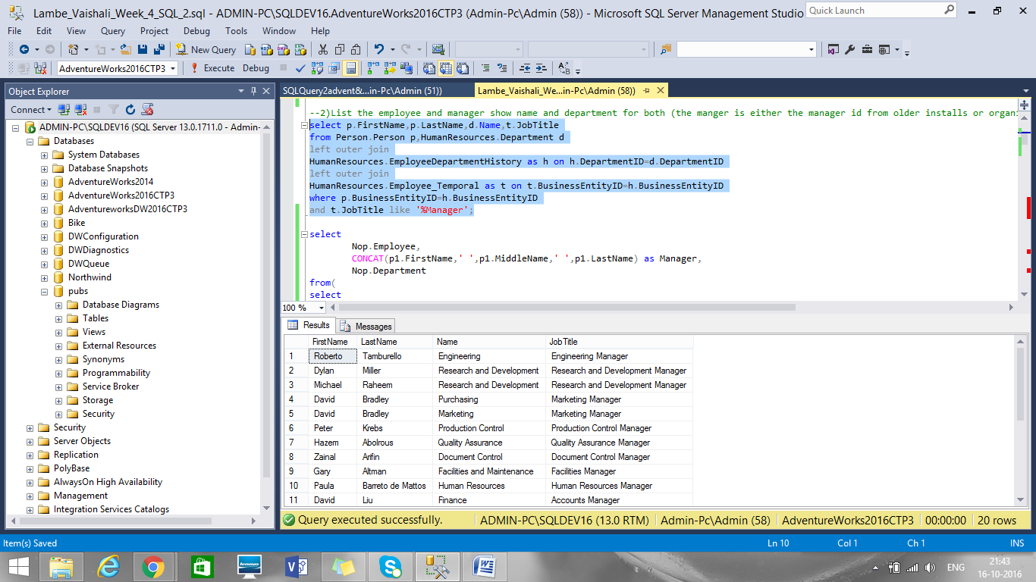

Q3. Using AdventureWorks - Show the employees and their current and prior departments

Current departments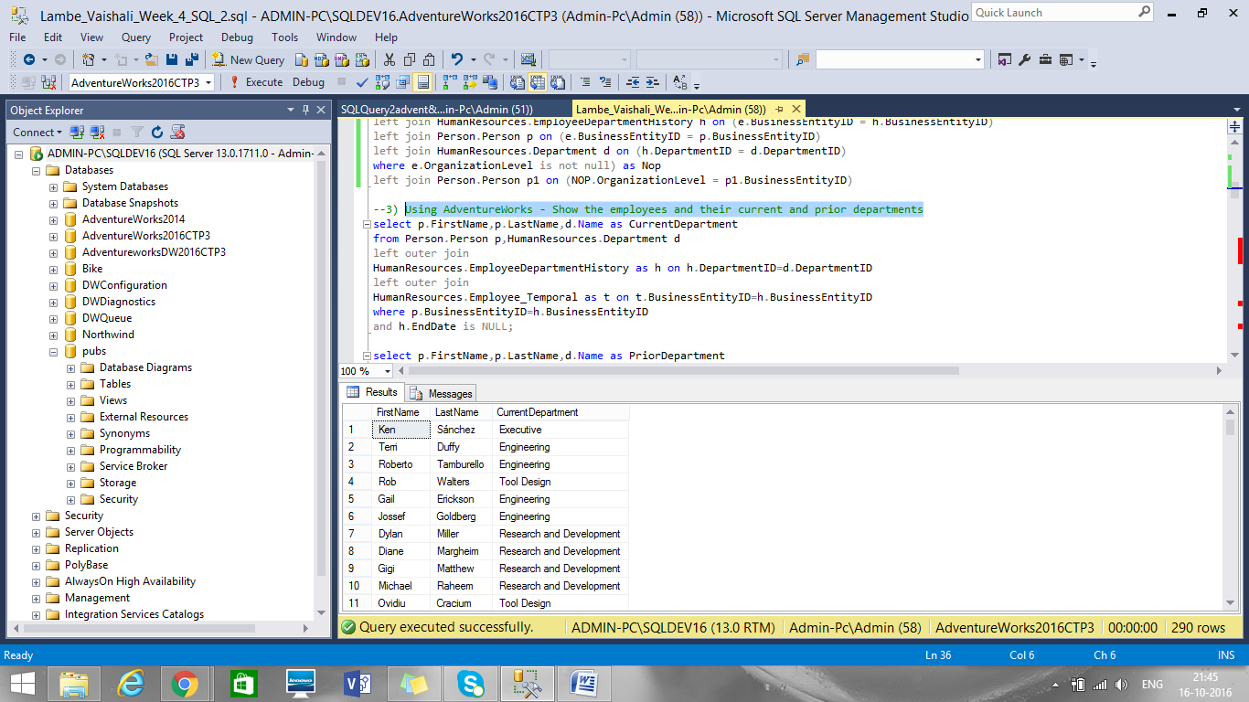

Prior departments

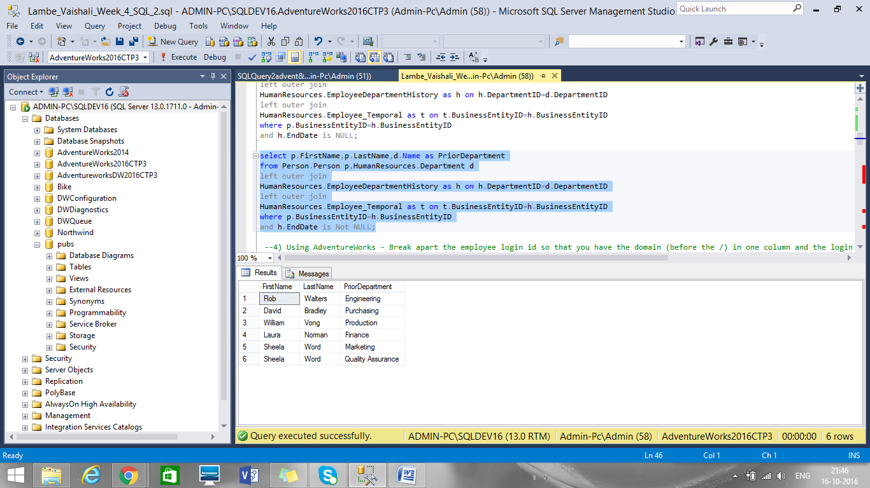

Q4. Using AdventureWorks - Break apart the employee login id so that you have the domain (before the /) in one column and the login id (after the /) in two columns

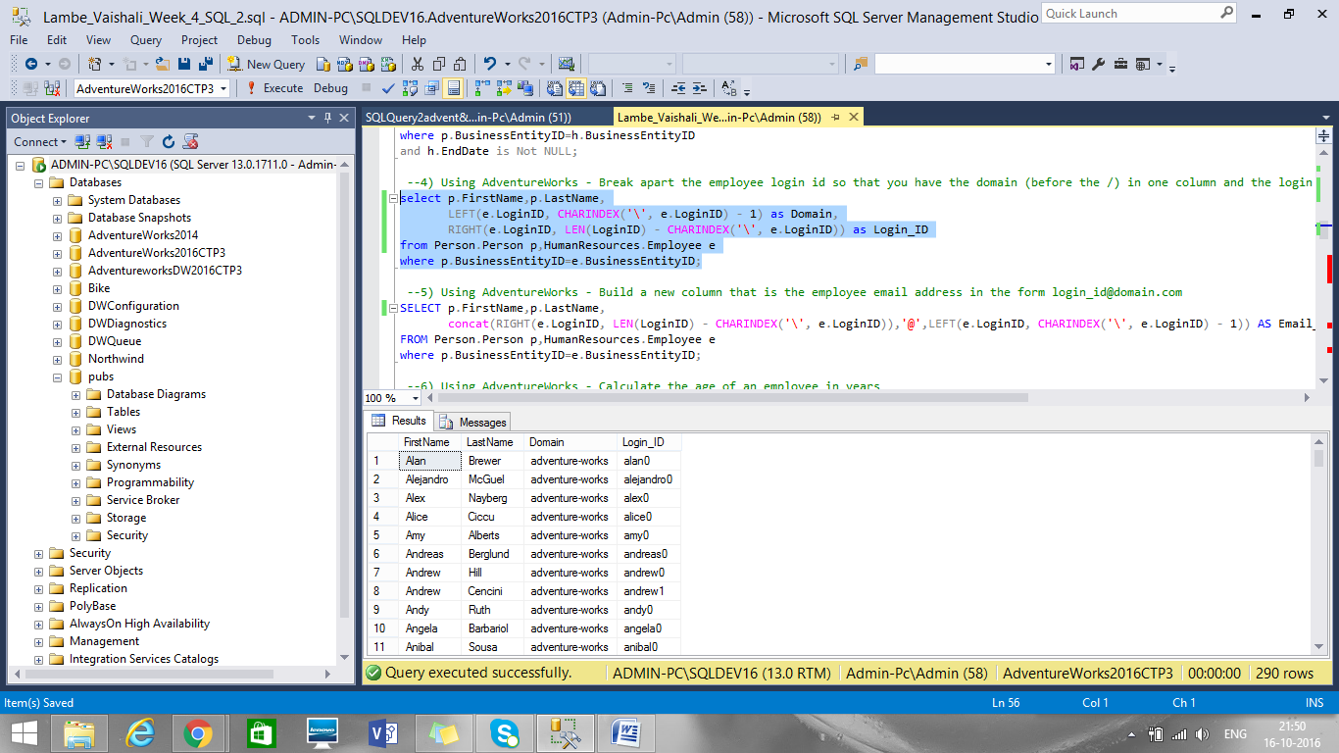

Q5. Using AdventureWorks - Build a new column that is the employee email address in the form login_id@domain.com

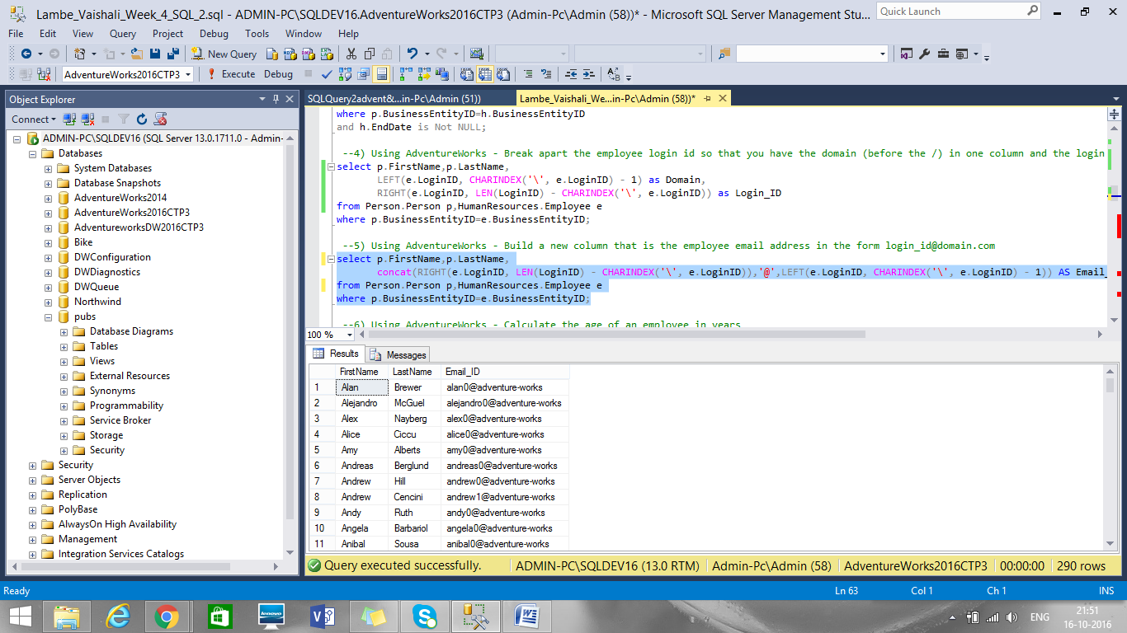

Q6. Using AdventureWorks - Calculate the age of an employee in years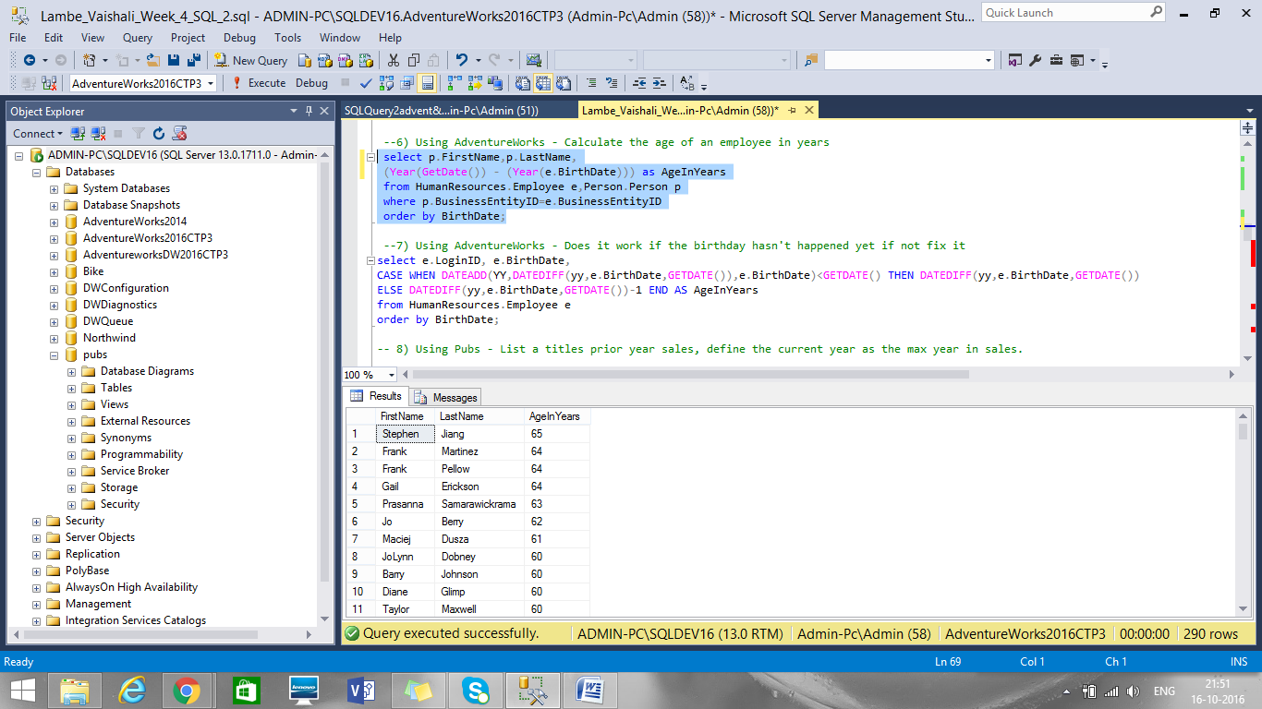

Q7. Using AdventureWorks - Does it work if the birthday hasn't happened yet if not fix it

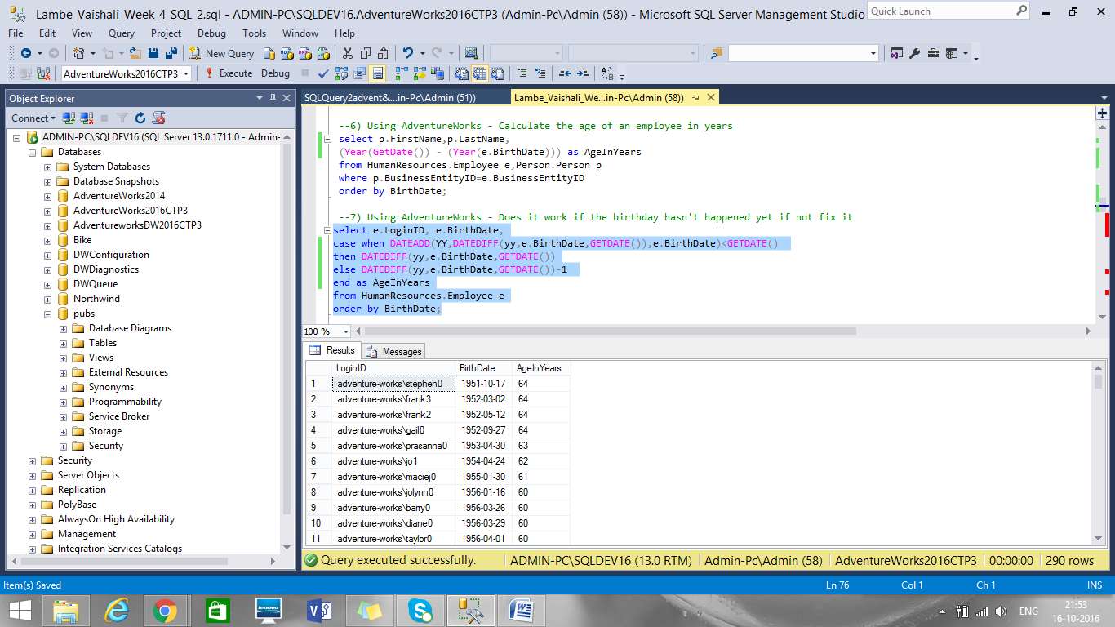

Q8. Using Pubs - List a titles prior year sales, define the current year as the max year in sales.

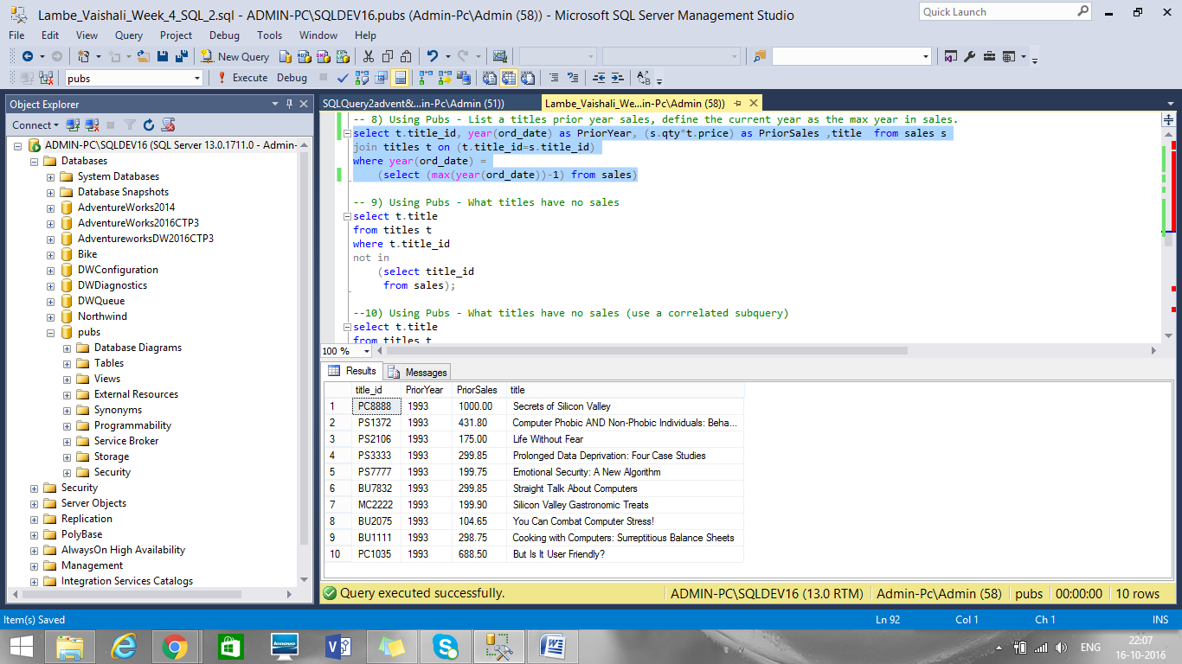

Q9. Using Pubs - What titles have no sales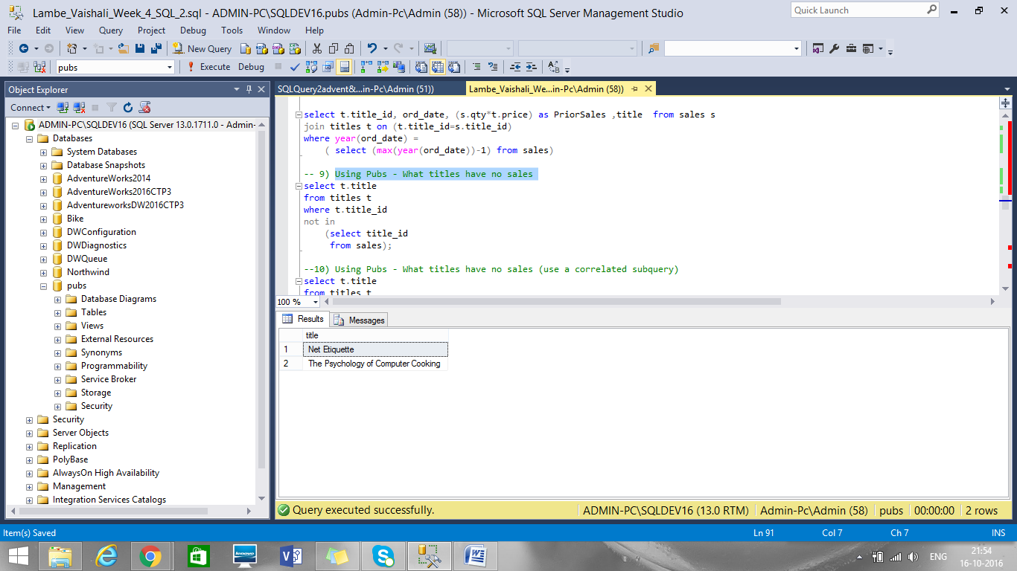

Q10. Using Pubs - What titles have no sales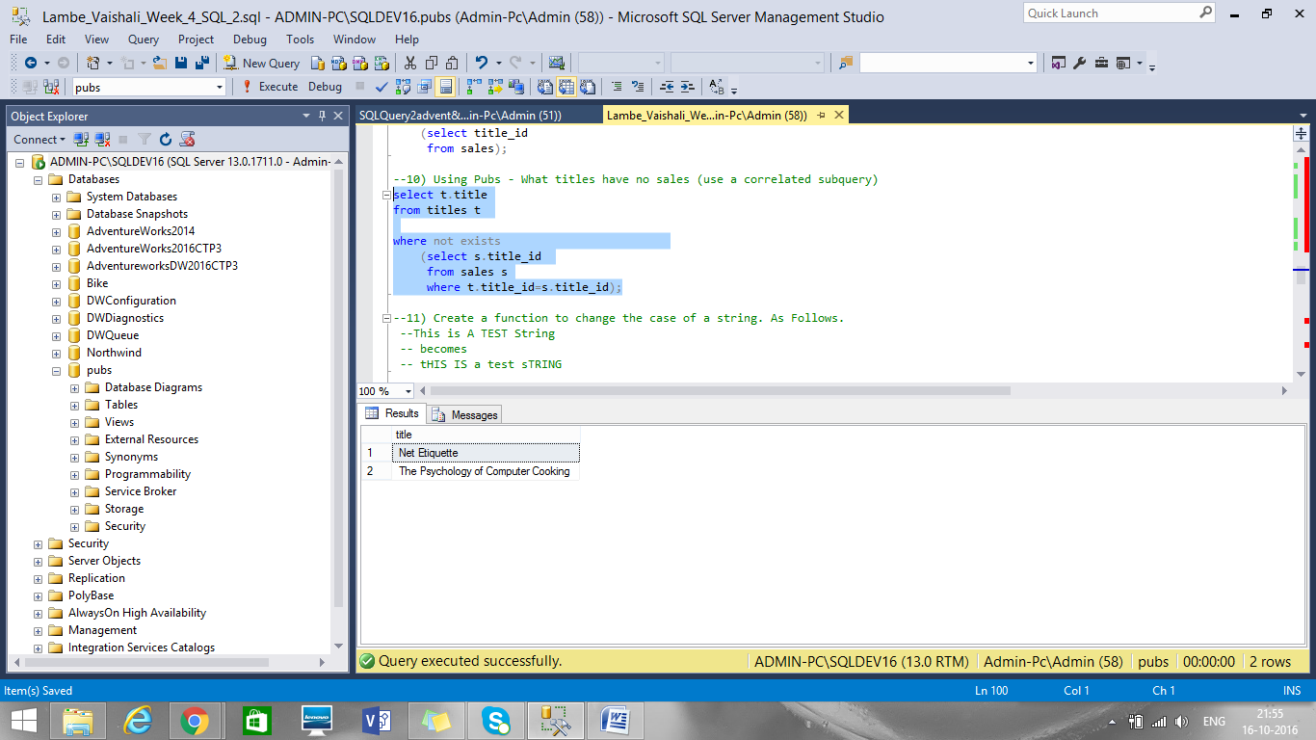

Q11. Create a function to change the case of a string. As Follows.

This is A TEST String becomes tHIS IS a test sTRING

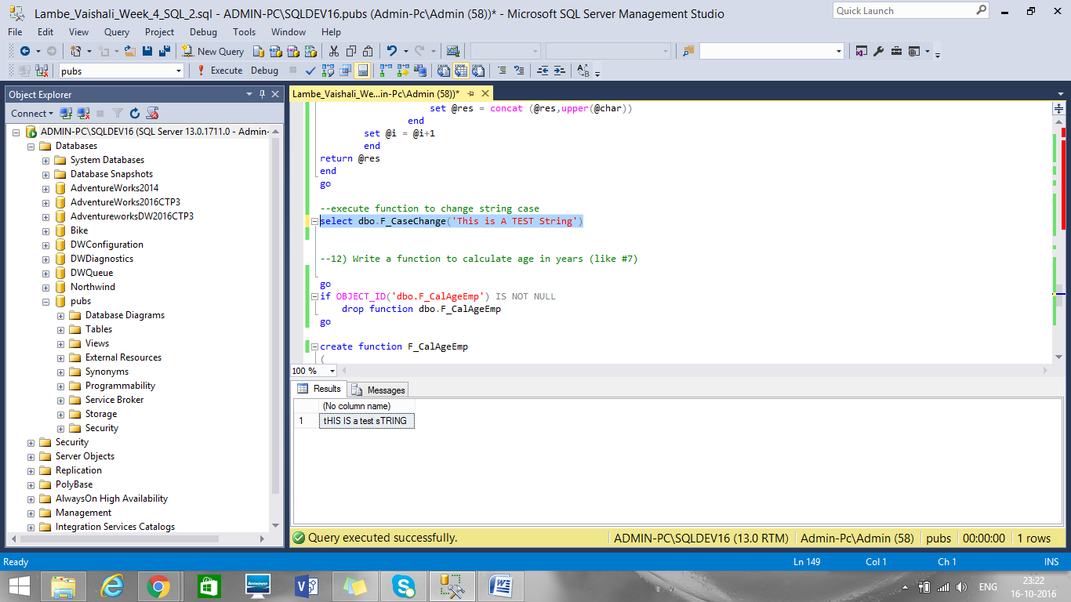

Q12. Write a function to calculate age in years (like #7)

