Bicycle Model

Database Design Document

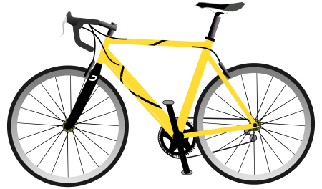

Revision History

| Date | Version | Description | Author | NUID |
| --- | --- | --- | --- | --- |
| 10/09/2016 | 1.0 | First version | Vaishali Lambe | 001286444 |
|  |  |  |  |  |

Table of Contents

Introduction……………………………………………………………………………………………………………………………………………. 3

Overview………………………………………………………………………………………………………………………………………………….3

Subject Area(Clusters)………………………………………………………………………………………………………………………………5

Glossary……………………………………………………………………………………………………………………………………………………6

In Scope…………………………………………………………………………………………………………………………………………………….6

Out of Scope……………………………………………………………………………………………………………………………………………..6

Entities and Attributes……………………………………………………………………………………………………………………………….7

**Introduction:**

It describes database design for product Bicycle. It contains entities Product (bicycle), Category, Sub-Category, Order, Order line, Inventory, Suppliers, Stores, Sales, Customer and Employee. The database includes information starting from availability of product amongst category till employee serves the order to a customer.

**Overview:**

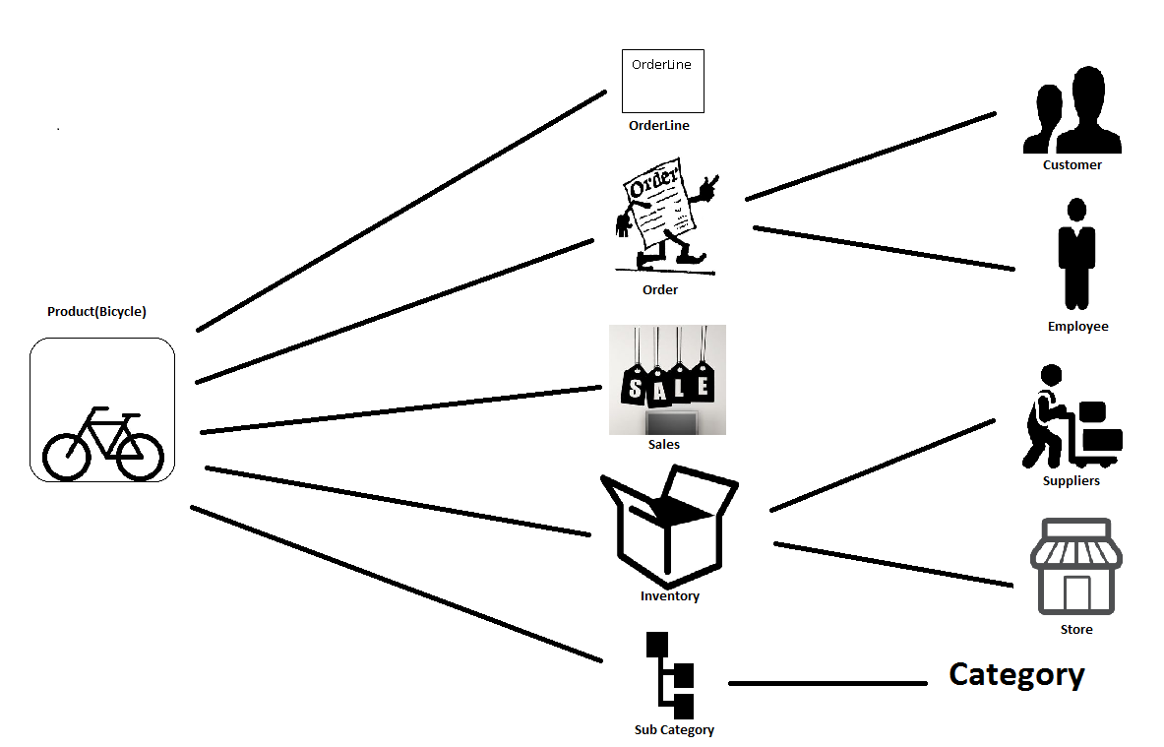

Product

|  |  |  |  |  |  |  |  |  |  |  |  |  |  |  |  |  |  |  |  |  |  |  |  |  |  |  |  |  |  |  |  |  |  |  |  |  |  |  |  |  |  |  |  |  |  |  |  |  |  |  |  |  |  |  |  |  |  |  |  |  |  |  |  |  |  |  |  |  |
| --- | --- | --- | --- | --- | --- | --- | --- | --- | --- | --- | --- | --- | --- | --- | --- | --- | --- | --- | --- | --- | --- | --- | --- | --- | --- | --- | --- | --- | --- | --- | --- | --- | --- | --- | --- | --- | --- | --- | --- | --- | --- | --- | --- | --- | --- | --- | --- | --- | --- | --- | --- | --- | --- | --- | --- | --- | --- | --- | --- | --- | --- | --- | --- | --- | --- | --- | --- | --- |
| **Subject Area(Clusters)Microsoft SQL Server 2014.bmp**  **Glossary:**   |  |  | | --- | --- | | **Term** | **Full Form/description** | | PK | Primary Key | | FK | Foreign Key | | PFK | Primary Foreign Key | | NN | Not Null |   **In Scope:**   |  |  | | --- | --- | | **Sr. No.** | **Description** | | IS001 | Order line must have at least one product | | IS002 | Product may have zero or more sub categories | | IS003 | Category may have zero or more sub categories | | IS004 | Order must be associated with a customer | | IS005 | A customer must have at least one order | | IS006 | Order have one or more order lines | | IS007 | Each order line corresponds to one product | | IS008 | Stores gives location of the product | | IS009 | Suppliers provide product to inventory | | IS010 | Inventory is a bridge between suppliers product and stores | | IS011 | Order Status has only four values , “OPEN”, “SHIPPED”, “PARTIAL RETURN”, “FULL RETURN” | | IS012 | Employee severs one or more orders | | IS013 | Tax amount is as order and order line level | | IS014 | Unit price of a product is at order line level | | IS015 | Total price of products in order is at order level | | IS016 | Order status is at order and order line level | | IS017 | Discounts are at order level | | IS018 | A product can be in multiple inventory locations (stores) | | IS019 | A product can be supplied by multiple suppliers | | IS020 | When a product is shipped by a supplier it is received by a single location (store) |   **Out of Scope:**   |  |  | | --- | --- | | **Sr. No.** | **Description** | | OS001 | Exchange of a product is out of scope | | OS002 | Tax amount at product level is out of scope | | OS003 | Discounts at product level out of scope | |  |  | |  |  |   **Entities and Attributes:**  **Entity: Product**  The outcome obtained from various businesses or manufacturing processes. It’s a physical form which can be available to buy or sale. Here it referred to bicycle. | | | | |
| **Attribute** | **Data Type** | **Not Null** | **Key** | **Definition** |
| Prod_ID | Int | NN | PK | Unique identification of a product which differentiate each product from other or the unique number or string to identify the product. |
| Prod_Name | Char(20) | NN |  | Attractive name given to a product to reach it to the customer and market. |
| Prod_Price | Decimal(5,3) | NN |  | Price at which product is available for customer to buy or selling price at which supplier will sell the product to customer. |
| Prod_Color | Char(15) | NN |  | Color of a product is how it appears visually to human like black, green etc. |
| Prod_Brand | Char(20) | NN |  | Some name or series to create own identification in the market. Its design or logo or name. |
| Prod_Size | Int | NN |  | Measurement of the product in measuring units like centimetres to define its length, height. |
| SubCat_ID | Int | NN | FK | It’s a foreign key to identify a product uniquely and givens more details about category. |

**Entity: Category**

Group of Products divided into different groups depending on same features, qualities

|  |  |  |  |  |
| --- | --- | --- | --- | --- |
| **Attribute** | **Data Type** | **NotNull** | **Key** | **Definition** |
| Cat_ID | Int | NN | PK | Unique identification given to identify particular category or Its an unique number or string to distinguish one product from other product on the basis of multiple attributes like colour, size, model, price. |
| Cat_Name | Char(20) | NN |  | Name given to identify particular series of categories depending upon its use or purpose. |

**Entity: SubCategory**

It is a descendent of category. Products can be distinguished further beyond category with more specific features.

|  |  |  |  |  |
| --- | --- | --- | --- | --- |
| **Attribute** | **Data Type** | **NotNull** | **Key** | **Definition** |
| SubCat_ID | Int | NN | PK | Group of categories divided again into groups to low level depending upon some more common features. |
| SubCat_Name | Char(20) | NN |  | Name given to identify each series of group of sub categories. |
| Cat_ID | Int | NN | FK | It is Foreign key to subcategory to give more information abour product category. |

**Entity: Order**

It’s a request made by a customer and served by a supplier. Customer places the order of product he needs.

|  |  |  |  |  |
| --- | --- | --- | --- | --- |
| **Attribute** | **Data Type** | **NotNull** | **Key** | **Definition** |
| Order_ID | Int | NN(PK) | PK | Unique number or string to identify specific request made by specific customer. |
| Discounts | Decimal(3,2) | NN |  | It’s is a deduction from original cost of a product so make it available to customer at lower price |
| Order_Status | Char(10) | NN |  | It refers to order position from shipment till the delivery. |
| Order_Loc | Char(10) | NN |  | It is address from where order is placed. |
| Total_Price | Decimal(6,4) | NN |  | Its price of the order made by customer in a particular order may correspond to one or more products. |
| Tax_amount | Decimal(5,3) | NN |  | Compulsory contribution to state revenue which is additional amount added along with total price. |
| Prod_ID | Int | NN | FK | It’s a foreign key to order table to identify which product is ordered. |
| Cust_ID | Int | NN | FK | It’s a foreign key to order to provide customer details. |
| Emp_ID | Int | NN | FK | It’s a foreign key to order to keep track of which employee is handling the order. |

**Entity: Customer**

The person or organisation, that buys the product from stores or business.

|  |  |  |  |  |
| --- | --- | --- | --- | --- |
| **Attribute** | **Data Type** | **NotNull** | **Key** | **Definition** |
| Cust_ID | Int | NN | PK | The unique number associated with every customer |
| Cust_Name | Char(30) | NN |  | The name present n records to identify the customer |
| Email_ID | Varchar(max) | NN |  | The unique mailing address |
| Phone_Num | Varchar(25) | NN |  | The number to call to a customer |
| Cust_Address | Varchar(max) |  |  | The address where customer stays |

**Entity: Employee**

A person who serves an order to a customer. Person performs activities related from shipping till its full delivery.

|  |  |  |  |  |
| --- | --- | --- | --- | --- |
| **Attribute** | **Data Type** | **NotNull** | **Key** | **Definition** |
| Emp_ID | Int | NN | PK | The unique number associated with every employee |
| Emp_lname | Char(20) | NN |  | Last name of the employee or family name |
| Emp_fname | Char(20) | NN |  | First name of the employee |
| Title | Varchar(10) | NN |  | Designation of the employee |
| Emp_Discounts | Decimal(3,2) |  |  | Special deduction to a product price made available for employees to get the same product at lower price. It can be zero or more. |

**Entity: Orderline**

It’s line for the particular order delivery. Order can have many order lines.

|  |  |  |  |  |  |
| --- | --- | --- | --- | --- | --- |
| **Attribute** | **Data Type** | **NotNull** | **Key** | | **Definition** |
| OrderLine_Num | Int | NN | PK | The unique number associated with every order line | |
| Orderline_Status | Char(10) | NN |  | It refers to order position from shipment till the delivery in order line. | |
| Unit_Price | Decimal(5,3) | NN |  | It’s a selling price of one unit of a product. | |
| Unit_Tax_Amt | Decimal(4,2) | NN |  | Its a tax accountable for one unit of product. | |
| Prod_ID | Int | NN | PFK | It’s a foreign key to an orderline to give information abut which product is there in orderline. | |

**Entity: Sales**

An event for the rapid disposal of goods at reduced prices for a period, especially at the end of a season.

|  |  |  |  |  |
| --- | --- | --- | --- | --- |
| **Attribute** | **Data Type** | **NotNull** | **Key** | **Definition** |
| Sale_ID | Char(4) | NN | PK | It’s unique number to identify a particular store. |
| Sale_Price | Decimal(6,4) | NN |  | It’s a name of the store. |
| From_Date | Date | NN |  | Start date of a sale on a particular product. |
| To_Date | Date | NN |  | End date of a sale on a particular product. |
| Prod_ID | Int | NN | PFK | It’s a primary foreign key for a sale as sale cannot exist without a product. |

**Entity: Inventory**

It’s a complete list of products in stock.

|  |  |  |  |  |
| --- | --- | --- | --- | --- |
| **Attribute** | **Date Type** | **Not Null** | **Key** | **Definition** |
| Inv_ID | Char(4) | NN | PK | It’s a unique number to identify a particular inventory. |
| Quantity | Int | NN |  | It’s a number to show how many products of same type are in stock or available. |
| Prod_ID | Int | NN | FK | It’s a foreign key to provide information about product to inventory |
| Sup_ID | Int | NN | FK | It’s a foreign key to provide information on who supplies a particular product to inventory |

**Entity: Suppliers**

A person or entity which supplies a product (bicycle).

|  |  |  |  |  |
| --- | --- | --- | --- | --- |
| **Attribute** | **Data Type** | **Not Null** | **Key** | **Definition** |
| Sup_ID | Int | NN | PK | It’s an unique number which is associated whith particular supplier. |
| Sup_Name | Char(20) | NN |  | It’s a name of the supplier. |
| Sup_City | Char(20) | NN |  | It’s a location name of the supplier. |
| Sup_Num | Int | NN |  | It’s a number associated with specific supplier. |

**Entity: Stores**

It corresponds to where the product is and from where the order is made.

|  |  |  |  |  |
| --- | --- | --- | --- | --- |
| **Attribute** | **Data Type** | **Not Null** | **Key** | **Definition** |
| Store_ID | Char(4) | NN | PK | It’s unique number to identify a particular store. |
| Location | Char(10) | NN |  | It’s a location where products are available in any particular inventory. |
| Sup_ID | Int | NN | FK | It’s unique number and act as a foreign key to losate particular supplier of a product. |