**Bicycle Model**

Database Design Document

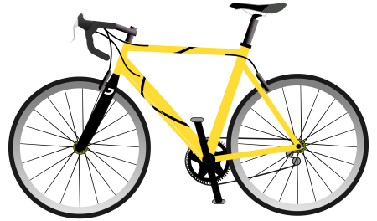

Revision History

| Date | Version | Description | Comments | Author | NUID |
| --- | --- | --- | --- | --- | --- |
| 10/09/2016 | 1.0 | First version | Initial draft version | Vaishali Lambe | 001286444 |
| 10/13/2016 | 1.1 | Updated version | Changes made for entities and attributes | Vaishali Lambe | 001286444 |

Table of Contents

Introduction……………………………………………………………………………………………………………………………………………………………………3

Overview………………………………………………………………………………………………………………………………………………………………………..3

Subject Area(Clusters)…………………………………………………………………………………………………………………………………………………….5

Glossary………………………………………………………………………………………………………………………………………………………………………….7

In Scope………………………………………………………………………………………………………………………………………………………………………….7

Out of Scope…………………………………………………………………………………………………………………………………………………………………..7

Entities and Attributes……………………………………………………………………………………………………………………………………………………8

References……………………………………………………………………………………………………………………………………………………………………12

**Introduction:**

It describes database design for product Bicycle. It contains entities Product (bicycle), Category, Sub-Category, Order, Order line, Inventory, Suppliers, Stores, Sales, Customer and Employee. The database includes information starting from availability of product amongst category till employee serves the order to a customer.

**Overview:**

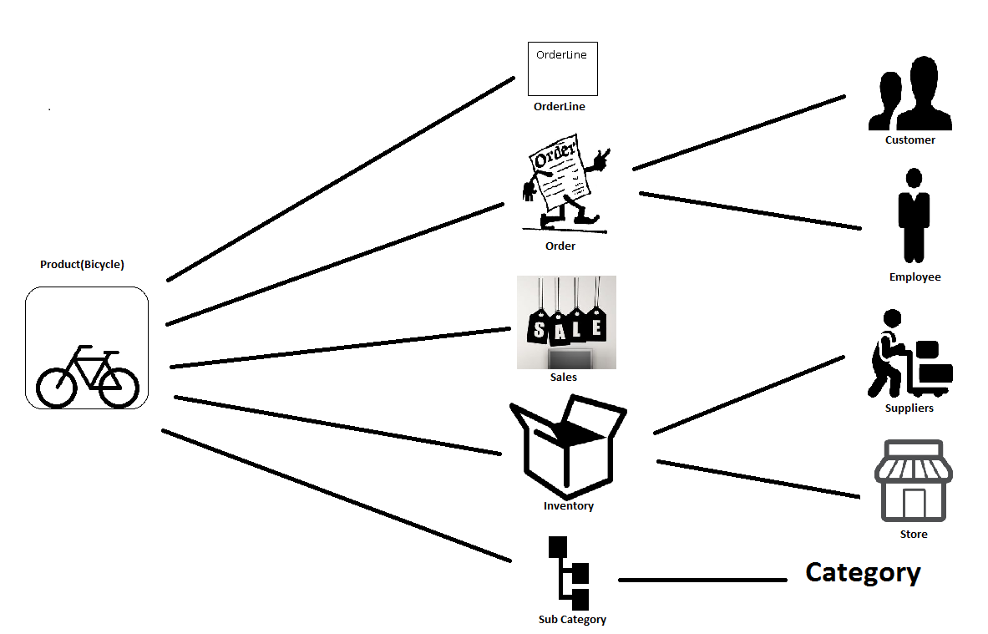

Product

|  |  |  |  |  |  |  |  |  |  |  |  |  |  |  |  |  |  |  |  |  |  |  |  |  |  |  |  |  |  |  |  |  |  |  |  |  |  |  |  |  |  |  |  |  |  |  |  |  |  |  |  |  |  |  |  |  |  |  |  |  |  |  |  |  |  |  |  |  |  |  |  |  |  |  |  |
| --- | --- | --- | --- | --- | --- | --- | --- | --- | --- | --- | --- | --- | --- | --- | --- | --- | --- | --- | --- | --- | --- | --- | --- | --- | --- | --- | --- | --- | --- | --- | --- | --- | --- | --- | --- | --- | --- | --- | --- | --- | --- | --- | --- | --- | --- | --- | --- | --- | --- | --- | --- | --- | --- | --- | --- | --- | --- | --- | --- | --- | --- | --- | --- | --- | --- | --- | --- | --- | --- | --- | --- | --- | --- | --- | --- |
| **Subject Area(Clusters):**  **C:\Users\Admin\Documents\Toad Data Modeler\2.png**  **C:\Users\Admin\Documents\Toad Data Modeler\Microsoft SQL Server 2014.png**  **Glossary:**   |  |  |  | | --- | --- | --- | | **Term** | **Full Form** | **Description/Definiton** | | PK | Primary Key | It is a special relational database table column (or combination of columns) designated to uniquely identify all table records | | FK | Foreign Key | It is a field (or collection of fields) in one table that uniquely identifies a row of another table | | PFK | Primary Foreign Key | The foreign key is defined in a second table, but it refers to the primary key in the first table | | NN | Not Null | It is a constraint which enforces a table column to not accept NULL values |   **In Scope:**   |  |  | | --- | --- | | **Sr. No.** | **Description** | | IS001 | Order line must have at least one product | | IS002 | Product may have zero or more sub categories | | IS003 | Category may have zero or more sub categories | | IS004 | Order must be associated with a customer | | IS005 | A customer must have at least one order | | IS006 | Order have one or more order lines | | IS007 | Each order line corresponds to one product | | IS008 | Stores gives location of the product | | IS009 | Suppliers provide product to inventory | | IS010 | Inventory is a bridge between suppliers product and stores | | IS011 | Order Status has only four values , “OPEN”, “SHIPPED”, “PARTIAL RETURN”, “FULL RETURN” | | IS012 | Employee severs one or more orders | | IS013 | Tax amount is as order and order line level | | IS014 | Unit price of a product is at order line level | | IS015 | Total price of products in order is at order level | | IS016 | Order status is at order and order line level | | IS017 | Discounts are at order level | | IS018 | A product can be in multiple inventory locations (stores) | | IS019 | A product can be supplied by multiple suppliers | | IS020 | When a product is shipped by a supplier it is received by a single location (store) | | IS021 | From date and To date for Sale product will work as a primary key along with Product ID |   **Out of Scope:**   |  |  | | --- | --- | | **Sr. No.** | **Description** | | OS001 | Exchange of a product is out of scope | | OS002 | Tax amount at product level is out of scope | | OS003 | Discounts at product level is out of scope | |  |  | |  |  |   **Entities and Attributes:**  **Entity: Product**  The outcome obtained from various businesses or manufacturing processes. It is a physical form which can be available to buy or sale. Here it referred to bicycle. | | | | |
| **Attribute** | **Data Type** | **Not Null** | **Key** | **Definition** |
| Prod_ID | Int | NN | PK | * Unique identification of a product which differentiate each product from other or the unique number or string to identify the product * It is a primary key for a Product |
| Prod_Name | Char(20) | NN |  | * Attractive name given to a product to reach it to the customer and market |
| Prod_Price | Decimal(5,3) | NN |  | * Price at which product is available for customer to buy or selling price at which supplier will sell the product to customer. |
| Prod_Color | Char(15) | NN |  | * Colour of a product is how it appears visually to human like black, green, orange, purple, pink, blue |
| Prod_Brand | Char(20) | NN |  | * Some name or series to create own identification in the market. Its design or logo or name |
| Prod_Size | Int | NN |  | * Measurement of the product in measuring units like centimetres to define its length, height |
| SubCat_ID | Int | NN | FK | * It is a foreign key to identify a product uniquely and givens more details about category |

**Entity: Category**

Group of Products divided into different groups depending on same features, qualities.

|  |  |  |  |  |
| --- | --- | --- | --- | --- |
| **Attribute** | **Data Type** | **Not Null** | **Key** | **Definition** |
| Cat_ID | Int | NN | PK | * Unique identification given to identify particular category * It is unique number or string to distinguish one product from other product on the basis of multiple attributes like colour, size, model, price * It is a primary key for product category |
| Cat_Name | Char(20) | NN |  | * Name given to identify particular series of categories depending upon its use or purpose |

**Entity: SubCategory**

It is a descendent of category. Products can be distinguished further beyond category with more specific features.

|  |  |  |  |  |
| --- | --- | --- | --- | --- |
| **Attribute** | **Data Type** | **Not Null** | **Key** | **Definition** |
| SubCat_ID | Int | NN | PK | * Group of categories divided again into groups to low level depending upon some more common features * It is a primary key for product subcategory |
| SubCat_Name | Char(20) | NN |  | * Name given to identify each series of group of sub categories |
| Cat_ID | Int | NN | FK | * It is a foreign key to subcategory to give more information about product category |

**Entity: Order**

It is a request made by a customer and served by a supplier. Customer places the order of product he needs.

|  |  |  |  |  |
| --- | --- | --- | --- | --- |
| **Attribute** | **Data Type** | **Not Null** | **Key** | **Definition** |
| Order_ID | Int | NN(PK) | PK | * Unique number or string to identify specific request made by specific customer * It is a primary key of an order |
| Discounts | Decimal(3,2) | NN |  | * It is is a deduction from original cost of a product so make it available to customer at lower price |
| Order_Status | Char(10) | NN |  | * It refers to order position from shipment till the delivery |
| Order_Loc | Char(10) | NN |  | * It is address from where order is placed |
| Total_Price | Decimal(6,4) | NN |  | * It is a price of the order made by customer in a particular order may correspond to one or more products |
| Tax_Amt | Decimal(5,3) | NN |  | * Compulsory contribution to state revenue which is additional amount added along with total price |
| Prod_ID | Int | NN | FK | * It is a foreign key to order table to identify which product is ordered |
| Cust_ID | Int | NN | FK | * It is a foreign key to order to provide customer details |
| Emp_ID | Int | NN | FK | * It is a foreign key to order to keep track of which employee is handling the order |

**Entity: Customer**

The person or organisation, that buys the product from stores or business.

|  |  |  |  |  |
| --- | --- | --- | --- | --- |
| **Attribute** | **Data Type** | **Not Null** | **Key** | **Definition** |
| Cust_ID | Int | NN | PK | * The unique number associated with every customer * It is a primary key for a customer |
| Cust_lname | Char(20) | NN |  | * The first name present in records to identify the customer |
| Cust_fname | Char(20) | NN |  | * The last name present in records to identify the customer |
| Email_ID | Varchar(max) | NN |  | * The unique mailing address |
| Phone_Num | Varchar(25) | NN |  | * The number to call to a customer |
| Cust_Address | Varchar(max) |  |  | * The address where customer stays |

**Entity: Employee**

A person who serves an order to a customer. Person performs activities related from shipping till its full delivery.

|  |  |  |  |  |
| --- | --- | --- | --- | --- |
| **Attribute** | **Data Type** | **Not Null** | **Key** | **Definition** |
| Emp_ID | Int | NN | PK | * The unique number associated with every employee * It is a primary key for the employee |
| Emp_lname | Char(20) | NN |  | * Last name of the employee or family name |
| Emp_fname | Char(20) | NN |  | * First name of the employee |
| Title | Varchar(10) | NN |  | * Designation of the employee |
| Emp_Discounts | Decimal(3,2) |  |  | * Special deduction to a product price made available for employees to get the same product at lower price * It can be zero or more |

**Entity: Orderline**

It is a line for the particular order delivery. Order can have many order lines.

|  |  |  |  |  |  |
| --- | --- | --- | --- | --- | --- |
| **Attribute** | **Data Type** | **Not Null** | **Key** | | **Definition** |
| OrderLine_Num | Int | NN | PK | * The unique number associated with every order line * It is a primary key for order line | |
| Orderline_Status | Char(10) | NN |  | * It refers to order position from shipment till the delivery in order line | |
| Unit_Price | Decimal(5,3) | NN |  | * It is a selling price of one unit of a product | |
| Unit_Tax_Amt | Decimal(4,2) | NN |  | * It is a tax accountable for one unit of product | |
| Prod_ID | Int | NN | PFK | * It is a primary foreign key to an orderline to give information about which product is there in orderline | |

**Entity: Sales**

An event for the rapid disposal of goods at reduced prices for a period, especially at the end of a season.

|  |  |  |  |  |
| --- | --- | --- | --- | --- |
| **Attribute** | **Data Type** | **Not Null** | **Key** | **Definition** |
| From_Date | Date | NN | PK | * Start date of a sale on a particular product * It is a composite key with To_Date and Prod_ID |
| To_Date | Date | NN | PK | * End date of a sale on a particular product * It is a composite key with From_Date and Prod_ID |
| Sale_Price | Decimal(6,4) | NN |  | * It is a price after deducting some amount from a product price |
| Prod_ID | Int | NN | PFK | * It is a primary foreign key for a sale as sale cannot exist without a product * It is a composite key with From_Date and To_Date |

**Entity: Inventory**

It is a complete list of products in stock.

|  |  |  |  |  |
| --- | --- | --- | --- | --- |
| **Attribute** | **Date Type** | **Not Null** | **Key** | **Definition** |
| Inv_ID | Int | NN | PK | * It is the unique number to identify a particular inventory * It is a primary key of Inventory |
| Quantity | Int | NN |  | * It is a number to show how many products of same type are in stock or available |
| Prod_ID | Int | NN | FK | * It is a foreign key to provide information about product to inventory |
| Sup_ID | Int | NN | FK | * It is a foreign key to provide information on who supplies a particular product to inventory |
| Store_ID | Int | NN | FK | * It is a foreign key to provide information on where the product is located and where order is placed |

**Entity: Suppliers**

A person or entity which supplies a product (bicycle).

|  |  |  |  |  |
| --- | --- | --- | --- | --- |
| **Attribute** | **Data Type** | **Not Null** | **Key** | **Definition** |
| Sup_ID | Int | NN | PK | * It is the unique number which is associated with particular supplier * It is a primary key of suppliers |
| Sup_Name | Char(20) | NN |  | * It is a name of the supplier |
| Sup_Contact# | Varchar(22) | NN |  | * It is supplier’s phone number |

**Entity: Stores**

It corresponds to where the product is and from where the order is made.

|  |  |  |  |  |
| --- | --- | --- | --- | --- |
| **Attribute** | **Data Type** | **Not Null** | **Key** | **Definition** |
| Store_ID | Int | NN | PK | * It is the unique number to identify a particular store * It is a primary key of stores |
| Location | Char(10) | NN |  | * It is a location where products are available in any particular inventory |
| Store_Name | Char(20) | NN |  | * It is a name of the store |

**References:**

[**http://www.databaseanswers.org/data_models/bicycle_rental/index.htm**](http://www.databaseanswers.org/data_models/bicycle_rental/index.htm)

[**http://www.access-programmers.co.uk/forums/showthread.php?t=205095**](http://www.access-programmers.co.uk/forums/showthread.php?t=205095)

[**http://www.tomjewett.com/dbdesign/dbdesign.php?page=manymany.php**](http://www.tomjewett.com/dbdesign/dbdesign.php?page=manymany.php)

[**http://stackoverflow.com/questions/2762302/sql-server-appropriate-datatype-for-holding-percent-values**](http://stackoverflow.com/questions/2762302/sql-server-appropriate-datatype-for-holding-percent-values)

[**http://fmforums.com/topic/84644-making-database-for-inventory-control/**](http://fmforums.com/topic/84644-making-database-for-inventory-control/)