My Diary



**Vaishali Lambe**

**NUID: 001286444**

**Group 2**

***Day 1: Friday: 30/09/2016: 19:39 PM***

I asked Yuxin Zhang, Zhiyi Wang and Shantam Gupta, whether they would like to form a project group with me? And all said yes. Then I formed our chat group on WhatsApp. Yuxin and Zhiyi immediately installed the app as they had some other social networking group in China and they were using this app first time. I found it great to interact with them. It was great sharing.

***Day2: Monday: 03.10.2016: 10:00 PM***

I asked everyone to share their NUID, Full Name and Husky e-mail on WhatsApp Group.

Send the details to professor with group member details.

***Day 3: Friday: 07/10/2016: 8:00 PM***

Today I asked Yuxin and Zhang whether they will be OK if I become a group leader, and they immediately said yes. I asked Shantam too and he said either me or you is OK for me. It seems there are two bridges forming in my group, I am the connector between Shantam on one side and Yuxin , Zhiyi on other side. Need to do something. So, if Shantam is also interested to be a group lead I can take a role of team member instead, which will help to form a group and Shantam, Yuxin and Zhiyi they will speak with each other directly.

***Day4: 16/10/2016: 13:05 AM***

It’s hard; as I am also interested to become lead of a group, but still I will ask everyone if they are fine to have Shantam Gupta as a group leader. I asked it on WhatsApp chat group. Everyone agreed. Cool.

***Day 5: Monday: 17/10/2016: 9:48 AM***

We planned to meet at curry centre to discuss about cellular company database design discussion.

Time for a meet is 6:15 PM.

***Day6: Monday: 17/10/2016: 10:00 PM***

First meet up with group. I was quite excited because individually I spoken with everyone, but as a group we were meeting first time.

In group discussion we have come up with some common entities for model and questions that we had about the model. We decided on project group name. Yuxin was quite shy, I tried to make her comfortable and asked to speak up and discuss her doubts without any hesitation. Then we all were good. Everyone was cross –checking whether everyone is on the same page or not. We end up with having a good group picture, which I made it as display picture for our WhatsApp group too. It seems I am really going to have fun working in a first international study group ☺

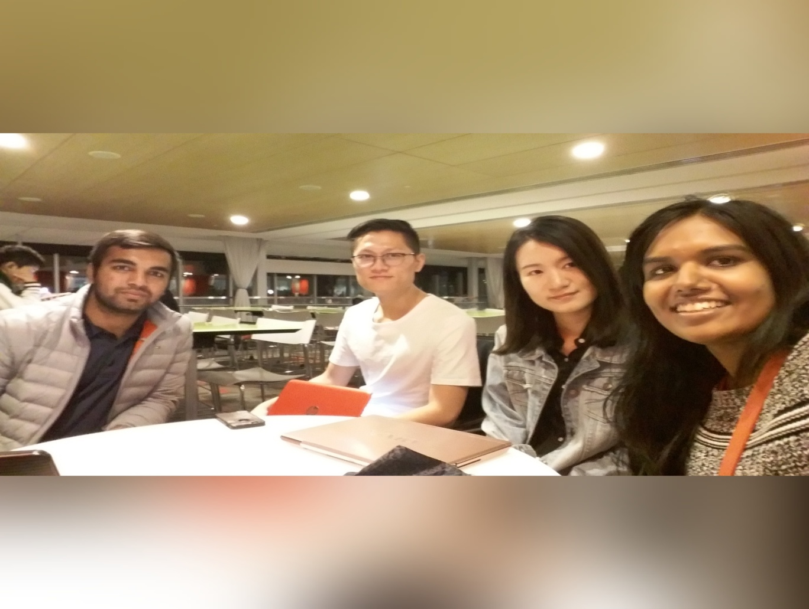

***Day 7: Friday: 10/21/2016: 10:00 PM***

We discussed on group chat, about our questions on model again. Few became out of scope as per Professor’s entity requirements.

***Day 8: Sunday: 23/10/2016: 9:06 PM***

I posted 5 questions on discussion board on model. Few things got out of scope. I liked it a lot that professor replied without any delay. I started preparing my own business rules document.

***Day 9: Tuesday: 25/102016: 11:00 PM***

This week I am busy with Java and DBMS midterm. It seems not able to spend time on my project.

I will be able to spend some time after Friday 28Oct.

Day 5: Saturday: 29/10/2016

I have searched online, and tried to find out similar telecommunication services and offers.

I got some input on data models and design on url:

<http://databaseanswers.org/data_models/>

***Day 10: Monday: 31/10/2016: 8:30 AM***

Today I checked real phone bill of my house. I got some idea on how plan and billing takes place.

***Day 11: Thursday: 03/11/2016: 10:55 AM***

I have posted one question on discussion board about issue tracking. Also, gone through all discussions happened till date.

***Day 12: Friday: 04/11/2016 9:30PM***

Today after a class we again met in a team, and decided agenda of the meeting as, to come up along with previous bicycle model and individual business rule to make a group business rule document.

Also, we planned to divide roles and responsibilities. There are two holiday weeks, so need to do time management.

Everyone will try to come up with some more ideas.

So, we are meeting on Tuesday 8th November.

***Day 13: Sunday: 06/11/2016: 12:09PM***

I have spent some time to read the discussion boards of Cell as well as Gym again. This really helps to understand everyone’s aspect on database model. And helps enhances our thinking capabilities, which I think most important thing in design. Also, informed team that journal means diary that we are writing not the entity definition document after confirming with professor.

***Day 14: Tuesday: 08/11/2016 9:30PM***

We met in a group today at curry centre. We discussed all our individual business rules one by one. Also, formed new group project document on business rules. Also, decided to work on other design part work responsibilities. Planned to have next meet on 11th November but I am travelling to new York so I will stay connected with them online.

***Day 15: Wednesday: 09/11/2018: 3:10 PM***

I spent some time to find information on location and tower entities. Also, read all our group business rules again.

***Day 16: Thursday: 10/11/2016 7:11PM***

I added two more business rules in the document. Had a chat with team and informed them about the same.

***Day 17: Friday: 11/11/2016: 9:00 PM***

Today Shantam, Yuxin and Zhiyi met again at 2:00 PM to finalize the document for business requirements. I was chatting with them online. I provided few inputs on document review. It was great to have teammates like this. Yuxin provided all updates to me.

***Day18: Monday: 14/11/2016: 10:30 AM***

Got a call from Shantam and we decided to have tem meeting on Wednesday 10AM

***Day19: Wednesday: 16/11/2016 4:00 PM***

We had a meeting today. We worked on a model and entity relationships. Also divided sample data and document preparation responsibilities amongst ourselves. It was great discussion today. We decided to meet on Thursday again at 9:00PM with our work to finalise the first draft. Zhiyi had a class so he left little earlier. I provided updates and tasks assigned on Whatsapp group.

***Day20: Thursday: 17/11/2016: 4:30 PM***

I asked and confirmed on datasheet format once again in a group. Also, read announcement from dashboard.

***Day 21: Friday: 18/11/2016: 10:00 AM***

We met yesterday. Collected and reviewed our work done so far. Draft is ready. All set ☺.

***Day 22: Sunday: 20/11/2016: 4:00 PM***

Jake is already on thanksgiving weekend. Me, Shantam and Carol meet today. Discussed all our business rules again and modified our model a bit. We have discussion with professor tomorrow. Shantam messaged it on a whatsapp group. Awesome!

***Day 23: Monday: 21/11/2016: 10:00 PM***

We met at 7:00 PM today. Before an hour, a call with professor. Discussed on which questions needs to be asked. After that had a call with professor and finally got really very valuable feedback from him. We have something on which we really need to think (Tower and Signal part).

***Day 24: Thursday: 24/11/2016: 8:00 PM***

Today had really a fun chat. We were planning to meet but everyone came up with different thanksgiving plans and different timings. Meeting didn’t happen. Finally. Happy thanksgiving...☺

***Day26: Wednesday: 27/11/2016: 12:00 PM***

I spent some time on PHP part. I installed wampserver. I completed set up. I downloaded the sample project provided by professor. Created one script for add customer.

***Day 25: Monday: 28/11/2016: 10:00 PM***

After so much discussion on group, we won’t make it to meet during thanksgiving. So, finally we met today at 5:00PM. Shantam didn’t able to come. I, Carol and Jake modified the design document as per professor’s feedback. Also, modified a model for minor changes. I shown then php set up as well. We ended up by 7:00PM.

***Day26: Wednesday: 30/11/2016: 12:00 PM***

I checked for my add customer script today and tried to run it through browser. Resolved some issues and able to run it now.

***Day 26: Monday: 05/12/2016: 8:00 PM***

We met again today. Jake was unable to come, went to Houston. We got our project first draft back and discussed on that. Made some changes. After a meeting I have spent another hour on PHP thing. I am able to run one Add customer script and able to create database using myPHPadmin and verified that customer got added to the table or not. It’s successfully added. Need to show same to team in tomorrow’s meeting.

***Day27: Wednesday: 07/12/2016 8:00PM***

I have spent some time on PHP thing. Now my insert, view and delete record is working fine. Now I am working on Update.

***Day 28: Thursday: 08/12/2016 9:20PM***

Professor asked to bring pdf of model in tomorrow’s class. I informed same to the group on what’s app.

***Day 29: Sunday: 11/12/2016 : 10:00PM***

Today, we had a skype meeting. Discussed on part of work yet to finish and divided it amongst us.

Afterwards I worked on Update query of PHP.

***Day 30: Wednesday: 14/12/2016 5:00PM***

Me, Carol, and Shantam met today. Jake had exam so he couldn’t make. But he is working on test data. I have finished PHP part. I added background image too to user interface. After that, started working on Presentation. I have talent responsibility of that too. We completed almost 70% presentation. Now we will meet tomorrow again to prepare for presentation. It’s going cool. I am enjoying it now.

***Day 31: Thursday: 15/12/2016 11:42PM***

Just came back from meeting. Today we have revised everything. Design document, Toad model, presentation, sample data. All is ready as a final draft now. We are meeting tomorrow again for presentation preparation and to print out everything. Figures crossed. Hope everything goes well. End of semester tomorrow. ☺☺