Q.1.

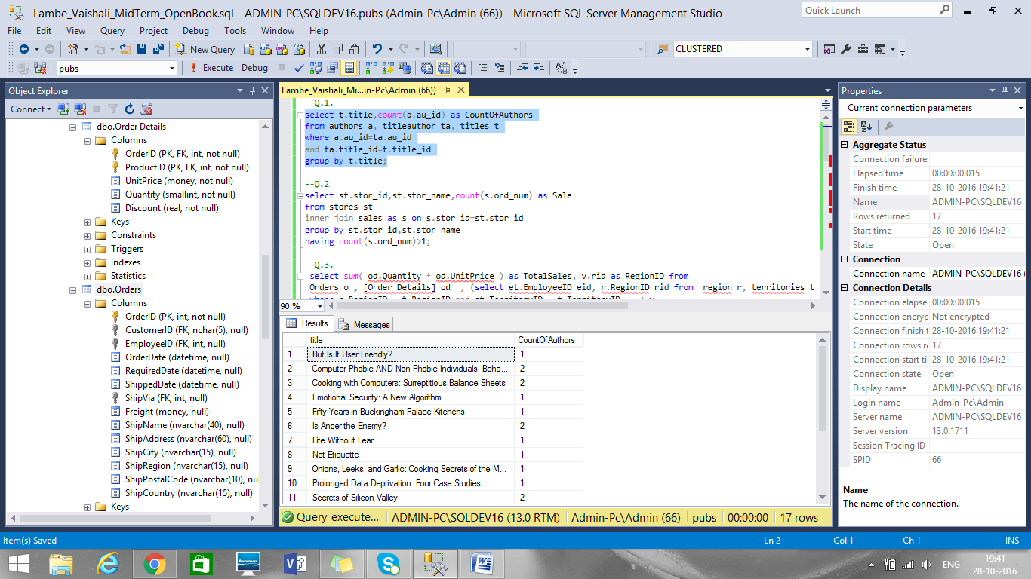

Q.2.

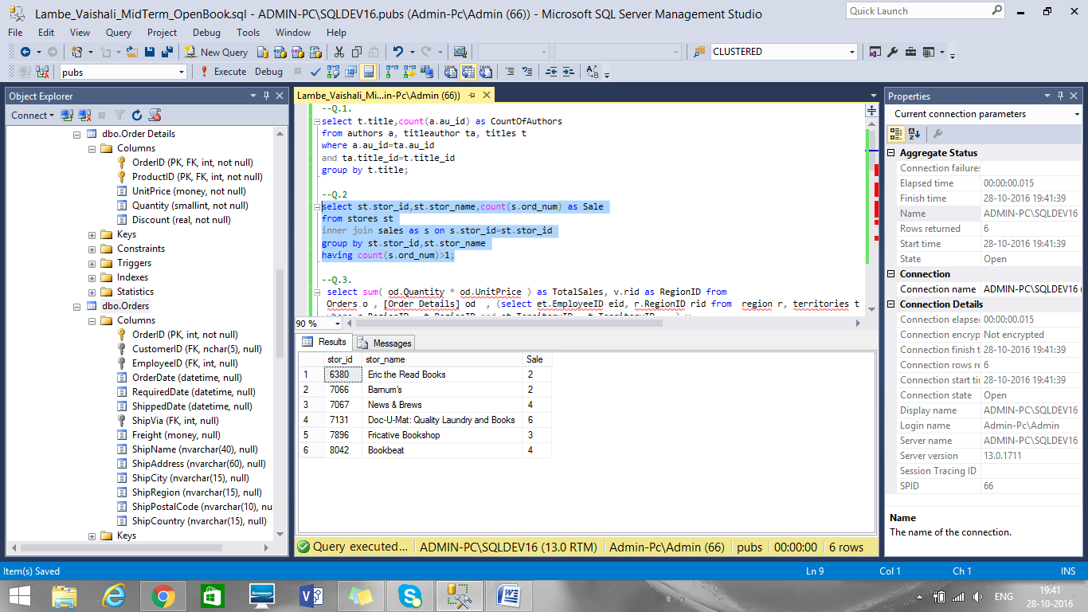

Q.3.

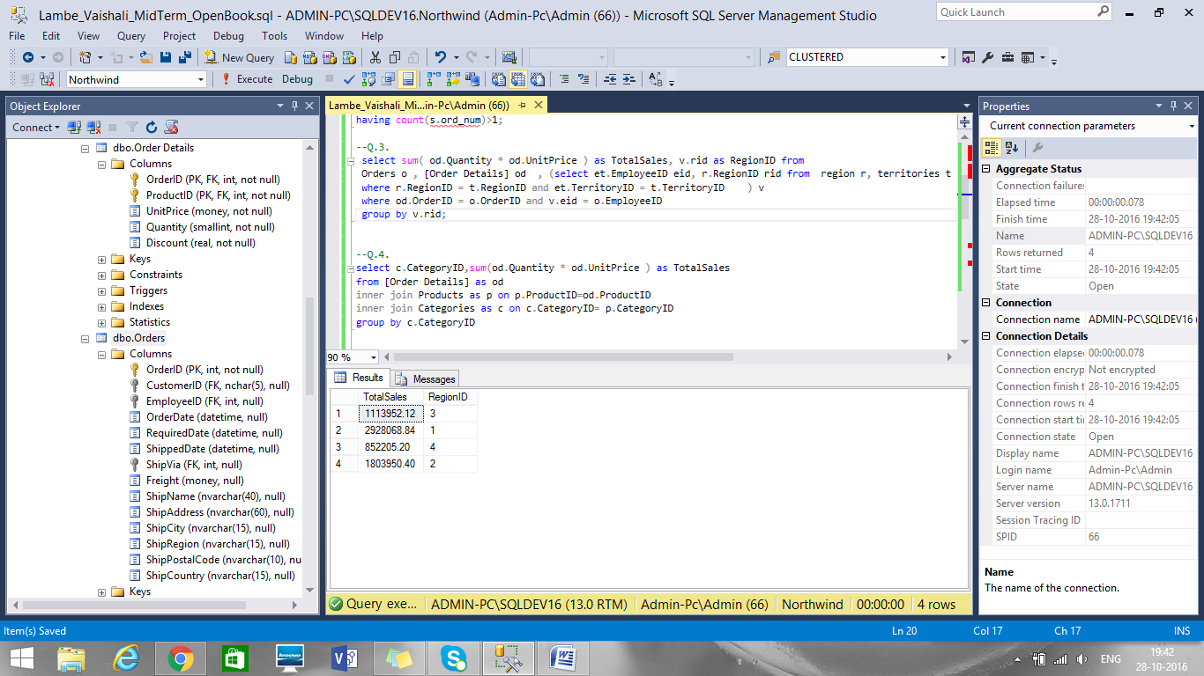

Q.4.

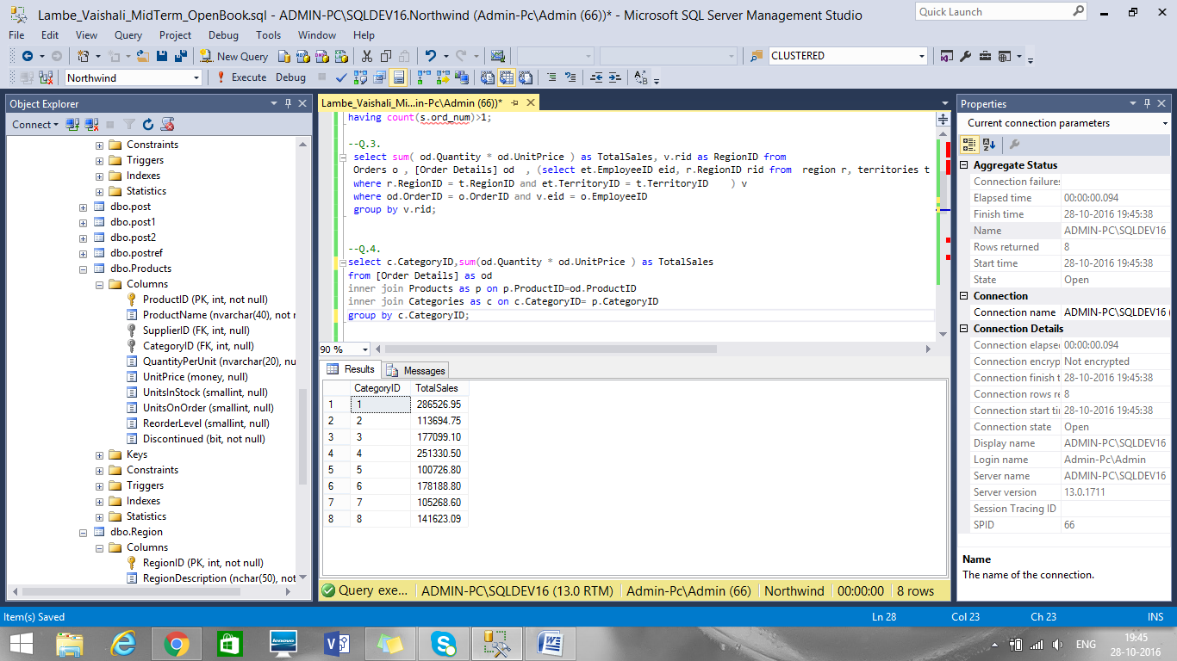

Q.5.

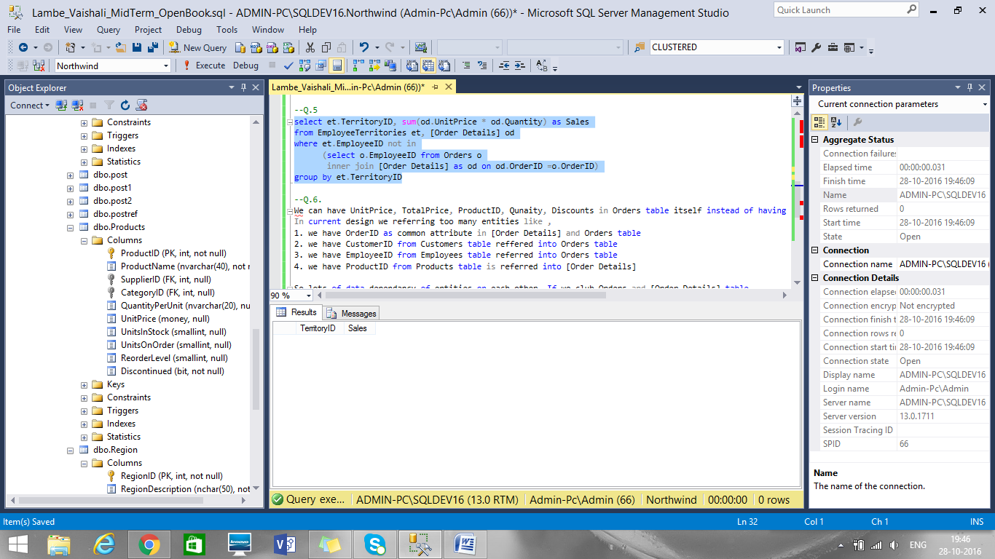

Q.6.

We can have UnitPrice, TotalPrice, ProductID, Qunaity, Discounts in Orders table itself instead of having a separte table called Order Details

In current design we referring too many entities like ,

1. We have OrderID as common attribute in [Order Details] and Orders table

2. We have CustomerID from Customers table reffered into Orders table

3. We have EmployeeID from Employees table referred into Orders table

4. We have ProductID from Products table is referred into [Order Details]

So lots of data dependancy of entities on each other. If we club Orders and [Order Details] table

We have only two entity dependancies like

1. We have CustomerID from Customers table reffered into Orders table

2. We have EmployeeID from Employees table referred into Orders table

gives more normalization by removing dependancies.