Answers:
Q1: What authors are in California
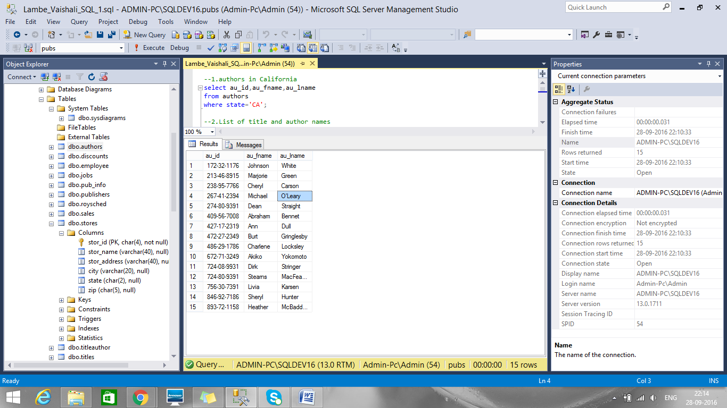

Q2. List the titles and author names
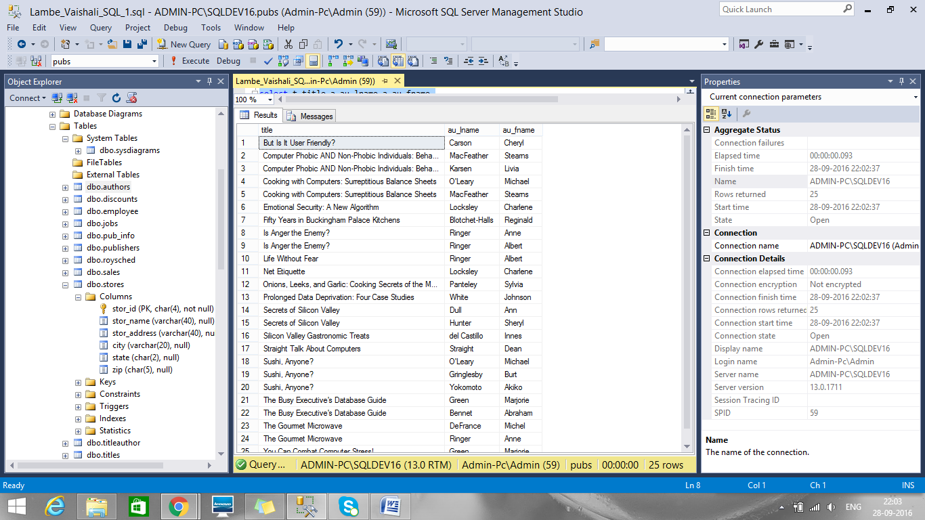

Q3. List all employees and their jobs
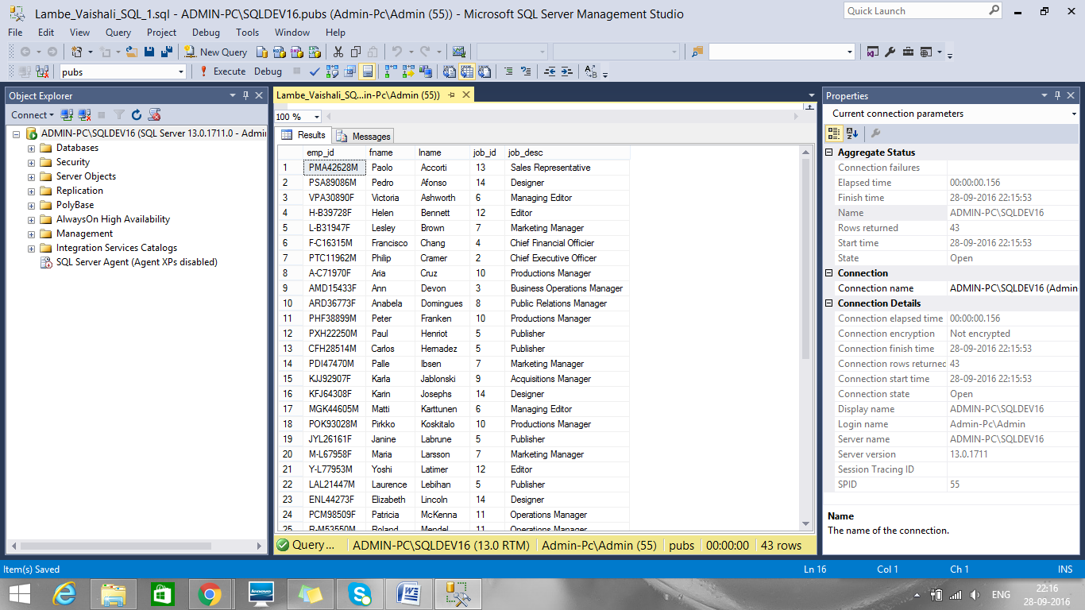

Q4. List the titles by total sales price
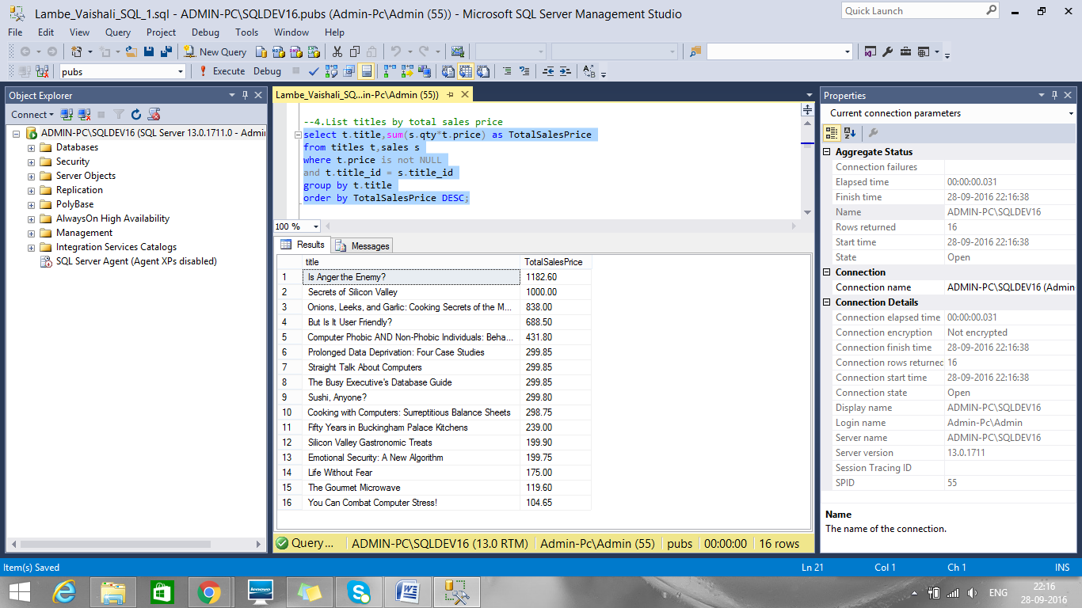

Q5. Find the sales for stores in California
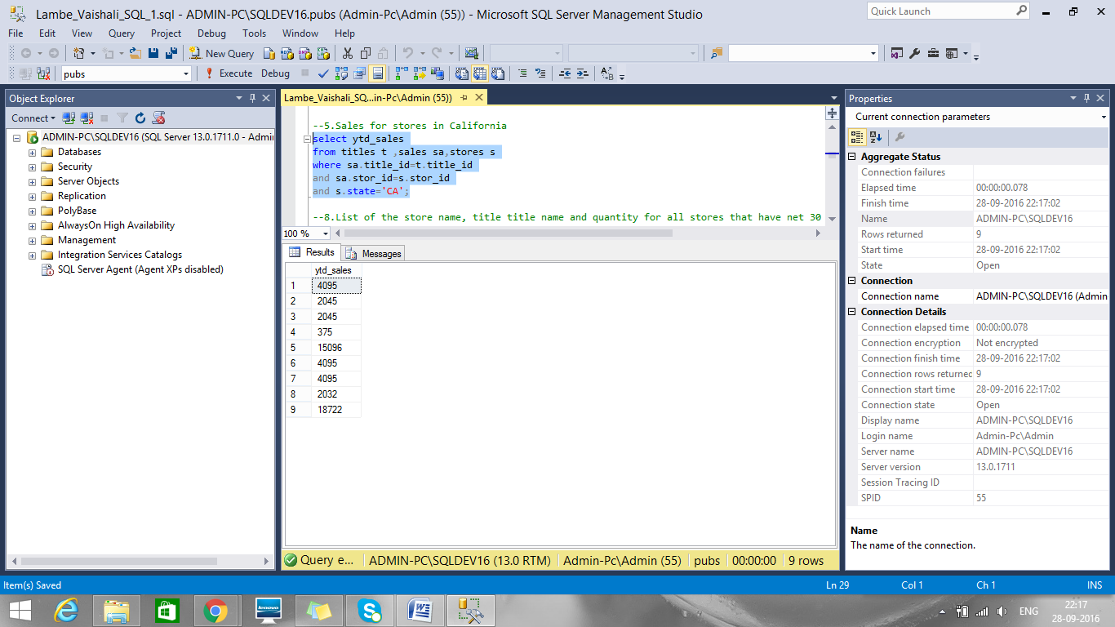

Q8. List the store name, title title name and quantity for all stores that have net 30 payterms
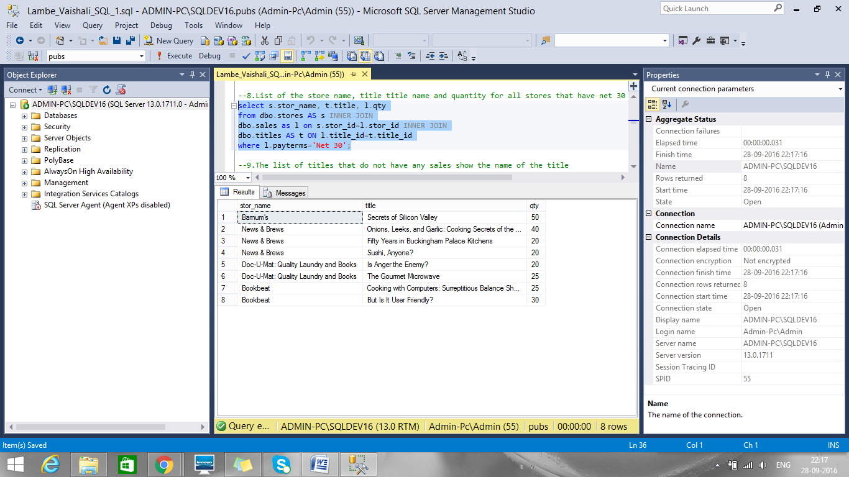

Q9. Find the titles that do not have any sales show the name of the title
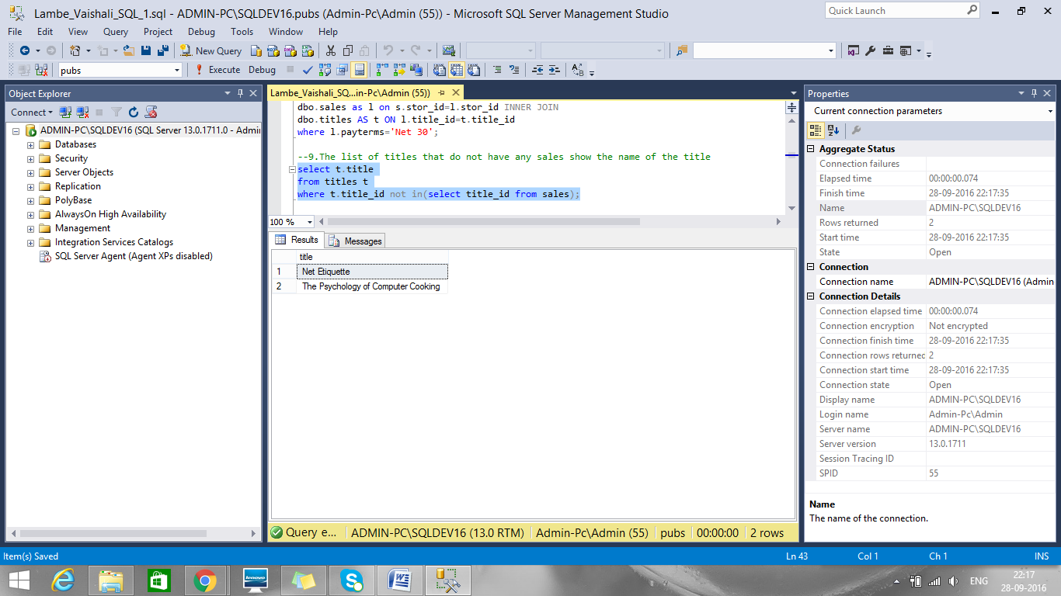

Q10. Do previous question another way
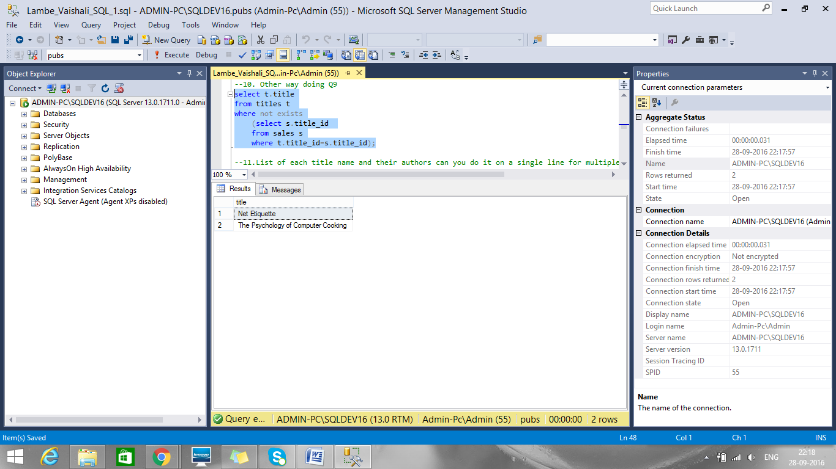

Q11. List each title name and their authors can you do it on a single line for multiple authors
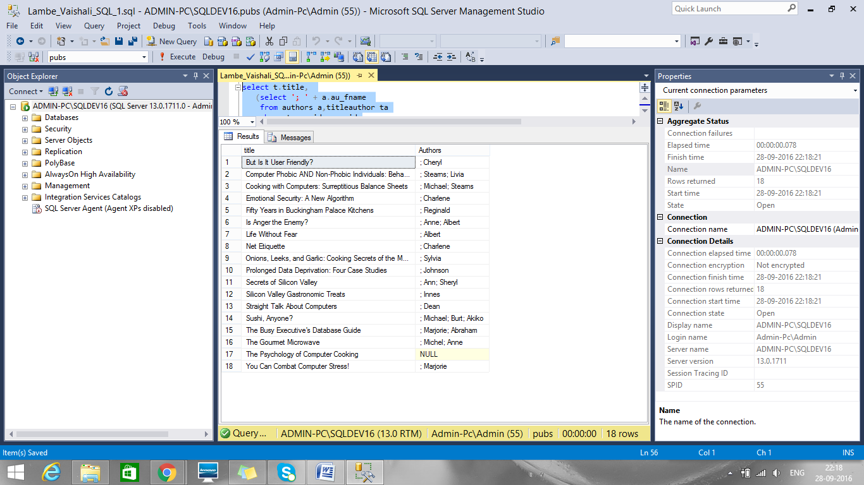

Q12. List the titles in order of total sale. Totals sales is determined by reading the qty from sales and calculating the sales price based on the price of the book in the titles table
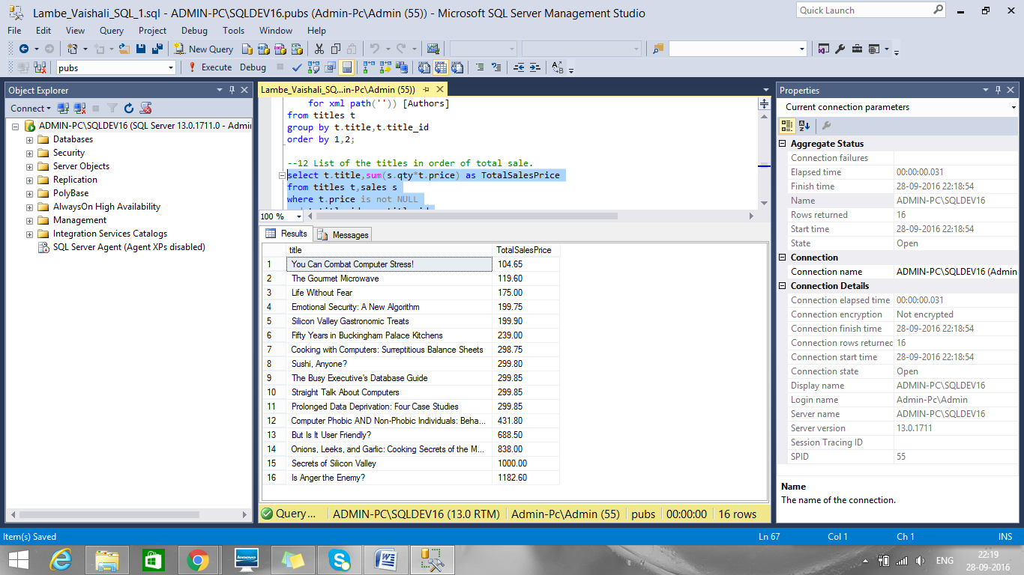

Q13. Add the store name to the query above
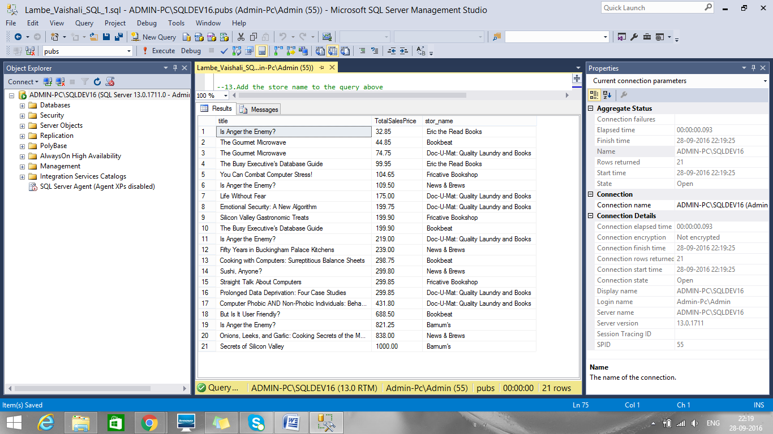

Q14. List all the titles and list the royalty schedule
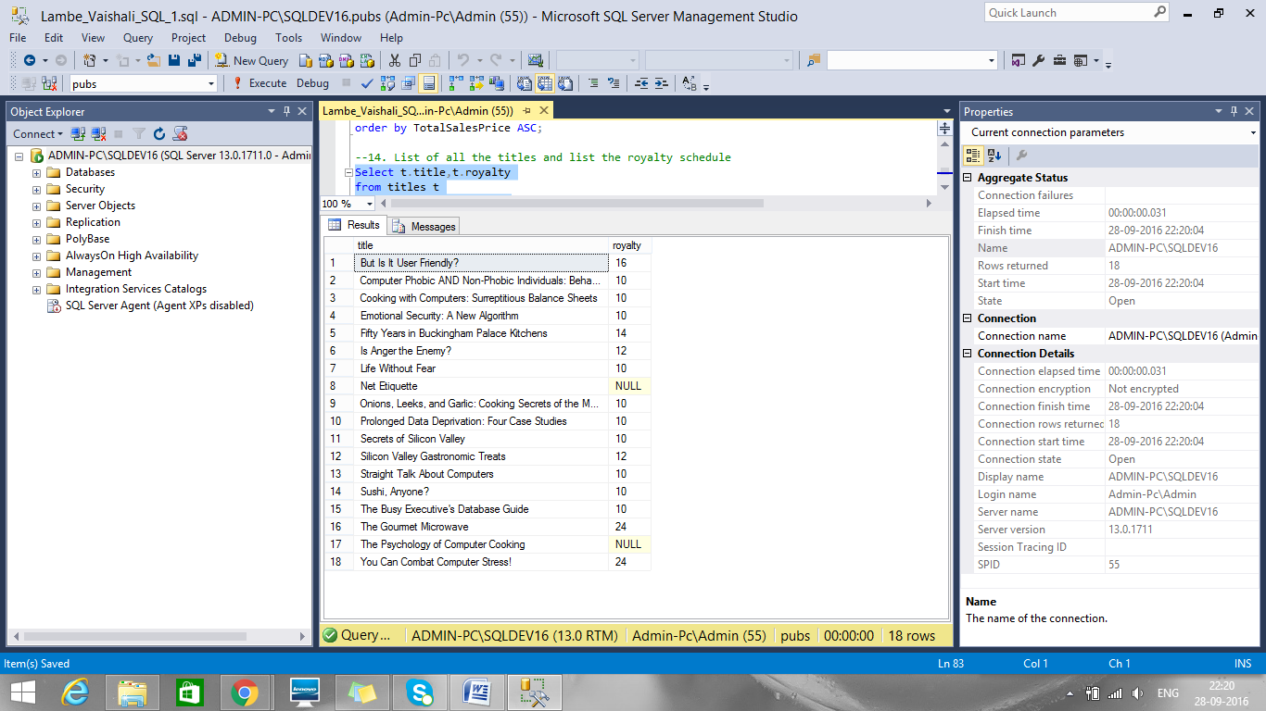

Q15. List the stores that have orders with more than one title on the order
