I

Bicycle Model
Database Design Document


Revision History
Date | Version | Description | Author
10/09/2016 | 1.0 | First version | Vaishali Lambe

Table of Contents
1. Introduction 1
2. Overview 2
3. In Scope 3
4. Out of Scope 4
5. Detailed Database Design 6

Introduction:
It describes database design for product Bicycle. It contains entities Product (bicycle), Category, Sub-Category, Order, Order line, Inventory, Suppliers, Stores, Sales, Customer and Employee. The database includes information starting from availability of product amongst category till employee serves the order to a customer.
Overview:
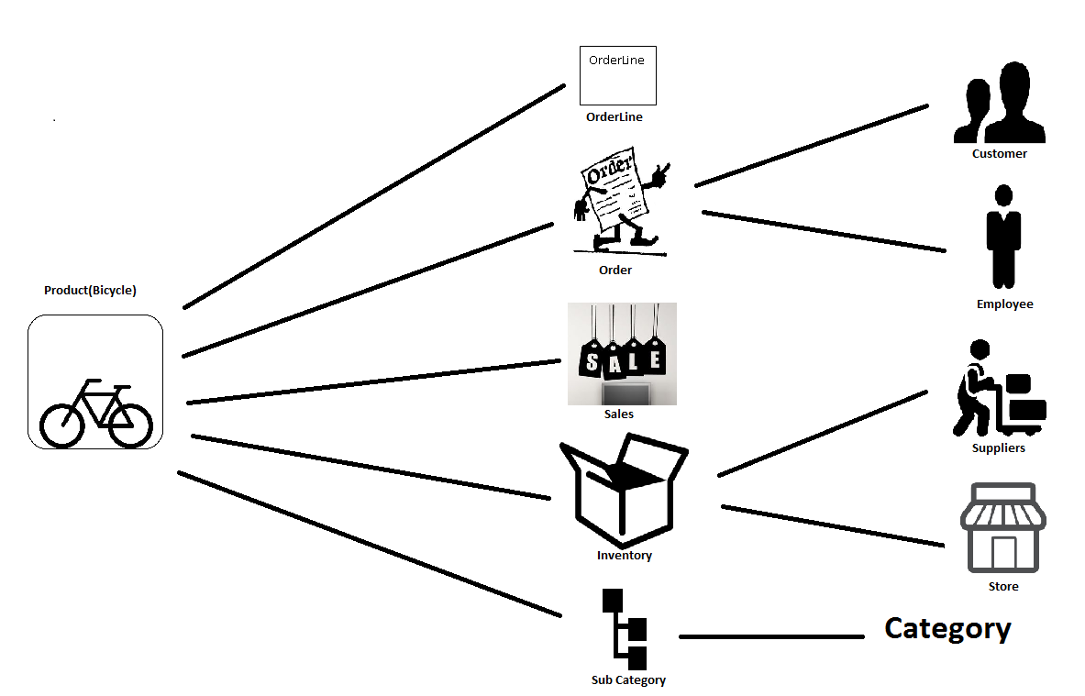

Customer place product order

Employee serves an order

Every order is related to one or more Products. Order is a request made by customer to purchase a product

Category has zero or more subcategories

Subcategory belongs to every product. Subcategory cannot exist without category.

Sales is the deduction of amount from product price. It cannot exist without a product.

Product

Suppliers provides product to inventory
Inventory contains one or more products in stock.

Stores show where the product is and where order is place
Order line contains at least one product.

Entity: Product

The outcome obtained from various businesses or manufacturing processes. It’s a physical form which can be available to buy or sale. Here it referred to bicycle.

Attribute |  |  |  |  | Data Type |  |  |  | NotNull |  |  |  |  | Key |  |  |  |  |  |  |  | Definition
Prod_ID |  |  |  |  | Int |  |  |  | NN |  |  |  |  | PK |  |  |  |  |  |  |  | Unique identification of a product which differentiate each product from other or the unique number or string to identify the product.
Prod_Name |  |  |  |  | Char(20) |  |  |  | NN |  |  |  |  |  |  |  |  |  |  |  |  | Attractive name given to a product to reach it to the customer and market.
Prod_Price |  |  |  |  | Decimal(5,3) |  |  |  | NN |  |  |  |  |  |  |  |  |  |  |  |  | Price at which product is available for customer to buy or selling price at which supplier will sell the product to customer.
Prod_Color |  |  |  |  | Char(15) |  |  |  | NN |  |  |  |  |  |  |  |  |  |  |  |  | Color of a product is how it appears visually to human like black, green etc.
Prod_Brand |  |  |  |  | Char(20) |  |  |  | NN |  |  |  |  |  |  |  |  |  |  |  |  | Some name or series to create own identification in the market. Its design or logo or name.
Prod_Size |  |  |  |  | Int |  |  |  | NN |  |  |  |  |  |  |  |  |  |  |  |  | Measurement of the product in measuring units like centimetres to define its length, height.
SubCat_ID |  |  |  |  | Int |  |  |  | NN |  |  |  |  | FK |  |  |  |  |  |  |  | It’s a foreign key to identify a product uniquely and givens more details about category.
Sup_ID |  |  |  |  | Int |  |  |  | NN |  |  |  |  | FK |  |  |  |  |  |  |  | Its supplier ID gives information about who supplies a particular product.It act as a foreign key to product table.
Table: Category- Group of products divided into different groups depending on same features, qualities etc.
Caption |  |  |  | Name |  | Data Type |  |  |  |  |  | NotNull |  |  |  |  |  |  | Definition
Attribute |  |  |  | Cat_ID |  | Int |  |  |  |  |  | NN(PK) |  |  |  |  |  |  | Unique identification given to identify particular category or Its an unique number or string to distinguish one product from other product on the basis of multiple attributes like colour, size, model, price.
Attribute |  |  |  | Cat_Name |  | Char(20) |  |  |  |  |  | NN |  |  |  |  |  |  | Name given to identify particular series of categories depending upon its use or purpose.
Table: SubCategory- Descendent of a category.
Caption |  |  |  | Name |  |  |  | Data Type |  |  |  |  | NotNull |  |  |  |  |  |  | Definition
Attribute |  |  |  | SubCat_ID |  |  |  | Int |  |  |  |  | NN(PK) |  |  |  |  |  |  | Group of categories divided again into groups to low level depending upon some more common features.
Attribute |  |  |  | SubCat_Name |  |  |  | Char(20) |  |  |  |  | NN |  |  |  |  |  |  | Name given to identify each series of group of sub categories.
Attribute |  |  |  | Cat_ID |  |  |  | Int |  |  |  |  | NN(FK) |  |  |  |  |  |  | It is Foreign key to subcategory to give more information abour product category.
Table: Order- It’s a request made by a customer and served by a supplier.
Caption | Name |  |  |  |  |  | Data Type |  |  |  |  |  |  |  |  | NotNull |  |  |  |  | Definition
Attribute | Order_ID |  |  |  |  |  | Int |  |  |  |  |  |  |  |  | NN(PK) |  |  |  |  | Unique number or string to identify specific request made by specific customer.
Attribute | Discounts |  |  |  |  |  | Decimal(5,3) |  |  |  |  |  |  |  |  | NN |  |  |  |  | It’s is a deduction from original cost of a product so make it available to customer at lower price
Attribute | Order_Status |  |  |  |  |  | Char(10) |  |  |  |  |  |  |  |  | NN |  |  |  |  | It refers to order position from shipment till the delivery.
Attribute | Order_Loc |  |  |  |  |  | VarChar(10) |  |  |  |  |  |  |  |  | NN |  |  |  |  | It is address from where order is placed.
Attribute | Total_Price |  |  |  |  |  | Decimal(6,4) |  |  |  |  |  |  |  |  | NN |  |  |  |  | Its price of the order made by customer in a particular order may correspond to one or more products.
Attribute | Tax_amount |  |  |  |  |  | Decimal(5,3) |  |  |  |  |  |  |  |  | NN |  |  |  |  | Compulsory contribution to state revenue which is additional amount added along with total price.
Attribute | Prod_ID |  |  |  |  |  | Int |  |  |  |  |  |  |  |  | NN(FK) |  |  |  |  | It’s a foreign key to order table to identify which product is ordered.
Attribute | Cust_ID |  |  |  |  |  | Int |  |  |  |  |  |  |  |  | NN(FK) |  |  |  |  | It’s a foreign key to order to provide cutomer details.
Attribute | Emp_ID |  |  |  |  |  | Int |  |  |  |  |  |  |  |  | NN(FK) |  |  |  |  | It’s a foreign key to orde to keep track of which employee is handling the order.
Attribute | Sale_ID |  |  |  |  |  | Int |  |  |  |  |  |  |  |  | NN(FK) |  |  |  |  | It’s a foreign key to order to provide information of sales items available if any.
Table: Customer- The person who buys the product
Caption |  |  | Name |  |  |  |  |  |  |  | Data Type |  |  |  |  |  |  | NotNull |  |  |  |  |  | Definition
Attribute |  |  | Cust_ID |  |  |  |  |  |  |  | Int |  |  |  |  |  |  | NN(PK) |  |  |  |  |  | The unique number associated with every customer
Attribute |  |  | Cust_Name |  |  |  |  |  |  |  | Char(30) |  |  |  |  |  |  | NN |  |  |  |  |  | The name present n records to identofy the customer
Attribute |  |  | Email_ID |  |  |  |  |  |  |  | Varchar(max) |  |  |  |  |  |  | NN |  |  |  |  |  | The unique mailing address
Attribute |  |  | Phone_Num |  |  |  |  |  |  |  | Varchar(25) |  |  |  |  |  |  | NN |  |  |  |  |  | The number to call to a customer
Attribute |  |  | Cust_Address |  |  |  |  |  |  |  | Varchar(max) |  |  |  |  |  |  |  |  |  |  |  |  | The address where customer stays
Table: Employee- The person to assist the order of a customer
Caption |  |  | Name |  |  |  |  |  | Data Type |  |  |  |  |  |  |  | NotNull |  |  |  |  |  | Definition
Attribute |  |  | Emp_ID |  |  |  |  |  | Int |  |  |  |  |  |  |  | NN(PK) |  |  |  |  |  | The unique number associated with every employee
Attribute |  |  | Emp_lname |  |  |  |  |  | Char(20) |  |  |  |  |  |  |  | NN |  |  |  |  |  | Last name of the employee or family name
Attribute |  |  | Emp_fname |  |  |  |  |  | Char(20) |  |  |  |  |  |  |  | NN |  |  |  |  |  | First name of the employee
Attribute |  |  | Title |  |  |  |  |  | Varchar(40) |  |  |  |  |  |  |  | NN |  |  |  |  |  | Designation of the employee
Attribute |  |  | Emp_Discounts |  |  |  |  |  | Decimal(5,3) |  |  |  |  |  |  |  |  |  |  |  |  |  | Special deduction to a product price made available for employees to get the same product at lower price. It can be zero or more.
Table: OrderLine-Its line for the particular order delivery. Order can have many orderlines
Caption |  | Name |  |  |  |  |  |  |  | Data Type |  |  |  |  | NotNull |  |  |  |  |  |  |  | Definition
Attribute |  | OrderLine_Num |  |  |  |  |  |  |  | Int |  |  |  |  | NN(PK) |  |  |  |  |  |  |  | The unique number associated with every order line
Attribute |  | Order_Status |  |  |  |  |  |  |  | Char(20) |  |  |  |  | NN |  |  |  |  |  |  |  | It refers to order position from shipment till the delivery in order line.
Attribute |  | Order_ID |  |  |  |  |  |  |  | Int |  |  |  |  | NN(PFK) |  |  |  |  |  |  |  | It’s a foreign key to an orderline to give more information about order.
Attribute |  | Prod_ID |  |  |  |  |  |  |  | Int |  |  |  |  | NN(PFK) |  |  |  |  |  |  |  | It’s a foreign key to an orderline to give information abut which product is there in orderline.
Attribute |  | Sale_ID |  |  |  |  |  |  |  | Int |  |  |  |  | NN(PFK) |  |  |  |  |  |  |  | It’s a foreign key to an orderline to give information on where product order is under sale items or not.

Table: Inventory- It’s a complete list of products in stock.
Caption | Name | Data Type | NotNull | Definition
Attribute | Quantity | Int | NN | It’s a number to show how many products of same type are in stock or available.
Attribute | Name | Char(10) | NN | It’s name given to inventory.
Attribute | Sup_ID | Int | NN(PFK) | It’s a primary foreign key which gives information on who supplies a particular product.

Table: Suppliers- A person or entity which source of a product(Bicycle)
Caption | Name | Data Type | NotNull | Definition
Attribute | Sup_ID | Int | NN(PK) | It’s an unique number which is associated whith particular supplier.
Attribute | Sup_Name | Char(20) | NN | It’s a name of the supplier.
Attribute | Sup_City | Char(20) | NN | It’s a location name of the supplier.
Attribute | Sup_Num | Int | NN | It’s a number associated with specific supplier.

Table: Stores – It corresponds to where the product is and from where the order is made.
Caption | Name | Data Type | NotNull | Definition
Attribute | Store_ID | Int | NN(PK) | It’s unique number to identify a particular store.
Attribute | Store_Name | Char(10) | NN | It’s a name of the store.
Attribute | Location | Char(10) | NN | It’s a location where products are available in any particular inventory.

Table: Sales
Caption | Name | Data Type | NotNull | Definition
Attribute | Sale_Code | Int | NN(PK) | It’s unique number to identify a particular store.
Attribute | Sale_Price | Decimal(6,4) | NN | It’s a name of the store.
Attribute | From_Date | Date | NN
Attribute | To_Date | Date | NN
Attribute | Prod_ID | Int | NN(PFK)

