**NAME OF STUDENT: Vaishali M**

**SLOT: L31 ,L32**

**DATE: 24-09-2021**

**LAB EXPERIMENT 1**

**INTRODUCTION TO PROGRAMMING IN R**

**AIM:**

To perform basic operations in R and to work with Tables

**Question: DATA SET- POPULATION OF INDIA**

1. Consider the following dataset:

https://www.worldometers.info/world-population/india-population/

Population of India (2020 and historical)

| **Year** | **Population** | **Yearly % Change** | **Yearly Change** | **Migrants (net)** | **Median Age** | **Fertility Rate** | **Density (P/Km²)** | **Urban Pop %** | **Urban Population** | **Country's Share of World Pop** | **World Population** | **India Global Rank** |
| --- | --- | --- | --- | --- | --- | --- | --- | --- | --- | --- | --- | --- |
| 2020 | **1,380,004,385** | 0.99 % | 13,586,631 | -532,687 | 28.4 | 2.24 | 464 | 35.0 % | 483,098,640 | 17.70 % | 7,794,798,739 | 2 |
| 2019 | **1,366,417,754** | 1.02 % | 13,775,474 | -532,687 | 27.1 | 2.36 | 460 | 34.5 % | 471,828,295 | 17.71 % | 7,713,468,100 | 2 |
| 2018 | **1,352,642,280** | 1.04 % | 13,965,495 | -532,687 | 27.1 | 2.36 | 455 | 34.1 % | 460,779,764 | 17.73 % | 7,631,091,040 | 2 |
| 2017 | **1,338,676,785** | 1.07 % | 14,159,536 | -532,687 | 27.1 | 2.36 | 450 | 33.6 % | 449,963,381 | 17.74 % | 7,547,858,925 | 2 |
| 2016 | **1,324,517,249** | 1.10 % | 14,364,846 | -532,687 | 27.1 | 2.36 | 445 | 33.2 % | 439,391,699 | 17.75 % | 7,464,022,049 | 2 |
| 2015 | **1,310,152,403** | 1.20 % | 15,174,247 | -470,015 | 26.8 | 2.40 | 441 | 32.7 % | 429,069,459 | 17.75 % | 7,379,797,139 | 2 |
| 2010 | **1,234,281,170** | 1.47 % | 17,334,249 | -531,169 | 25.1 | 2.80 | 415 | 30.8 % | 380,744,554 | 17.74 % | 6,956,823,603 | 2 |
| 2005 | **1,147,609,927** | 1.67 % | 18,206,876 | -377,797 | 23.8 | 3.14 | 386 | 29.1 % | 334,479,406 | 17.54 % | 6,541,907,027 | 2 |
| 2000 | **1,056,575,549** | 1.85 % | 18,530,592 | -136,514 | 22.7 | 3.48 | 355 | 27.6 % | 291,350,282 | 17.20 % | 6,143,493,823 | 2 |
| 1995 | **963,922,588** | 1.99 % | 18,128,958 | -110,590 | 21.8 | 3.83 | 324 | 26.5 % | 255,558,824 | 16.78 % | 5,744,212,979 | 2 |
| 1990 | **873,277,798** | 2.17 % | 17,783,558 | 9,030 | 21.1 | 4.27 | 294 | 25.5 % | 222,296,728 | 16.39 % | 5,327,231,061 | 2 |
| 1985 | **784,360,008** | 2.33 % | 17,081,433 | 115,942 | 20.6 | 4.68 | 264 | 24.3 % | 190,321,782 | 16.10 % | 4,870,921,740 | 2 |
| 1980 | **698,952,844** | 2.32 % | 15,169,989 | 222,247 | 20.2 | 4.97 | 235 | 23.0 % | 160,941,941 | 15.68 % | 4,458,003,514 | 2 |
| 1975 | **623,102,897** | 2.33 % | 13,582,621 | 421,208 | 19.7 | 5.41 | 210 | 21.3 % | 132,533,810 | 15.27 % | 4,079,480,606 | 2 |
| 1970 | **555,189,792** | 2.15 % | 11,213,294 | -68,569 | 19.3 | 5.72 | 187 | 19.7 % | 109,388,950 | 15.00 % | 3,700,437,046 | 2 |
| 1965 | **499,123,324** | 2.07 % | 9,715,129 | -17,078 | 19.6 | 5.89 | 168 | 18.7 % | 93,493,844 | 14.95 % | 3,339,583,597 | 2 |
| 1960 | **450,547,679** | 1.91 % | 8,133,417 | -30,805 | 20.2 | 5.90 | 152 | 17.9 % | 80,565,723 | 14.85 % | 3,034,949,748 | 2 |
| 1955 | **409,880,595** | 1.72 % | 6,711,079 | -21,140 | 20.7 | 5.90 | 138 | 17.6 % | 71,958,495 | 14.78 % | 2,773,019,936 | 2 |

1. Create a data frame with the above data.

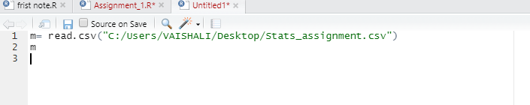

Data set can be read with the above command where the data is read from the csv file and is displayed below in the console.

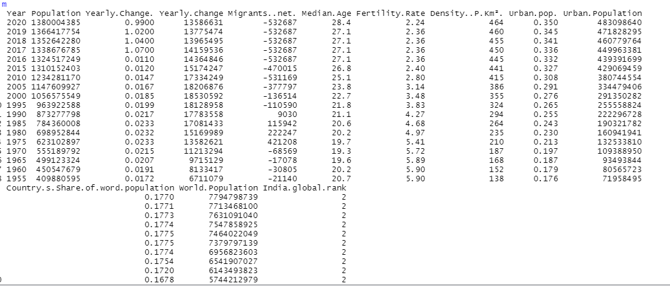

Also View(m) command displays the output in a new window which is more readable.

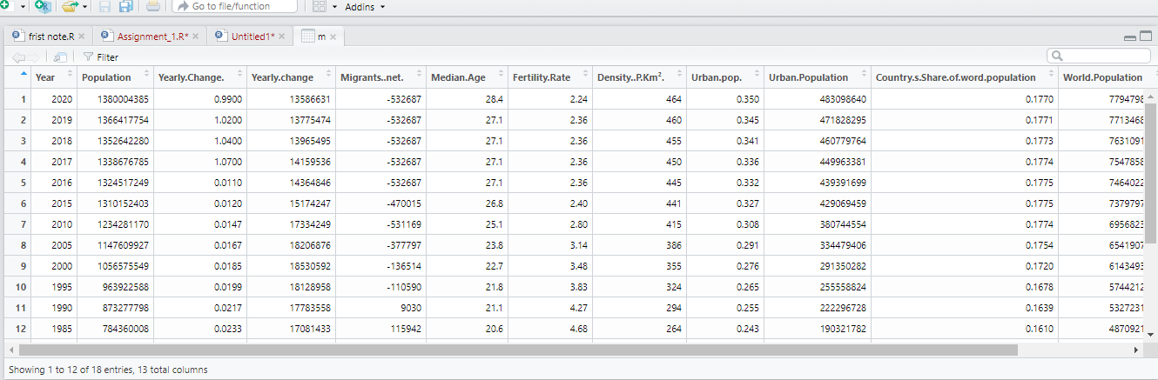

2. Find the summary of the whole data set. (Use appropriate syntax)

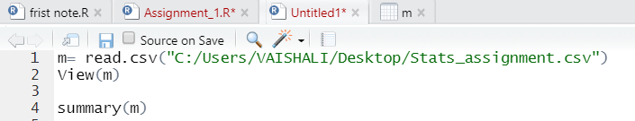

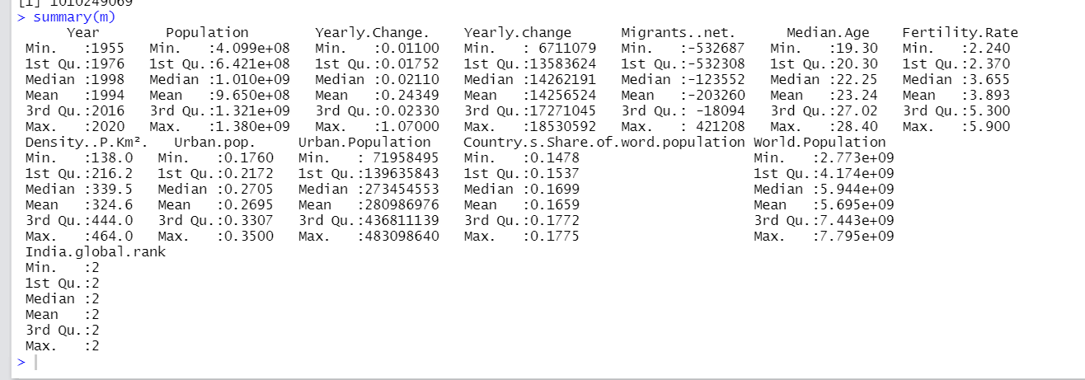

3. Find the mean, median for the population of India between 1955 and 2020 and justify your answer.

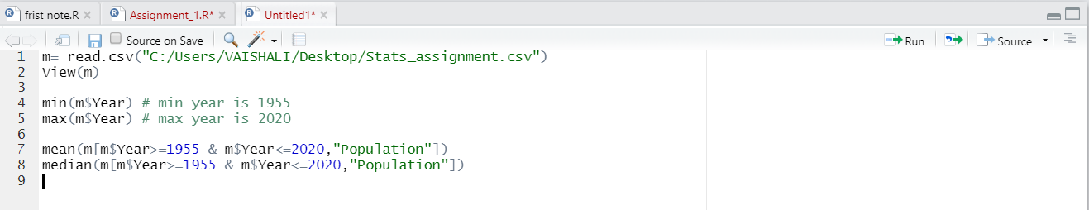

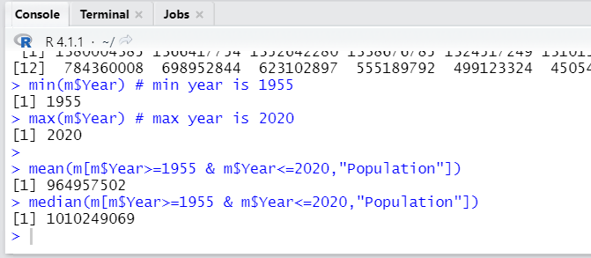

4. Find the variance, standard deviation of population of India and population of the world.

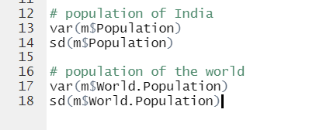

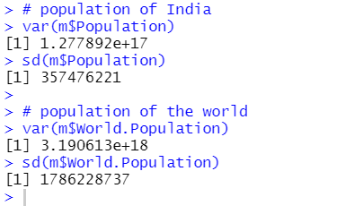

5. calculate the average density.



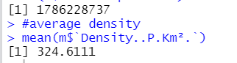

6. Any other notable analysis from the above dataset.

