|  |  |
| --- | --- |
| **Name** | **VAISHALI M** |
| **Sub name &Slot** | **MAT LAB**  **L31, L32** |
| **Assignment name and Date** | **Various Graphs in R** |

**Histogram**

* A histogram is a bar graph-like representation of data that buckets a range of outcomes into columns along the x-axis.
* The y-axis represents the number count or percentage of occurrences in the data for each column and can be used to visualize data distributions.
* hist(m$Population, main = "Population", breaks = 20)

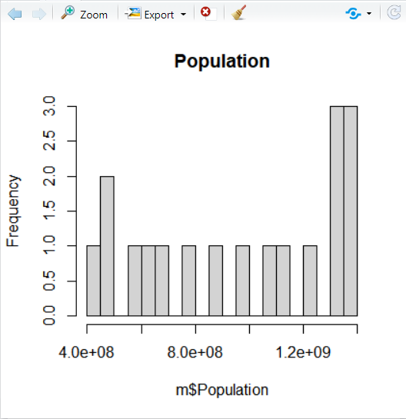

* hist(m$Urban.Population,main = "Urban",breaks = 15,col="Yellow")

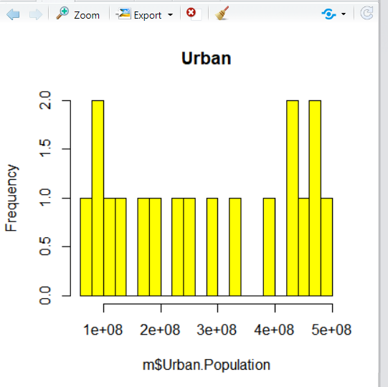

* 4 Histograms in same page

par(mfrow=c(2,2))

hist(m$Yearly.change,main = "Yearly change of population",breaks = 10,col="Yellow")

hist(m$Median.Age,main = "Median Age",breaks = 10,col="green")

hist(m$Urban.Population,main = "Urban Population",breaks = 10,col="red")

hist(m$`Density..P.Km².`,main = "Density",breaks = 10,col="Blue")

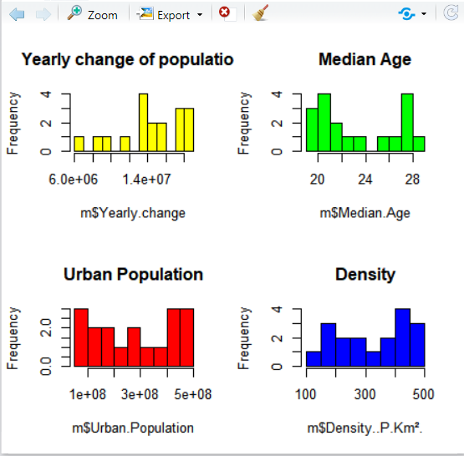

Many graphs can be visualized in the same page in the above picture.

* Fitting Curve on the Data

x = m$Population

m = mean(x)

std = sd(x)

hist(m$Population,main = "Population",breaks = 20)

curve(dnorm(x,mean = m,sd=std),col="darkblue")

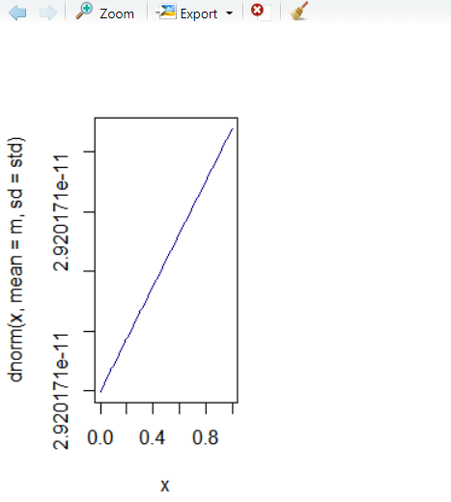

**BOX PLOTS**

**box plot** or **boxplot** is a method for graphically depicting groups of numerical data through their quartiles. Box plots may also have lines extending from the boxes (*whiskers*) indicating variability outside the upper and lower quartiles, hence the terms **box-and-whisker plot** and **box-and-whisker diagram**.

boxplot(m$Population,main = "Population",col="Pink")

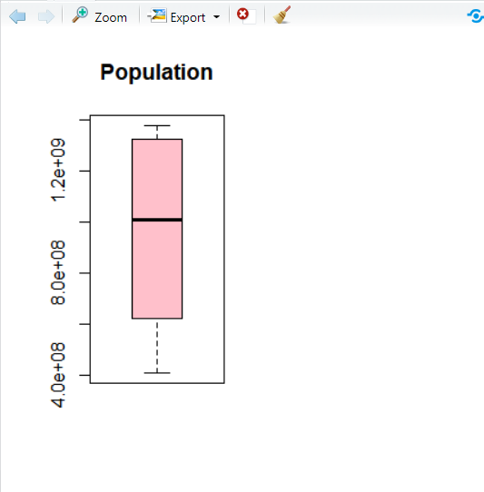

* par(mfrow=c(1,2))

boxplot(m$Population,main = "Population",col="Pink")

boxplot(m$Median.Age,main = "yearly change",col="Yellow")

boxplot(m[,1:4])

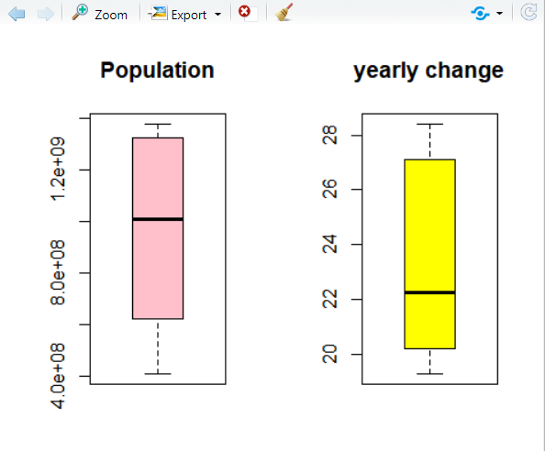

**SCATTER PLOTS**

A scatter plot (aka scatter chart, scatter graph) uses dots to represent values for two different numeric variables.

* plot(m$Population,m$Urban.pop.,col ="red",pch= 17,main="relation btwn population and urban population")

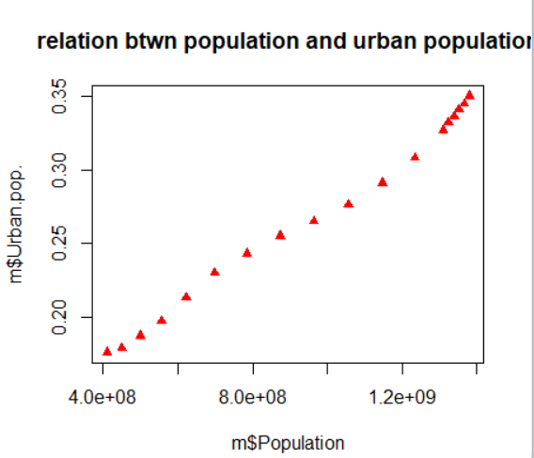

* plot(m$Population,m$Urban.pop.,col ="red",pch= 17, type = "l",main="relation btwn population and urban population")

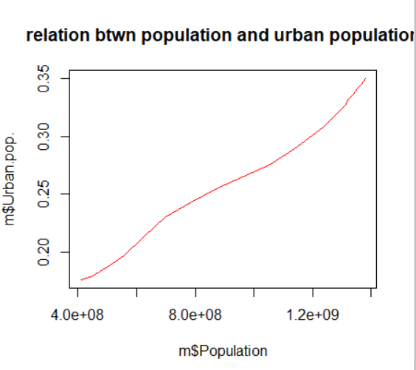

* plot(m$Population,m$Urban.pop.,col ="red",pch= 15, type = "b",main="relation btwn population and urban population")

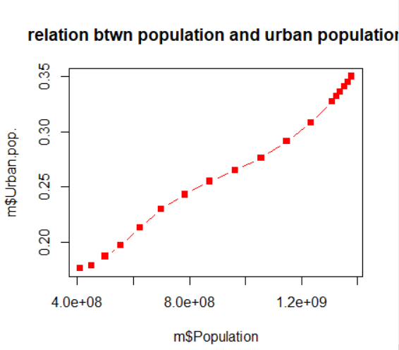

**PIE CHART**

A **pie chart** (or a **circle chart**) is a circular statistical graphic, which is divided into slices to illustrate numerical proportion.

slices = m$`Density..P.Km².`

urban = m$Urban.Population

pie(slices, labels = urban, main="Pie Chart of density of urban population")

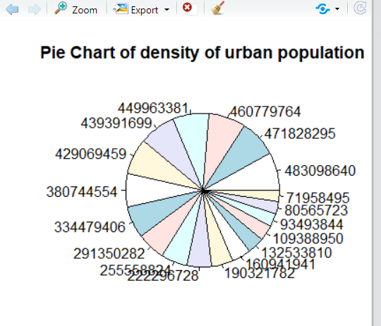

**3D PIE CHART**

* slices = m$`Density..P.Km².`

urban = m$Median.Age

pie3D(slices, labels = urban,explode = 0.1 ,main="Pie Chart of density and median age")

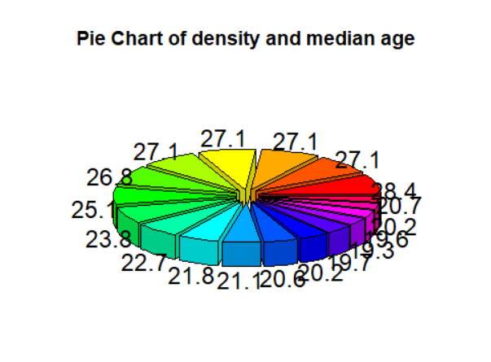

**BOX PLOT**

A bar plot or bar chart is a graph that represents the category of data with rectangular bars with lengths and heights that is proportional to the values which they represent.

* barplot(m$Population,col ="skyblue",pch= 17,main="box plot of population")

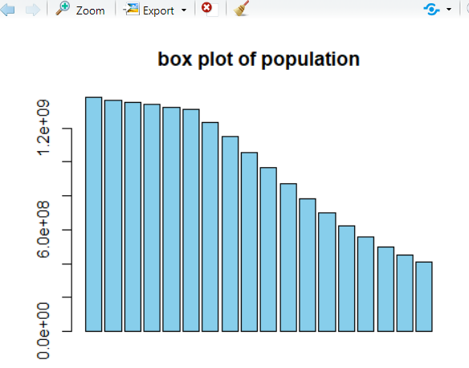

**DENSITY PLOT**

slices = m$`Density..P.Km².

den = density(slices)

plot(den,col="red",main="Density..P.Km")

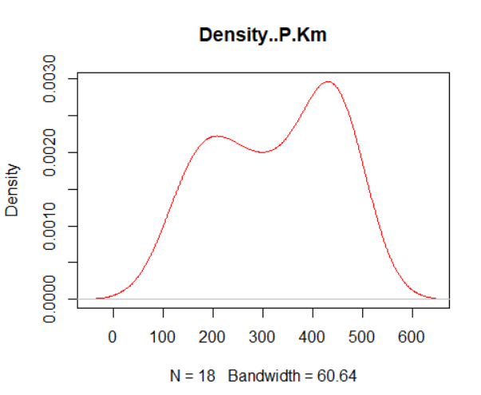

polygon(den, col = "light green", border = "black",main="Density..P.Km")

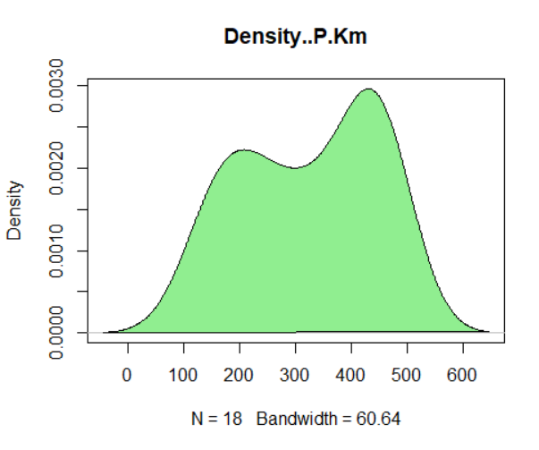

**DOT CHART**

dotchart(m$Median.Age, main="Median age",col="black")

