|  |  |
| --- | --- |
| **Name** | **VAISHALI M** |
| **Sub name &Slot** | **MAT LAB**  **L31, L32** |
| **Assignment name and Date** | **Hypothesis and normal distribution** |

1. Suppose the manufacture claims that the mean lifetime of a light bulb is less than 10,000 hours. In a sample of 30 light bulbs, it was found that they only last 9,900 hours on an average. Assume the population standard deviation is 120 hours. At 0.05 significance level, test the claim by the manufacture?

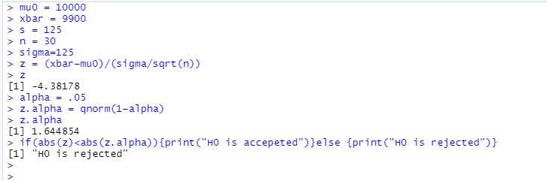

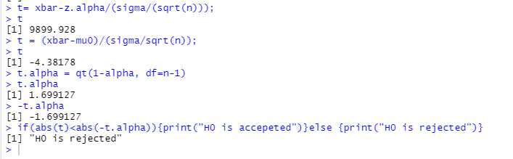

The test statistic -4.3818 is less than the critical value of -1.6991. Hence, at .05 significance level, we can reject the claim that mean lifetime of a light bulb is above 10,000 hours.

2 .Suppose the food label on a cookie bag states that there is at least 2 grams of saturated fat in a single cookie. In a sample of 35 cookies, it is found that the mean amount of saturated fat per cookie is 2.1 grams. Assume that the population standard deviation is 0.25 grams. At 0.05 significance level, test the claim on food label?

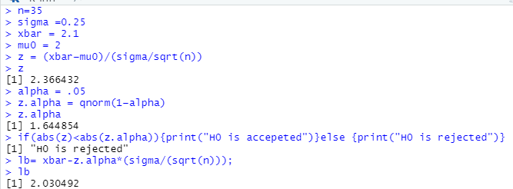

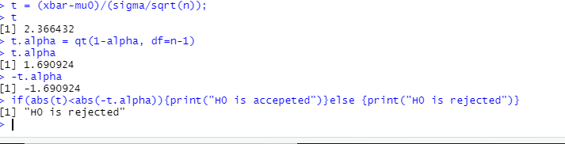

The test statistic 2.36 is greater than the critical value of 1.66.Hence, at 0.05 significance level, we reject the claim that there is at most 2 grams of saturated fat in a cookie.

3. Suppose the mean weight of King Penguins found in an Antarctic colony last year was

15.4 Kg. In a sample of 35 penguin weight is 14.6 Kg. Assume the Population standard

deviation is 2.5 Kg. At 0.05 significance level, test the Null hypothesis that the mean penguin weight does not differ from last year?

Here, mu0=15.4

Sample mean (xbar) = 14.6

Sigma (population standard deviation) = 2.5

Sample size = 35

Significance level (alpha)= 0.05

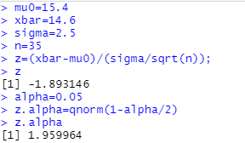

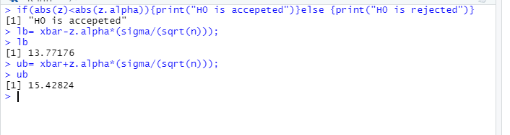

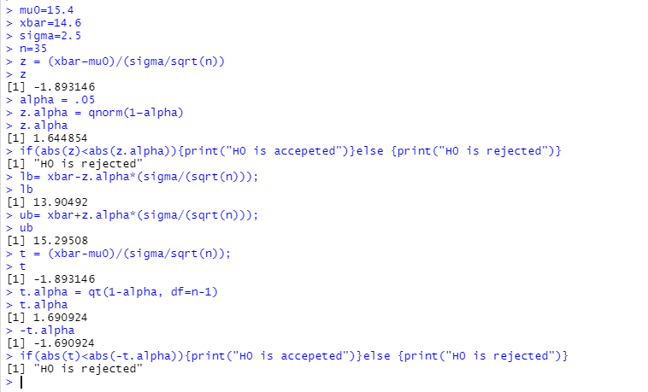

The test statistic value -1.89 lies between the critical values -1.96 and 1.96. Hence, at 0.05, significance level, we do not reject the null hypothesis i.e., the mean penguin weight does not differ from last year.

4.. A company finds that the time taken by one of its engineers to complete or repair

job has a normal distribution with mean 40 minutes and S.D 5 minutes. State what

proportion of jobs take:

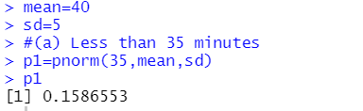

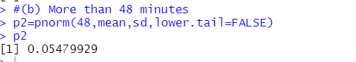

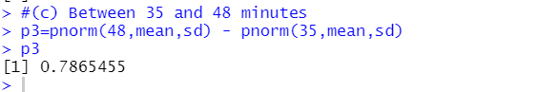

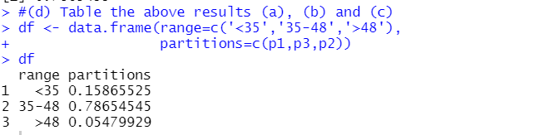



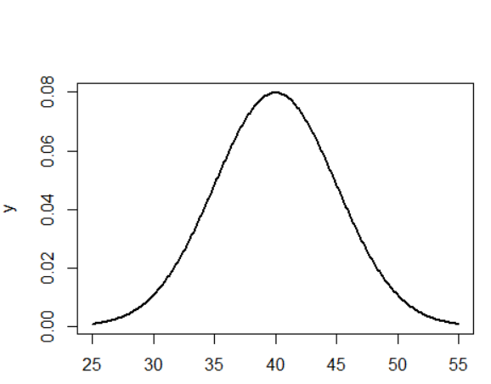v



