|  |  |
| --- | --- |
| **Name** | **VAISHALI M** |
| **Sub name &Slot** | **MAT 6001**  **A1** |
| **Assignment name and Date** | **Scatter plots for 8 different correlations.** |

**Perfect Positive**

In this data set the number of years in investing and compounding of the money is taken for consideration . Where , as the number of years in investing the money increases the compounding of the money also increases accordingly.

|  |  |
| --- | --- |
| Investment No of Year | Compounding |
| 1 | 100 |
| 2 | 200 |
| 3 | 300 |
| 4 | 400 |
| 5 | 500 |
| 6 | 600 |
| 7 | 700 |
| 8 | 800 |
| 9 | 900 |
| 10 | 1000 |

Here Number of investing year is taken as X and compounding of money is taken as Y

The graph for the above data set is

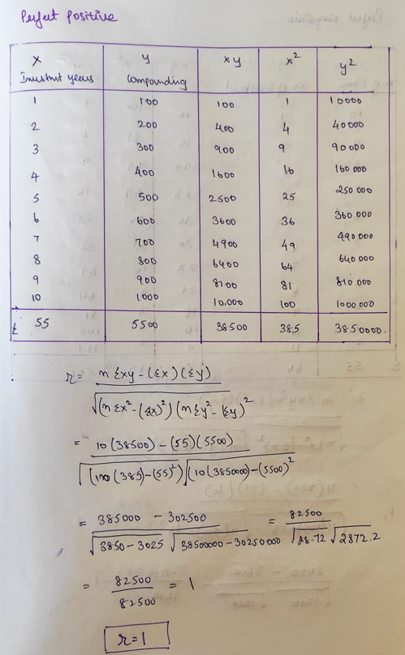

Here the correlation coefficient is 1 .Hence it is **PERFECT POSITIVE CORRELATION**.

**Perfect Negative**

In this dataset number of loans and number of investment is taken into consideration .Where , as the number of loan increases, the number of investment decreases respectively.

|  |  |
| --- | --- |
| No of Loan | No of Investment |
| 10 | 1 |
| 9 | 2 |
| 8 | 3 |
| 7 | 4 |
| 6 | 5 |
| 5 | 6 |
| 4 | 7 |
| 3 | 8 |
| 2 | 9 |
| 1 | 10 |
| 0 | 11 |

Here the Number of Loans is taken as X and Number of Investment is taken as Y

The graph for the above dataset is

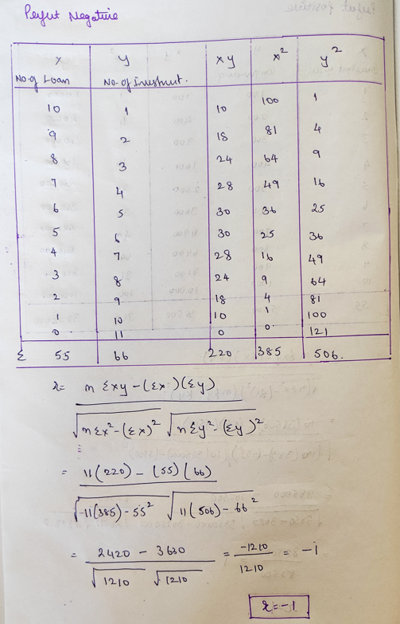

Here the correlation coefficient is - 1 .Hence it is **PERFECT NEGATIVE CORRELATION.**

**Low Degree Positive**

Here Motivation given by the mentors and performance of the students is taken for consideration. In this data set, Motivation given by the mentors has some positive impact on the performance of the students.

|  |  |
| --- | --- |
| Motivation% | Performance increase in students |
| 10 | 5 |
| 10 | 2 |
| 20 | 8 |
| 20 | 40 |
| 30 | 10 |
| 40 | 20 |
| 50 | 10 |
| 50 | 20 |
| 15 | 4 |
| 40 | 10 |

Here Motivation Percentage is taken as X and the performance increase is taken as Y.

The graph for the above data set is

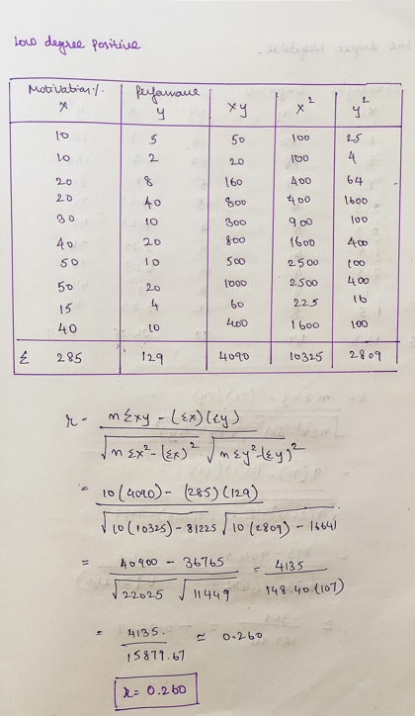

Here the correlation coefficient is 0.260 which is a **LOW DEGREE POSITIVE CORRE**LATION which depicts that motivation given was not that impactful but helpful to some extent.

**Low degree Negative**

In this dataset , Exercise hours of different people and the corresponding weight gain is taken into consideration where increase in exercising hrs. leads to less weight gain to some extent.

|  |  |  |
| --- | --- | --- |
| People id | Exercise hr | weight gain per person |
| 1 | 1 | 10 |
| 2 | 2 | 12 |
| 3 | 1 | 5 |
| 4 | 2.5 | 6 |
| 5 | 0.5 | 8 |
| 6 | 1.5 | 6 |
| 7 | 2.5 | 4 |
| 8 | 1 | 8 |
| 9 | 1.5 | 8 |

Here Exercising hr. is taken as X and amount of Weight gain is taken as Y

The graph for the above dataset is

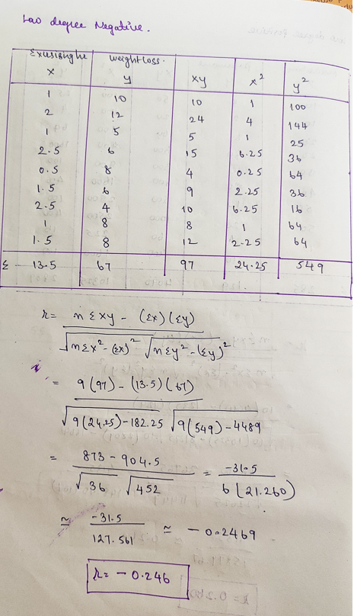

Here the correlation coefficient is -0.246 which is **LOW DEGREE NEGATIVE** which depicts that amount of weight gained is related to the number of exercising hr. to a very small extent.

**High Degree Positive**

In this dataset the number of people visiting the shop and the shop sales is taken for consideration. Where Increase in foot fall has a very great impact on shopping sales.

|  |  |
| --- | --- |
| Footfall | Shopping sales |
| 100 | 10 |
| 200 | 20 |
| 300 | 30 |
| 400 | 40 |
| 500 | 45 |
| 600 | 55 |
| 250 | 40 |

Here Foot fall is taken as X and the shopping sales is taken as Y.

The graph for the above dataset is

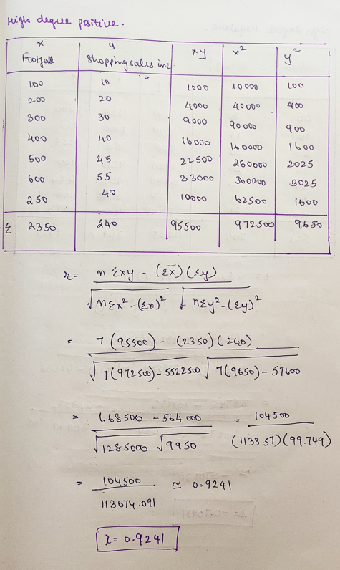

Here the correlation coefficient is 0.9241 which is **HIGH DEGREE POSITIVE** which in turn depicts that the increase in number of visitors increases the shop sales.

**High Degree Negative**

In this dataset weather outside and the temperature of the AC/Heater of different houses are taken into consideration. Where increase in weather outside results in decrease in AC/Heater temperature in houses.

|  |  |  |
| --- | --- | --- |
| House Id | weather Degree | AC/heater temperature |
| 1 | 35 | 80 |
| 2 | 90 | 15 |
| 3 | 25 | 35 |
| 4 | 96 | 20 |
| 5 | 95 | 22 |
| 6 | 82 | 10 |
| 7 | 100 | 24 |

Here Weather outside is taken as X and AC/Heater temperature is taken as Y

The graph for above dataset is given as

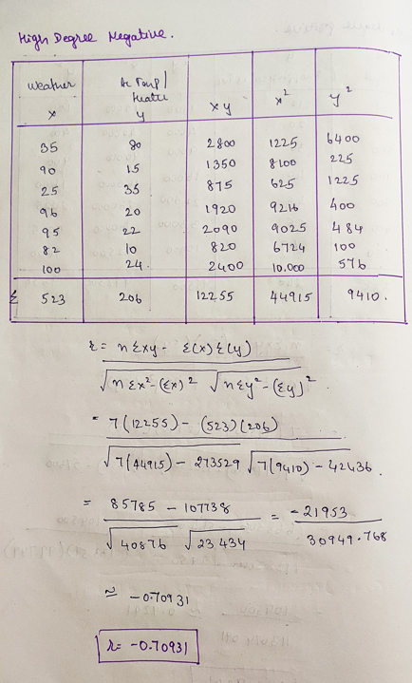

Here the correlation coefficient is -0.70931 which is **HIGH DEGREE NEGATIVE** which in turn depicts that increase in weather outside results in decrease in temperature of AC/Heater inside.

**No Correlation**

Here the weights of different people and their salary is taken into consideration which literally has no relationship.

|  |  |
| --- | --- |
| weight | Income |
| 55 | 30 |
| 80 | 100 |
| 120 | 10 |
| 40 | 38 |
| 77 | 90 |
| 66 | 140 |
| 44 | 20 |
| 105 | 53 |

Here Weight is taken as X and their incomes are taken as Y.

The graph for the above dataset is

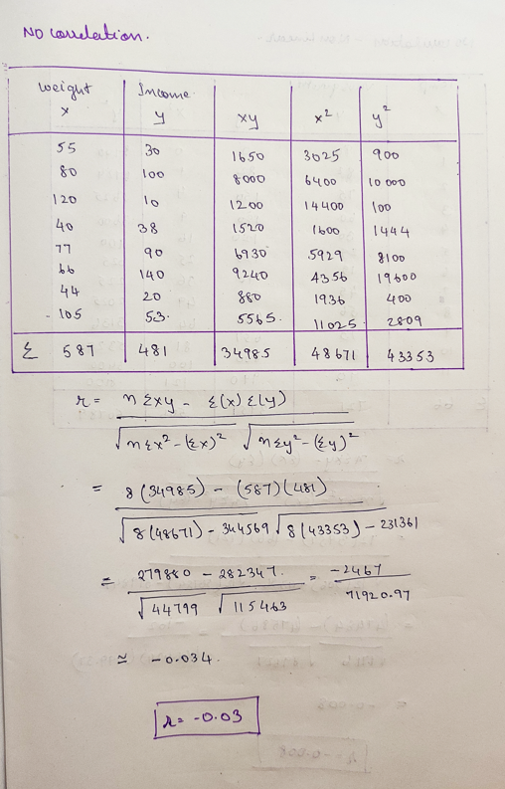

Here the correlation coefficient is -0.0 which is **NO CORRELATION** which depicts that weight and income has no relationship.

**Non Linear no correlation**

Here the microbes growth in various room temperature is taken into consideration. Where the microbes grows in both extreme temperatures.

|  |  |
| --- | --- |
| Room Temperature | Microbes |
| 0 | 90 |
| 1 | 82 |
| 2 | 75 |
| 3 | 60 |
| 4 | 30 |
| 5 | 25 |
| 6 | 15 |
| 7 | 45 |
| 8 | 56 |
| 9 | 73 |
| 10 | 80 |
| 11 | 90 |

Here the room Temperature is taken as X and Growth of Microbes is taken as Y.

The graph for the above dataset is

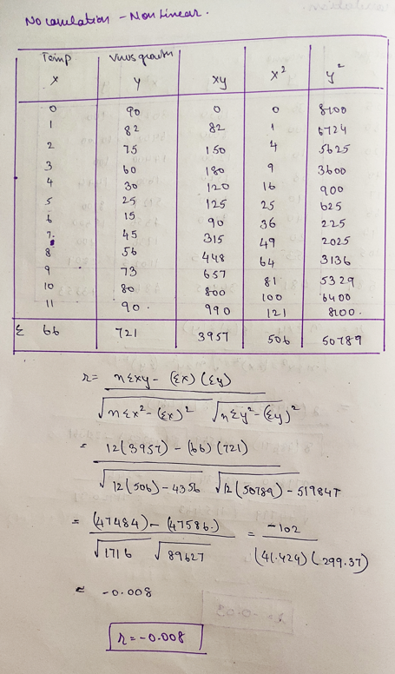

Here the correlation coefficient is -0.00 which is **NO CORRELATION** which depicts that the microbes grow non linearly