OBSERVATIONS THROUGH DESCRIPTIVE ANALYSIS IN TABLEAU:

1. ANTE NATAL CARE SERVICE.

The obvious fact is evident in the plot, that is lower rate of women registered for ANC scheme within trimester

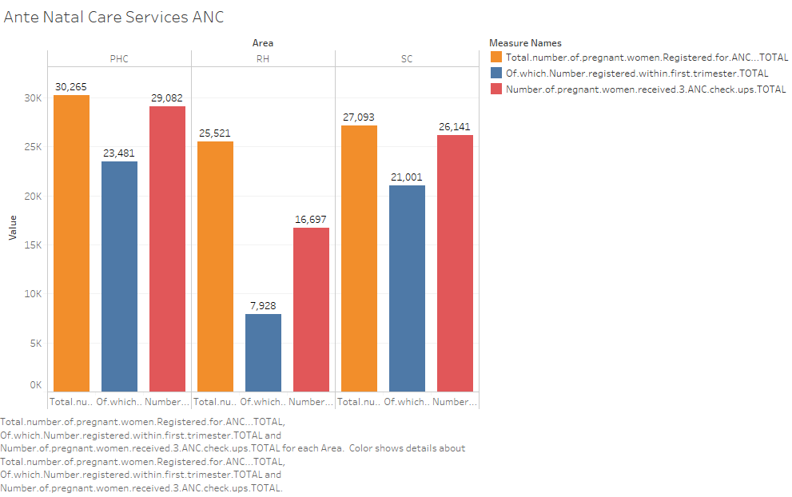

2. Distribution of ANC services wrt to TT1, TT2 and Iron tablets.

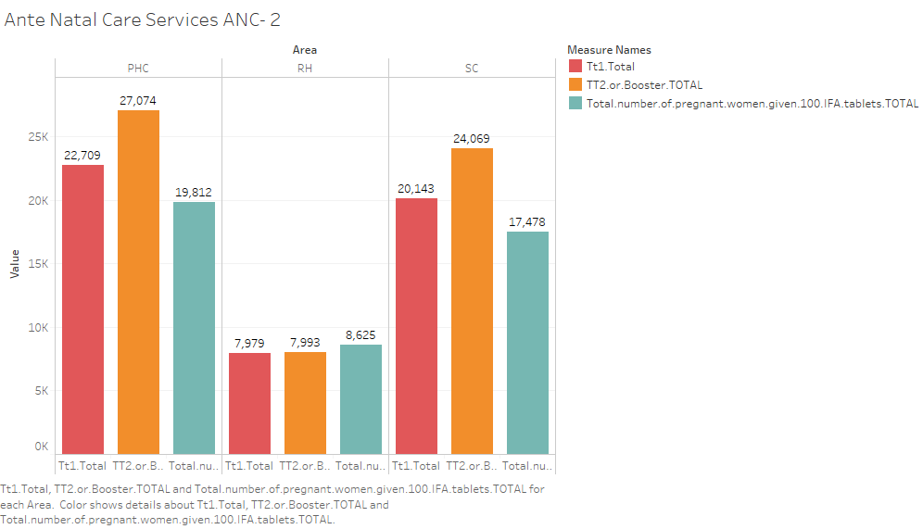

3. Distribution of mothers facing anemia and new born weights’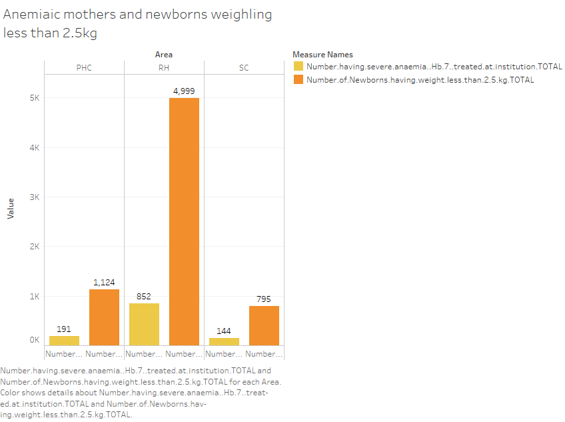

4. lower Abortion count on ANC services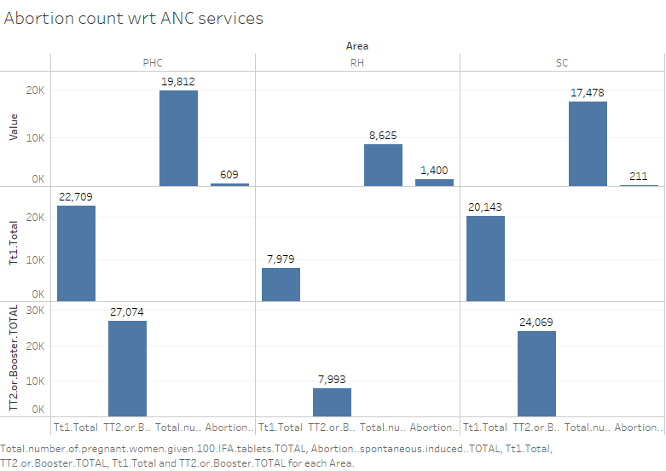

5. Distribution of family care services

. 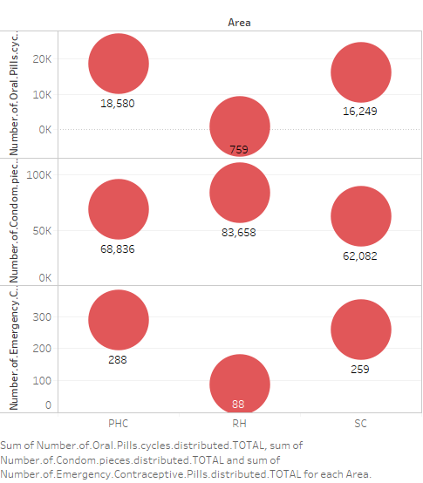

6. 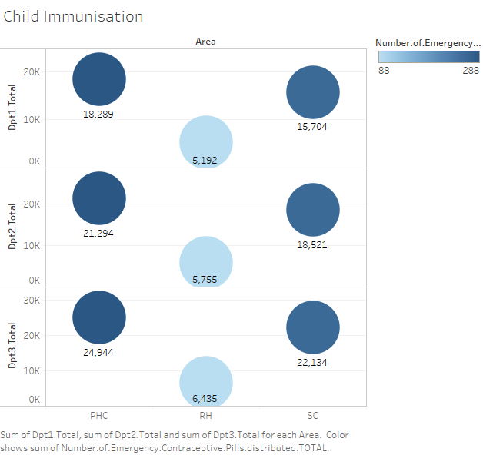

7. 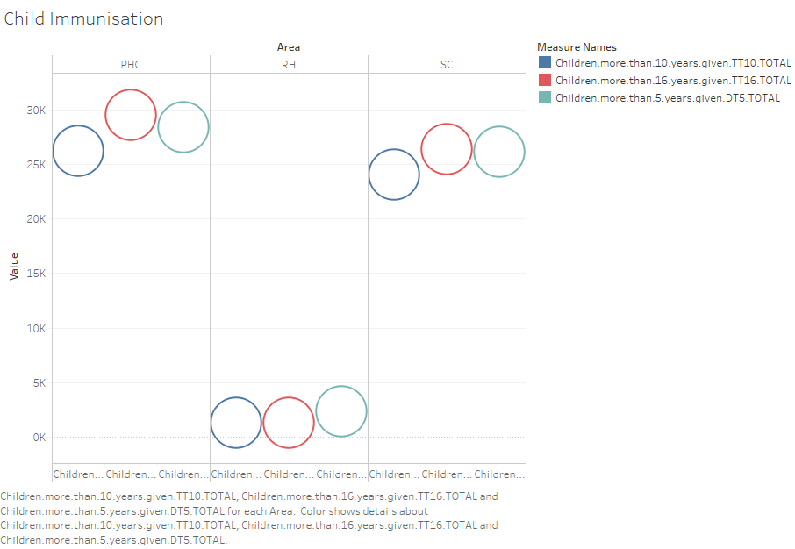

8.

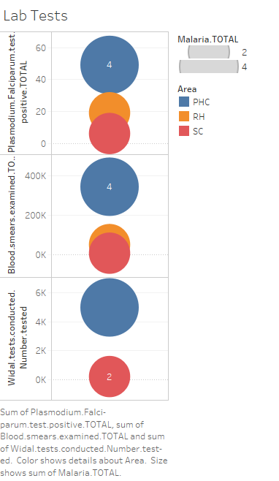

9. Distribution of child immunization.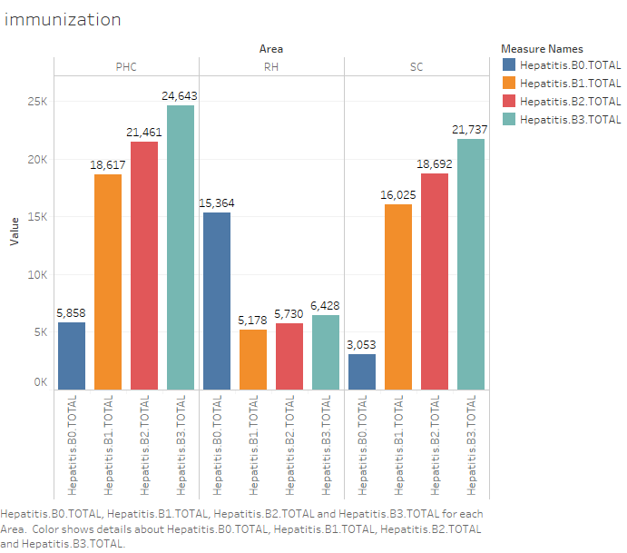

10. 