[**CMPE 202 - Silicon Valley Codecamp 2016**](https://sjsu.instructure.com/courses/1224887/pages/cmpe-202-silicon-valley-codecamp-2016)

**Ashna Sebastian**

**010726482**

[**ashna.sebastian@gmail.com**](mailto:ashna.sebastian@gmail.com)

**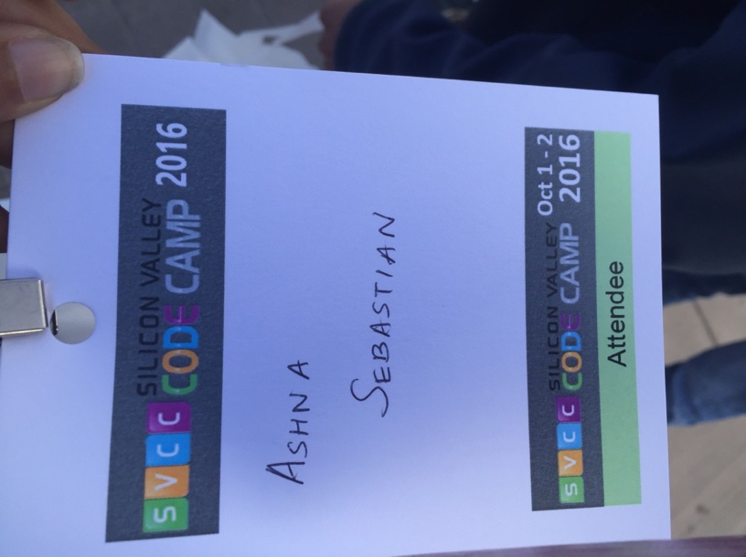**

## **Talk #1**

## **Title of the Talk :** So you want to be a data scientist?

## **URL to the Talk :** <https://www.siliconvalley-codecamp.com/Session/2016/so-you-want-to-be-a-data-scientist>

**Comments:** The speaker was Andrew Moll who is working in Microsoft. The talk was interesting and was about what are the technologies in the data science field, how can we become a data scientist. He also demonstrated a simple example of how data analysis can be done using Azure features. There are many competitions in [www.kaggle.com](http://www.kaggle.com) and he chose [**Titanic: Machine Learning from Disaster**](https://www.kaggle.com/c/titanic) topic to give us a hands on experience on how data analysis can be done. We got an excel sheet with some data to perform the analysis. For example, we analyzed what is the probability of survival if the person had a seat in the first class versus second class and the position in the deck. This can be used to create a analysis model and view the result using the features in Azure. He also showed us how this can be deployed as a REST service using Azure. The tech provided a basic idea of what a data scientist work is.

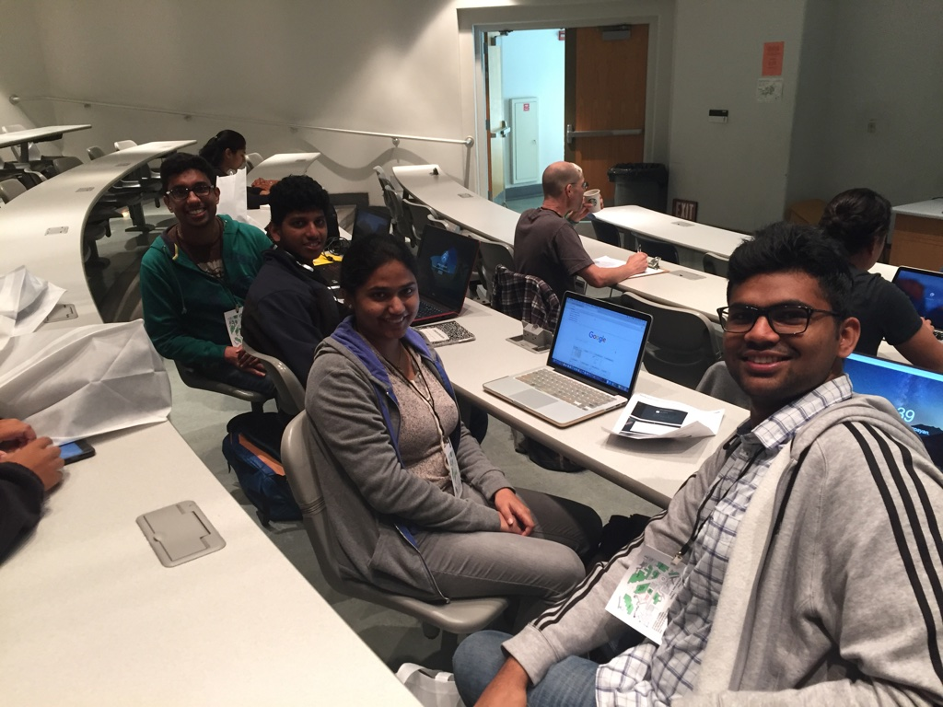

## **Talk #2**

## **Title of the Talk :** Machine Learning Exposed!

## **URL to the Talk :** <https://www.siliconvalley-codecamp.com/Session/2016/machine-learning-exposed>

## **Comments:**

## **../../../../../Pictures/Photos%20Library.photoslibrary/Thumbnails/2016/10/01/20161001-191749/uMpYFubsQE+yllr1V%25IQgA/thumb_IMG_3328_1**

## **Talk #3**

## **Title of the Talk :** Angular 2 101: The Adventure Continues

## **URL to the Talk :** <https://www.siliconvalley-codecamp.com/Session/2016/angular-2-101-the-adventure-continues>

## **Comments:**

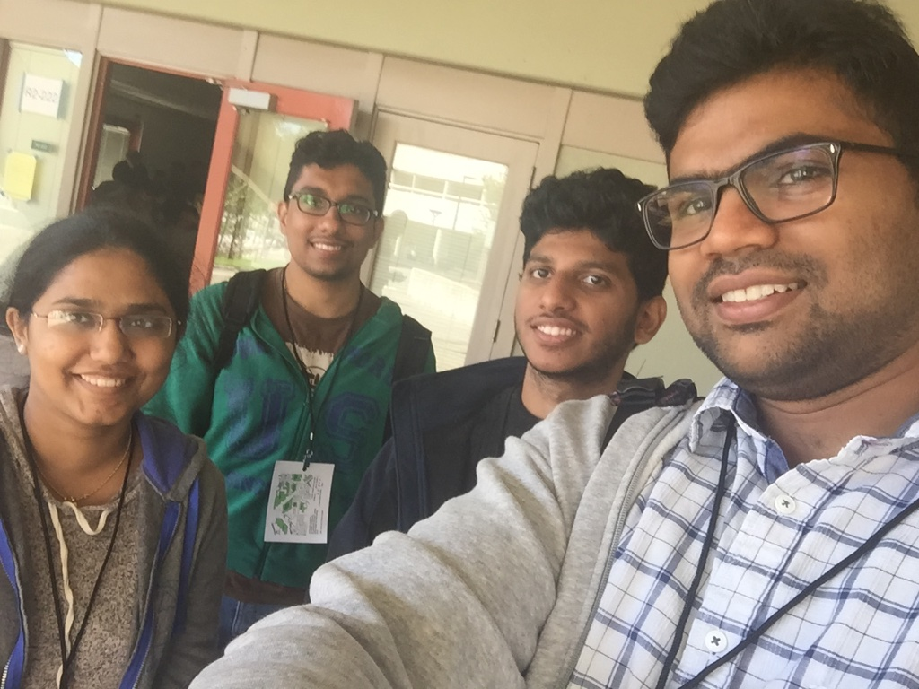

## **Talk #4**

## **Title of the Talk :** Cracking the Coding Interview

## **URL to the Talk :** <https://www.siliconvalley-codecamp.com/Session/2016/cracking-the-coding-interview>

## **Comments:**

