## **VISVESVARAYA TECHNOLOGICAL UNIVERSITY**

### “Jnana Sangama”, Belagavi – 590 018, Karnataka



#### MINI PROJECT REPORT

**ON**

**“OBSTACLE AVOIDANCE ROBOT”**

***Submitted in partial fulfillment of the requirements for the Microcontrollers and Embedded Systems (18CS44)***

*Submitted by:*

DEEPAK P 1JT20AI005

VAISHNAVI BS 1JT20AI048

HITESH SM 1JT20AI011

**Under the guidance of**

### **Ramya B N**

**Assistant Professor**

** Department of Artificial intelligence and Machine learning**

Department of Artificial intelligence and Machine learning

Jyothy Institute of Technology

Tataguni, Off. Kanakapura Road, Bengaluru – 560 082

**2021– 2022**

**INTRODUCTION**

Robotics is part of Todays communication. In today’s world ROBOTICS is fast growing and interesting field. It is simplest way for latest technology modification. Now a days communication is part of advancement of technology, so we decided to work on ROBOTICS field, and design something which will make human life simpler in day today aspect. Thus we are supporting this cause.

An obstacle avoiding robot is an intelligent device, which can automatically sense and overcome obstacles on its path. Obstacle Avoidance is a robotic discipline with the objective of moving vehicles on the basis of the sensorial information. The use of these methods front to classic methods (path planning) is a natural alternative when the scenario is dynamic with an unpredictable behaviour. In these cases, the surroundings do not remain invariable, and thus the sensory information is used to detect the changes consequently adapting moving. It will automatically scan the surrounding for further path.

This project is basic stage of any automatic robot. This ROBOT has sufficient intelligence to cover the maximum area of provided space. It has a ultrasonic sensor which are used to sense the obstacles coming in between the path of ROBOT. It will move in a particular direction and avoid the obstacle which is coming in its path. We have used two D.C motors to give motion to the ROBOT. The construction of the ROBOT circuit is easy and small. The electronics parts used in the ROBOT circuits are easily available and cheap too.

**LITERATURE** **SURVEY**

We reviewed different obstacle detecting robot mechanisms that have been built by a lot of students and other practitioners that are in existence. For an autonomous mobile robot performing a navigation-based task in a vague environment, to detect and to avoid encountered obstacles is an important issue and a key function for the robot body safety as well as for the task continuity. Obstacle detection and avoidance in a real world environment that appears so easy to humans is a rather difficult task for autonomous mobile robots and is still a well- researched topic in robotics. In many previous works, a wide range of sensors and various methods for detecting and avoiding obstacles for mobile robot purpose have been proposed. Good references related to the developed sensor systems and proposed detection and avoidance algorithms can be found. Based on these developed sensor systems, various approaches related to this work can be grouped.

**DESIGN & HARDWARE REQUIREMENTS**

Design :

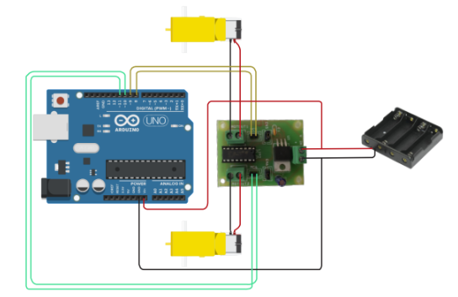**DETAILS ABOUT SOFTWARE USED IN THE PROJECT**

 Hardware:

• Arduino Uno

• Ultrasonic sensor

• Motor (100 RPM)

• Motor driver IC (L293D)

• Battery AA 1.5v

The Arduino Integrated Development Environment - or Arduino Software (IDE) - contains a text editor for writing code, a message area, a text console, a toolbar with buttons for common functions and a series of menus. It connects to the Arduino hardware to upload programs and communicate with them.

Programs written using Arduino Software (IDE) are called **sketches**. These sketches are written in the text editor and are saved with the file extension .ino. The editor has features for cutting/pasting and for searching/replacing text. The message area gives feedback while saving and exporting and also displays errors. The console displays text output by the Arduino Software (IDE), including complete error messages and other information. The toolbar buttons allow you to verify and upload programs, create, open, and save sketches, and open the serial monitor.

**Working Principle**

The obstacle avoidance robotic vehicle uses ultrasonic sensors for its movements. Arduino is used to achieve the desired operation. The motors are connected through motor driver IC to Arduino. The ultrasonic sensor is attached in front of the robot. Whenever the robot is going on the desired path the ultrasonic sensor transmits the ultrasonic waves continuously from its sensor head. Whenever an obstacle comes ahead of it the ultrasonic waves are reflected back from an object and that information is passed to the arduino. The arduino controls the motors left, right, back, front, based on ultrasonic signals. In order to control the speed of each motor pulse width modulation is used (PWM). When ultrasonic sensor detect the object which is kept inside the path it will send the signal toward the arduino uno and according to that it will it will rotate the motor M1 in forward direction and rotate the motor M2 in reverse direction such way that the car get moving in left direction . Similarly in every time when ever an obstacle in found to be in path of car it will detect it and rotate the car in left direction to avoid the obstacle.

**APPLICATIONS**

This device has application in surveying different landscapes and mapping them. It can also be used in commercial devices like

• Automated lawn mover

• Smart room cleaner

Obstacle avoiding robots can be used in almost all mobile robot navigation systems.

• They can also be used in dangerous environments, where human penetration could be fatal.

• Unmanned vehicle driving

• Mining Vehicle that uses Obstacle Detection

FUTURE ENHANCEMENTS

* Obstacle avoidance can be further enhanced by developing better resolution camera for on field live feed video of remote land.
* Can be used in Defense applications.
* Can be used as ADAS – Automated driver assistance systems function in cars for better road safety.

**EXPERIMENTAL RESULTS**

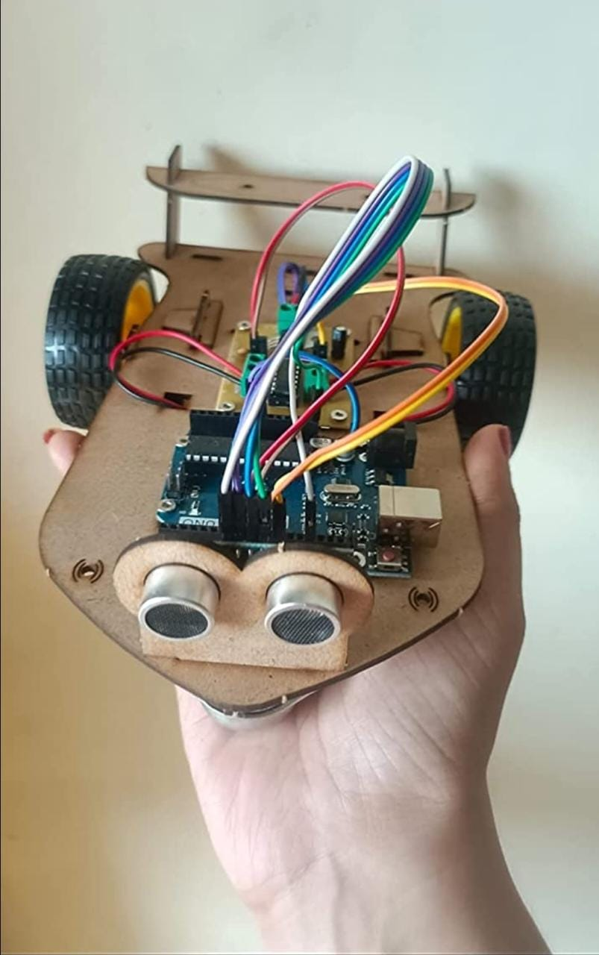

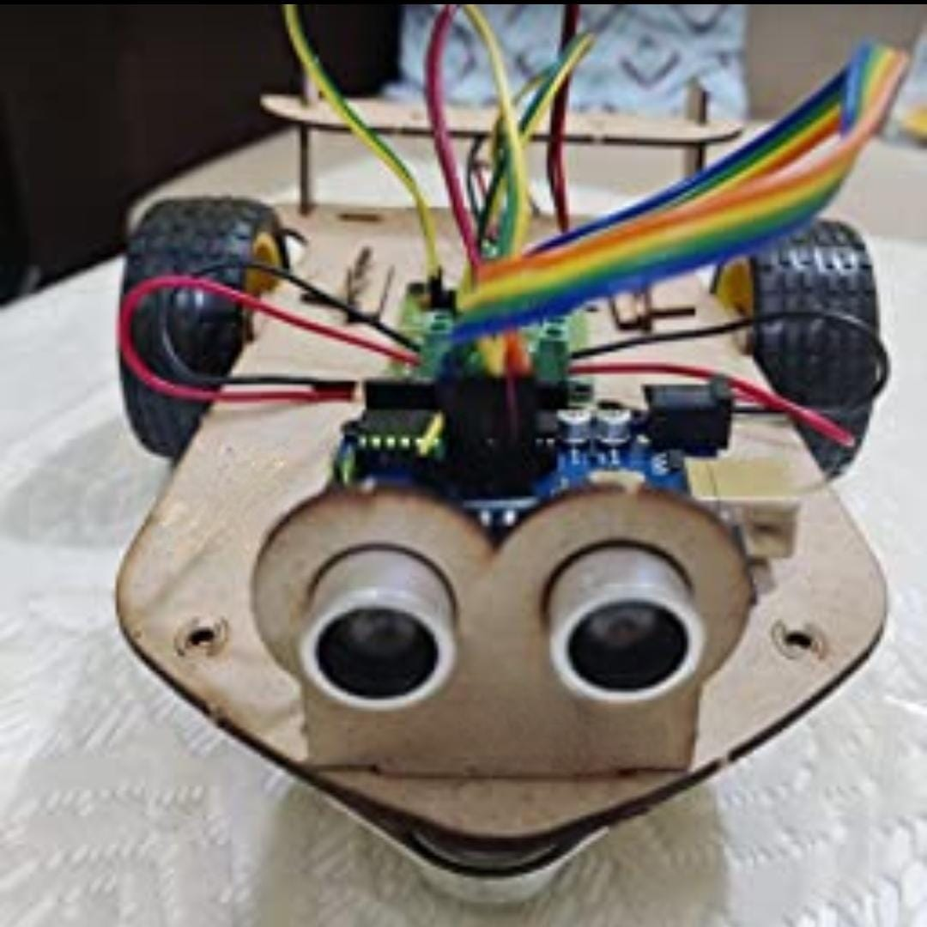

**CONCLUSION**

The goal of our project is to create an autonomous robot which intelligently detects the obstacle in it’s path and navigate according to the actions we set for it, abiding to all the coded regulations and limits.

**PROGRAM**

**#define trigPin 6 // Trig Pin Of HC-SR04**

**#define echoPin 7 // Echo Pin Of HC-SR04**

**#define MLa 8 //left motor 1st pin**

**#define MLb 9 //left motor 2nd pin**

**#define MRa 10 //right motor 1st pin**

**#define MRb 11 //right motor 2nd pin**

**long duration, distance;**

**void setup() {**

**Serial.begin(9600);**

**pinMode(MLa, OUTPUT); // Set Motor Pins As O/P**

**pinMode(MLb, OUTPUT);**

**pinMode(MRa, OUTPUT);**

**pinMode(MRb, OUTPUT);**

**pinMode(trigPin, OUTPUT); // Set Trig Pin As O/P To Transmit Waves**

**pinMode(echoPin, INPUT); //Set Echo Pin As I/P To Receive Reflected Waves**

**}**

**void loop()**

**{**

**Serial.begin(9600);**

**digitalWrite(trigPin, LOW);**

**delayMicroseconds(2);**

**digitalWrite(trigPin, HIGH);**

**delayMicroseconds(10);**

**duration = pulseIn(echoPin, HIGH);**

**distance = duration / 58.2; // Get Distance**

**Serial.println(distance);**

**delay(10);**

**if (distance > 15) // Condition For Absence Of Obstacle**

**{**

**digitalWrite(MRb, HIGH); // Move Forward**

**digitalWrite(MRa, LOW);**

**digitalWrite(MLb, HIGH);**

**digitalWrite(MLa, LOW);**

**}**

**else if ((distance < 10)&&(distance > 0)) // Condition For Presence Of Obstacle**

**{**

**digitalWrite(MRb, LOW); //Stop**

**digitalWrite(MRa, LOW);**

**digitalWrite(MLb, LOW);**

**digitalWrite(MLa, LOW);**

**delay(100);**

**digitalWrite(MRb, LOW); // Move Backward**

**digitalWrite(MRa, HIGH);**

**digitalWrite(MLb, LOW);**

**digitalWrite(MLa, HIGH);**

**delay(500);**

**digitalWrite(MRb, LOW); //Stop**

**digitalWrite(MRa, LOW);**

**digitalWrite(MLb, LOW);**

**digitalWrite(MLa, LOW);**

**delay(100);**

**digitalWrite(MRb, HIGH); // Move Left**

**digitalWrite(MRa, LOW);**

**digitalWrite(MLa, LOW);**

**digitalWrite(MLb, LOW);**

**delay(500);**

**}**

**}**

**REFERENCES**

**WEBSITES :**

* [**http://science.howstuffworks.com/robot2.htm**](http://science.howstuffworks.com/robot2.htm)
* [**http://arduino.cc/en/Main/arduinoBoardUno**](http://arduino.cc/en/Main/arduinoBoardUno)
* [**https://www.intorobotics.com/obstacle-avoidance-robot**](https://www.intorobotics.com/obstacle-avoidance-robot)
* **https://iopscience.iop.org/article/10.1088/1757-899X/981/4/042002/pdf**