**FUTURE OF SALES PREDICTION USING MACHINE LEARNING**

Phase 3 submission project

Project title: future sales prediction

Topic: start building the future sales prediction model by loading and preprocessing the dataset

Future sales prediction

Indroduction:

In the analysis of the "Future Sales Prediction" dataset, we conducted a comprehensive series of data analysis steps to create an accurate prediction model. The process began with Exploratory Data Analysis (EDA) to understand the dataset's characteristics. Subsequently, we performed data preprocessing, including outlier detection and handling using the winzoring technique, as well as data normalization using the min-max method. We then developed multiple models, including Linear Regression, Ridge Regression, Lasso Regression, Decision Tree, and Random Forest, all of which were evaluated through cross-validation. The model evaluation results revealed that Random Forest outperformed others, yielding an average Mean Squared Error (MSE) of 10.32%, Root Mean Squared Error (RMSE) of 8.09%, Mean Absolute Error (MAE) of 5.99%, and an R-squared value of 94.27%. Additionally, we conducted classic assumption tests, including tests for linearity, homoscedasticity, normality, multicollinearity, outliers, and independence, to ensure the validity of our model. These results provide in-depth insights into the quality of our prediction model and its relevance in the context of future sales forecasting.

# **Load Data**

In[1]:

import pandas as pd

df = pd.read_csv('/input/future-sales-prediction/Sales.csv')

df.head()

output 1:

|  | TV | Radio | Newspaper | Sales |
| --- | --- | --- | --- | --- |
| 0 | 230.1 | 37.8 | 69.2 | 22.1 |
| 1 | 44.5 | 39.3 | 45.1 | 10.4 |
| 2 | 17.2 | 45.9 | 69.3 | 12.0 |
| 3 | 151.5 | 41.3 | 58.5 | 16.5 |
| 4 | 180.8 | 10.8 | 58.4 | 17.9 |

Features explanation:

* **TV**: this feature represents the amount of advertising budget spent on television media for a product or service in a certain period, for example in thousands of dollars (USD).
* **Radio**: this feature represents the amount of advertising budget spent on radio media in the same period as TV.
* **Newspaper**: this feature represents the amount of advertising budget spent in newspapers or print media in the same period as TV and Radio.
* **Sales**: This feature represents product or service sales data in the same period as advertising expenditure on TV, Radio and Newspaper.

In[2]:

df.shape

ot[2]:

(200, 4)

In[3]:

df.info()

<class 'pandas.core.frame.DataFrame'>

RangeIndex: 200 entries, 0 to 199

Data columns (total 4 columns):

# Column Non-Null Count Dtype

--- ------ -------------- -----

0 TV 200 non-null float64

1 Radio 200 non-null float64

2 Newspaper 200 non-null float64

3 Sales 200 non-null float64

dtypes: float64(4)

memory usage: 6.4 KB

In[4]:

df.describe().T

out[4]:

|  | count | mean | std | min | 25% | 50% | 75% | max |
| --- | --- | --- | --- | --- | --- | --- | --- | --- |
| TV | 200.0 | 147.0425 | 85.854236 | 0.7 | 74.375 | 149.75 | 218.825 | 296.4 |
| Radio | 200.0 | 23.2640 | 14.846809 | 0.0 | 9.975 | 22.90 | 36.525 | 49.6 |
| Newspaper | 200.0 | 30.5540 | 21.778621 | 0.3 | 12.750 | 25.75 | 45.100 | 114.0 |
| Sales | 200.0 | 15.1305 | 5.283892 | 1.6 | 11.000 | 16.00 | 19.050 | 27.0 |

# **Exploratory Data Analysis (EDA)**

In [5]:

import plotly.express as px

figure = px.scatter(df, x='Sales', y='TV', size='TV', trendline='ols', title='Relationship Between Sales and TV Advertising')

figure.update_traces(marker=dict(line=dict(width=2, color='DarkSlateGrey')), selector=dict(mode='markers'))

figure.update_layout(

xaxis_title='Sales',

yaxis_title='TV Advertising',

legend_title='TV Ad Size',

plot_bgcolor='white'

)

figure.show()

out[5]:

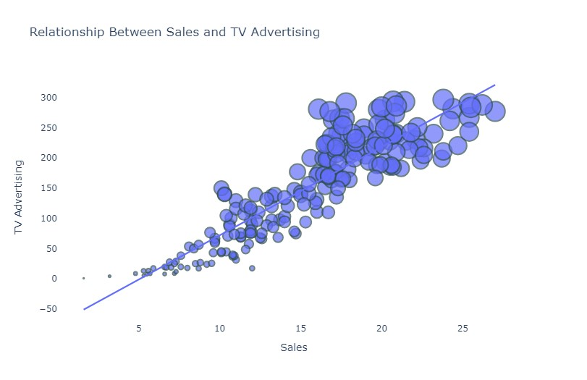

In[6]:

figure = px.scatter(df, x='Sales', y='Newspaper', size='Newspaper', trendline='ols', title='Relationship Between Sales and Newspaper Advertising')

figure.update_traces(marker=dict(line=dict(width=2, color='DarkSlateGrey')), selector=dict(mode='markers'))

figure.update_layout(

xaxis_title='Sales',

yaxis_title='Newspaper Advertising',

legend_title='Newspaper Ad Size',

plot_bgcolor='white'

)

figure.show()

Relationship Between Sales and Newspaper Advertising

:

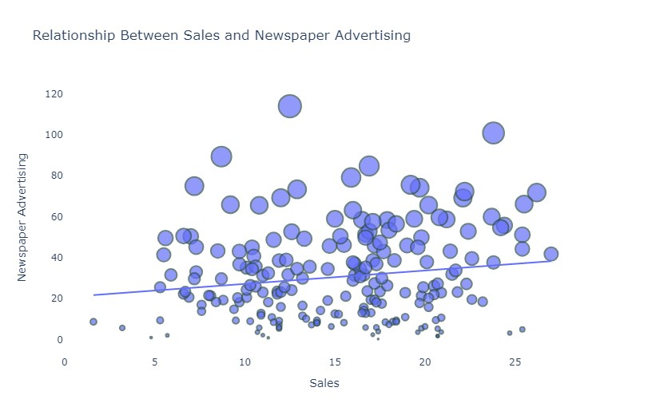

In[7]:

figure = px.scatter(df, x='Sales', y='Radio', size='Radio', trendline='ols', title='Relationship Between Sales and Radio Advertising')

figure.update_traces(marker=dict(line=dict(width=2, color='DarkSlateGrey')), selector=dict(mode='markers'))

figure.update_layout(

xaxis_title='Sales',

yaxis_title='Radio Advertising',

legend_title='Radio Ad Size',

plot_bgcolor='white'

)

figure.show()

Relationship Between Sales and Radio Advertising :

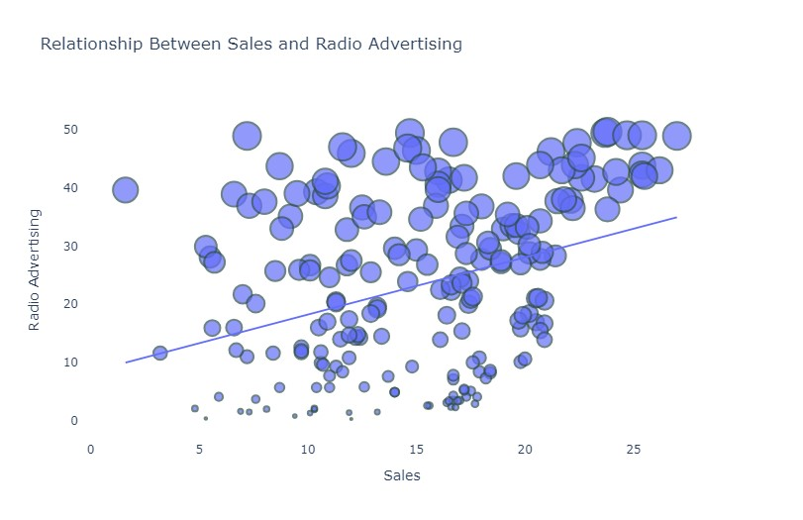

*In[8]:*

*# Calculate the correlation*

correlation = df.corr()

sales_correlation = correlation["Sales"].sort_values(ascending=False)

*# Format and style the correlation values*

styled_sales_correlation = sales_correlation.apply(lambda x: f'**{**x**:**.2f**}**')

styled_sales_correlation = styled_sales_correlation.reset_index()

styled_sales_correlation.columns = ["Feature", "Correlation with Sales"]

styled_sales_correlation.style.background_gradient(cmap='coolwarm', axis=0)

Out[8]:

|  | Feature | Correlation with Sales |
| --- | --- | --- |
| 0 | Sales | 1.00 |
| 1 | TV | 0.90 |
| 2 | Radio | 0.35 |
| 3 | Newspaper | 0.16 |

# **Data Preprocessing**

In [9]:

linkcode

import seaborn as sns

import matplotlib.pyplot as plt

*# Create the box plot*

plt.figure(figsize=(8, 6))

sns.boxplot(x='TV', data=df, palette='Blues')

plt.title('Box Plot of TV Advertising')

plt.xlabel('TV Advertising Spending')

plt.grid(axis='x', linestyle='--', alpha=0.6)

*# Show the plot*

plt.show()

out[9]:

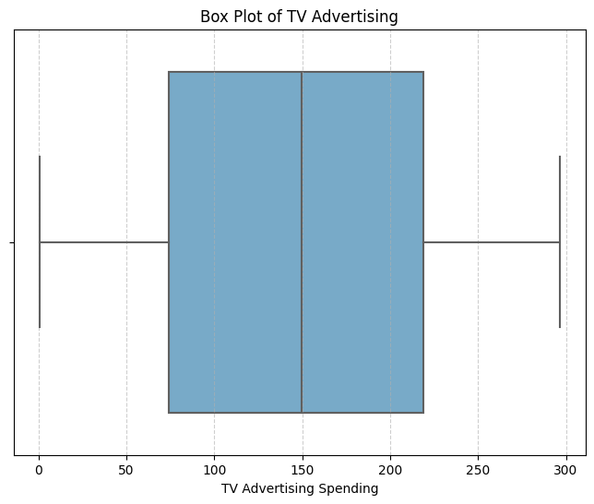

*In[10]:*

*# Create the box plot*

plt.figure(figsize=(8, 6))

sns.boxplot(x='Radio', data=df, palette='Oranges')

plt.title('Box Plot of Radio Advertising')

plt.xlabel('Radio Advertising Spending')

plt.grid(axis='x', linestyle='--', alpha=0.6)

*# Show the plot*

plt.show()

out[10]:

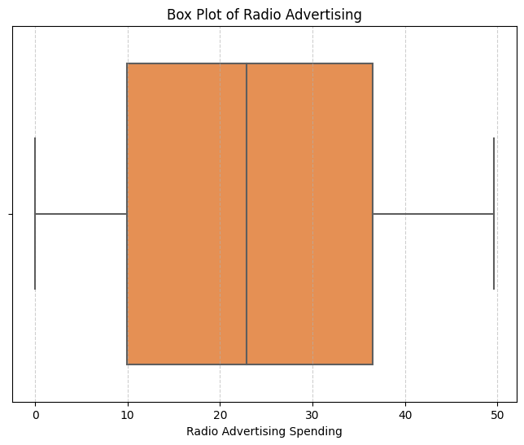

*In[11]:*

*Create the box plot*

plt.figure(figsize=(8, 6))

sns.boxplot(x='Newspaper', data=df, palette='YlGnBu')

plt.title('Box Plot of Newspaper Advertising')

plt.xlabel('Newspaper Advertising Spending')

plt.grid(axis='x', linestyle='--', alpha=0.6)

*# Show the plot*

plt.show()

out[11]:

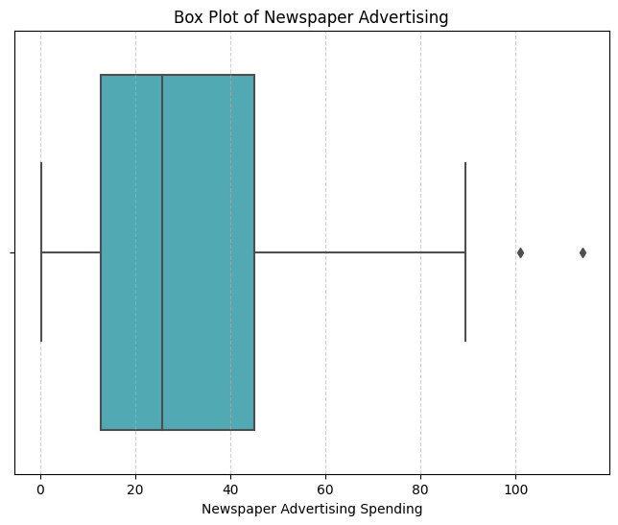

In[12]:

import numpy as np

upper_threshold = 2 * np.std(df['Newspaper']) + np.mean(df['Newspaper'])

df['Newspaper'] = np.where(df['Newspaper'] > upper_threshold, upper_threshold, df['Newspaper'])

In [13]:

*# Create the box plot*

plt.figure(figsize=(8, 6))

sns.boxplot(x='Newspaper', data=df, palette='YlGnBu')

plt.title('Box Plot of Newspaper Advertising')

plt.xlabel('Newspaper Advertising Spending')

plt.grid(axis='x', linestyle='--', alpha=0.6)

*# Show the plot*

plt.show()

out[13]:

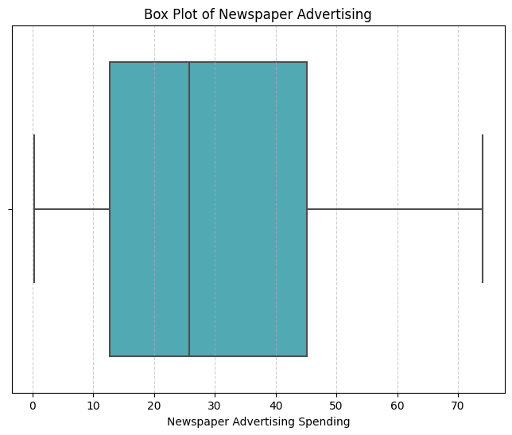

In[14]:

from sklearn.preprocessing

import MinMaxScaler

*# Create a MinMaxScaler object*

scaler = MinMaxScaler()

*# Columns to be normalized (e.g., TV, Radio, Newspaper)*

columns_to_normalize = ['TV', 'Radio', 'Newspaper']

*# Apply Min-Max normalization to the selected columns*

df[columns_to_normalize] = scaler.fit_transform(df[columns_to_normalize])

df.head()

Out[14]:

|  | TV | Radio | Newspaper | Sales |
| --- | --- | --- | --- | --- |
| 0 | 0.775786 | 0.762097 | 0.934843 | 22.1 |
| 1 | 0.148123 | 0.792339 | 0.607851 | 10.4 |
| 2 | 0.055800 | 0.925403 | 0.936200 | 12.0 |
| 3 | 0.509976 | 0.832661 | 0.789664 | 16.5 |
| 4 | 0.609063 | 0.217742 | 0.788307 | 17.9 |

# **Modelling and Evaluation**

At the modeling stage, we use 5 algorithms for comparison, namely Linear Regression, Ridge Regression, Lasso Regression, Decision Tree, and Random Forest.

And for evaluation using MSE, RMSE, MAE and R-Squared.

In [15]:

linkcode

X = df[['TV', 'Radio', 'Newspaper']]

y = df['Sales']

In[16]:

from sklearn.model_selection import cross_val_score

*# Performing 5-fold cross-validation (can be adjusted to the desired number of folds)*

num_folds = 5

*# Function to perform cross-validation and calculate metrics in percentage*

def perform_cross_validation(model, X, y, num_folds):

mse_scores = -cross_val_score(model, X, y, cv=num_folds, scoring='neg_mean_squared_error')

rmse_scores = np.sqrt(mse_scores)

mae_scores = -cross_val_score(model, X, y, cv=num_folds, scoring='neg_mean_absolute_error')

r2_scores = cross_val_score(model, X, y, cv=num_folds, scoring='r2')

return mse_scores, rmse_scores, mae_scores, r2_scores

In[17]:

from sklearn.linear_model import LinearRegression, Ridge, Lasso

*# Linear Regression*

linear_model = LinearRegression()

linear_mse, linear_rmse, linear_mae, linear_r2 = perform_cross_validation(linear_model, X, y, num_folds)

print("Linear Regression:")

print(f"Average MSE: **{**np.mean(linear_mse) / np.mean(y) * 100**:**.2f**}**%")

print(f"Average RMSE: **{**np.mean(linear_rmse) / np.mean(y) * 100**:**.2f**}**%")

print(f"Average MAE: **{**np.mean(linear_mae) / np.mean(y) * 100**:**.2f**}**%")

print(f"Average R-squared: **{**np.mean(linear_r2) * 100**:**.2f**}**%")

print("**\n**")

Linear Regression:

Average MSE: 18.90%

Average RMSE: 11.01%

Average MAE: 8.38%

Average R-squared: 89.53%

In[18]:

#*Ridge Regression*

ridge_model = Ridge(alpha=1.0) *# can adjust alpha as needed*

ridge_mse, ridge_rmse, ridge_mae, ridge_r2 = perform_cross_validation(ridge_model, X, y, num_folds)

print("Ridge Regression:")

print(f"Average MSE: **{**np.mean(ridge_mse) / np.mean(y) * 100**:**.2f**}**%")

print(f"Average RMSE: **{**np.mean(ridge_rmse) / np.mean(y) * 100**:**.2f**}**%")

print(f"Average MAE: **{**np.mean(ridge_mae) / np.mean(y) * 100**:**.2f**}**%")

print(f"Average R-squared: **{**np.mean(ridge_r2) * 100**:**.2f**}**%")

print("**\n**")

Ridge Regression:

Average MSE: 19.67%

Average RMSE: 11.20%

Average MAE: 8.54%

Average R-squared: 89.19%

*In[19]:*

*# Lasso Regression*

lasso_model = Lasso(alpha=1.0) *# can adjust alpha as needed*

lasso_mse, lasso_rmse, lasso_mae, lasso_r2 = perform_cross_validation(lasso_model, X, y, num_folds)

print("Lasso Regression:")

print(f"Average MSE: **{**np.mean(lasso_mse) / np.mean(y) * 100**:**.2f**}**%")

print(f"Average RMSE: **{**np.mean(lasso_rmse) / np.mean(y) * 100**:**.2f**}**%")

print(f"Average MAE: **{**np.mean(lasso_mae) / np.mean(y) * 100**:**.2f**}**%")

print(f"Average R-squared: **{**np.mean(lasso_r2) * 100**:**.2f**}**%")

print("**\n**")

Lasso Regression:

Average MSE: 115.55%

Average RMSE: 27.51%

Average MAE: 22.39%

Average R-squared: 35.98%

In[20]:

from sklearn.tree import DecisionTreeRegressor

*# Decision Trees*

tree_model = DecisionTreeRegressor(max_depth=None, random_state=0) *# can adjust parameters as needed*

tree_mse, tree_rmse, tree_mae, tree_r2 = perform_cross_validation(tree_model, X, y, num_folds)

print("Decision Trees:")

print(f"Average MSE: **{**np.mean(tree_mse) / np.mean(y) * 100**:**.2f**}**%")

print(f"Average RMSE: **{**np.mean(tree_rmse) / np.mean(y) * 100**:**.2f**}**%")

print(f"Average MAE: **{**np.mean(tree_mae) / np.mean(y) * 100**:**.2f**}**%")

print(f"Average R-squared: **{**np.mean(tree_r2) * 100**:**.2f**}**%")

print("**\n**")

Decision Trees:

Average MSE: 16.73%

Average RMSE: 10.40%

Average MAE: 7.56%

Average R-squared: 90.65%

In[21]:

from sklearn.ensemble

import RandomForestRegressor

*# Random Forest*

forest_model = RandomForestRegressor(n_estimators=100, random_state=0) *# can adjust parameters as needed*

forest_mse, forest_rmse, forest_mae, forest_r2 = perform_cross_validation(forest_model, X, y, num_folds)

print("Random Forest:")

print(f"Average MSE: **{**np.mean(forest_mse) / np.mean(y) * 100**:**.2f**}**%")

print(f"Average RMSE: **{**np.mean(forest_rmse) / np.mean(y) * 100**:**.2f**}**%")

print(f"Average MAE: **{**np.mean(forest_mae) / np.mean(y) * 100**:**.2f**}**%")

print(f"Average R-squared: **{**np.mean(forest_r2) * 100**:**.2f**}**%")

Random Forest:

Average MSE: 10.32%

Average RMSE: 8.09%

Average MAE: 5.99%

Average R-squared: 94.27%

# **Classic assumption test**

At the classical assumption testing stage, 5 assumption tests are used, namely linearity test, homoscedasticity test, normality test, multicollinearity test, outliers test, and independent test.

In [22]:

import statsmodels.api as sm

import statsmodels.stats.api as sms

*# Adding a constant to the independent variables (intercept)*

X = sm.add_constant(X)

*# Fit the regression model*

model = sm.OLS(y, X).fit()

*# Residuals (model residuals)*

residuals = model.resid

In [23]:

linkcode

*# Assumption 1: Linearity*

*# You can check linearity using residual vs. fitted values plot*

import matplotlib.pyplot as plt

plt.scatter(model.fittedvalues, residuals)

plt.xlabel("Fitted Values")

plt.ylabel("Residuals")

plt.title("Linearity Check")

plt.show()

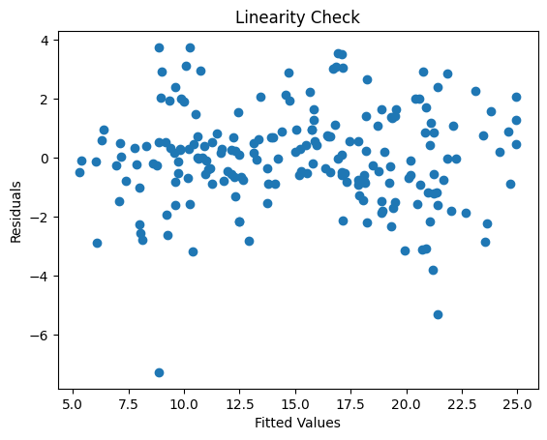

In[24]:

*Assumption 2: Homoskedasticity*

*# You can check homoskedasticity using Breusch-Pagan test*

_, p_homo, _, _ = sms.het_breuschpagan(residuals, X)

print(f"Homoskedasticity (Breusch-Pagan): p-value = **{**p_homo**:**.4f**}**")

Homoskedasticity (Breusch-Pagan): p-value = 0.2634

In [25]:

*# Assumption 3: Independence (Serial Correlation)*

*# You can check for serial correlation using Durbin-Watson test*

from statsmodels.stats.stattools import durbin_watson

dw_stat = durbin_watson(residuals)

print(f"Serial Correlation (Durbin-Watson): DW Statistic = **{**dw_stat**:**.2f**}**")

Serial Correlation (Durbin-Watson): DW Statistic = 2.25

*In[26]:*

*# Assumption 4: Normality*

*# You can check normality using a normal probability plot (Q-Q plot)*

import scipy.stats as stats

fig, ax = plt.subplots(figsize=(6, 4))

_, (__, ___, r) = stats.probplot(residuals, plot=ax, fit=True)

ax.get_lines()[0].set_markerfacecolor('C0')

ax.get_lines()[0].set_markersize(5.0)

ax.get_lines()[1].set_linewidth(3.0)

plt.title("Normal Probability Plot")

plt.show()

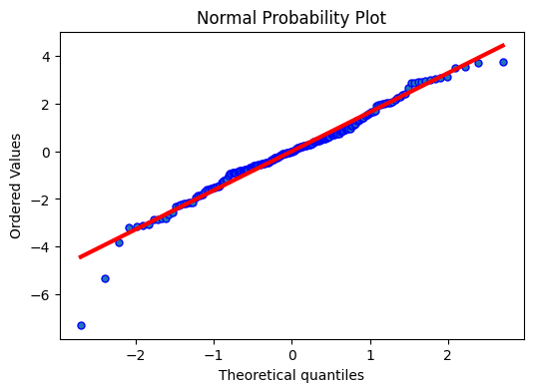

*In[27]:*

*# Assumption 5: Multicollinearity*

*# You can check multicollinearity using the Variance Inflation Factor (VIF)*

from statsmodels.stats.outliers_influence import variance_inflation_factor

vif = pd.DataFrame()

vif["Features"] = X.columns

vif["VIF"] = [variance_inflation_factor(X.values, i) for i **in** range(X.shape[1])]

print("Multicollinearity (VIF):")

print(vif)

Multicollinearity (VIF):

Features VIF

0 const 6.898975

1 TV 1.005037

2 Radio 1.150018

3 Newspaper 1.150920

*In[28]:*

*# Assumption 6: Outliers*

*# You can check for outliers using the studentized residuals and the Cook's distance*

student_resid = model.get_influence().resid_studentized_internal

cooks_d = model.get_influence().cooks_distance[0]

outliers = pd.DataFrame({'Studentized Residuals': student_resid, "Cook's Distance": cooks_d})

outliers.index = X.index

print("Outliers:")

print(outliers[outliers['Studentized Residuals'].abs() > 2])

Outliers:

Studentized Residuals Cook's Distance

10 2.272004 0.021004

33 -2.322006 0.037363

97 2.148943 0.007995

130 -4.468814 0.195094

150 -3.233182 0.056641

154 2.120557 0.013399

196 2.261963 0.021244

Conclusion:

In conclusion, the realm of future sales prediction is marked by a dynamic interplay of data, technology, and strategic foresight.

As businesses navigate the complexities of evolving markets, embracing innovation in predictive analytics becomes not merely a choice but a necessity.

The journey towards accurate sales forecasts involves continual adaptation to emerging technologies, harnessing the power of big data, and a commitment to refining predictive models.

By doing so, organizations position themselves not just to anticipate market trends, but to proactively shape their own destinies in an everchanging business landscape.

The ability to foresee and respond to future sales dynamics becomes a competitive advantage that propels businesses toward sustained growth and resilience in the face of uncertaint