**FUTURE SALES PREDICTION USING MACHINE LEARNING**

**PHASE 5 SUBMISSION DOCUMENT**

**PROJECT TITLE: FUTURE SALES PREDICTION**

**Introduction:**

* In the ever-evolving landscape of business, accurate sales prediction stands as a cornerstone for informed decision-making and strategic planning.
* As we gaze into the future, leveraging innovative approaches becomes paramount.
* Combining the power of data analytics, machine learning, and cutting edge technologies, businesses can unlock the potential to anticipate market dynamics and consumer behaviour.
* This introduction sets the stage for exploring the intricacies of future sales prediction, where the convergence of data-driven insights and forward-thinking methodologies paves the way for a more resilient and adaptive business environment.

Here a list of tools and software and commonly used in the process:

**Programming language:**

Python is a most popular language for machine learning due to its extensive library and framework numpy,pandas,scikit-learn and more.

**Integrated Development Environment (IDE):**

Choose an IDE for coding and running machine learning experiments. Some popular options into Jupiter notebook, Google colab or traditional IDE are like pycharm.

**Data visualization tools:**

Libraries like pandas help with data cleaning, manipulation, and pre processing.

**Data collection and storage:**

Depending on our data source need web scraping tools for data storage.

**Version control:**

Version control system like Git are valuable for tracking changes in your code and collaborating with others.

**External data sources:**

Depending on your projects scope, you might require tools to access external data sources, such as API’s or data scraping tools.

**DESIGN THINKING AND PRESENT IN FORM OF DOCUMENT**

**Design thinking:**

* Over the past few years, [design thinking](https://www.forbes.com/sites/propointgraphics/2017/06/17/design-thinking-your-next-competitive-advantage/) has quickly gained momentum in the business world. Some of the world’s leading brands the likes of Apple, Google, HBO, Samsung, World Bank, and General Electric—have embraced design thinking as a means of optimizing product innovation.
* At its core, design thinking is a methodology for creative problem solving. In stark contrast to analytical thinking, which involves the breaking down of ideas, design thinking involves the building up of ideas.
* Times are changing. The sales cycle is becoming increasingly complex and customers are demanding a more personalized experience.
* If you’re a sales rep, you know you need to up your game and become more innovative.
* Sales teams are recognizing the value of incorporating a design thinking approach into their daily activities such as:

**1. Empathize:**

Empathy is at the core of design thinking. Empathy involves both a cognitive dimension—an ability to look at a situation from another person’s perspective as well as an affective dimensions an ability to relate to relate to a person and develop an emotional bond with them.

Begin by understanding the needs and pain points of the stakeholders involved in sales prediction, such as sales teams, inventory managers, and executives.

**2. Define:**

The objective of the define stage is to craft a problem statement or, in design thinking speak, a point of view. So often sales people define the problem before developing an empathetic understanding of a buyer’s needs.

Clearly define the problem you are trying to solve in the context of sales prediction. Develop a problem statement that encapsulates the challenge and aligns with business objective.

**3. Ideate:**

* The ideate stage unlocks the true potential of design thinking, especially in the context of sales.
* This is when the focus shifts from problem identification to solution generation.
* And it’s all about quantity—about generating a wide range of possible solutions, not necessarily the final solution. It involves thinking beyond the obvious and necessarily entails significant creativity.
* If the customer sells a free or inexpensive product or service, take it for a test run.
* Read through customer community forums and reviews. Encourage creative thinking and generate a wide range of ideas through use of techniques like mind mapping, brainstorming sessions.

**4. Prototype:**

The fourth stage of the design thinking process is prototyping. It is developing more fleshed-out and scaled solutions.

These prototypes can be in the form of simplified modules, dashboards or data visualization.

**5. Test:**

* + The final stage of the design thinking process is to test the final offering.
  + During the test phase, salespeople need to be strategic and see themselves on the same team as the customer.
  + In a world where each customer earns personalized selling wants, this mindset is problematic.
  + Design thinking - which is especially well suited for solving ambiguously defined problems.
  + it is key to establishing a genuine connection with customers and engaging them throughout the sales process. It’s key to sales success.

**Implement:**

Develop a production-ready machine learning solution for future sales prediction, integrating best performing algorithm and data source.

Implement transparency measures, such as model interpretability tools, to ensure users understand how predictions are generator.

**DESIGN INTO INOVATION**

**Innovation:**

* Predicting future sales requires a combination of data analytics, machine learning, and innovative approaches.
* Utilizing advanced algorithms to analyze historical sales data, incorporating external factors like economic trends, and implementing predictive modelling can enhance accuracy.
* AI-driven demand forecasting or predictive analytics based on real-time data can contribute to more precise sales predictions for the future.
* The advanced technique used in future sales predicting are regression forecasting model and linear regression model.
* Combining the power of data analytics, machine learning, and cutting edge technologies, businesses can unlock the potential to anticipate market dynamics and consumer behaviour.

**PYTHON PROGRAM**

# **Load Data**

**In[1]:**

importpandasaspd

df=pd.read_csv('/input/future-sales-prediction/Sales.csv')

df.head()

**output 1:**

|  | TV | Radio | Newspaper | Sales |
| --- | --- | --- | --- | --- |
| 0 | 230.1 | 37.8 | 69.2 | 22.1 |
| 1 | 44.5 | 39.3 | 45.1 | 10.4 |
| 2 | 17.2 | 45.9 | 69.3 | 12.0 |
| 3 | 151.5 | 41.3 | 58.5 | 16.5 |
| 4 | 180.8 | 10.8 | 58.4 | 17.9 |

**In[2]:**

df.info()

<class 'pandas.core.frame.DataFrame'>

RangeIndex: 200 entries, 0 to 199

Data columns (total 4 columns):

# Column Non-Null Count Dtype

--- ------ -------------- -----

0 TV 200 non-null float64

1 Radio 200 non-null float64

2 Newspaper 200 non-null float64

3 Sales 200 non-null float64

dtypes: float64(4)

memory usage: 6.4 KB

**In[3]:**

df.describe().T

**out[3]:**

|  | count | mean | std | min | 25% | 50% | 75% | max |
| --- | --- | --- | --- | --- | --- | --- | --- | --- |
| TV | 200.0 | 147.0425 | 85.854236 | 0.7 | 74.375 | 149.75 | 218.825 | 296.4 |
| Radio | 200.0 | 23.2640 | 14.846809 | 0.0 | 9.975 | 22.90 | 36.525 | 49.6 |
| Newspaper | 200.0 | 30.5540 | 21.778621 | 0.3 | 12.750 | 25.75 | 45.100 | 114.0 |
| Sales | 200.0 | 15.1305 | 5.283892 | 1.6 | 11.000 | 16.00 | 19.050 | 27.0 |

# **Data Preprocessing**

Input:

linkcode

importseabornassns

importmatplotlib.pyplotasplt

*# Create the box plot*

plt.figure(figsize=(8,6))

sns.boxplot(x='TV',data=df,palette='Blues')

plt.title('Box Plot of TV Advertising')

plt.xlabel('TV Advertising Spending')

plt.grid(axis='x',linestyle='--',alpha=0.6)

*# Show the plot*

plt.show()

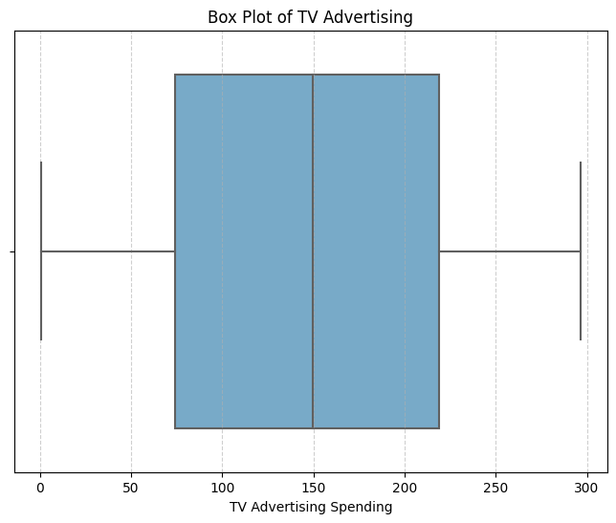

***Input:***

*# Create the box plot*

plt.figure(figsize=(8,6))

sns.boxplot(x='Radio',data=df,palette='Oranges')

plt.title('Box Plot of Radio Advertising')

plt.xlabel('Radio Advertising Spending')

plt.grid(axis='x',linestyle='--',alpha=0.6)

*# Show the plot*

plt.show()

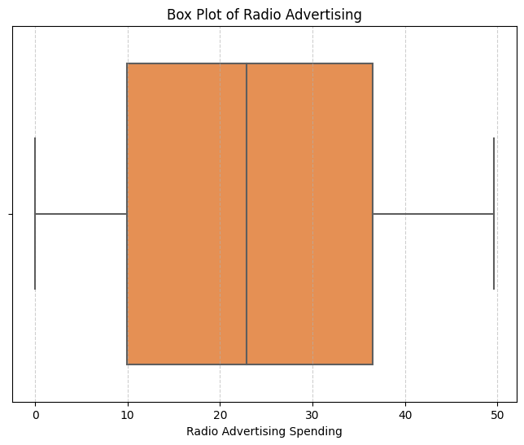

***Input:***

*#Create the box plot*

plt.figure(figsize=(8,6))

sns.boxplot(x='Newspaper',data=df,palette='YlGnBu')

plt.title('Box Plot of Newspaper Advertising')

plt.xlabel('Newspaper Advertising Spending')

plt.grid(axis='x',linestyle='--',alpha=0.6)

*# Show the plot*

plt.show()

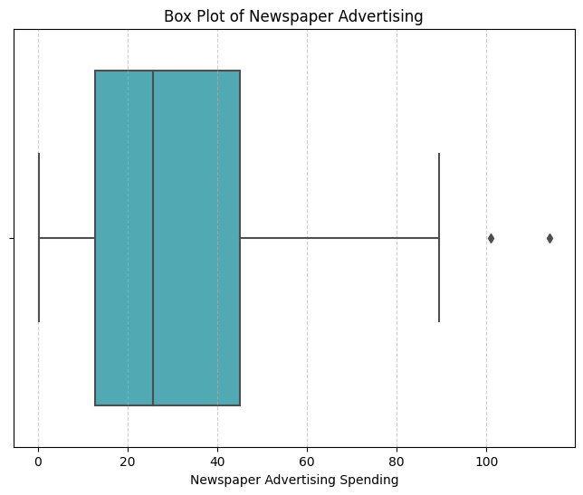

**BUILD LOADING AND PREPROCESSING DATA SET**

**Data collection:**

Obtain the data set that contains information about futures and their corresponding prices.

This data set can be obtained from sources like real estate websites government records or other reliable data providers.

**Load the data set:**

Import relevant libraries, such as pandas for data manipulation and numpy for numerical operation.

Load the data set into a pandas data frame for easy data handling.

# **Load Data**

Input:

importpandasaspd

df=pd.read_csv('/input/future-sales-prediction/Sales.csv')

df.head()

**output :**

|  | TV | Radio | Newspaper | Sales |
| --- | --- | --- | --- | --- |
| 0 | 230.1 | 37.8 | 69.2 | 22.1 |
| 1 | 44.5 | 39.3 | 45.1 | 10.4 |
| 2 | 17.2 | 45.9 | 69.3 | 12.0 |
| 3 | 151.5 | 41.3 | 58.5 | 16.5 |
| 4 | 180.8 | 10.8 | 58.4 | 17.9 |

**Input:**

df.info()

<class 'pandas.core.frame.DataFrame'>

RangeIndex: 200 entries, 0 to 199

Data columns (total 4 columns):

# Column Non-Null Count Dtype

--- ------ -------------- -----

0 TV 200 non-null float64

1 Radio 200 non-null float64

2 Newspaper 200 non-null float64

3 Sales 200 non-null float64

dtypes: float64(4)

memory usage: 6.4 KB

**Input**:

df.describe().T

**output**:

|  | count | mean | std | min | 25% | 50% | 75% | max |
| --- | --- | --- | --- | --- | --- | --- | --- | --- |
| TV | 200.0 | 147.0425 | 85.854236 | 0.7 | 74.375 | 149.75 | 218.825 | 296.4 |
| Radio | 200.0 | 23.2640 | 14.846809 | 0.0 | 9.975 | 22.90 | 36.525 | 49.6 |
| Newspaper | 200.0 | 30.5540 | 21.778621 | 0.3 | 12.750 | 25.75 | 45.100 | 114.0 |
| Sales | 200.0 | 15.1305 | 5.283892 | 1.6 | 11.000 | 16.00 | 19.050 | 27.0 |

**Feature engineering:**

Feature engineering is a crucial aspect of building a house price prediction model using machine learning. It involves creating new features, transforming existing ones, and selecting the most relevant variables to improve the model's predictive power.

**Unitary item prices**.

train_monthly['item_price_unit']=train_monthly['item_price'] // train_monthly['item_cnt']

train_monthly['item_price_unit'].fillna(0, inplace=True)

**Group based features:**

gp_item_price = train_monthly.sort_values('date_block_num').groupby(['item_id'], as_index=False).agg({'item_price':[np.min, np.max]})

gp_item_price.columns = ['item_id', 'hist_min_item_price', 'hist_max_item_price']

train_monthly = pd.merge(train_monthly, gp_item_price, on='item_id', how='left')

# Min value

f_min = lambda x: x.rolling(window=3, min_periods=1).min()

# Max value

f_max = lambda x: x.rolling(window=3, min_periods=1).max()

# Mean value

f_mean = lambda x: x.rolling(window=3, min_periods=1).mean()

# Standard deviation

f_std = lambda x: x.rolling(window=3, min_periods=1).std()

function_list = [f_min, f_max, f_mean, f_std]

function_name = ['min', 'max', 'mean', 'std']

for i in range(len(function_list)):

train_monthly[('item_cnt_%s' % function_name[i])] = train_monthly.sort_values('date_block_num').groupby(['shop_id', 'item_category_id', 'item_id'])['item_cnt'].apply(function_list[i])

# Fill the empty std features with 0

train_monthly['item_cnt_std'].fillna(0, inplace=True)

**Lag based features:**

lag_list = [1, 2, 3]

**Build test set:**

latest_records=pd.concat([train_set, validation_set]).drop_duplicates(subset=['shop_id', 'item_id'], keep='last')

X_test = pd.merge(test, latest_records, on=['shop_id', 'item_id'], how='left', suffixes=['', '_'])

X_test['year'] = 2015

X_test['month'] = 9

X_test.drop('item_cnt_month', axis=1, inplace=True)

X_test[int_features] = X_test[int_features].astype('int32')

X_test = X_test[X_train.columns]

Replacing missing values.

sets = [X_train, X_validation, X_test]

**PERFORMING DIFFERENT ACTIVITIES LIKE FEATURE ENGINEERING, MODEL TRAINING EVALUATION etc**

**Data preprocessing & visualization:**

Continue data preprocessing by handling any remaining missing values or outlier based on insights from your data exploration.

linkcode

X=df[['TV','Radio','Newspaper']]

y=df['Sales']

**Input:**

fromsklearn.model_selectionimportcross_val_score

*# Performing 5-fold cross-validation (can be adjusted to the desired number of folds)*

num_folds=5

*# Function to perform cross-validation and calculate metrics in percentage*

defperform_cross_validation(model,X,y,num_folds):

mse_scores=-cross_val_score(model,X,y,cv=num_folds,scoring='neg_mean_squared_error')

rmse_scores=np.sqrt(mse_scores)

mae_scores=-cross_val_score(model,X,y,cv=num_folds,scoring='neg_mean_absolute_error')

r2_scores=cross_val_score(model,X,y,cv=num_folds,scoring='r2')

returnmse_scores,rmse_scores,mae_scores,r2_scores

**Input:**

fromsklearn.linear_modelimportLinearRegression,Ridge,Lasso

*# Linear Regression*

linear_model=LinearRegression()

linear_mse,linear_rmse,linear_mae,linear_r2=perform_cross_validation(linear_model,X,y,num_folds)

print("Linear Regression:")

print(f"Average MSE: **{**np.mean(linear_mse)/np.mean(y)*100**:**.2f**}**%")

print(f"Average RMSE: **{**np.mean(linear_rmse)/np.mean(y)*100**:**.2f**}**%")

print(f"Average MAE: **{**np.mean(linear_mae)/np.mean(y)*100**:**.2f**}**%")

print(f"Average R-squared: **{**np.mean(linear_r2)*100**:**.2f**}**%")

print("**\n**")

**Linear Regression:**

Average MSE: 18.90%

Average RMSE: 11.01%

Average MAE: 8.38%

Average R-squared: 89.53%

**Input:**

#*Ridge Regression*

ridge_model=Ridge(alpha=1.0)*# You can adjust alpha as needed*

ridge_mse,ridge_rmse,ridge_mae,ridge_r2=perform_cross_validation(ridge_model,X,y,num_folds)

print("Ridge Regression:")

print(f"Average MSE: **{**np.mean(ridge_mse)/np.mean(y)*100**:**.2f**}**%")

print(f"Average RMSE: **{**np.mean(ridge_rmse)/np.mean(y)*100**:**.2f**}**%")

print(f"Average MAE: **{**np.mean(ridge_mae)/np.mean(y)*100**:**.2f**}**%")

print(f"Average R-squared: **{**np.mean(ridge_r2)*100**:**.2f**}**%")

print("**\n**")

**Ridge Regression:**

Average MSE: 19.67%

Average RMSE: 11.20%

Average MAE: 8.54%

Average R-squared: 89.19%

***Input:***

*# Lasso Regression*

lasso_model=Lasso(alpha=1.0)*# You can adjust alpha as needed*

lasso_mse,lasso_rmse,lasso_mae,lasso_r2=perform_cross_validation(lasso_model,X,y,num_folds)

print("Lasso Regression:")

print(f"Average MSE: **{**np.mean(lasso_mse)/np.mean(y)*100**:**.2f**}**%")

print(f"Average RMSE: **{**np.mean(lasso_rmse)/np.mean(y)*100**:**.2f**}**%")

print(f"Average MAE: **{**np.mean(lasso_mae)/np.mean(y)*100**:**.2f**}**%")

print(f"Average R-squared: **{**np.mean(lasso_r2)*100**:**.2f**}**%")

print("**\n**")

**Lasso Regression**:

Average MSE: 115.55%

Average RMSE: 27.51%

Average MAE: 22.39%

Average R-squared: 35.98%

**Input**:

fromsklearn.treeimportDecisionTreeRegressor

*# Decision Trees*

tree_model=DecisionTreeRegressor(max_depth=None,random_state=0)*# You can adjust parameters as needed*

tree_mse,tree_rmse,tree_mae,tree_r2=perform_cross_validation(tree_model,X,y,num_folds)

print("Decision Trees:")

print(f"Average MSE: **{**np.mean(tree_mse)/np.mean(y)*100**:**.2f**}**%")

print(f"Average RMSE: **{**np.mean(tree_rmse)/np.mean(y)*100**:**.2f**}**%")

print(f"Average MAE: **{**np.mean(tree_mae)/np.mean(y)*100**:**.2f**}**%")

print(f"Average R-squared: **{**np.mean(tree_r2)*100**:**.2f**}**%")

print("**\n**")

**Decision Trees:**

Average MSE: 16.73%

Average RMSE: 10.40%

Average MAE: 7.56%

Average R-squared: 90.65%

**Input:**

fromsklearn.ensembleimportRandomForestRegressor

*# Random Forest*

forest_model=RandomForestRegressor(n_estimators=100,random_state=0)*# You can adjust parameters as needed*

forest_mse,forest_rmse,forest_mae,forest_r2=perform_cross_validation(forest_model,X,y,num_folds)

print("Random Forest:")

print(f"Average MSE: **{**np.mean(forest_mse)/np.mean(y)*100**:**.2f**}**%")

print(f"Average RMSE: **{**np.mean(forest_rmse)/np.mean(y)*100**:**.2f**}**%")

print(f"Average MAE: **{**np.mean(forest_mae)/np.mean(y)*100**:**.2f**}**%")

print(f"Average R-squared: **{**np.mean(forest_r2)*100**:**.2f**}**%")

**Random Forest**:

Average MSE: 10.32%

Average RMSE: 8.09%

Average MAE: 5.99%

Average R-squared: 94.27%

**Input:**

importstatsmodels.apiassm

importstatsmodels.stats.apiassms

*# Adding a constant to the independent variables (intercept)*

X=sm.add_constant(X)

*# Fit the regression model*

model=sm.OLS(y,X).fit()

*# Residuals (model residuals)*

residuals=model.resid

**Input:**

linkcode

*# Assumption 1: Linearity*

*# You can check linearity using residual vs. fitted values plot*

importmatplotlib.pyplotasplt

plt.scatter(model.fittedvalues,residuals)

plt.xlabel("Fitted Values")

plt.ylabel("Residuals")

plt.title("Linearity Check")

plt.show()

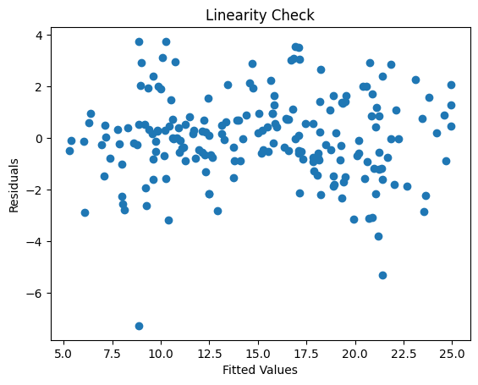

**Input:**

*# Assumption 4: Normality*

*# You can check normality using a normal probability plot (Q-Q plot)*

importscipy.statsasstats

fig,ax=plt.subplots(figsize=(6,4))

_,(__,___,r)=stats.probplot(residuals,plot=ax,fit=True)

ax.get_lines()[0].set_markerfacecolor('C0')

ax.get_lines()[0].set_markersize(5.0)

ax.get_lines()[1].set_linewidth(3.0)

plt.title("Normal Probability Plot")

plt.show()

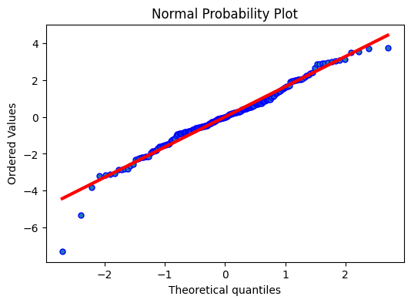

**XGBoost:**

# Use only part of features on XGBoost.

xgb_features = ['item_cnt','item_cnt_mean', 'item_cnt_std', 'item_cnt_shifted1',

'item_cnt_shifted2', 'item_cnt_shifted3', 'shop_mean',

'shop_item_mean', 'item_trend', 'mean_item_cnt']

xgb_train = X_train[xgb_features]

xgb_val = X_validation[xgb_features]

xgb_test = X_test[xgb_features]

xgb_model = XGBRegressor(max_depth=8,

n_estimators=500,

min_child_weight=1000,

colsample_bytrees=0.7 subsample=0.7, eta=0.3, seed=0)

xgb_model.fit(xgb_train,

Y_train,

eval_metric="rmse",

eval_set=[(xgb_train, Y_train), (xgb_val, Y_validation)],

verbose=20,

early_stopping_rounds=20)

[20:29:47] Tree method is automatically selected to be 'approx' for faster speed. To use old behavior (exact greedy algorithm on single machine), set tree_method to 'exact'.

validation_0-rmse:0.937872 validation_1-rmse:0.924623

**Clustering models:**

KNN Regressor

# Use only part of features on KNN.

knn_features = ['item_cnt', 'item_cnt_mean', 'item_cnt_std', 'item_cnt_shifted1',

'item_cnt_shifted2', 'shop_mean', 'shop_item_mean',

'item_trend', 'mean_item_cnt']

X_train_sampled = X_train[:100000]

Y_train_sampled = Y_train[:100000]

knn_train = X_train_sampled[knn_features]

knn_val = X_validation[knn_features]

knn_test=X_test[knn_features]

**Model evaluation:**

* Model evaluation is the process of assessing the performance of a machine learning model on unseen data. This is important to ensure that the model will generalize well to new data.
* There are a number of different metrics that can be used to evaluate the performance of future sales prediction model. Some of the most common metrics include:
* **Mean squared error (MSE):** This metric measures the average squared difference between the predicted and actual sales prices.
* **Root mean squared error (RMSE):** This metric is the square root of the MSE.
* **Mean absolute error (MAE):** This metric measures the average absolute difference between the predicted and actual sales prices
* **R-squared:** This metric measures how well the model explains the variation in the actual sales prices.

**In addition to these metrics, it is also important to consider the following factors when evaluating a sales price prediction model:**

* **Bias**: Bias is the tendency of a model to consistently over- or underestimates sales prices.
* **Variance:** Variance is the measure of how much the predictions of a model vary around the true sales prices.
* **Interpretability:** Interpretability is the ability to understand how the model makes its predictions.

**Evaluation of Predicted Data:**

**Input**

plt.figure(figsize=(12,6))

plt.plot(np.arange(len(Y_test)), Y_test, label='Actual Trend')

plt.plot(np.arange(len(Y_test)), Prediction5, label='Predicted Trend')

plt.xlabel('Data')

plt.ylabel('Trend')

plt.legend()

plt.title('Actual vs Predicted')

**Output:**

Text(0.5, 1.0, 'Actual vs Predicted')

**Predicting future sales has several advantages for businesses:**

**Optimized Inventory Management**: Accurate sales predictions help businesses maintain optimal inventory levels, reducing carrying costs and preventing stock outs or overstocking.

**Resource Allocation:** It enables companies to allocate resources efficiently, such as staff, marketing budgets, and production capacity, to meet expected demand.

**Improved Cash Flow**: Sales forecasts assist in managing cash flow by allowing companies to plan for revenue and expenses more effectively.

**Market Response**: Businesses can adapt their strategies based on sales predictions, responding to market trends and changing consumer preferences more proactively.

**Product Development**: Knowing future sales potential can guide product development, helping companies create products that align with anticipated demand.

**Marketing and Promotions:** Predictions help in planning marketing campaigns and promotions during peak sales periods, maximizing their impact.

**Sales Target Setting:** Businesses can set realistic sales targets and performance goals for their teams, enhancing motivation and accountability.

**Investor Confidence**: Accurate sales forecasts can boost investor confidence and attract capital for expansion or innovation.

**Risk Mitigation**: By identifying potential revenue shortfalls early, companies can implement risk mitigation strategies and contingency plans.

**Competitive Advantage**: Businesses that can predict sales trends more accurately gain a competitive edge in their industry, as they can respond to market changes faster and more effectively.

**Disadvantage of future sales prediction:**

**Inaccuracy:** Sales forecasts are inherently uncertain, and inaccuracies can lead to misguided decisions, such as overproduction or underinvestment.

**Data Limitations**: Predictions rely on historical data and assumptions, which may not account for unforeseen events or market shifts, making them less reliable during volatile times.

**Overreliance on Data:** Overreliance on predictions can lead to neglecting qualitative insights and human judgment, which are valuable in understanding market dynamics.

**Resource Costs**: Developing and maintaining sophisticated forecasting models can be expensive, requiring investments in technology, data analysis, and personnel.

**Complexity**: Highly complex models may be difficult to interpret and act upon, especially for smaller businesses with limited resources.

**Time-Consuming**: Accurate predictions often require significant time and effort to collect and analyze data, which might not align with the pace of decision-making.

**Market Competition**: If competitors have access to similar data and employ advanced forecasting methods, it can reduce the competitive advantage gained from predictions.

**Bias and Assumptions**: Predictions can be influenced by biases in the data, model assumptions, or the choice of variables, potentially leading to flawed forecasts.

**External Factors**: Unforeseen events like natural disasters, economic crises, or pandemics can disrupt sales predictions, rendering them obsolete.

**Over-Planning:** Relying too heavily on forecasts can lead to over planning, resulting in excess inventory, which can be costly and wasteful.

**Employee Morale:** Setting overly ambitious targets based on predictions can demotivate employees if they perceive them as unattainable.

**Privacy Concerns**: In some cases, using personal data for predictions can raise privacy and ethical concerns, requiring careful handling of customer information.

**Predicting future sales offers several benefits for businesses:**

**Better Inventory Management:** Accurate sales predictions help businesses optimize their inventory levels, reducing overstock or under stock situations, which can lead to cost savings.

**Improved Financial Planning**: Sales forecasts aid in budgeting and financial planning, enabling businesses to allocate resources effectively and make informed investment decisions.

**Enhanced Marketing Strategies:** With insight into future sales trends, businesses can tailor their marketing campaigns and promotions to target the right audience at the right time.

**Staffing and Resource Allocation:** Predicting sales can assist in workforce planning, ensuring that the right number of employees is available during peak demand periods.

**Supply Chain Optimization**: Companies can streamline their supply chain processes based on sales predictions, ensuring timely deliveries and reducing transportation costs.

**Customer Satisfaction:** Accurate sales forecasts can lead to better customer service by ensuring product availability and reducing the risk of stock outs.

**Competitive Advantage**: Being able to anticipate market trends and customer preferences can give a business a competitive edge in a dynamic marketplace.

**Risk Mitigation:** Sales predictions can help identify potential risks and challenges, allowing companies to proactively address them.

**Product Development**: Anticipating sales can guide product development decisions, helping companies create or improve products that align with market demand.

**Profit Maximization:** Ultimately, accurate sales predictions can lead to increased profits by reducing costs and optimizing revenue-generating activities.

**Conclusion:**

Each of these stages plays an indispensable role in crafting a model that can provide meaningful insights and estimates for one of the most significant financial decisions individuals and businesses make—real estate transactions.

* Model training is where the model's predictive power is forged. We have explored a variety of regression techniques, fine-tuning their parameters to learn from historical data patterns. This step allows the model to capture the intricate relationships between features and sales prices, giving it the ability to generalize beyond the training dataset.
* Finally, model evaluation is the litmus test for our predictive prowess. Using metrics like Mean Squared Error, Root Mean Squared Error, Mean Absolute Error, and R-squared, we've quantified the model's performance. This phase provides us with the confidence to trust the model's predictions and assess its ability to adapt to unseen data.
* The journey towards accurate sales forecasts involves continual adaptation to emerging technologies, harnessing the power of big data, and a commitment to refining predictive models. By doing so, organizations position themselves not just to anticipate market trends, but to proactively shape their own destinies in an ever-changing business landscape.
* The ability to foresee and respond to future sales dynamics becomes a competitive advantage that propels businesses toward sustained growth and resilience in the face of uncertainty.
* Employing advanced analytics and machine learning models can enhance prediction accuracy.
* Regularly updating and refining your prediction models will help adapt to changing market conditions and customer preferences.
* Keep in mind that while predictions can provide valuable insights, To make accurate future sales predictions, it's crucial to consider historical sales they are not guarantees, and ongoing monitoring and adjustments are necessary to stay competitive in the market.