Alteryx Workflow Project Documentation (Final)
Author: Vaishnavi Manogaran
Tools: Alteryx Designer · Excel · Tableau
Data Sources: vibrant_tests.csv, vibrant_patients.csv

1. Project Overview
This Alteryx workflow demonstrates data preparation, integration, feature engineering, and predictive analytics.

2. Input Data Sources
• vibrant_tests.csv – Lab test records.
• vibrant_patients.csv – Patient demographics.

3. Workflow Steps (Matching Alteryx Design)
Step 1 — Input Data (Tests) [vibrant_tests.csv]
Loads raw test data and optimizes field types.
Step 2 — Date Parsing [vibrant_tests.csv]
Formula: ResultDate_DT = DateTimeParse([ResultDate], "%Y-%m-%d")
Step 3 — Feature Engineering [vibrant_tests.csv]
DeltaFromPrior = [ResultValue] - [PriorResultAvg]
IsOutlier = IF Abs([DeltaFromPrior]) > 20 THEN 1 ELSE 0 ENDIF
Step 4 — Input Data (Patients) [vibrant_patients.csv]
Loads demographic data.
Step 5 — AgeGroup [vibrant_patients.csv]
Formula: AgeGroup = IF [Age] < 30 THEN "Under 30" ELSEIF [Age] < 50 THEN "30-49" ELSE "50+" ENDIF
Step 6 — Join Tool
Joins test and patient data on PatientID.
Step 7 — Sort
Sort by PatientID, ResultDate.
Step 8 — RollingAvg3
3-point rolling average using Multi-Row Formula.

7. Workflow Canvas Diagram
The following image shows the complete Alteryx workflow:
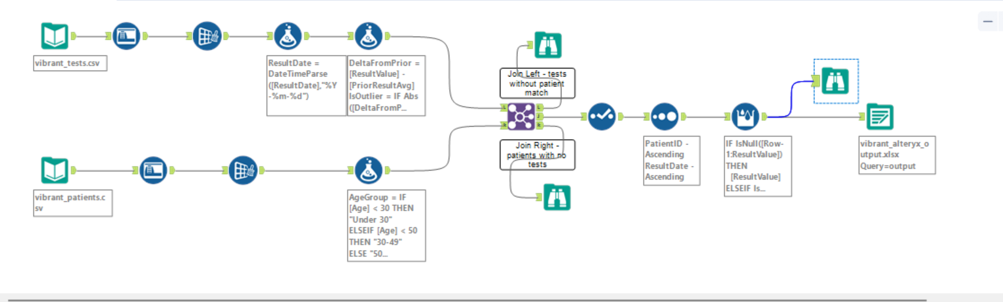

4. Predictive Analytics Features
• DeltaFromPrior – Tracks changes between test results over time.
• IsOutlier – Flags abnormal test values using a threshold method.
• RollingAvg3 – Smoothens patient-specific test trends using multi-row logic.
• ProcessingBucket – Categorises turnaround time into performance groups.
5. Tableau Output
Final dataset supports dashboards including trend analysis, demographic segmentation, outlier detection, and turnaround-time analysis.
6. Skills Demonstrated
✔ Alteryx Workflow Design (Input → Clean → Join → Sort → Rolling Calculations → Output)
✔ Predictive Analytics Concepts (trend, deltas, outliers)
✔ Feature Engineering
✔ Healthcare/Lab Data Understanding
✔ Tableau-ready Data Preparation
✔ Real-world analytical thinking

Laboratory Insights & Performance Dashboard

🧩 1. Project Overview
This project demonstrates how laboratory test data can be transformed, analyzed, and visualized using Alteryx (for data preparation) and Tableau (for business intelligence dashboards).
The goal is to provide a comprehensive view of diagnostic testing trends, patient distribution, predictive analytics, and operational performance.
The dashboard brings together multiple analytical perspectives, enabling stakeholders to understand:
- How test results evolve over time
- Which test types are most in demand
- How laboratory turnaround times compare across categories
- Where patients are located
- How predictive rolling averages compare with actual results

⚙️ 2. Data Preparation (Alteryx Summary)
Data from two CSV files — vibrant_tests.csv and vibrant_patients.csv — were cleaned, joined, enriched, and transformed using Alteryx.
Key processing steps:
- Date Parsing: Converted ResultDate into proper Date format
- Feature Engineering:
  - PriorResultAvg
  - DeltaFromPrior
  - IsOutlier
  - RollingAvg3 (3-point rolling calculation using Multi-Row Formula)
  - AgeGroup classification
- Join: Combined patient demographics with test results using PatientID
- Sorting: Ensured chronological order for rolling averages
- Output: Exported an Excel dataset for Tableau visualization

📊 3. Visualization Sheets Explained (Tableau)
The dashboard consists of five key visualizations, each highlighting a different aspect of laboratory analytics.

🧪 Sheet 1: Test Result Trend Over Time
Chart Type: Line Chart
Purpose: Shows how average test results change over the years.
Interpretation:
- Fluctuations show years with higher or lower test readings.
- Rising result values may indicate increased severity in patient diagnostics or changes in testing patterns.
- Helps identify unusual spikes, stable periods, or downward trends.
Why it matters:
Provides a longitudinal view of patient test severity, supporting forecasting and monitoring changes in patient health patterns or test volume.

🗺️ Sheet 2: Patient Distribution Across U.S. States
Chart Type: Filled Geographic Map
Purpose: Displays where most patients/tests originate.
Interpretation:
- Darker states represent higher patient volumes.
- Helps identify geographic trends, high-demand regions, and operational load.
Why it matters:
Supports resource planning, test routing optimization, and understanding demographic reach.

🧫 Sheet 3: Number of Tests by Panel Type
Chart Type: Bar Chart
Purpose: Shows the number of tests conducted for each medical panel type.
Interpretation:
- Panels like Autoimmune, Metabolic, or Cardiac Markers may have higher demand.
- Indicates workload distribution across departments.
Why it matters:
Helps diagnose which test types require more resources, staffing, or quality monitoring.

🔮 Sheet 4: Rolling 3-Point Average vs Actual Results
Chart Type: Dual-Line Chart
Purpose: Compares actual test results with a predictive smoothed average.
Interpretation:
- RollingAvg3 smooths fluctuations by averaging each result with the two previous values.
- Highlights stable trends vs actual variability.
- Deviations between lines indicate periods of abnormality.
Why it matters:
Demonstrates predictive smoothing, a common analytical method to reduce noise and identify underlying patterns.
Shows strong Alteryx data engineering skills.

⏱️ Sheet 5: Turnaround Time Performance
Chart Type: Horizontal Bar Chart
Purpose: Displays how many tests fall into each processing time category:
- 0–60 minutes
- 60–120 minutes
- 120+ minutes
Interpretation:
- Identifies efficiency of laboratory operations.
- Highlights bottlenecks or delayed processing patterns.
Why it matters:
Operational performance is critical for laboratories.
This visualization supports quality assurance and performance improvement.

📊 4. Dashboard Explanation
Dashboard Name:
Laboratory Insights & Performance Dashboard
Purpose:
To provide a unified analytical view of patient test trends, geographic distribution, workload, predictive analytics, and processing performance.
What the Dashboard Shows:

🧪 1. Test Result Trend Over Time
Shows how patient test severity has changed year by year.
Aids in identifying medical and operational patterns.

🗺️ 2. Patient Distribution Across U.S. States
Reveals high-volume states, helping identify demographic and geographic insights.

🧫 3. Number of Tests by Panel Type
Shows operational workload and which test types are most frequently ordered.

🔮 4. Rolling 3-Point Average vs Actual Results
Highlights predictive trends and compares them to real test results, showing stability vs variability.

⏱️ 5. Turnaround Time Performance
Shows how efficiently the lab processes tests and highlights slow vs fast categories.

⭐ 5. Key Insights & Takeaways
- Certain years show higher test result values, indicating increased abnormal findings.
- States like TX, CA, WA, PA, NY have higher patient activity.
- Tests like Metabolic Panel and Cardiac Markers are more frequently ordered.
- Rolling averages reveal consistent underlying trends beneath noisy actual values.
- Most tests fall into the 120+ minutes processing bucket, indicating opportunities for operational improvement.

🎯 6. Conclusion
This dashboard provides a complete overview of laboratory activity from multiple perspectives:
- Clinical: Test result patterns
- Geographic: Patient distribution
- Operational: Processing performance
- Analytical: Predictive smoothing via rolling average
- Business: Test volume by category
Using a combination of Alteryx ETL skills and Tableau visualization, the project demonstrates end-to-end data engineering, analytics, and business intelligence capability.

