Week 3: Advanced Data Analysis and Visualization in Logistics
Internship Task Report

1. Introduction
This report presents exploratory data analysis (EDA) and visualization of a hypothetical logistics dataset. The purpose is to understand delivery performance, shipment volumes, transportation costs, and possible relationships between these measures. The dataset is simulated for learning and does not represent actual company records.

2. Objectives
- Explore a simulated logistics dataset using Python.
- Calculate descriptive statistics and examine distributions.
- Study relationships among delivery days, shipment volume, and transportation cost.
- Create visualizations and interpret logistics performance.
- Suggest practical areas for operational improvement.

3. Dataset Description
The dataset contains 15 hypothetical orders and five columns: order_id (unique order number), delivery_days (delivery duration in days), shipment_volume (shipment quantity/volume in the chosen practice unit), transportation_cost (cost in hypothetical currency units), and destination (delivery city).
order_id | delivery_days | shipment_volume | transportation_cost | destination
1001 | 2 | 50 | 500 | Pune
1002 | 4 | 80 | 900 | Mumbai
1003 | 3 | 60 | 650 | Nanded
1004 | 5 | 100 | 1200 | Nashik
1005 | 2 | 40 | 450 | Pune
1006 | 6 | 120 | 1500 | Mumbai
1007 | 3 | 70 | 750 | Aurangabad
1008 | 4 | 90 | 1000 | Pune
1009 | 2 | 55 | 550 | Nanded
1010 | 5 | 110 | 1350 | Mumbai
1011 | 3 | 65 | 700 | Nashik
1012 | 4 | 85 | 950 | Aurangabad
1013 | 7 | 130 | 1700 | Mumbai
1014 | 2 | 45 | 480 | Pune
1015 | 5 | 105 | 1250 | Nanded

4. Tools and Methodology
Python was used in Google Colab. Pandas supported data loading, grouping, and summary calculations. NumPy was imported for numerical work. Matplotlib and Seaborn were used to create charts. The workflow included loading the CSV file, checking the first rows and data types, calculating descriptive statistics, computing Pearson correlations, grouping results by destination, and saving visualizations.

5. Exploratory Data Analysis
The dataset contains 15 orders and no missing values in the supplied practice data. Average delivery time is 3.80 days, with a median of 4.00 days. Average shipment volume is 80.33, and average transportation cost is 928.67. The transportation-cost median is 900.00. The standard deviation of delivery days is 1.57, shipment volume is 28.31, and transportation cost is 396.55.
Metric | Mean | Median | Std. Deviation
Delivery days | 3.80 | 4.00 | 1.57
Shipment volume | 80.33 | 80.00 | 28.31
Transportation cost | 928.67 | 900.00 | 396.55

6. Visualizations and Interpretations
Figure 1. Average delivery days by destination. A bar chart is suitable for comparing a numerical measure across categories.
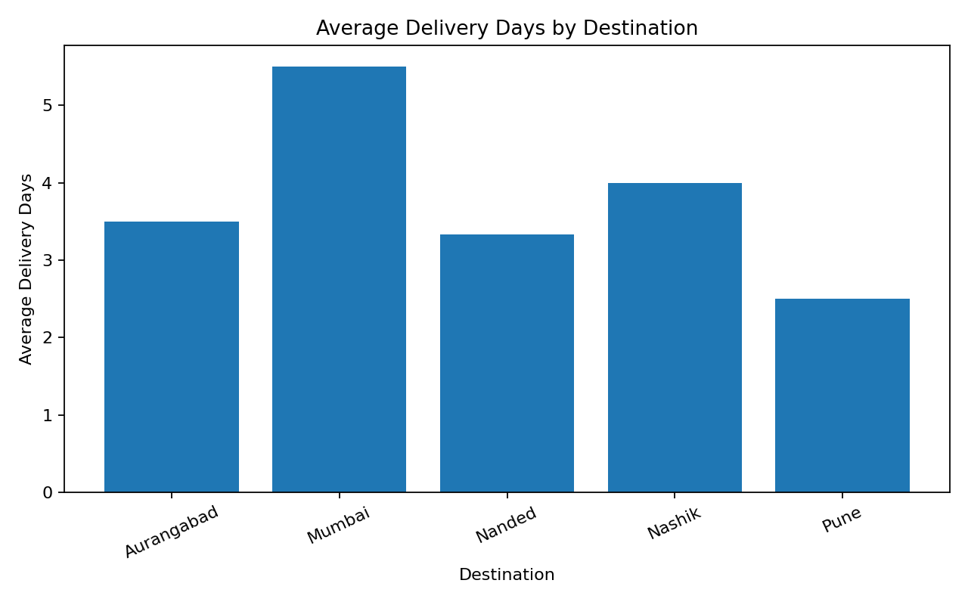
Interpretation: Mumbai has the highest average delivery time (5.50 days) in this sample, while Pune has the lowest (2.50 days). This suggests that Mumbai orders may need closer review of route, distance, or scheduling assumptions.
Figure 2. Transportation cost distribution. A histogram shows how frequently cost values fall into different ranges.
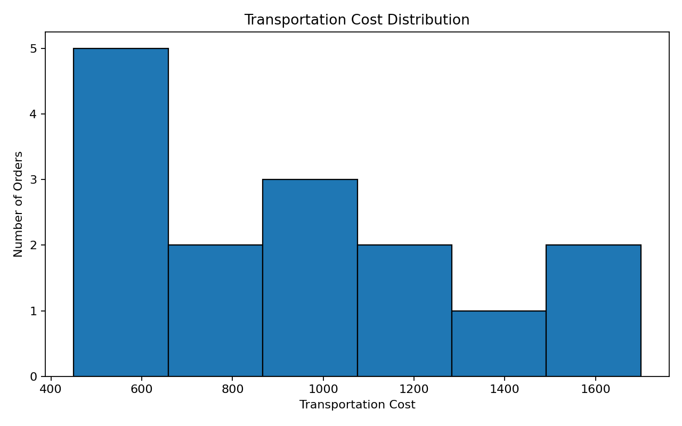
Interpretation: Costs range from 450 to 1,700. The histogram helps identify the spread of costs and whether orders are concentrated in lower or higher cost ranges.
Figure 3. Shipment volume versus transportation cost. A scatter plot is useful for examining relationships between two numerical variables.
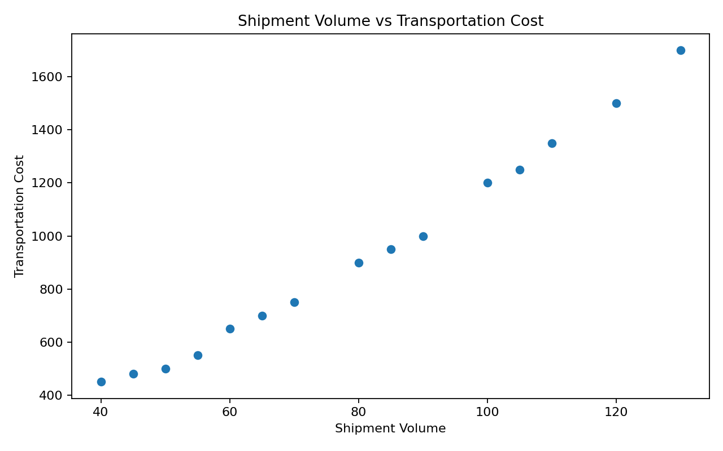
Interpretation: The points show a strong upward pattern: orders with larger shipment volumes generally have higher transportation costs in this simulated dataset.
Figure 4. Correlation heatmap. A heatmap presents correlation coefficients in a compact visual form.
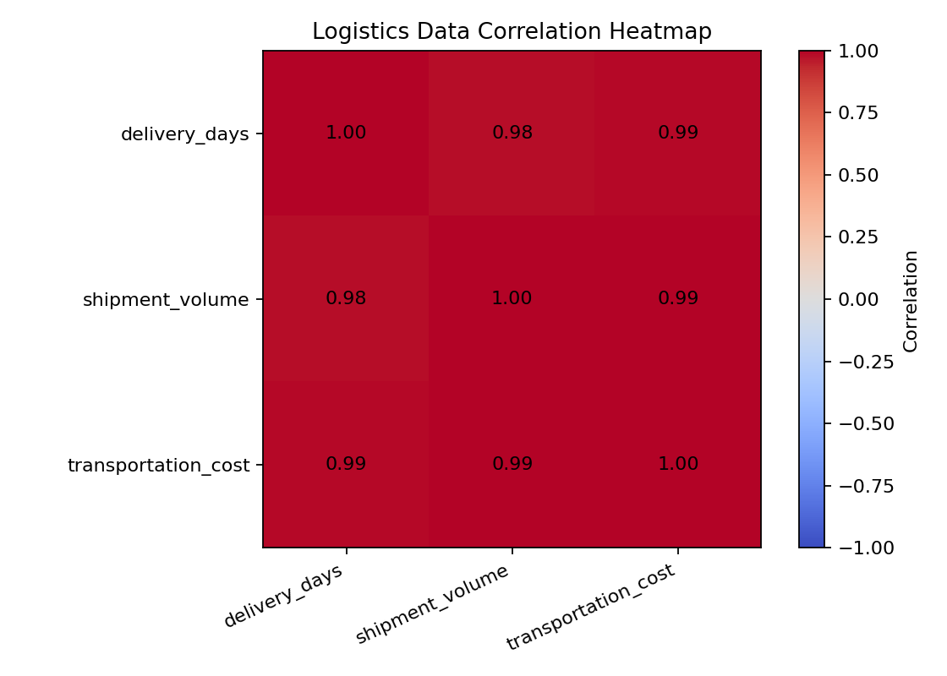
Interpretation: Delivery days and transportation cost have a strong positive correlation (r = 0.99). Shipment volume and transportation cost also have a strong positive correlation (r = 0.99). Correlation indicates association, not proof that one variable causes another.

7. Destination-wise Performance
Destination | Avg. Delivery Days | Avg. Cost | Avg. Volume
Aurangabad | 3.50 | 850.00 | 77.50
Mumbai | 5.50 | 1362.50 | 110.00
Nanded | 3.33 | 816.67 | 73.33
Nashik | 4.00 | 950.00 | 82.50
Pune | 2.50 | 607.50 | 56.25

8. Key Findings
- Mumbai has the highest average delivery time and average transportation cost among the destinations in this sample.
- Pune has the lowest average delivery time and average transportation cost in this sample.
- Transportation cost increases alongside shipment volume in the simulated records.
- The high positive correlation between delivery days and transportation cost suggests that longer delivery durations are associated with higher costs in this dataset.
- These patterns are exploratory and should be validated with larger, real operational data before business decisions are made.

9. Recommendations
- Review routes and delivery schedules for destinations with higher average delivery times.
- Compare transport modes and route plans to identify opportunities to reduce cost.
- Plan vehicle capacity according to shipment volume and monitor cost per unit of shipment.
- Track delivery time, transportation cost, and shipment volume regularly using a dashboard.
- Repeat the analysis on a larger real-world dataset, including distance, fuel usage, vehicle type, and traffic conditions.

10. Python Code Used
import pandas as pd
import matplotlib.pyplot as plt
import seaborn as sns
df = pd.read_csv("logistics_data.csv")
print(df.info())
print(df.describe())
print("Mean:\n", df.mean(numeric_only=True))
print("Median:\n", df.median(numeric_only=True))
print("Standard deviation:\n", df.std(numeric_only=True))
corr = df[["delivery_days", "shipment_volume",
"transportation_cost"]].corr()
print(corr)
# Destination-wise average delivery time
df.groupby("destination")["delivery_days"].mean().plot(kind="bar")
plt.title("Average Delivery Days by Destination")
plt.xlabel("Destination")
plt.ylabel("Average Delivery Days")
plt.tight_layout()
plt.show()
# Cost distribution
plt.hist(df["transportation_cost"], bins=6, edgecolor="black")
plt.title("Transportation Cost Distribution")
plt.xlabel("Transportation Cost")
plt.ylabel("Number of Orders")
plt.tight_layout()
plt.show()
# Shipment volume vs transportation cost
plt.scatter(df["shipment_volume"], df["transportation_cost"])
plt.title("Shipment Volume vs Transportation Cost")
plt.xlabel("Shipment Volume")
plt.ylabel("Transportation Cost")
plt.tight_layout()
plt.show()
# Correlation heatmap
sns.heatmap(corr, annot=True, cmap="coolwarm")
plt.title("Logistics Data Correlation Heatmap")
plt.tight_layout()
plt.show()

11. Conclusion
This task demonstrated how exploratory data analysis and visualizations can support logistics performance review. Descriptive statistics summarized delivery time, shipment volume, and cost. Bar charts, histograms, scatter plots, and a correlation heatmap helped reveal destination differences, cost distribution, and variable relationships. The analysis suggests areas for further investigation, especially higher-cost and longer-delivery destinations. Because the data is hypothetical and limited to 15 orders, the findings are practice insights rather than operational conclusions.

12. References
Pandas documentation: https://pandas.pydata.org/docs/
Matplotlib documentation: https://matplotlib.org/stable/
Seaborn documentation: https://seaborn.pydata.org/
Google Colab: https://colab.research.google.com/

